3. SYSTEM DESIGN
3.1 Introduction:
The goal of design process is to produce a model or representation of a system, which can be used later to build the system. Systems design is the process of defining the architecture, modules, interfaces, and data for a system to satisfy specified requirements. The focus of system design is on deciding which modules are needed for system, the specifications of these modules and how the modules should be interconnected.

Systems design could be seen as the application of systems theory to product development. Systems design implies a systematic approach to the design of a system. It may take a bottom-up or top-down approach, but either way the process is systematic wherein it takes into account all related variables of the system that needs to be created. The system design controls the major structural characteristics of the system. It has a major impact on the testability and modifiability of system. The output is the architectural design for the software system to be built.

The Grocery Delivery System is designed to manage online grocery ordering, product management, shop registration, delivery assignment, and payment processing. The system provides services to multiple users including customers, shops, farmers, delivery personnel, and administrators. The system uses MongoDB as the database and follows MERN architecture. The system design defines system architecture, modules, interfaces, data flow, and database structure. It ensures efficient interaction between different modules such as product management, order management, payment processing, and delivery tracking. The system design improves maintainability, scalability, and performance of the application.

3.2 Context Flow Diagram:
Context flow diagram is a top-level data flow diagram. It only contains one process node that generalizes the function of the entire system in relationship to external entities. In context diagram the entire system is treated as a single process and all its inputs, outputs, sinks and sources are identified and shown.
In Grocery Delivery System, the main external entities are:
- Customer
- Admin
- Shop
- Farmer
- Delivery Personnel
The system processes user requests such as registration, product browsing, ordering, payment, and delivery management.
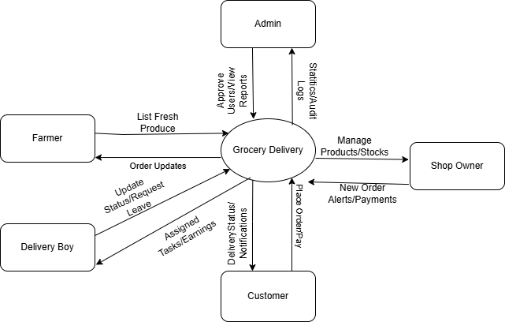
3.3 Data Flow diagram:

Data Flow Diagram is a graphical representation of a system or a portion of the system. It consists of data flows, process, sources and sink and stores all the description through the use of easily understandable symbols. DFD is one of the most important modelling tools.

It is used to model the system, components that interact with the system, uses the data and information flows in the system. DFD shows the information moves through the and how it is modified by a series of transformations. It is a graphical technique that depicts information moves from input or output.
DFD is also knows as bubble chart or Data Flow Graphs. DFD may be used to represent the system at any level of abstraction. DFD’s may partition into a level that represents increasing information flows and functional details.

3.4 Rules Regarding DFD construction
- A process cannot have only outputs.
- A process cannot have only inputs.
- The inputs to a process must be sufficient to produce the outputs from the process.
- All data stores must be connected to at least one process.
- All data stores must be connected to a source or sink via a process.
- A data flow can have only one direction of flow.
- Data cannot flow directly back into the process it has just left.
- All data flows must be named using a noun phrase.

3.5 DFD Symbols
Name | Notation | Description
Process |  | A process transforms incoming data flow into outgoing data flow.
Data Store |  | Data stores are repositories of data in the system (Database).
Data Flow |  | Data flows are pipelines through which information flows.
External Entity |  | External entities are objects outside the system that communicate with it.
%3CmxGraphModel%3E%3Croot%3E%3CmxCell%20id%3D%220%22%2F%3E%3CmxCell%20id%3D%221%22%20parent%3D%220%22%2F%3E%3CmxCell%20id%3D%222%22%20parent%3D%221%22%20style%3D%22html%3D1%3Bdashed%3D0%3BwhiteSpace%3Dwrap%3Bshape%3DpartialRectangle%3Bright%3D0%3B%22%20value%3D%22%22%20vertex%3D%221%22%3E%3CmxGeometry%20height%3D%2230%22%20width%3D%22100%22%20x%3D%2250%22%20y%3D%22200%22%20as%3D%22geometry%22%2F%3E%3C%2FmxCell%3E%3C%2Froot%3E%3C%2FmxGraphModel%3E%3CmxGraphModel%3E%3Croot%3E%3CmxCell%20id%3D%220%22%2F%3E%3CmxCell%20id%3D%221%22%20parent%3D%220%22%2F%3E%3CmxCell%20id%3D%222%22%20parent%3D%221%22%20style%3D%22html%3D1%3Bdashed%3D0%3BwhiteSpace%3Dwrap%3Bshape%3DpartialRectangle%3Bright%3D0%3B%22%20value%3D%22%22%0vertex%3D%221%22%3E%3CmxGeometry%20height%3D%2230%22%20width%3D%22100%22%20x%3D%2250%22%20y%3D%22200%22%20as%3D%22geometry%22%2F%3E%3C%2FmxCell%3E%3C%2Froot%3E%3C%2FmxGraphModel%3E%3CmxGraphModel%3E%3Croot%3E%3CmxCell%20id%3D%220%22%2F%3E%3CmxCell%20id%3D%221%22%20parent%3D%220%22%2F%3E%3CmxCell%20id%3D%222%22%20parent%3D%221%22%20style%3D%22html%3D1%3Bdashed%3D0%3BwhiteSpace%3Dwrap%3Bshape%3DpartialRectangle%3Bright%3D0%3B%22%20value%3D%22%22%20vertex%3D%221%22%3E%3CmxGeometry%20height%3D%2230%22%20width%3D%22100%22%20x%3D%2250%22%20y%3D%22200%22%20as%3D%22geometry%22%2F%3E%3C%2FmxCell%3E%3C%2Froot%3E%3C%2FmxGraphMo

3.6 DFD Level 1(Admin):
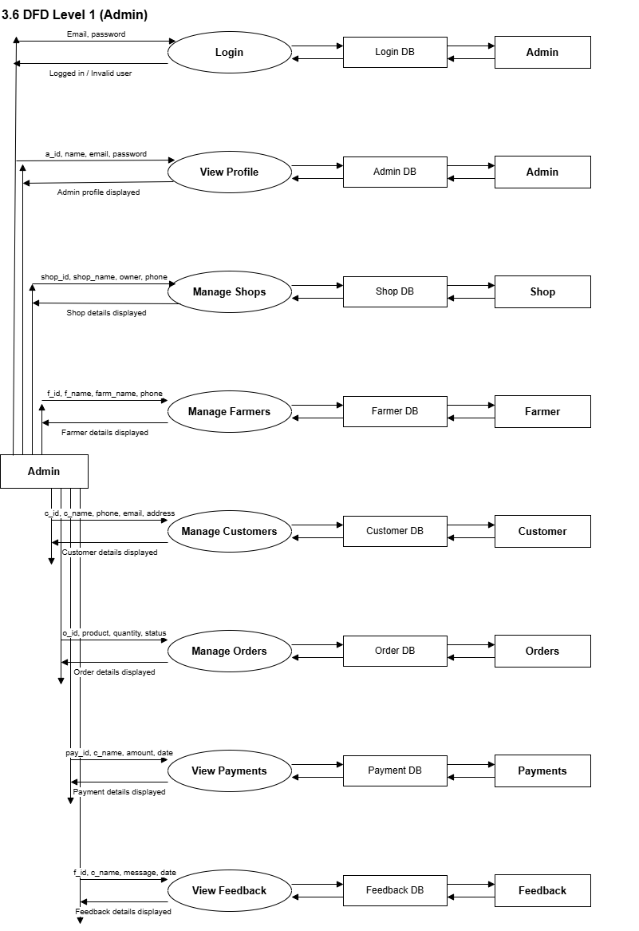

3.6.1 DFD Level 2 (Manage Shops):
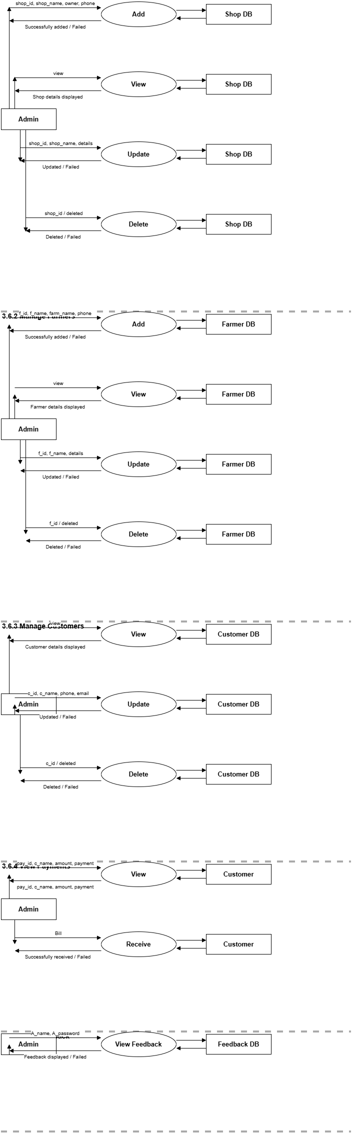
3.6.2 DFD Level 2 (Manage Farmers):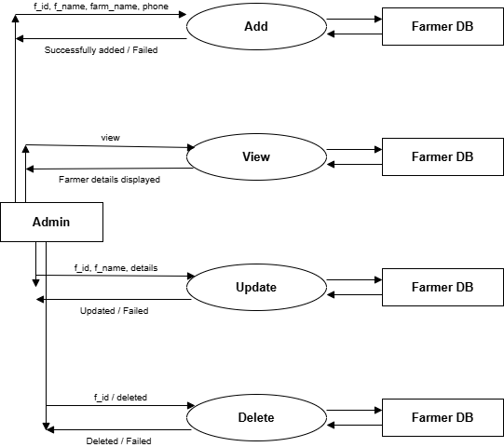
3.6.3 DFD Level 2 (Manage Customers):
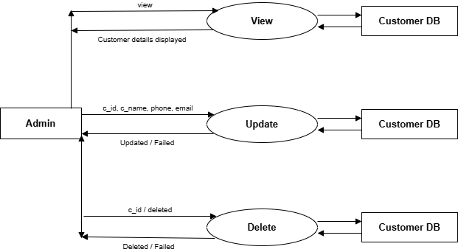

3.6.4 DFD Level 2 (View Payments):
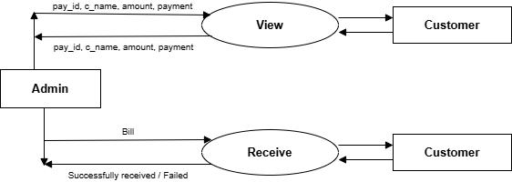

3.6.5 DFD Level 2 (View Feedback):
3.7 DFD Level 1 (Shop):
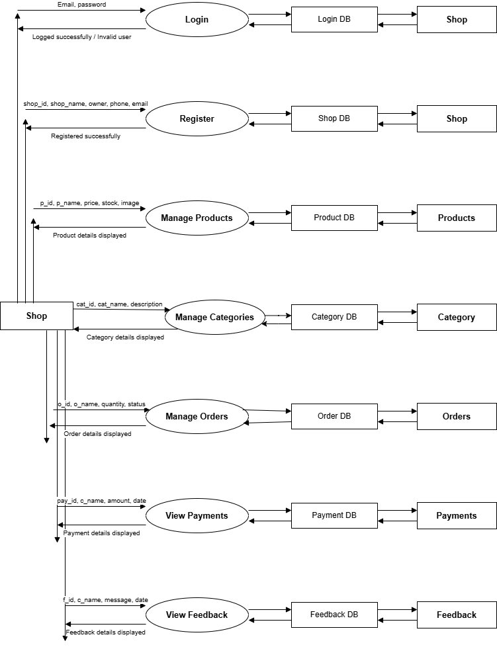
3.7.1 DFD Level 2 (Login):
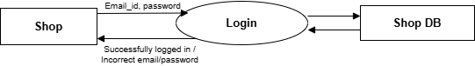
3.7.2 DFD Level 2 (Register):
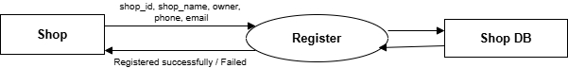
3.7.3 DFD Level 2 (Manage Products):

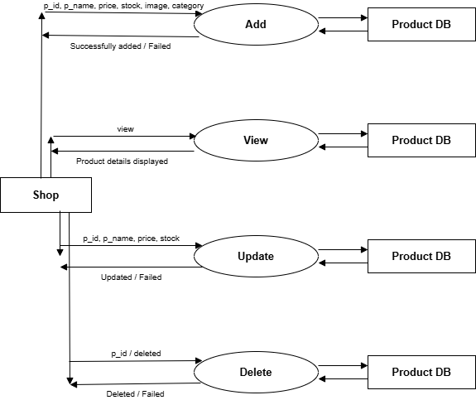
3.7.4 DFD Level 2 (Manage Categories):

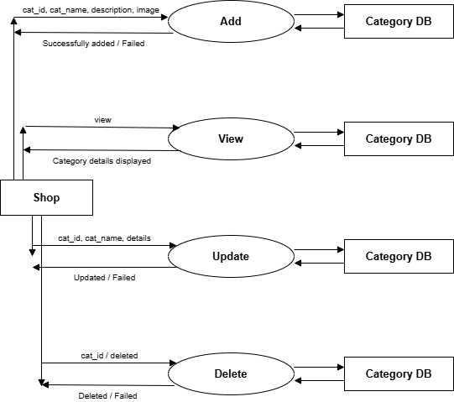
3.7.5 DFD Level 2 (Manage Orders):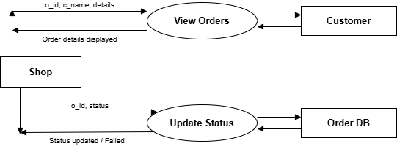3.7.6 DFD Level 2 (View Feedback):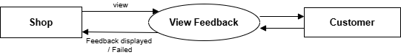
3.7.7 DFD Level 1 (Customer):
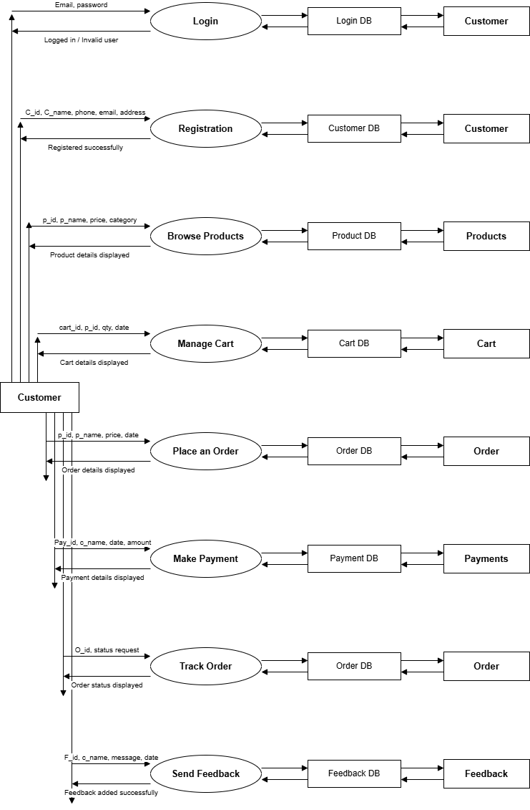
3.7.8 DFD Level 2 (Login):

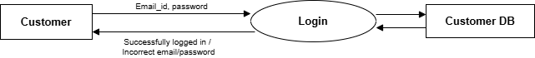

3.7.9 DFD Level 2 (Register):

3.7.10 DFD Level 2 (Browse Products):
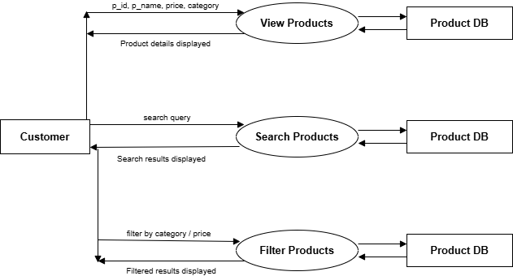

3.7.11 DFD Level 2(Manage Cart):
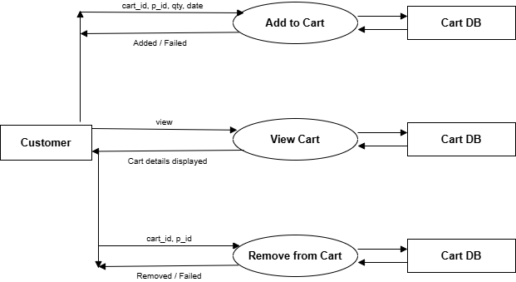
3.7.12 DFD Level 2(Place Order):

3.7.13 DFD Level 2(Make Payment):

3.7.14 DFD Level 2(Track Order):
3.7.15 DFD Level 2(Send Feedback):
3.7.16 DFD Level 1(Delivery):
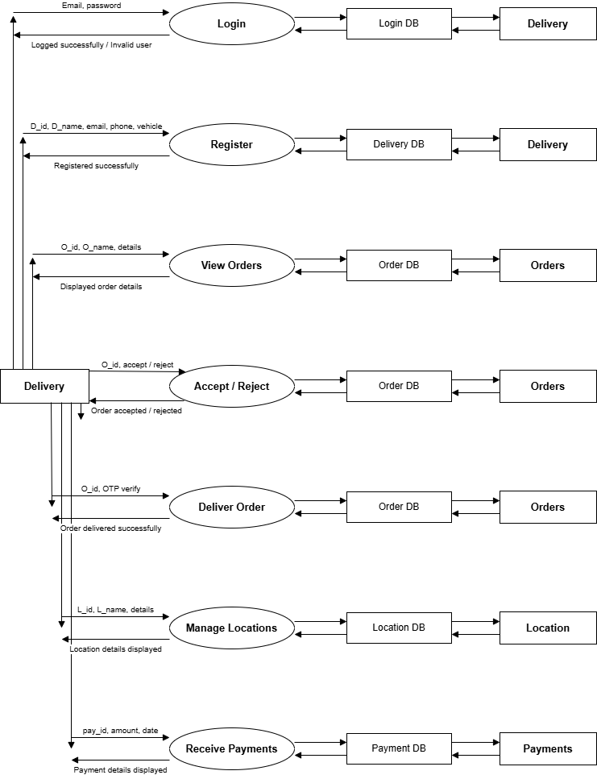
3.7.17 DFD Level 2(Login):
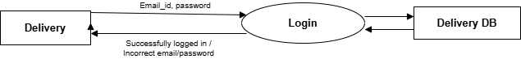
3.7.18 DFD Level 2(Register):
3.7.19 DFD Level 2(View Orders):
3.7.20 DFD Level 2(Manage Location):
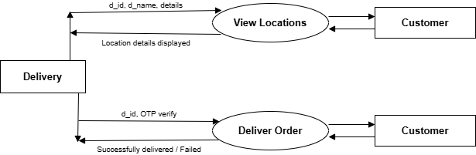
3.7.21 DFD Level 2(Receive Payments):

3.7.22 DFD Level 1(Farmer):

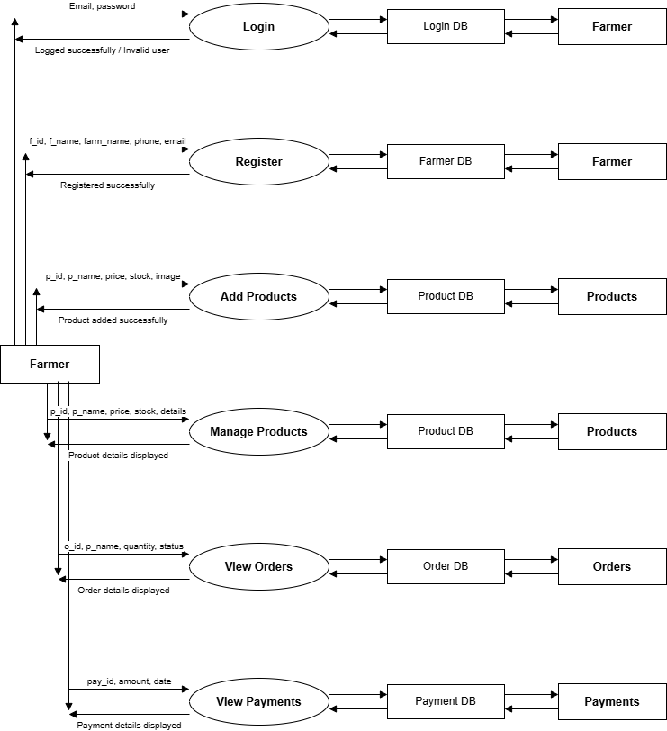

3.7.23 DFD Level 2(Login):
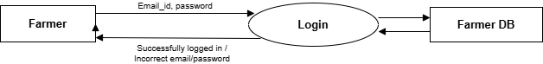
3.7.24 DFD Level 2(Register):
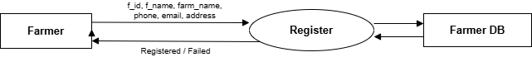
3.7.25 DFD Level 2(Manage Products):
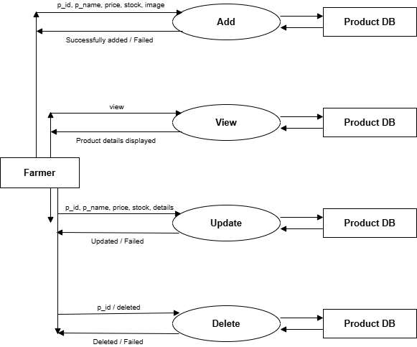
3.7.26 DFD Level 2(View Orders):
3.7.27 DFD Level 2(View Payments):
3.8 Entity Relationship Diagram
A set of primary components are identified for the ER Diagram: Data object, Attributes, Relationships and various type indicators. The primary purpose of the ER Diagram is to represent data objects and their relationships.

3.8.1 Data Objects
A data object is a representation of almost any composite information that must be understood by software. Composite information refers to something that has a number of different properties or attributes.

3.8.2 Attributes
Attributes defines the properties of data object and take on one of three different characteristics. They can be used to (1) name an instance of the data object (2) describe the instance or (3) make reference to another instance in another table. In addition, one or more of the attributes must be defined as an identifier that is the identifier attribute becomes a “key” when we want to find an instance of the data object.

3.8.3 Relationships
Indicate the manner in which data objects are “connected” to one another.

3.8.4 Cardinality
The data model must be capable of representing the number of occurrences objects in a given relationships. Tillman defines the cardinality of an object/relationships pair in the following manner: “Cardinality is the specification of the number of occurrences of one [object] that can be related to the number of occurrences of another [object]. Cardinality is usually expressed as simply ‘one’ or ‘many’”. Taking into consideration all combinations of ‘one’ and ‘many’, two [object] can be as:
The Symbols are shown in below table:

Name | Notation | Description
Entity | Entity name | It may be an object with the physical existence or conceptual existence. It is represented by a Rectangle.
Attribute | Attribute  name  name | The properties of the entity can be a attribute. It is represented by a Ellipse.
Relationship | relation | Whenever an attribute of one entity refers to another entity, some relationship exists. It is represented by a Diamond.
Link |  | Lines link attributes to entity sets and entity sets to relation.
Derived attribute | Attribute | Dashed ellipse denote derived attributes.
Key Attribute | Key attribute | An entity type usually has an attribute whose values are distinct for each individual entry in the entity set. It is represented by a Underlined word in ellipse.
Multivalued Attribute | Multivalued attribute | Attributes that have different numbers of values for a particular attribute. It is represented by a Double ellipse represents multi-valued attributes.
Cardinality Ratio | 1) 1:1  2) 1:M  3) M:1  4) M:M | It specifies the maximum number of relationships instances that an entity can participate in. There are four cardinality ratios.

3.9 ER Diagram:
