**Flag 1**

**Graph:**

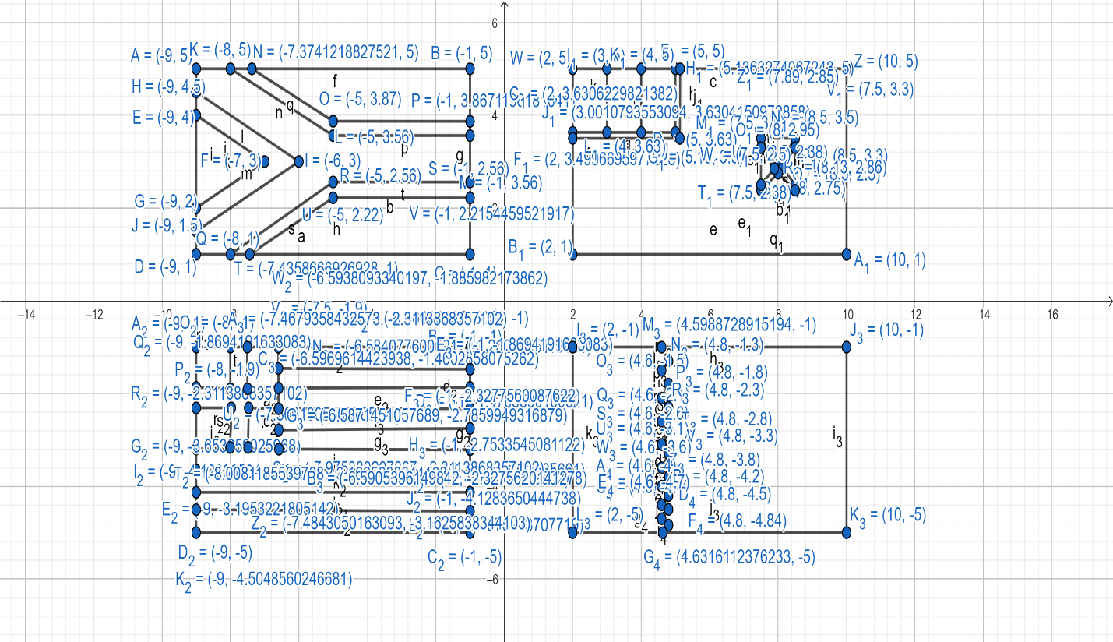

**Code:**

#include <windows.h>

#include <GL/glut.h>

#include <math.h>

void flag_1()

{

//1st

//border

glColor3ub(0,0,0);

glBegin(GL_POLYGON);

glVertex2f(2,5);

glVertex2f(10,5);

glVertex2f(10,1);

glVertex2f(2,1);

glEnd();

//redfull

glColor3ub(244,16,8);

glBegin(GL_POLYGON);

glVertex2f(2,3.5);

glVertex2f(5.13,3.5);

glVertex2f(5.13,5);

glVertex2f(10,5);

glVertex2f(10,1);

glVertex2f(2,1);

glEnd();

//graymiddle

glColor3ub(228,226,225);

glBegin(GL_POLYGON);

glVertex2f(2,3.5);

glVertex2f(2,3.63);

glVertex2f(3,3.63);

glVertex2f(4,3.63);

glVertex2f(5,3.63);

glVertex2f(5,5);

glVertex2f(5.13,5);

glVertex2f(5.13,3.5);

glEnd();

//blue

glColor3ub(29,59,141);

glBegin(GL_POLYGON);

glVertex2f(2,3.63);

glVertex2f(2,5);

glVertex2f(3,5);

glVertex2f(3,3.63);

glEnd();

//grayup

glColor3ub(228,226,225);

glBegin(GL_POLYGON);

glVertex2f(3,3.63);

glVertex2f(3,5);

glVertex2f(4,5);

glVertex2f(4,3.63);

glEnd();

//red

glColor3ub(244,16,8);

glBegin(GL_POLYGON);

glVertex2f(4,3.63);

glVertex2f(4,5);

glVertex2f(5,5);

glVertex2f(5,3.63);

glEnd();

//gray1up

glColor3ub(228,226,225);

glBegin(GL_POLYGON);

glVertex2f(7.5,3.5);

glVertex2f(8.5,3.5);

glVertex2f(8,2.95);

glEnd();

//gray2right

glColor3ub(228,226,225);

glBegin(GL_POLYGON);

glVertex2f(8.5,3.3);

glVertex2f(8.5,2.5);

glVertex2f(8.13,2.86);

glEnd();

//gray3down

glColor3ub(228,226,225);

glBegin(GL_POLYGON);

glVertex2f(8,2.75);

glVertex2f(8.5,2.38);

glVertex2f(7.5,2.38);

glEnd();

//gray4left

glColor3ub(228,226,225);

glBegin(GL_POLYGON);

glVertex2f(7.5,3.3);

glVertex2f(7.89,2.85);

glVertex2f(7.5,2.5);

glEnd();

//2nd

//border

glColor3ub(0,0,0);

glBegin(GL_POLYGON);

glVertex2f(-9,5);

glVertex2f(-1,5);

glVertex2f(-1,1);

glVertex2f(-9,1);

glEnd();

//black

glColor3ub(0,0,0);

glBegin(GL_POLYGON);

glVertex2f(-9,2);

glVertex2f(-9,4);

glVertex2f(-7,3);

glEnd();

//yellow

glColor3ub(255,195,0);

glBegin(GL_POLYGON);

glVertex2f(-7,3);

glVertex2f(-9,4);

glVertex2f(-9,4.5);

glVertex2f(-6,3);

glVertex2f(-9,1.5);

glVertex2f(-9,2);

glEnd();

//green

glColor3ub(56,119,34);

glBegin(GL_POLYGON);

glVertex2f(-6,3);

glVertex2f(-9,4.5);

glVertex2f(-9,5);

glVertex2f(-8,5);

glVertex2f(-5,3.56);

glVertex2f(-1,3.56);

glVertex2f(-1,2.56);

glVertex2f(-5,2.56);

glVertex2f(-8,1);

glVertex2f(-9,1);

glVertex2f(-9,1.5);

glEnd();

//whiteup

glColor3ub(255,255,255);

glBegin(GL_POLYGON);

glVertex2f(-8,5);

glVertex2f(-7.374,5);

glVertex2f(-5,3.87);

glVertex2f(-1,3.87);

glVertex2f(-1,3.56);

glVertex2f(-5,3.56);

glEnd();

//whitedown

glColor3ub(255,255,255);

glBegin(GL_POLYGON);

glVertex2f(-8,1);

glVertex2f(-5,2.56);

glVertex2f(-1,2.56);

glVertex2f(-1,2.22);

glVertex2f(-5,2.22);

glVertex2f(-7.44,1);

glEnd();

//red

glColor3ub(244,16,8);

glBegin(GL_POLYGON);

glVertex2f(-7.374,5);

glVertex2f(-1,5);

glVertex2f(-1,3.87);

glVertex2f(-5,3.87);

glEnd();

//blue

glColor3ub(29,59,141);

glBegin(GL_POLYGON);

glVertex2f(-7.44,1);

glVertex2f(-5,2.22);

glVertex2f(-1,2.22);

glVertex2f(-1,1);

glEnd();

//3rd

//border

glColor3ub(0,0,0);

glBegin(GL_POLYGON);

glVertex2f(-9,-1);

glVertex2f(-1,-1);

glVertex2f(-1,-5);

glVertex2f(-9,-5);

glEnd();

//whitemidddle

glColor3ub(255,255,255);

glBegin(GL_POLYGON);

glVertex2f(-9,-2.3);

glVertex2f(-9,-1.9);

glVertex2f(-8,-1.9);

glVertex2f(-8,-1);

glVertex2f(-7.5,-1);

glVertex2f(-7.5,-1.9);

glVertex2f(-6.6,-1.9);

glVertex2f(-6.6,-2.3);

glVertex2f(-7.5,-2.3);

glVertex2f(-7.5,-3.19);

glVertex2f(-8,-3.19);

glVertex2f(-8,-2.3);

glEnd();

//blue1

glColor3ub(88,114,184 );

glBegin(GL_POLYGON);

glVertex2f(-9,-1.9);

glVertex2f(-9,-1);

glVertex2f(-8,-1);

glVertex2f(-8,-1.9);

glEnd();

//blue2

glColor3ub(88,114,184 );

glBegin(GL_POLYGON);

glVertex2f(-7.5,-1.9);

glVertex2f(-7.5,-1);

glVertex2f(-6.6,-1);

glVertex2f(-6.6,-1.5);

glVertex2f(-6.6,-1.9);

glEnd();

//blue3

glColor3ub(88,114,184 );

glBegin(GL_POLYGON);

glVertex2f(-7.5,-3.19);

glVertex2f(-7.5,-2.3);

glVertex2f(-6.6,-2.3);

glVertex2f(-6.6,-2.8);

glVertex2f(-6.6,-3.2);

glEnd();

//blue4

glColor3ub(88,114,184 );

glBegin(GL_POLYGON);

glVertex2f(-9,-3.19);

glVertex2f(-9,-2.3);

glVertex2f(-8,-2.3);

glVertex2f(-8,-3.19);

glEnd();

//allLine

glColor3ub(255,255,255);

glBegin(GL_POLYGON);

glVertex2f(-6.6,-1.5);

glVertex2f(-1,-1.5);

glVertex2f(-1,-1.9);

glVertex2f(-6.6,-1.9);

glEnd();

glColor3ub(255,255,255);

glBegin(GL_POLYGON);

glVertex2f(-6.6,-2.3);

glVertex2f(-1,-2.3);

glVertex2f(-1,-2.8);

glVertex2f(-6.6,-2.8);

glEnd();

glColor3ub(255,255,255);

glBegin(GL_POLYGON);

glVertex2f(-9,-3.2);

glVertex2f(-1,-3.2);

glVertex2f(-1,-3.65);

glVertex2f(-9,-3.65);

glEnd();

glColor3ub(255,255,255);

glBegin(GL_POLYGON);

glVertex2f(-9,-4.1);

glVertex2f(-1,-1.5);

glVertex2f(-1,-4.5);

glVertex2f(-9,-4.5);

glEnd();

glColor3ub(88,114,184 );

glBegin(GL_POLYGON);

glVertex2f(-6.6,-1);

glVertex2f(-1,-1);

glVertex2f(-1,-1.5);

glVertex2f(-6.6,-1.5);

glEnd();

glColor3ub(88,114,184 );

glBegin(GL_POLYGON);

glVertex2f(-6.6,-1.9);

glVertex2f(-1,-1.9);

glVertex2f(-1,-2.3);

glVertex2f(-6.6,-2.3);

glEnd();

glColor3ub(88,114,184 );

glBegin(GL_POLYGON);

glVertex2f(-6.6,-2.8);

glVertex2f(-1,-2.8);

glVertex2f(-1,-3.2);

glVertex2f(-6.6,-3.2);

glEnd();

glColor3ub(88,114,184 );

glBegin(GL_POLYGON);

glVertex2f(-9,-3.65);

glVertex2f(-1,-3.65);

glVertex2f(-1,-4.1);

glVertex2f(-9,-4.1);

glEnd();

glColor3ub(88,114,184 );

glBegin(GL_POLYGON);

glVertex2f(-9,-4.5);

glVertex2f(-1,-4.5);

glVertex2f(-1,-5);

glVertex2f(-9,-5);

glEnd();

//4th

//border

glColor3ub(0,0,0);

glBegin(GL_POLYGON);

glVertex2f(2,-1);

glVertex2f(10,-1);

glVertex2f(10,-5);

glVertex2f(2,-5);

glEnd();

//red

glColor3ub(199,0,57);

glBegin(GL_POLYGON);

glVertex2f(4.6,-5);

glVertex2f(4.8,-4.84);

glVertex2f(4.6,-4.7);

glVertex2f(4.8,-4.5);

glVertex2f(4.6,-4.4);

glVertex2f(4.8,-4.2);

glVertex2f(4.6,-4);

glVertex2f(4.8,-3.8);

glVertex2f(4.6,-3.6);

glVertex2f(4.8,-3.3);

glVertex2f(4.6,-3.1);

glVertex2f(4.8,-2.8);

glVertex2f(4.6,-2.6);

glVertex2f(4.8,-2.3);

glVertex2f(4.6,-2.1);

glVertex2f(4.8,-1.8);

glVertex2f(4.6,-1.5);

glVertex2f(4.8,-1.3);

glVertex2f(4.6,-1);

glVertex2f(10,-1);

glVertex2f(10,-5);

glEnd();

//grey

glColor3ub(251,240,250);

glBegin(GL_POLYGON);

glVertex2f(2,-1);

glVertex2f(4.6,-1);

glVertex2f(4.8,-1.3);

glVertex2f(4.6,-1.5);

glVertex2f(4.8,-1.8);

glVertex2f(4.6,-2.1);

glVertex2f(4.8,-2.3);

glVertex2f(4.6,-2.6);

glVertex2f(4.8,-2.8);

glVertex2f(4.6,-3.1);

glVertex2f(4.8,-3.3);

glVertex2f(4.6,-3.6);

glVertex2f(4.8,-3.8);

glVertex2f(4.6,-4);

glVertex2f(4.8,-4.2);

glVertex2f(4.6,-4.4);

glVertex2f(4.8,-4.5);

glVertex2f(4.6,-4.7);

glVertex2f(4.8,-4.84);

glVertex2f(4.6,-5);

glVertex2f(2,-5);

glEnd();

}

void display()

{

glClearColor(0,0,1,0);

glClear(GL_COLOR_BUFFER_BIT);

flag_1();

glFlush();

}

int main(int argc, char** argv)

{

glutInit(&argc, argv);

glutCreateWindow("Flag_1");

glutInitWindowSize(320, 320);

glutDisplayFunc(display);

gluOrtho2D(-20,20,-10,10);

glutMainLoop();

return 0;

}

**Output:**

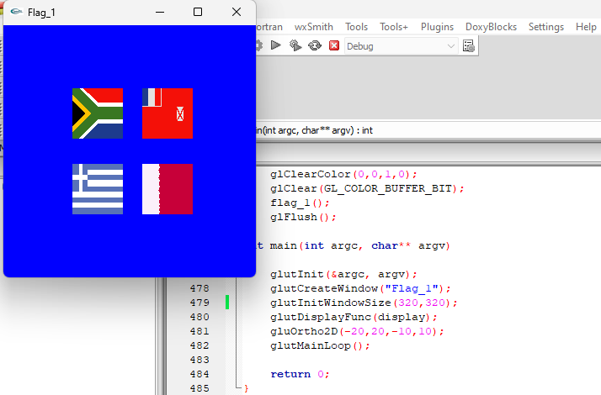

**Flag 2**

**Graph:**

**Code:**

#include <windows.h>

#include <GL/glut.h>

#include <math.h>

/////flag2

void flag_1()

{

glColor3ub(90, 198, 249);

glBegin(GL_POLYGON);

glVertex2f(-9,6);

glVertex2f(-3,6);

glVertex2f(-3,2);

glVertex2f(-9,2);

glEnd();

glColor3ub(255,255,255);

glBegin(GL_POLYGON);

glVertex2f(-6.06,4.8);

glVertex2f(-6,4.9);

glVertex2f(-5.94,4.8);

glVertex2f(-5.8,4.8);

glVertex2f(-5.9,4.7);

glVertex2f(-5.85,4.55);

glVertex2f(-6,4.65);

glVertex2f(-6.15,4.55);

glVertex2f(-6.1,4.7);

glVertex2f(-6.2,4.8);

glEnd();

glBegin(GL_POLYGON);

glVertex2f(-7.26,3.98);

glVertex2f(-7.2,4.1);

glVertex2f(-7.14,3.98);

glVertex2f(-7,3.98);

glVertex2f(-7.12,3.88);

glVertex2f(-7.04,3.74);

glVertex2f(-7.2,3.8);

glVertex2f(-7.36,3.74);

glVertex2f(-7.28,3.88);

glVertex2f(-7.4,3.98);

glEnd();

glBegin(GL_POLYGON);

glVertex2f(-6.08,3.38);

glVertex2f(-6,3.5);

glVertex2f(-5.94,3.38);

glVertex2f(-5.82,3.38);

glVertex2f(-5.94,3.28);

glVertex2f(-5.84,3.14);

glVertex2f(-6,3.22);

glVertex2f(-6.16,3.14);

glVertex2f(-6.08,3.28);

glVertex2f(-6.2,3.38);

glEnd();

glBegin(GL_POLYGON);

glVertex2f(-4.86,4.02);

glVertex2f(-4.81,4.14);

glVertex2f(-4.76,4.02);

glVertex2f(-4.64,4.02);

glVertex2f(-4.72,3.92);

glVertex2f(-4.68,3.78);

glVertex2f(-4.81,3.84);

glVertex2f(-4.94,3.78);

glVertex2f(-4.88,3.92);

glVertex2f(-4.98,4.02);

glEnd();

}

//2

void flag_2()

{

glColor3ub(199, 0, 57);

glBegin(GL_POLYGON);

glVertex2f(3.5,6);

glVertex2f(10.5,6);

glVertex2f(10.5,2);

glVertex2f(3.5,2);

glEnd();

glColor3ub(9, 110, 8);

glLineWidth(8);

glBegin(GL_LINES);

glVertex2f(7,5.2);

glVertex2f(8,2.8);

glVertex2f(8,2.8);

glVertex2f(5.6,4.2);

glVertex2f(5.6,4.2);

glVertex2f(8.4,4.2);

glVertex2f(8.4,4.2);

glVertex2f(6,2.8);

glVertex2f(6,2.8);

glVertex2f(7,5.2);

glEnd();

}

//3

void flag_3()

{

glColor3ub(14, 15, 221);

glBegin(GL_POLYGON);

glVertex2f(3,-1.8);

glVertex2f(10,-1.8);

glVertex2f(10,-3.2);

glVertex2f(3,-3.2);

glEnd();

glColor3ub(255,255,255);

glBegin(GL_POLYGON);

glVertex2f(10,-3.2);

glVertex2f(3,-3.2);

glVertex2f(3,-4.6);

glVertex2f(10,-4.6);

glEnd();

glColor3ub(255,0,0);

glBegin(GL_POLYGON);

glVertex2f(3,-4.6);

glVertex2f(10,-4.6);

glVertex2f(10,-6);

glVertex2f(3,-6);

glEnd();

glColor3ub(255,0,0);

glBegin(GL_POLYGON);

glVertex2f(6.2,-3.4);

glVertex2f(6.5,-2.7);

glVertex2f(6.8,-3.4);

glVertex2f(7.8,-3.4);

glVertex2f(7.1,-3.9);

glVertex2f(7.6,-4.8);

glVertex2f(6.5,-4.2);

glVertex2f(5.4,-4.8);

glVertex2f(6,-3.9);

glVertex2f(5.3,-3.4);

glEnd();

glColor3ub(255,255,0);

glLineWidth(4);

glBegin(GL_LINES);

glVertex2f(6.2,-3.4);

glVertex2f(6.5,-2.7);

glVertex2f(6.5,-2.7);

glVertex2f(6.8,-3.4);

glVertex2f(6.8,-3.4);

glVertex2f(7.8,-3.4);

glVertex2f(7.8,-3.4);

glVertex2f(7.1,-3.9);

glVertex2f(7.1,-3.9);

glVertex2f(7.6,-4.8);

glVertex2f(7.6,-4.8);

glVertex2f(6.5,-4.2);

glVertex2f(6.5,-4.2);

glVertex2f(5.4,-4.8);

glVertex2f(5.4,-4.8);

glVertex2f(5.96,-3.9);

glVertex2f(5.96,-3.9);

glVertex2f(5.3,-3.4);

glVertex2f(5.3,-3.4);

glVertex2f(6.2,-3.4);

glEnd();

}

//4

void flag_4()

{

glColor3ub(14, 15, 221);

glBegin(GL_POLYGON);

glVertex2f(-10,-1.8);

glVertex2f(-2,-1.8);

glVertex2f(-2,-2.8);

glVertex2f(-10,-2.8);

glEnd();

glColor3ub(255,255,255);

glBegin(GL_POLYGON);

glVertex2f(-2,-2.8);

glVertex2f(-10,-2.8);

glVertex2f(-10,-5.2);

glVertex2f(-2,-5.2);

glEnd();

glColor3ub(14, 15, 221);

glBegin(GL_POLYGON);

glVertex2f(-10,-5.2);

glVertex2f(-2,-5.2);

glVertex2f(-2,-6.2);

glVertex2f(-10,-6.2);

glEnd();

glColor3ub(14, 15, 221);

glLineWidth(8);

glBegin(GL_LINES);

glVertex2f(-7.4,-3.5);

glVertex2f(-4.6,-3.5);

glVertex2f(-4.6,-3.5);

glVertex2f(-6,-5);

glVertex2f(-6,-5);

glVertex2f(-7.4,-3.5);

glVertex2f(-6,-3);

glVertex2f(-4.6,-4.5);

glVertex2f(-4.6,-4.5);

glVertex2f(-7.4,-4.5);

glVertex2f(-7.4,-4.5);

glVertex2f(-6,-3);

glEnd();

}

void display()

{

glClearColor(1.0f, 1.0f, 1.0f, 1.0f);

glClear(GL_COLOR_BUFFER_BIT);

flag_1();

flag_2();

flag_3();

flag_4();

glFlush();

}

int main(int argc, char** argv)

{

glutInit(&argc, argv);

glutCreateWindow("Flag_2");

glutInitWindowSize(320, 320);

glutDisplayFunc(display);

gluOrtho2D(-12,12,-9,9);

glutMainLoop();

return 0;

}

**Output:**

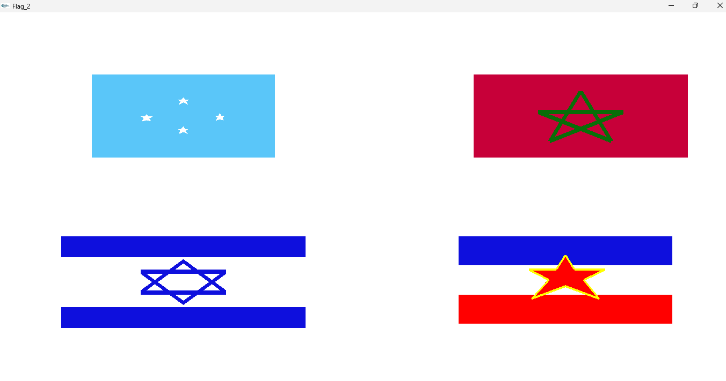

**Flag 3**

**Graph:**

**Code:**

**Output:**

**Flag 4**

**Graph:**

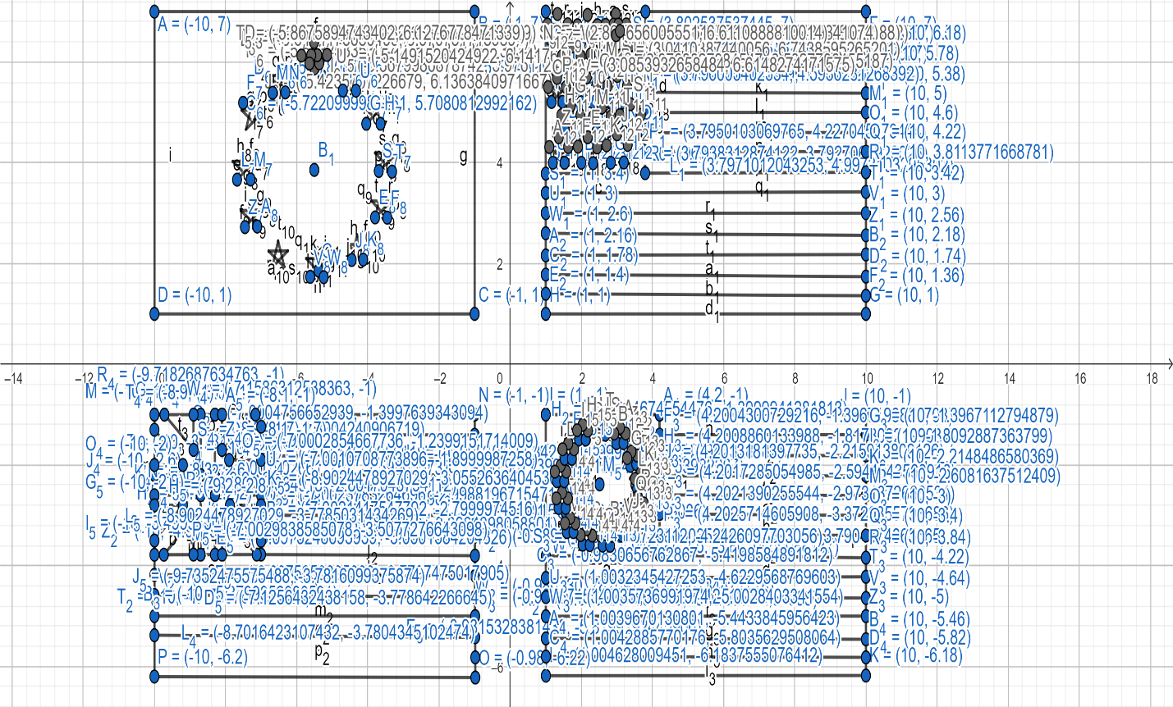

**Code:**

#include <windows.h>

#include <GL/glut.h>

#include <math.h>

void flag_4()

{

//1st

//border

glColor3ub(0,0,0);

glBegin(GL_POLYGON);

glVertex2f(1,7);

glVertex2f(10,7);

glVertex2f(10,1);

glVertex2f(1,1);

glEnd();

//blue

glColor3ub(17,20,116);

glBegin(GL_POLYGON);

glVertex2f(1,3.8);

glVertex2f(1,7);

glVertex2f(3.8,7);

glVertex2f(3.8,3.8);

glEnd();

//white1

glColor3ub(255,255,255);

glBegin(GL_POLYGON);

glVertex2f(1.3,6.9);

glVertex2f(1.4,6.8);

glVertex2f(1.6,6.8);

glVertex2f(1.5,6.6);

glVertex2f(1.5,6.4);

glVertex2f(1.3,6.5);

glVertex2f(1.2,6.4);

glVertex2f(1.2,6.6);

glVertex2f(1.1,6.8);

glVertex2f(1.2,6.8);

glEnd();

//white2

glColor3ub(255,255,255);

glBegin(GL_POLYGON);

glVertex2f(2.2,6.9);

glVertex2f(2.2,6.7);

glVertex2f(2.5,6.7);

glVertex2f(2.3,6.6);

glVertex2f(2.4,6.4);

glVertex2f(2.2,6.5);

glVertex2f(2,6.4);

glVertex2f(2,6.6);

glVertex2f(1.9,6.7);

glVertex2f(2.1,6.7);

glEnd();

//white3

glColor3ub(255,255,255);

glBegin(GL_POLYGON);

glVertex2f(2.9,6.9);

glVertex2f(3.1,6.7);

glVertex2f(3.3,6.8);

glVertex2f(3.1,6.6);

glVertex2f(3.2,6.4);

glVertex2f(2.9,6.5);

glVertex2f(2.8,6.4);

glVertex2f(2.9,6.6);

glVertex2f(2.7,6.7);

glVertex2f(2.9,6.8);

glEnd();

//white4

glColor3ub(255,255,255);

glBegin(GL_POLYGON);

glVertex2f(1.7,6.3);

glVertex2f(1.8,6.1);

glVertex2f(2,6.1);

glVertex2f(1.8,6);

glVertex2f(1.9,5.8);

glVertex2f(1.7,5.9);

glVertex2f(1.6,5.8);

glVertex2f(1.6,6);

glVertex2f(1.5,6.1);

glVertex2f(1.7,6.1);

glEnd();

//white5

glColor3ub(255,255,255);

glBegin(GL_POLYGON);

glVertex2f(2.5,6.4);

glVertex2f(2.6,6.1);

glVertex2f(2.8,6.1);

glVertex2f(2.6,6);

glVertex2f(2.7,5.8);

glVertex2f(2.5,5.9);

glVertex2f(2.4,5.8);

glVertex2f(2.4,6);

glVertex2f(2.1,6.1);

glVertex2f(2.5,6.1);

glEnd();

//white6

glColor3ub(255,255,255);

glBegin(GL_POLYGON);

glVertex2f(3.3,6.5);

glVertex2f(3.4,6.1);

glVertex2f(3.6,6.1);

glVertex2f(3.4,6);

glVertex2f(3.5,5.8);

glVertex2f(3.3,5.9);

glVertex2f(3.2,5.8);

glVertex2f(3.2,6);

glVertex2f(3.1,6.1);

glVertex2f(3.3,6.1);

glEnd();

//white7

glColor3ub(255,255,255);

glBegin(GL_POLYGON);

glVertex2f(1.3,5.7);

glVertex2f(1.4,5.5);

glVertex2f(1.6,5.6);

glVertex2f(1.4,5.4);

glVertex2f(1.5,5.2);

glVertex2f(1.3,5.3);

glVertex2f(1.2,5.2);

glVertex2f(1.2,5.4);

glVertex2f(1.1,5.5);

glVertex2f(1.3,5.5);

glEnd();

//white8

glColor3ub(255,255,255);

glBegin(GL_POLYGON);

glVertex2f(2.1,5.7);

glVertex2f(2.2,5.5);

glVertex2f(2.4,5.5);

glVertex2f(2.3,5.4);

glVertex2f(2.3,5.2);

glVertex2f(2.1,5.3);

glVertex2f(2,5.2);

glVertex2f(2.1,5.4);

glVertex2f(1.9,5.5);

glVertex2f(2.1,5.5);

glEnd();

//white9

glColor3ub(255,255,255);

glBegin(GL_POLYGON);

glVertex2f(2.9,5.7);

glVertex2f(3,5.5);

glVertex2f(3.2,5.5);

glVertex2f(3.1,5.4);

glVertex2f(3.1,5.2);

glVertex2f(2.9,5.3);

glVertex2f(2.8,5.2);

glVertex2f(2.9,5.4);

glVertex2f(2.7,5.5);

glVertex2f(2.9,5.5);

glEnd();

//white10

glColor3ub(255,255,255);

glBegin(GL_POLYGON);

glVertex2f(1.7,5.1);

glVertex2f(1.8,4.9);

glVertex2f(1.9,4.9);

glVertex2f(1.8,4.8);

glVertex2f(1.9,4.6);

glVertex2f(1.7,4.7);

glVertex2f(1.6,4.6);

glVertex2f(1.6,4.8);

glVertex2f(1.4,4.9);

glVertex2f(1.6,4.9);

glEnd();

//white11

glColor3ub(255,255,255);

glBegin(GL_POLYGON);

glVertex2f(2.5,5.2);

glVertex2f(2.6,4.9);

glVertex2f(2.7,4.9);

glVertex2f(2.6,4.8);

glVertex2f(2.7,4.6);

glVertex2f(2.5,4.7);

glVertex2f(2.4,4.6);

glVertex2f(2.4,4.8);

glVertex2f(2.2,4.9);

glVertex2f(2.4,4.9);

glEnd();

//white12

glColor3ub(255,255,255);

glBegin(GL_POLYGON);

glVertex2f(3.3,5.3);

glVertex2f(3.4,4.9);

glVertex2f(3.5,4.9);

glVertex2f(3.4,4.8);

glVertex2f(3.5,4.6);

glVertex2f(3.3,4.7);

glVertex2f(3.2,4.6);

glVertex2f(3.2,4.8);

glVertex2f(3,4.9);

glVertex2f(3.2,4.9);

glEnd();

//white13

glColor3ub(255,255,255);

glBegin(GL_POLYGON);

glVertex2f(1.4,4.5);

glVertex2f(1.4,4.3);

glVertex2f(1.6,4.3);

glVertex2f(1.5,4.1);

glVertex2f(1.5,4);

glVertex2f(1.4,4.1);

glVertex2f(1.2,4);

glVertex2f(1.3,4.1);

glVertex2f(1.1,4.3);

glVertex2f(1.3,4.3);

glEnd();

//white14

glColor3ub(255,255,255);

glBegin(GL_POLYGON);

glVertex2f(2.2,4.6);

glVertex2f(2.2,4.3);

glVertex2f(2.4,4.3);

glVertex2f(2.4,4.2);

glVertex2f(2.3,4);

glVertex2f(2.2,4.1);

glVertex2f(2,4);

glVertex2f(2.1,4.1);

glVertex2f(1.9,4.3);

glVertex2f(2.1,4.3);

glEnd();

//white15

glColor3ub(255,255,255);

glBegin(GL_POLYGON);

glVertex2f(3,4.6);

glVertex2f(3,4.3);

glVertex2f(3.2,4.3);

glVertex2f(3.2,4.2);

glVertex2f(3.3,4);

glVertex2f(2.8,4.1);

glVertex2f(2.8,4);

glVertex2f(2.9,4.1);

glVertex2f(2.7,4.3);

glVertex2f(2.9,4.3);

glEnd();

//all line

//red1

glColor3ub(245,49,26);

glBegin(GL_POLYGON);

glVertex2f(3.8,6.6);

glVertex2f(3.8,7);

glVertex2f(10,7);

glVertex2f(10,6.6);

glEnd();

//red2

glColor3ub(245,49,26);

glBegin(GL_POLYGON);

glVertex2f(3.8,5.8);

glVertex2f(3.8,6.2);

glVertex2f(10,6.2);

glVertex2f(10,5.8);

glEnd();

//red3

glColor3ub(245,49,26);

glBegin(GL_POLYGON);

glVertex2f(3.8,4.6);

glVertex2f(3.8,5.4);

glVertex2f(10,5.4);

glVertex2f(10,5);

glEnd();

//red4

glColor3ub(245,49,26);

glBegin(GL_POLYGON);

glVertex2f(3.8,4.2);

glVertex2f(3.8,4.6);

glVertex2f(10,4.6);

glVertex2f(10,4.2);

glEnd();

//red5

glColor3ub(245,49,26 );

glBegin(GL_POLYGON);

glVertex2f(1,3.4);

glVertex2f(1,3.8);

glVertex2f(10,3.8);

glVertex2f(10,3.4);

glEnd();

//red6

glColor3ub(245,49,26 );

glBegin(GL_POLYGON);

glVertex2f(1,2.6);

glVertex2f(1,3);

glVertex2f(10,3);

glVertex2f(10,2.6);

glEnd();

//red7

glColor3ub(245,49,26 );

glBegin(GL_POLYGON);

glVertex2f(1,1.8);

glVertex2f(1,2.2);

glVertex2f(10,2.2);

glVertex2f(10,1.8);

glEnd();

//red8

glColor3ub(245,49,26 );

glBegin(GL_POLYGON);

glVertex2f(1,1);

glVertex2f(1,1.4);

glVertex2f(10,1.4);

glVertex2f(10,1);

glEnd();

//white1

glColor3ub(255,255,255);

glBegin(GL_POLYGON);

glVertex2f(3.8,6.2);

glVertex2f(3.8,6.6);

glVertex2f(10,6.6);

glVertex2f(10,6.2);

glEnd();

//white2

glColor3ub(255,255,255);

glBegin(GL_POLYGON);

glVertex2f(3.8,5.4);

glVertex2f(3.8,5.8);

glVertex2f(10,5.8);

glVertex2f(10,5.4);

glEnd();

//white3

glColor3ub(255,255,255);

glBegin(GL_POLYGON);

glVertex2f(3.8,4.6);

glVertex2f(3.8,5);

glVertex2f(10,5);

glVertex2f(10,4.6);

glEnd();

//white4

glColor3ub(255,255,255);

glBegin(GL_POLYGON);

glVertex2f(3.8,3.8);

glVertex2f(3.8,4.2);

glVertex2f(10,4.2);

glVertex2f(10,3.8);

glEnd();

//white5

glColor3ub(255,255,255);

glBegin(GL_POLYGON);

glVertex2f(1,3);

glVertex2f(1,3.4);

glVertex2f(10,3.4);

glVertex2f(10,3);

glEnd();

//white6

glColor3ub(255,255,255 );

glBegin(GL_POLYGON);

glVertex2f(1,2.2);

glVertex2f(1,2.6);

glVertex2f(10,2.6);

glVertex2f(10,2.2);

glEnd();

//white7

glColor3ub(255,255,255 );

glBegin(GL_POLYGON);

glVertex2f(1,1.4);

glVertex2f(1,1.8);

glVertex2f(10,1.8);

glVertex2f(10,1.4);

glEnd();

//2nd

//border

glColor3ub(0,0,0);

glBegin(GL_POLYGON);

glVertex2f(-10,7);

glVertex2f(-1,7);

glVertex2f(-1,1);

glVertex2f(-10,1);

glEnd();

//blue

glColor3ub(29,59,141);

glBegin(GL_POLYGON);

glVertex2f(-10,7);

glVertex2f(-1,7);

glVertex2f(-1,1);

glVertex2f(-10,1);

glEnd();

//yellow1

glColor3ub(255,195,0);

glBegin(GL_POLYGON);

glVertex2f(-5.5,6.4);

glVertex2f(-5.4,6.1);

glVertex2f(-5.1,6.1);

glVertex2f(-5.4,5.9);

glVertex2f(-5.3,5.7);

glVertex2f(-5.5,5.9);

glVertex2f(-5.7,5.7);

glVertex2f(-5.6,5.9);

glVertex2f(-5.9,6.1);

glVertex2f(-5.6,6.1);

glEnd();

//yellow2

glColor3ub(255,195,0);

glBegin(GL_POLYGON);

glVertex2f(-4.5,6);

glVertex2f(-4.4,5.8);

glVertex2f(-4.2,5.8);

glVertex2f(-4.4,5.6);

glVertex2f(-4.3,5.4);

glVertex2f(-4.5,5.6);

glVertex2f(-4.7,5.4);

glVertex2f(-4.6,5.7);

glVertex2f(-4.8,5.8);

glVertex2f(-4.6,5.8);

glEnd();

//yellow3

glColor3ub(255,195,0);

glBegin(GL_POLYGON);

glVertex2f(-3.9,5.4);

glVertex2f(-3.8,5.2);

glVertex2f(-3.5,5.2);

glVertex2f(-3.7,5);

glVertex2f(-3.6,4.8);

glVertex2f(-3.9,4.9);

glVertex2f(-4,4.8);

glVertex2f(-3.9,5);

glVertex2f(-4.1,5.1);

glVertex2f(-3.9,5.1);

glEnd();

//yellow4

glColor3ub(255,195,0);

glBegin(GL_POLYGON);

glVertex2f(-3.5,4.4);

glVertex2f(-3.4,4.2);

glVertex2f(-3.2,4.2);

glVertex2f(-3.4,4.1);

glVertex2f(-3.3,3.8);

glVertex2f(-3.5,3.9);

glVertex2f(-3.7,3.8);

glVertex2f(-3.6,4.1);

glVertex2f(-3.8,4.2);

glVertex2f(-3.6,4.2);

glEnd();

//yellow5

glColor3ub(255,195,0);

glBegin(GL_POLYGON);

glVertex2f(-3.6,3.4);

glVertex2f(-3.6,3.2);

glVertex2f(-3.3,3.2);

glVertex2f(-3.5,3.1);

glVertex2f(-3.5,2.9);

glVertex2f(-3.6,3);

glVertex2f(-3.8,2.9);

glVertex2f(-3.7,3.1);

glVertex2f(-3.9,3.2);

glVertex2f(-3.7,3.2);

glEnd();

//yellow6

glColor3ub(255,195,0);

glBegin(GL_POLYGON);

glVertex2f(-4.3,2.6);

glVertex2f(-4.2,2.4);

glVertex2f(-4,2.4);

glVertex2f(-4.2,2.3);

glVertex2f(-4.1,2.1);

glVertex2f(-4.3,2.2);

glVertex2f(-4.5,2.1);

glVertex2f(-4.4,2.3);

glVertex2f(-4.6,2.4);

glVertex2f(-4.4,2.4);

glEnd();

//yellow7

glColor3ub(255,195,0);

glBegin(GL_POLYGON);

glVertex2f(-5.4,2.3);

glVertex2f(-5.4,2.1);

glVertex2f(-5.1,2.1);

glVertex2f(-5.3,1.9);

glVertex2f(-5.2,1.7);

glVertex2f(-5.4,1.9);

glVertex2f(-5.6,1.7);

glVertex2f(-5.5,1.9);

glVertex2f(-5.7,2.1);

glVertex2f(-5.5,2.1);

glEnd();

//yellow8

glColor3ub(255,195,0);

glBegin(GL_POLYGON);

glVertex2f(-6.5,2.5);

glVertex2f(-6.5,2.3);

glVertex2f(-6.3,2.3);

glVertex2f(-6.4,2.1);

glVertex2f(-6.3,1.9);

glVertex2f(-6.5,2.1);

glVertex2f(-6.7,1.9);

glVertex2f(-6.6,2.1);

glVertex2f(-6.8,2.2);

glVertex2f(-6.6,2.3);

glEnd();

//yellow9

glColor3ub(255,195,0);

glBegin(GL_POLYGON);

glVertex2f(-7.3,3.3);

glVertex2f(-7.2,3.1);

glVertex2f(-7,3.1);

glVertex2f(-7.2,2.9);

glVertex2f(-7.1,2.7);

glVertex2f(-7.3,2.9);

glVertex2f(-7.5,2.7);

glVertex2f(-7.4,2.9);

glVertex2f(-7.6,3);

glVertex2f(-7.4,3.1);

glEnd();

//yellow10

glColor3ub(255,195,0);

glBegin(GL_POLYGON);

glVertex2f(-7.5,4.3);

glVertex2f(-7.4,4);

glVertex2f(-7.2,4);

glVertex2f(-7.4,3.9);

glVertex2f(-7.3,3.7);

glVertex2f(-7.5,3.8);

glVertex2f(-7.7,3.7);

glVertex2f(-7.6,3.9);

glVertex2f(-7.8,4);

glVertex2f(-7.6,4);

glEnd();

//yellow11

glColor3ub(255,195,0);

glBegin(GL_POLYGON);

glVertex2f(-7.3,5.3);

glVertex2f(-7.1,5.1);

glVertex2f(-6.9,5.1);

glVertex2f(-7.1,4.9);

glVertex2f(-7.1,4.7);

glVertex2f(-7.2,4.8);

glVertex2f(-7.4,4.7);

glVertex2f(-7.4,4.9);

glVertex2f(-7.5,5.1);

glVertex2f(-7.3,5.1);

glEnd();

//yellow12

glColor3ub(255,195,0);

glBegin(GL_POLYGON);

glVertex2f(-6.5,5.9);

glVertex2f(-6.4,5.7);

glVertex2f(-6.2,5.7);

glVertex2f(-6.4,5.6);

glVertex2f(-6.3,5.4);

glVertex2f(-6.5,5.5);

glVertex2f(-6.7,5.4);

glVertex2f(-6.6,5.6);

glVertex2f(-6.8,5.7);

glVertex2f(-6.6,5.7);

glEnd();

//3rd

//border

glColor3ub(0,0,0);

glBegin(GL_POLYGON);

glVertex2f(-10,-1);

glVertex2f(-1,-1);

glVertex2f(-1,-6.22);

glVertex2f(-10,-6.2);

glEnd();

//redmidddle

glColor3ub(245,49,26 );

glBegin(GL_POLYGON);

glVertex2f(-10,-2.6);

glVertex2f(-10,-2.2);

glVertex2f(-8.7,-2.2);

glVertex2f(-8.7,-1);

glVertex2f(-8.3,-1);

glVertex2f(-8.3,-2.2);

glVertex2f(-7,-2.2);

glVertex2f(-7,-2.6);

glVertex2f(-8.3,-2.6);

glVertex2f(-8.3,-3.8);

glVertex2f(-8.7,-3.8);

glVertex2f(-8.7,-2.6);

glEnd();

//white1

glColor3ub(255,255,255);

glBegin(GL_POLYGON);

glVertex2f(-10,-2.2);

glVertex2f(-10,-2);

glVertex2f(-9.2,-2);

glVertex2f(-10,-1.3);

glVertex2f(-10,-1);

glVertex2f(-9.7,-1);

glVertex2f(-8.9,-1.7);

glVertex2f(-8.9,-1);

glVertex2f(-8.7,-1);

glVertex2f(-8.7,-2.2);

glEnd();

//white2

glColor3ub(255,255,255);

glBegin(GL_POLYGON);

glVertex2f(-8.3,-2.2);

glVertex2f(-8.3,-1);

glVertex2f(-8.1,-1);

glVertex2f(-8.1,-1.7);

glVertex2f(-7.2,-1);

glVertex2f(-7,-1);

glVertex2f(-7,-1.2);

glVertex2f(-7.9,-1.9);

glVertex2f(-7,-1.9);

glVertex2f(-7,-2.2);

glEnd();

//white3

glColor3ub(255,255,255);

glBegin(GL_POLYGON);

glVertex2f(-8.3,-3.8);

glVertex2f(-8.3,-2.6);

glVertex2f(-7,-2.6);

glVertex2f(-7,-2.8);

glVertex2f(-7.9,-2.8);

glVertex2f(-7,-3.5);

glVertex2f(-7,-3.8);

glVertex2f(-7.1,-3.8);

glVertex2f(-8.1,-3.1);

glVertex2f(-8.1,-3.8);

glEnd();

//white4

glColor3ub(255,255,255);

glBegin(GL_POLYGON);

glVertex2f(-10,-3.8);

glVertex2f(-10,-3.5);

glVertex2f(-9.2,-2.8);

glVertex2f(-10,-2.8);

glVertex2f(-10,-2.6);

glVertex2f(-8.7,-2.6);

glVertex2f(-8.7,-3.8);

glVertex2f(-8.9,-3.8);

glVertex2f(-8.9,-3.1);

glVertex2f(-9.7,-3.8);

glEnd();

//blue1

glColor3ub(17,20,116);

glBegin(GL_POLYGON);

glVertex2f(-10,-2);

glVertex2f(-10,-1.3);

glVertex2f(-9.2,-2);

glEnd();

//blue2

glColor3ub(17,20,116);

glBegin(GL_POLYGON);

glVertex2f(-9.7,-1);

glVertex2f(-8.9,-1);

glVertex2f(-8.9,-1.7);

glEnd();

//blue3

glColor3ub(17,20,116);

glBegin(GL_POLYGON);

glVertex2f(-8.1,-1.7);

glVertex2f(-8.1,-1);

glVertex2f(-7.2,-1);

glEnd();

//blue4

glColor3ub(17,20,116);

glBegin(GL_POLYGON);

glVertex2f(-7.9,-1.9);

glVertex2f(-7,-1.2);

glVertex2f(-7,-1.4);

glVertex2f(-7,-1.8);

glVertex2f(-7,-1.9);

glEnd();

//blue5

glColor3ub(17,20,116);

glBegin(GL_POLYGON);

glVertex2f(-7.9,-2.8);

glVertex2f(-7,-2.8);

glVertex2f(-7,-3);

glVertex2f(-7,-3.4);

glVertex2f(-7,-3.5);

glEnd();

//blue6

glColor3ub(17,20,116);

glBegin(GL_POLYGON);

glVertex2f(-8.1,-3.8);

glVertex2f(-8.1,-3.1);

glVertex2f(-7.1,-3.8);

glEnd();

//blue7

glColor3ub(17,20,116);

glBegin(GL_POLYGON);

glVertex2f(-9.7,-3.8);

glVertex2f(-8.9,-3.1);

glVertex2f(-8.9,-3.8);

glEnd();

//blue8

glColor3ub(17,20,116);

glBegin(GL_POLYGON);

glVertex2f(-10,-3.5);

glVertex2f(-10,-2.8);

glVertex2f(-9.2,-2.8);

glEnd();

//all line

//red1

glColor3ub(245,49,26);

glBegin(GL_POLYGON);

glVertex2f(-7,-1.4);

glVertex2f(-7,-1.2);

glVertex2f(-7,-1);

glVertex2f(-1,-1);

glVertex2f(-1,-1.4);

glEnd();

//red2

glColor3ub(245,49,26);

glBegin(GL_POLYGON);

glVertex2f(-7,-2.2);

glVertex2f(-7,-1.9);

glVertex2f(-7,-1.8);

glVertex2f(-1,-1.8);

glVertex2f(-1,-2.2);

glEnd();

//red3

glColor3ub(245,49,26);

glBegin(GL_POLYGON);

glVertex2f(-7,-3);

glVertex2f(-7,-2.8);

glVertex2f(-7,-2.6);

glVertex2f(-1,-2.6);

glVertex2f(-1,-3);

glEnd();

//red4

glColor3ub(245,49,26);

glBegin(GL_POLYGON);

glVertex2f(-7,-3.8);

glVertex2f(-7,-3.5);

glVertex2f(-7,-3.4);

glVertex2f(-1,-3.4);

glVertex2f(-1,-3.8);

glEnd();

//red5

glColor3ub(245,49,26 );

glBegin(GL_POLYGON);

glVertex2f(-10,-4.6);

glVertex2f(-10,-4.2);

glVertex2f(-1,-4.2);

glVertex2f(-1,-4.6);

glEnd();

//red6

glColor3ub(245,49,26 );

glBegin(GL_POLYGON);

glVertex2f(-10,-5.4);

glVertex2f(-10,-5);

glVertex2f(-1,-5);

glVertex2f(-1,-5.4);

glEnd();

//red7

glColor3ub(245,49,26 );

glBegin(GL_POLYGON);

glVertex2f(-10,-6.2);

glVertex2f(-10,-5.8);

glVertex2f(-1,-5.8);

glVertex2f(-1,-6.22);

glEnd();

//white1

glColor3ub(255,255,255);

glBegin(GL_POLYGON);

glVertex2f(-7,-1.8);

glVertex2f(-7,-1.4);

glVertex2f(-1,-1.4);

glVertex2f(-1,-1.8);

glEnd();

//white2

glColor3ub(255,255,255);

glBegin(GL_POLYGON);

glVertex2f(-7,-2.6);

glVertex2f(-7,-2.2);

glVertex2f(-1,-2.2);

glVertex2f(-1,-2.6);

glEnd();

//white3

glColor3ub(255,255,255);

glBegin(GL_POLYGON);

glVertex2f(-7,-3.4);

glVertex2f(-7,-3);

glVertex2f(-1,-3);

glVertex2f(-1,-3.4);

glEnd();

//white4

glColor3ub(255,255,255);

glBegin(GL_POLYGON);

glVertex2f(-10,-4.2);

glVertex2f(-10,-3.8);

glVertex2f(-1,-3.8);

glVertex2f(-1,-4.2);

glEnd();

//white5

glColor3ub(255,255,255);

glBegin(GL_POLYGON);

glVertex2f(-10,-5);

glVertex2f(-10,-4.6);

glVertex2f(-1,-4.6);

glVertex2f(-1,-5);

glEnd();

//white6

glColor3ub(255,255,255 );

glBegin(GL_POLYGON);

glVertex2f(-10,-5.8);

glVertex2f(-10,-5.4);

glVertex2f(-1,-5.4);

glVertex2f(-1,-5.8);

glEnd();

//4th

//border

glColor3ub(0,0,0);

glBegin(GL_POLYGON);

glVertex2f(1,-1);

glVertex2f(10,-1);

glVertex2f(10,-6.18);

glVertex2f(1,-6.18);

glEnd();

//blue

glColor3ub(17,20,116);

glBegin(GL_POLYGON);

glVertex2f(1,-3.8);

glVertex2f(1,-1);

glVertex2f(4.2,-1);

glVertex2f(4.2,-3.8);

glEnd();

//white1

glColor3ub(255,255,255);

glBegin(GL_POLYGON);

glVertex2f(2.6,-1.1);

glVertex2f(2.6,-1.2);

glVertex2f(2.7,-1.2);

glVertex2f(2.6,-1.3);

glVertex2f(2.7,-1.4);

glVertex2f(2.6,-1.3);

glVertex2f(2.5,-1.4);

glVertex2f(2.5,-1.3);

glVertex2f(2.4,-1.2);

glVertex2f(2.5,-1.2);

glEnd();

//white2

glColor3ub(255,255,255);

glBegin(GL_POLYGON);

glVertex2f(3.1,-1.2);

glVertex2f(3.1,-1.4);

glVertex2f(3.2,-1.4);

glVertex2f(3.1,-1.4);

glVertex2f(3.2,-1.6);

glVertex2f(3.1,-1.5);

glVertex2f(3,-1.6);

glVertex2f(3,-1.4);

glVertex2f(2.9,-1.4);

glVertex2f(3,-1.4);

glEnd();

//white3

glColor3ub(255,255,255);

glBegin(GL_POLYGON);

glVertex2f(3.4,-1.6);

glVertex2f(3.5,-1.8);

glVertex2f(3.6,-1.8);

glVertex2f(3.5,-1.8);

glVertex2f(3.6,-2);

glVertex2f(3.4,-1.9);

glVertex2f(3.3,-2);

glVertex2f(3.4,-1.8);

glVertex2f(3.2,-1.8);

glVertex2f(3.4,-1.8);

glEnd();

//white4

glColor3ub(255,255,255);

glBegin(GL_POLYGON);

glVertex2f(3.7,-2.2);

glVertex2f(3.7,-2.3);

glVertex2f(3.8,-2.3);

glVertex2f(3.7,-2.3);

glVertex2f(3.8,-2.5);

glVertex2f(3.7,-2.4);

glVertex2f(3.6,-2.5);

glVertex2f(3.6,-2.3);

glVertex2f(3.5,-2.3);

glVertex2f(3.6,-2.3);

glEnd();

//white5

glColor3ub(255,255,255);

glBegin(GL_POLYGON);

glVertex2f(3.6,-2.6);

glVertex2f(3.6,-2.8);

glVertex2f(3.8,-2.8);

glVertex2f(3.6,-2.8);

glVertex2f(3.7,-3);

glVertex2f(3.6,-2.9);

glVertex2f(3.5,-3);

glVertex2f(3.5,-2.8);

glVertex2f(3.4,-2.8);

glVertex2f(3.5,-2.8);

glEnd();

//white6

glColor3ub(255,255,255);

glBegin(GL_POLYGON);

glVertex2f(3.2,-3.1);

glVertex2f(3.3,-3.2);

glVertex2f(3.4,-3.2);

glVertex2f(3.3,-3.3);

glVertex2f(3.3,-3.4);

glVertex2f(3.2,-3.3);

glVertex2f(3.1,-3.4);

glVertex2f(3.2,-3.3);

glVertex2f(3.1,-3.2);

glVertex2f(3.2,-3.2);

glEnd();

//white7

glColor3ub(255,255,255);

glBegin(GL_POLYGON);

glVertex2f(2.7,-3.3);

glVertex2f(2.7,-3.4);

glVertex2f(2.9,-3.4);

glVertex2f(2.8,-3.5);

glVertex2f(2.8,-3.6);

glVertex2f(2.7,-3.5);

glVertex2f(2.6,-3.6);

glVertex2f(2.6,-3.5);

glVertex2f(2.5,-3.5);

glVertex2f(2.7,-3.4);

glEnd();

//white8

glColor3ub(255,255,255);

glBegin(GL_POLYGON);

glVertex2f(2.1,-3.3);

glVertex2f(2.2,-3.4);

glVertex2f(2.3,-3.4);

glVertex2f(2.2,-3.5);

glVertex2f(2.2,-3.6);

glVertex2f(2.1,-3.5);

glVertex2f(2,-3.6);

glVertex2f(2.1,-3.5);

glVertex2f(2,-3.4);

glVertex2f(2.1,-3.4);

glEnd();

//white9

glColor3ub(255,255,255);

glBegin(GL_POLYGON);

glVertex2f(1.7,-3.1);

glVertex2f(1.7,-3.2);

glVertex2f(1.8,-3.2);

glVertex2f(1.7,-3.2);

glVertex2f(1.8,-3.3);

glVertex2f(1.7,-3.3);

glVertex2f(1.6,-3.3);

glVertex2f(1.6,-3.2);

glVertex2f(1.5,-3.2);

glVertex2f(1.7,-3.2);

glEnd();

//white10

glColor3ub(255,255,255);

glBegin(GL_POLYGON);

glVertex2f(1.5,-2.5);

glVertex2f(1.5,-2.7);

glVertex2f(1.6,-2.7);

glVertex2f(1.5,-2.7);

glVertex2f(1.6,-2.9);

glVertex2f(1.5,-2.8);

glVertex2f(1.4,-2.9);

glVertex2f(1.4,-2.7);

glVertex2f(1.3,-2.7);

glVertex2f(1.4,-2.7);

glEnd();

//white11

glColor3ub(255,255,255);

glBegin(GL_POLYGON);

glVertex2f(1.4,-2);

glVertex2f(1.5,-2.1);

glVertex2f(1.6,-2.1);

glVertex2f(1.5,-2.2);

glVertex2f(1.5,-2.3);

glVertex2f(1.4,-2.2);

glVertex2f(1.3,-2.3);

glVertex2f(1.4,-2.2);

glVertex2f(1.3,-2.1);

glVertex2f(1.4,-2.1);

glEnd();

//white12

glColor3ub(255,255,255);

glBegin(GL_POLYGON);

glVertex2f(1.6,-1.6);

glVertex2f(1.6,-1.7);

glVertex2f(1.8,-1.7);

glVertex2f(1.7,-1.8);

glVertex2f(1.7,-1.9);

glVertex2f(1.6,-1.8);

glVertex2f(1.5,-1.9);

glVertex2f(1.6,-1.8);

glVertex2f(1.5,-1.7);

glVertex2f(1.6,-1.7);

glEnd();

//white13

glColor3ub(255,255,255);

glBegin(GL_POLYGON);

glVertex2f(2,-1.2);

glVertex2f(2.1,-1.3);

glVertex2f(2.2,-1.3);

glVertex2f(2.1,-1.4);

glVertex2f(2.1,-1.5);

glVertex2f(2,-1.4);

glVertex2f(1.9,-1.5);

glVertex2f(2,-1.3);

glVertex2f(1.9,-1.3);

glVertex2f(2,-1.3);

glEnd();

//all line

//red1

glColor3ub(245,49,26);

glBegin(GL_POLYGON);

glVertex2f(4.2,-1.4);

glVertex2f(4.2,-1);

glVertex2f(10,-1);

glVertex2f(10,-1.4);

glEnd();

//red2

glColor3ub(245,49,26);

glBegin(GL_POLYGON);

glVertex2f(4.2,-2.2);

glVertex2f(4.2,-1.8);

glVertex2f(10,-1.8);

glVertex2f(10,-2.2);

glEnd();

//red3

glColor3ub(245,49,26);

glBegin(GL_POLYGON);

glVertex2f(4.2,-3);

glVertex2f(4.2,-2.6);

glVertex2f(10,-2.6);

glVertex2f(10,-3);

glEnd();

//red4

glColor3ub(245,49,26);

glBegin(GL_POLYGON);

glVertex2f(4.2,-3.8);

glVertex2f(4.2,-3.4);

glVertex2f(10,-3.4);

glVertex2f(10,-3.8);

glEnd();

//red5

glColor3ub(245,49,26 );

glBegin(GL_POLYGON);

glVertex2f(1,-4.6);

glVertex2f(1,-4.2);

glVertex2f(10,-4.2);

glVertex2f(10,-4.6);

glEnd();

//red6

glColor3ub(245,49,26 );

glBegin(GL_POLYGON);

glVertex2f(1,-5.5);

glVertex2f(1,-5);

glVertex2f(10,-5);

glVertex2f(10,-5.5);

glEnd();

//red7

glColor3ub(245,49,26 );

glBegin(GL_POLYGON);

glVertex2f(1,-6.18);

glVertex2f(1,-5.8);

glVertex2f(10,-5.8);

glVertex2f(10,-6.18);

glEnd();

//white1

glColor3ub(255,255,255);

glBegin(GL_POLYGON);

glVertex2f(4.2,-1.8);

glVertex2f(4.2,-1.4);

glVertex2f(10,-1.4);

glVertex2f(10,-1.8);

glEnd();

//white2

glColor3ub(255,255,255);

glBegin(GL_POLYGON);

glVertex2f(4.2,-2.6);

glVertex2f(4.2,-2.2);

glVertex2f(10,-2.2);

glVertex2f(10,-2.6);

glEnd();

//white3

glColor3ub(255,255,255);

glBegin(GL_POLYGON);

glVertex2f(4.2,-3.4);

glVertex2f(4.2,-3);

glVertex2f(10,-3);

glVertex2f(10,-3.4);

glEnd();

//white4

glColor3ub(255,255,255);

glBegin(GL_POLYGON);

glVertex2f(1,-4.2);

glVertex2f(1,-3.8);

glVertex2f(10,-3.8);

glVertex2f(10,-4.2);

glEnd();

//white5

glColor3ub(255,255,255);

glBegin(GL_POLYGON);

glVertex2f(1,-5);

glVertex2f(1,-4.6);

glVertex2f(10,-4.6);

glVertex2f(10,-5);

glEnd();

//white6

glColor3ub(255,255,255 );

glBegin(GL_POLYGON);

glVertex2f(1,-5.8);

glVertex2f(1,-5.5);

glVertex2f(10,-5.5);

glVertex2f(10,-5.8);

glEnd();

}

void display()

{

glClearColor(0,0,0,0);

glClear(GL_COLOR_BUFFER_BIT);

flag_4();

glFlush();

}

int main(int argc, char** argv)

{

glutInit(&argc, argv);

glutCreateWindow("Flag_4");

glutInitWindowSize(320,320);

glutDisplayFunc(display);

gluOrtho2D(-20,20,-10,10);

glutMainLoop();

return 0;

}

**Ouput:**

