American International University- Bangladesh

## Department of Electrical and Electronic Engineering

EEE2104: Electronic Devices Laboratory

**Title:** Bipolar Junction Transistor (BJT): Study of Single Stage Transistor Common Emitter Amplifier

## Abstract:

The main objectives of this experiment are to-

* Trace the circuit diagram of a single stage transistor Amplifier;
* Measure Beta (β) of the transistor with multimeter.
* Measure the Q – Point.
* Measure the maximum signal that can be amplified with the amplifier without any distortion.
* Measure the voltage gain of the amplifier at 1KHz.
* Measure the voltage gain of the amplifier at different values of load resistance.

## Introduction:

The aim of the ac analysis is to determine the Q point of a common emitter configuration which will ensure an undistorted amplification of a signal. In this regard a Dc analysis will be performed to adjust Q at a suitable location on the characteristic curve. After performing the dc analysis, the small signal parameters will be calculated depending on the model being used. Gain dependency on the load resistors will also be observed.

## Theoretical Background:

The most common circuit configuration for an NPN transistor is that of the Common Emitter Amplifier and that a family of curves known commonly as the Output Characteristics Curves, relates the Collector current (IC), to the output or Collector voltage (VCE), for different values of Base current (IB). All types of transistor amplifiers operate using AC signal inputs which alternate between a positive value and a negative value. Presetting the amplifier circuit to operate between these two maximum or peak values is achieved using a process known as Biasing. Biasing is very important in amplifier design as it establishes the correct operating point of the transistor amplifier ready to receive signals, thereby reducing any distortion to the output signal.

The single stage common emitter amplifier circuit shown below uses what is commonly called "Voltage Divider Biasing". The Base voltage (VB) can be easily calculated using the simple voltage divider formula below:

𝑉𝐶𝐶 𝑅2

𝑉𝐵 = 𝑅

1

+𝑅2

Thus the base voltage is fixed by biasing and independent of base current provided the current in the divider circuit is large compared to the base current. Thus assuming IB ≈0, one can do the approximate analysis of the voltage divider network without using the transistor gain, β, in the calculation. Note that the approximate approach can be applied with a high degree of accuracy when the following condition is satisfied: βRE ≥ 10R2.

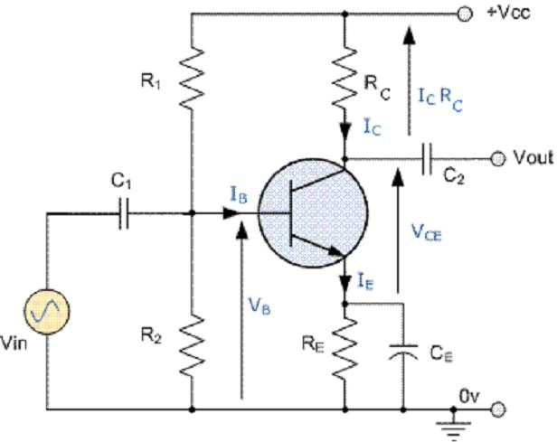

Fig. 1: The Hybrid π-model

## Load line and Q-point

A static or DC load line can be drawn onto the output characteristics curves of the transistor

to show all the possible operating points of the transistor from fully "ON" (𝐼𝐶

= 𝑉𝐶𝐶 ) to

(𝑅𝐶+𝑅𝐸)

fully "OFF" (IC = 0). The quiescent operating point or Q-point is a point on this load line which represents the values of IC and VCE that exist in the circuit when no input signal is applied. Knowing VB, IC and VCE can be calculated to locate the operating point of the circuit as follows:

*VE =VB −VBE*

So, the emitter current, 𝐼𝐸

= 𝐼𝐶

= 𝑉𝐸

𝑅𝐸

and 𝑉𝐶𝐸

= 𝑉𝐶𝐶

− 𝐼𝐶

(𝑅𝐶

+ 𝑅𝐸)

It can be noted here that the sequence of calculation does not need the knowledge of β and IB is not calculated. So the Q-point is stable against any replacement of the transistor. Since the aim of any small signal amplifier is to generate an amplified input signal at the output with minimum distortion possible, the best position for this Q-point is as close to the centre position of the load line as reasonably possible, thereby producing a Class A type amplifier

operation, i.e.𝑉

= 1 𝑉 .

𝐶𝐸

2 𝐶𝐶

## Coupling and Bypass Capacitors

In CE amplifier circuits, capacitors C1 and C2 are used as Coupling Capacitors to separate the AC signals from the DC biasing voltage. The capacitors will only pass AC signals and block any DC component. Thus they allow coupling of the AC signal into an amplifier stage without disturbing its Q point. The output AC signal is then superimposed on the biasing of the following stages. Also a bypass capacitor, CE is included in the Emitter leg circuit. This capacitor is an open circuit component for DC bias, meaning that the biasing currents and voltages are not affected by the addition of the capacitor maintaining a good Q-point stability. However, this bypass capacitor acts as a short circuit path across the emitter resistor at high frequency signals increasing the voltage gain to its maximum. Generally, the value of the bypass capacitor, CE is chosen to provide a reactance of at most, 1/10th the value of RE at the lowest operating signal frequency.

## Amplifier Operation

Once the Q-point is fixed through DC bias, an AC signal is applied at the input using coupling capacitor C1. During positive half cycle of the signal VBE increases leading to increased IB. Therefore IC increases by β times leading to decrease in the output voltage, VCE. Thus the CE amplifier produces an amplified output with a phase reversal. The voltage Gain of the common emitter amplifier is equal to the ratio of the change in the output voltage to the change in the input voltage. Thus,

𝐴𝑉 =

𝑉𝑜𝑢𝑡

𝑉𝑖𝑛

∆𝑉𝐶𝐸

# =

∆𝑉𝐵𝐸

The input (Zi) and output (Zo) impedances of the circuit can be computed for the case when the emitter resistor RE is completely bypassed by the capacitor, CE:

# 𝑍𝑖 = 𝑅1 𝑅2 𝛽𝑟𝑒 and 𝑍0 = 𝑅𝐶 r0

Where, re (26mV/IE) and ro are the emitter diode resistance and output dynamic resistance (can be determined from output characteristics of transistor). Usually ro≥10 RC, thus the gain can be approximated as

𝐴𝑉 =

𝑉𝑜𝑢𝑡

= −

𝑉𝑖𝑛

𝛽𝐼𝐵(𝑅𝑐

𝐼𝐵𝛽𝑟𝑒

𝑟𝑒)

𝑅𝐶

≅ −

𝑟𝑒

The negative sign accounts for the phase reversal at the output. In the circuit diagram provided below, the emitter resistor is split into two in order to reduce the gain to avoid distortion. So the expression for gain is modified as,

𝐴𝑉 ≅ − 𝑅

𝑅𝐶

+𝑟

𝐸 𝑒

## Pre-lab Homework:

Read about single stage transistor amplifier and their equivalent models from “Microelectronic Circuits” by A.S. Sedra, K.C. Smith and use Pspice to generate the output of the circuits provided in this lab sheet. Compare the graphs given in the textbook with your results. Save the simulation results and bring it to the lab.

In order to analyze the single stage CE amplifier, consider the circuit described in the above figure 3. Hence do the following:

* Use “PSpice” to implement the above circuit using 2N2222 transistor.
* Determine the DC operation point values for VB, VC, VCE, VE, IC, and IB
* Perform a transient analysis of a sinusoidal input signal. The input signal VS exhibits a frequency of 1 KHz and an amplitude 10 mV peak. Display the input voltage and the voltage across load resistance RL together to see the transistor amplification characteristics. Also display the base voltage VB.

## Apparatus:

|  |  |  |
| --- | --- | --- |
| **No.** | **Apparatus** | **Quantity** |
| 1 | Transistor (C828) | 1 |
| 2 | 33k, 10k, 4.7k, 1k, 3.3k, 1.5k, 330Ω Resistance | 1 for each |
| 3 | Project Board | 1 |
| 4 | Cathode Ray Oscilloscope (CRO) | 1 |
| 5 | Multimeter | 1 |
| 6 | Signal Generator | 1 |
| 7 | 100μF Capacitor | 1 |
| 8 | Probes | 2 |
| 9 | Power Supply Cable | 2 |

**Precaution:**

Transistors are sensitive to be damaged by electrical overloads, heat, humidity, and radiation. Damage of this nature often occurs by applying the incorrect polarity voltage to the collector circuit or excessive voltage to the input circuit. One of the most frequent causes of damage to a transistor is the electrostatic discharge from the human body when the device is handled.

## Circuit Diagram:

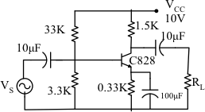

Fig. 3: Single Stage CE Amplifier

**Experimental Procedure:**

1. Measure β of the transistor with multimeter.
2. Calculate DC operating point of the transistor circuit.
3. Implement the circuit as shown in the figure.
4. Measure the operating point with the help of table: 1 and compare with your calculated value.
5. Feed ac Signal of 1 kHz at the input and observe the input and output on the CRO.
6. Increase the input signal till the output wave shape starts getting distorted. Measure this input signal. This is the maximum input signal that the amplifier can amplify without any distortion.
7. Now feed an ac signal that is less than the maximum signal handling capacity of the amplifier. Fix the input signal frequency at 1 KHz, Draw the input and output voltage wave shape and calculate gain.
8. Connect different load resistors and find the voltage gain of the amplifier for each.

## Results and Observations:

1. Q – Point of the amplifier.

|  |  |  |  |  |
| --- | --- | --- | --- | --- |
| **VCC** | **VC** | **VCC - VC** | **IC = (VCC-VC) / RC** | **VCE** |
|  |  |  |  |  |

1. It depends on the applied input voltage and the operating frequency. This one can be varied! Please check in the lab for a specific condition.
2. Voltage Gain of the amplifier:

|  |  |  |  |
| --- | --- | --- | --- |
| **Load Resistor** | **Input voltage** | **Output Voltage** | **Gain** |
| 1K |  |  |  |
| 4.7K |  |  |  |
| 10K |  |  |  |
| 100K |  |  |  |

## Discussion and Conclusion:

Interpret the data/findings and determine the extent to which the experiment was successful in complying with the goal that was initially set. Discuss any mistake you might have made while conducting the investigation and describe ways the study could have been improved.

## Report:

1. Show all the experimental data and calculations in your report.
2. Why do we need all of the capacitors and resistors shown in the circuit?
3. Discuss the experiment as a whole.

## References:

1. American International University–Bangladesh (AIUB) Electronic Devices Lab Manual.
2. A.S. Sedra, K.C. Smith, “Microelectronic Circuits,” Oxford University Press (1998).
3. J. Keown, ORCAD PSpice and Circuit Analysis, Prentice Hall Press (2001)
4. P. Horowitz, W. Hill, “The Art of Electronics,” Cambridge University Press (1989).