Module-03

Module-03: React basic & working with components.

Simple react project with some components that shows the expense item from some dummy data.

Applying CSS in custom component.

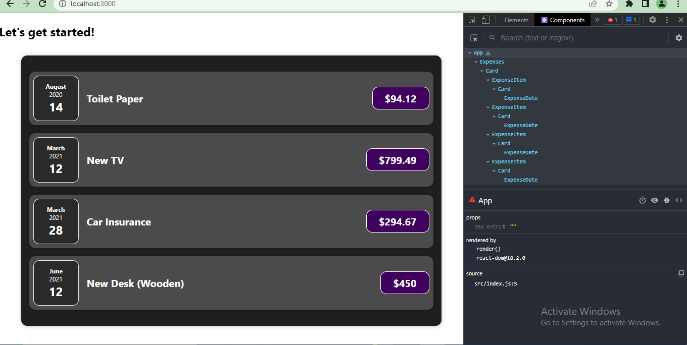

at last, one important thing,,   
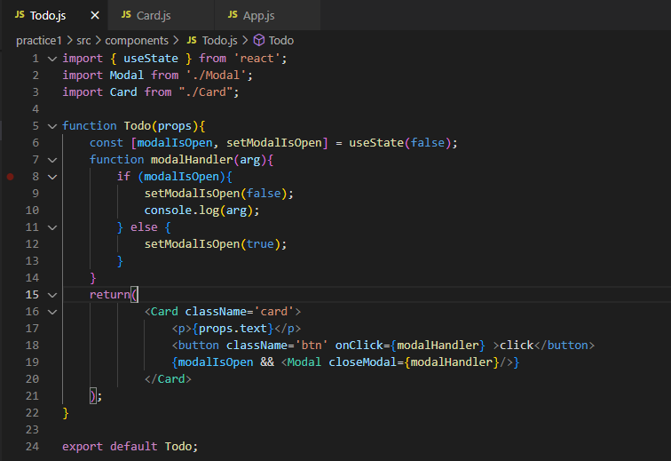

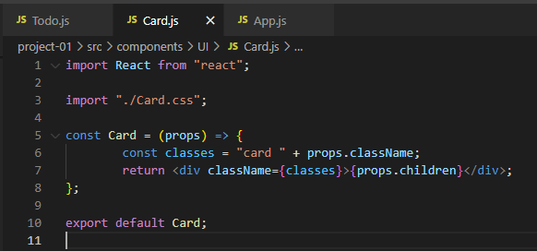  
  
In above two pictures,   
Card is a custom component defined by us. So, if we want to render CSS from outside the component, we need to accept those CSS through props. It’s shown here.