module-10_1

Project Name: Email & Password validation using useEffect.  
[module-10_1: module-10_1 is about useEffect.

useEffect only re-renders when its dependency changes.

an important react hook,

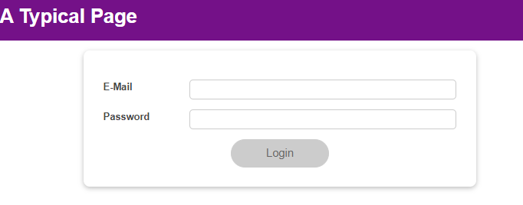

useEffect returns a function that runs only before the re-execution of useEffect hook,

** check the last picture for better understanding,

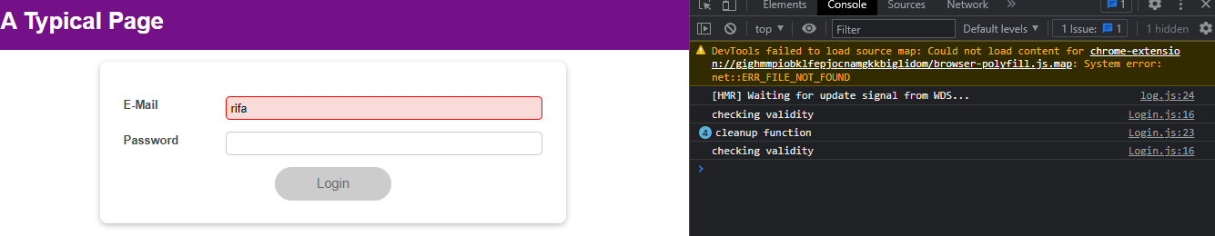

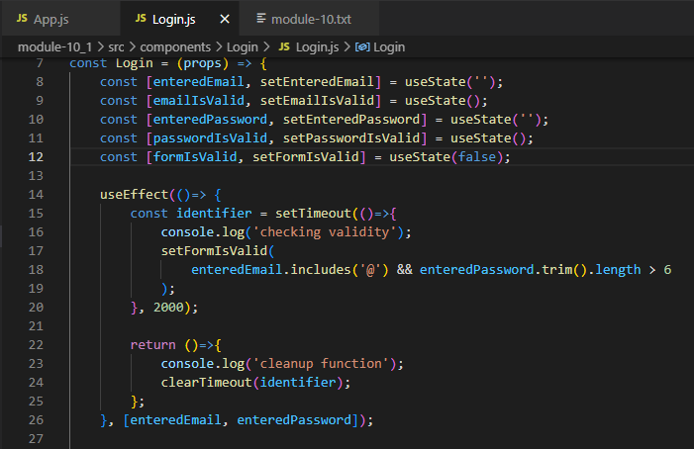

Let’s, check the code & the console in the above picture, checking validity runs only once, because, when we give input in the form, dependency of useEffect changes & re-renders. But before re-render, it goes to return function of useEffect & previous setTimeout is destroyed by clearTimeout. And then when useEffect re-renders, new timeout is set again and so on. This is really interesting,