module-10__1

Project Name: Email & Password validation using useEffects.  
[module-10__1: module-10__1 is about useEffect.

useEffect only rerenders when its dependency changes.

an important react hook,,

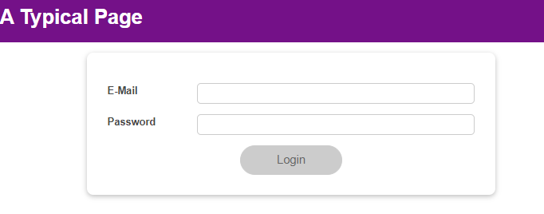

useEffect returns a function that runs only before the re-execution of useEffect hook,,

** check the last picture for better understanding,,

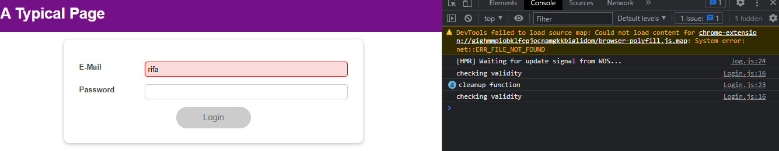

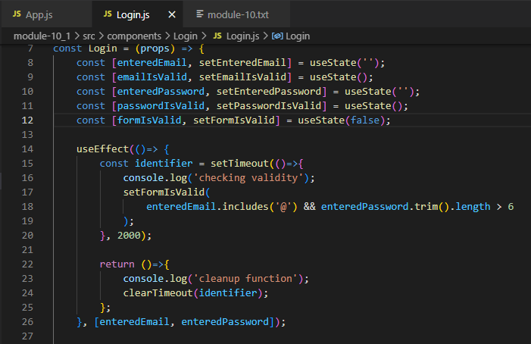

Lets, check the code & the console in the above picture,, checking validity runs only once, because, when we give input in the form, dependency of useEffect changes & re-renders. But before re-render, it goes to return function of useEffect & previous setTimeout is destroyed by clearTimeout. And then when useEffect re-renders, new timeout is set again and so on. This is really interesting,,