module-14_2

[module 14: Sending HTTP requests]

module-14_2 starts here,, tutorial: 9-11

Project Name: Inserting & Fetching Movie Data from api. Movies data are sorted according to released date.

Api: https://module-14-2-e90d2-default-rtdb.firebaseio.com

Project details: Inserting & Fetching movies data from an api using an async await function, handling the errors, useEffect & useCallback used here.

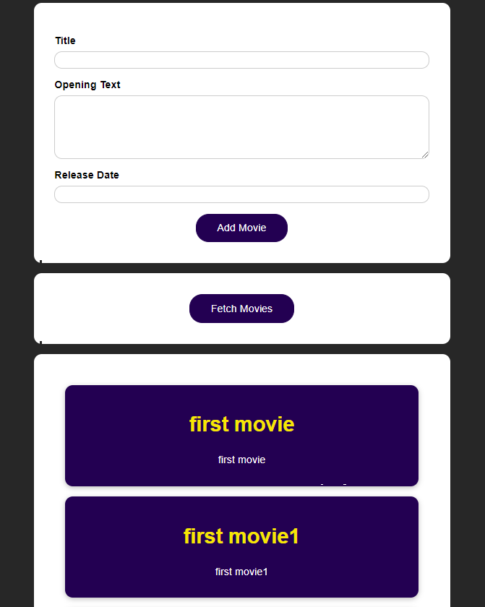

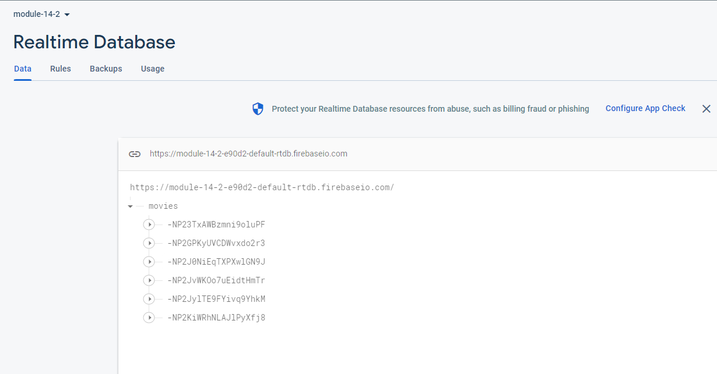

Firebase is used here,   
movie data can be inserted & fetched from this Realtime database.

Post method syntax:

async function postMethod(data) {

        const response = await fetch(url, {

            method: "POST",

            // body accepts json data, json format is used for exchanging data between frontend & backend

            body : JSON.stringify(movie), // JSON.stringify takes an obj & turns it json format.

            headers : {

                'Content-Type': 'application/json'

            }

        });

        const data = await response.json();

        console.log(data);

    }