module-15_3

[module-15: Building custom react hooks]

Project Name: Custom http hooks for both get & post data in api

module-15_3 starts here, tutorial: 6-10

Project details: In this project, custom http hook (useHttp.js) is used by App and NewTask components via function.

Firebase database: https://module-15-3-default-rtdb.firebaseio.com/tasks.json

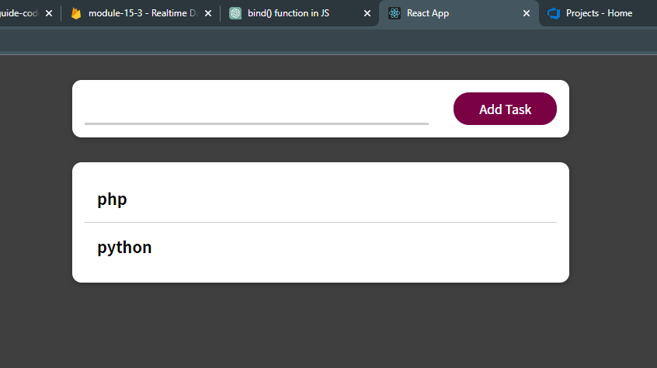

In NewTask, bind() method is used to configure the createTask function. This is js specific, not react.