module-16_1

module-16: working with forms & user input

module-16_1 starts here,, tutorial: 1-8

In an input element,

ref deals with the current value of an input field

onChange deals with every keystroke inside an input field

here, we have used useState for different properties like enteredValue, onBlur, isValid etc.

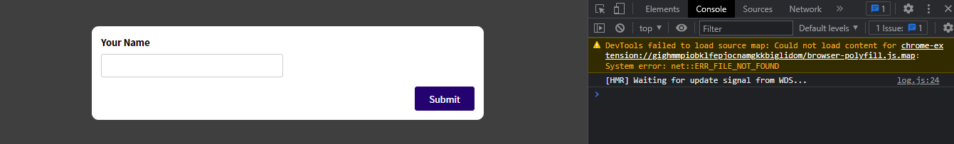

* Initial form

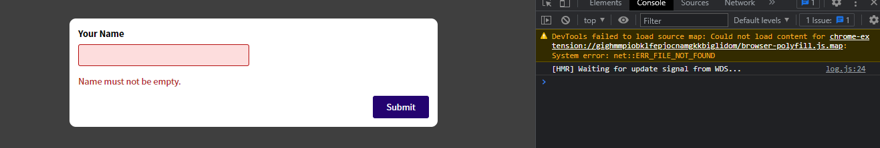

* When form input in invalid