module-16_2

module-16: working with forms & user input

module-16_2 starts here,, tutorial: 9-10

In input element,

ref deals with the current value of an input field

onchange deals with every keystroke in an input field

### here, it's same as module-16_1, but states are refactored & derived and form validity is managed.

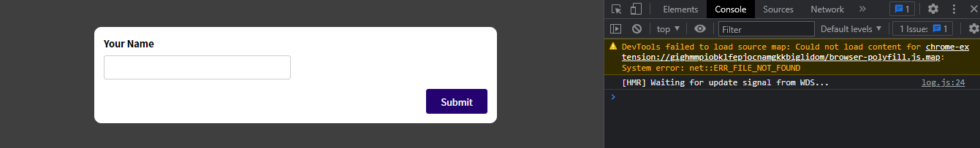

* Initial form

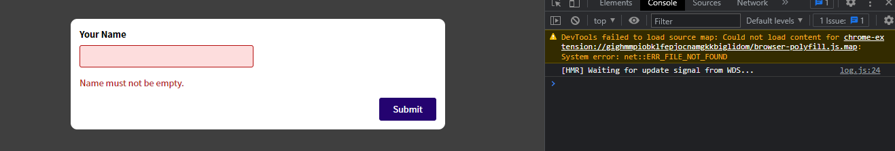

* When form input in invalid