module-16_3

module-16: working with forms & user input

module-16_3 starts here,, tutorial: 11-14

**Here, input element is managed by custom hook.**

In input element,

ref deals with the current value of an input field

onchange deals with every keystroke in an input field

### here, in the form,email is handled by useState & name is handled **by custom hook.**

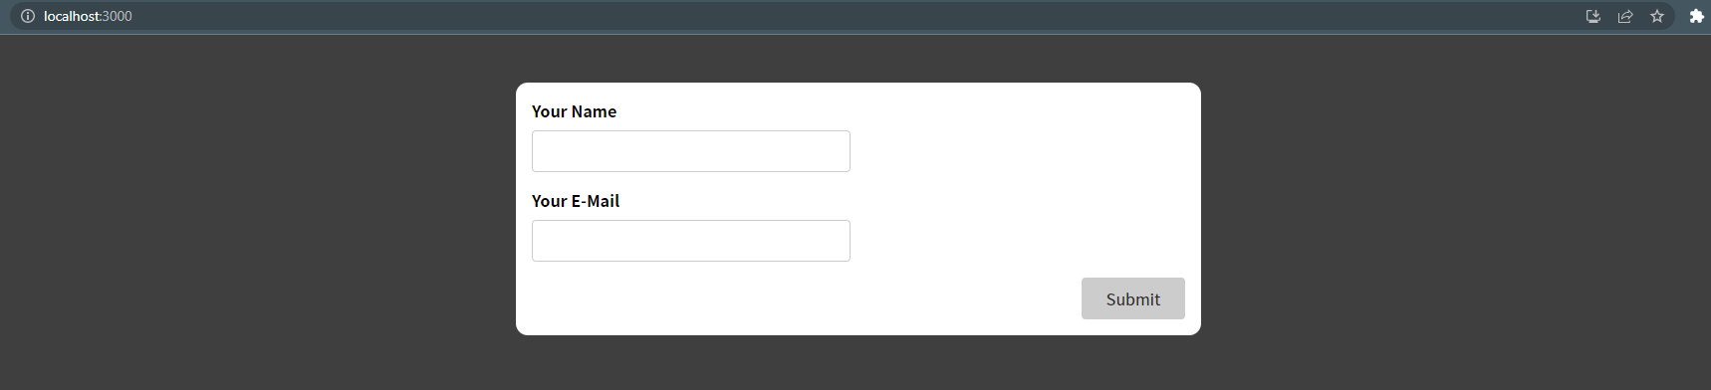

* Initial form

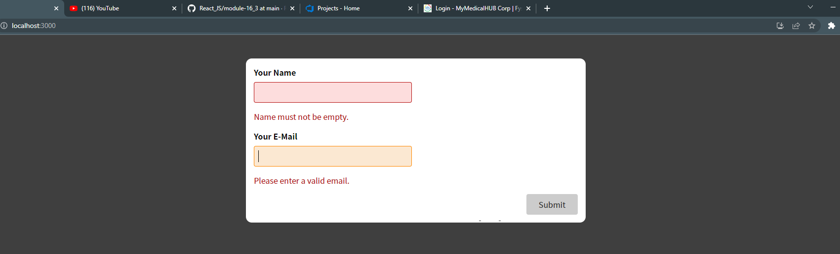

* When form input in invalid