module-11

[module-11: practice project, building a food order app.

Project Name: Building a food order app.

Description: food order app shows available meals to the customers. Customers can add or remove meal items to the cart & see the total expense.  
  
 useReducer is used here to update the cart &

useRef is used to take input from customers.

useContext is used to share the cart among different areas of our project.

useEffect is used in the header button of navigation bar for a little bump when new item is added or removed.

This is the page with the available meals. Order amounts can be controlled by the customers from here.

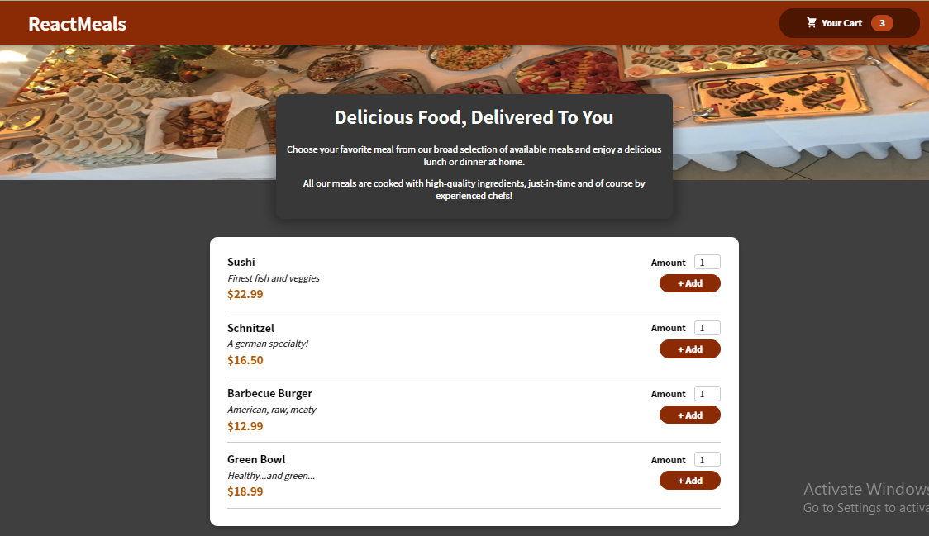

This modal is the cart item, customers can see their amount of items and total expense from here.

