module-18_1

[Module-18 Diving into redux]

tutorial: 7-

tutorial 12 shows redux with class-based components

# basic:

3 types of components:

1. local => belongs to single component,,

we use useState/useReducer hook

ex: listeing input, toggling 'show more' etc.

1. cross-component => affect multiple components,,

we use useState/useReducer but need to build props chains.

ex: open/close modal

1. app-wide state => affects entire app

we use useState/useReducer but need to build props chains.

ex: user-authentication

context/redux helps to manage the cross component or app-wide state.

install:

npm install redux react-redux

NB: in redux, don't mutate the object, create a brand-new object.

# Project:

Project Name: Increment & decrement using redux

Description: Some buttons are used for increment & decrement. There is a toggle button which shows & hides the counter on each click.

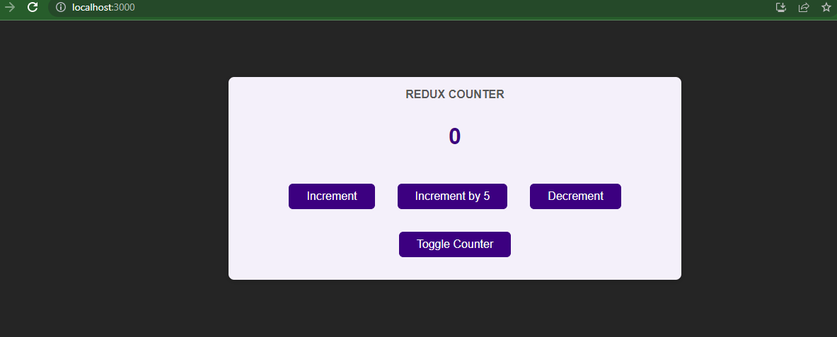

Counter is hidden when “Toggle Counter” button is clicked.  
On next click, it shows the counter again.

