Project-09

Project Name: Course Goal  
[module 06: styling CSS components using css module]

CSS module is used here,,  
checkout CourseInput.js & Button.js for details,,,

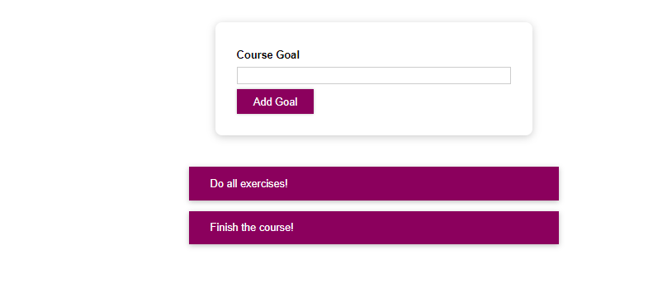

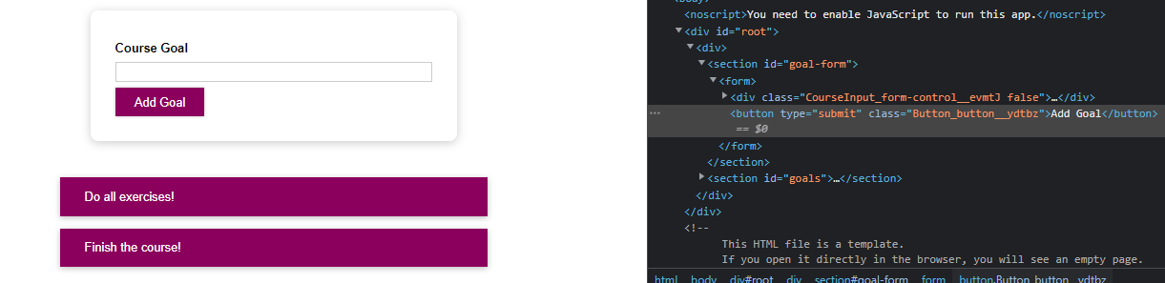

Let’s see the button class.  
css module gives a unique value to the button,   
component name => our class name => unique class name