From Anomaly Scores to Cost-Sensitive Inspection Decisions: A Two-Stage Experimental Framework Using Handcrafted-Feature Isolation Forest Detection and Tabular Q-Learning
[Author names] · [Affiliations] · [Corresponding author e-mail]

Abstract
Visual inspection in manufacturing involves two linked tasks: identifying anomalies and deciding what to do with the inspection outcome. This study presents a two-stage experimental framework that addresses the transition from anomaly detection to decision-making. The first stage uses handcrafted colour, texture, and shape representations with an Isolation Forest trained solely on normal images from the bottle category of the MVTec Anomaly Detection (MVTec AD) dataset. Combining the feature families gives the best detection performance, with a ROC-AUC of 0.947 (95% bootstrap CI 0.879–0.993), accuracy of 0.916, precision of 0.967, recall of 0.921, and F1-score of 0.943. Among individual families, shape (HOG plus edge density) is strongest (ROC-AUC 0.938), texture is intermediate (0.787), and colour is at chance level (0.496). Performance varies with defect size: large defects reach perfect recall (1.000), compared with 0.844 for small defects, and all five missed defects lie below the median defect area. The second stage maps anomaly scores into ten discrete states and applies tabular Q-learning to choose among Accept, Reject, and Human Review under asymmetric manufacturing costs, in which missed defects are penalised more heavily than false rejections and human review costs less. On held-out samples, the learned policy raised the average reward from 0.143 (fixed threshold) to 0.405 and reduced missed defects from three to zero. This came with a trade-off: false rejects rose from one to five and five items (11.9%) were referred for human review. Sensitivity experiments over nine cost configurations show that the policy depends on the assumed cost of human review but, within the tested range, not on the missed-defect penalty: cheaper review (−0.5) raised the average reward to 0.464 with zero misses, whereas costlier review (−2) eliminated reviews, raised false rejects to nine, and lowered the reward to 0.357. The results provide a transparent, auditable simulation of how anomaly scores become cost-sensitive inspection decisions.
Keywords: industrial visual inspection; anomaly detection; Isolation Forest; handcrafted features; Q-learning; cost-sensitive decision-making; reject option; MVTec AD
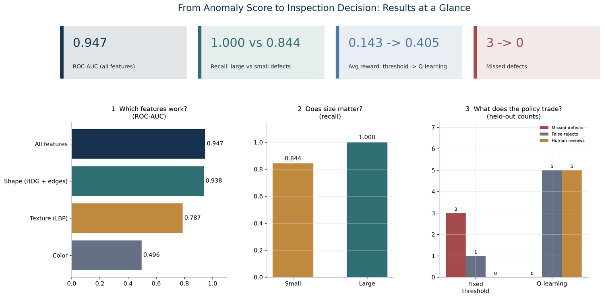
Graphical abstract. Key results at a glance: feature-family ROC-AUC, recall by defect size, and the operational trade-offs of the learned policy.

1. Introduction
A detector produces a number; a production line needs an action. Between the two sits a decision rule, and in most anomaly-detection studies that rule is a single threshold fixed without reference to what each mistake costs. Accepting a defective item risks shipping a defect, rejecting a good item scraps value, and sending an ambiguous item to a person costs inspection time but can avoid both errors. A threshold-free metric such as ROC-AUC cannot say which action is best, and a detector with an AUC near 0.95 can still lead to expensive decisions if its operating point ignores cost asymmetry.
This paper treats the gap between detection and decision as the object of study. Stage 1 turns an image into an anomaly score with a deliberately simple detector trained on defect-free images only; Stage 2 turns the score into one of three actions with a small tabular Q-learning policy (Fig. 1). The study is a transparent simulation on a public benchmark, not a deployment claim.
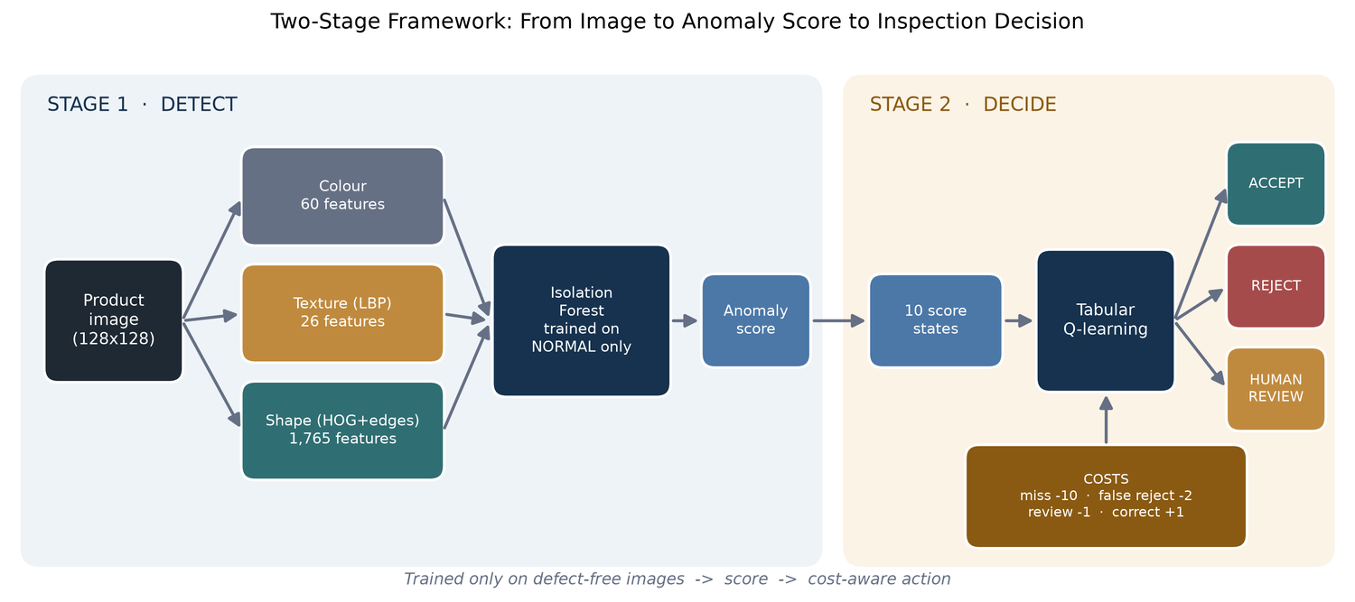
Fig. 1. Two-stage framework. Stage 1 extracts colour, texture and shape features and scores them with an Isolation Forest trained on normal images; Stage 2 discretises the score and applies Q-learning to choose Accept, Reject or Human Review.
Research questions. RQ1: how well can handcrafted features and an Isolation Forest trained on normal images detect defects? RQ2: which visual property carries the signal, and does defect size matter? RQ3: does a cost-aware Q-learning policy reduce costly errors relative to a fixed threshold? RQ4: how does the learned policy depend on the assumed costs?
Contributions.
- A reproducible framework linking label-free anomaly scoring to an Accept/Reject/Human Review decision layer.
- Feature-family, defect-type and defect-size analyses with confidence intervals.
- A nine-configuration cost-sensitivity study with a closed-form break-even analysis explaining when review is worthwhile.
- A candid comparison with a cost-tuned threshold, showing what the learned policy does and does not add.

2. Related Work
Anomaly detection on MVTec AD. MVTec AD [1] trains on defect-free images and tests on normal and defective items; leading methods are deep and feature-based, such as student–teacher networks [9], PaDiM [10] and PatchCore [11]. Classical detectors remain useful as interpretable low-compute baselines [12]. Here we use Local Binary Patterns [3], Histograms of Oriented Gradients [4] and colour statistics with Isolation Forest [2].
Decision layers. Treating the final action separately has a long history: the reject option [13], cost-sensitive learning [7], and learning to defer to a human [14, 15]. Reinforcement learning [5, 6] learns action values from reward; since each product is decided independently, our formulation is single-step and equivalent to a contextual bandit [16]. We keep the Q-table because it can be read row by row.

3. Methods

3.1 Data
We use the bottle category of MVTec AD [1, 17]: 209 normal training images and 83 test images (20 good; 63 defective: 20 broken-large, 22 broken-small, 21 contamination) with pixel-level masks (Fig. 2). Images are read from a local copy of the dataset and resized to 128 × 128. MVTec AD is released by MVTec Software GmbH under the CC BY-NC-SA 4.0 licence and is used here for non-commercial research.
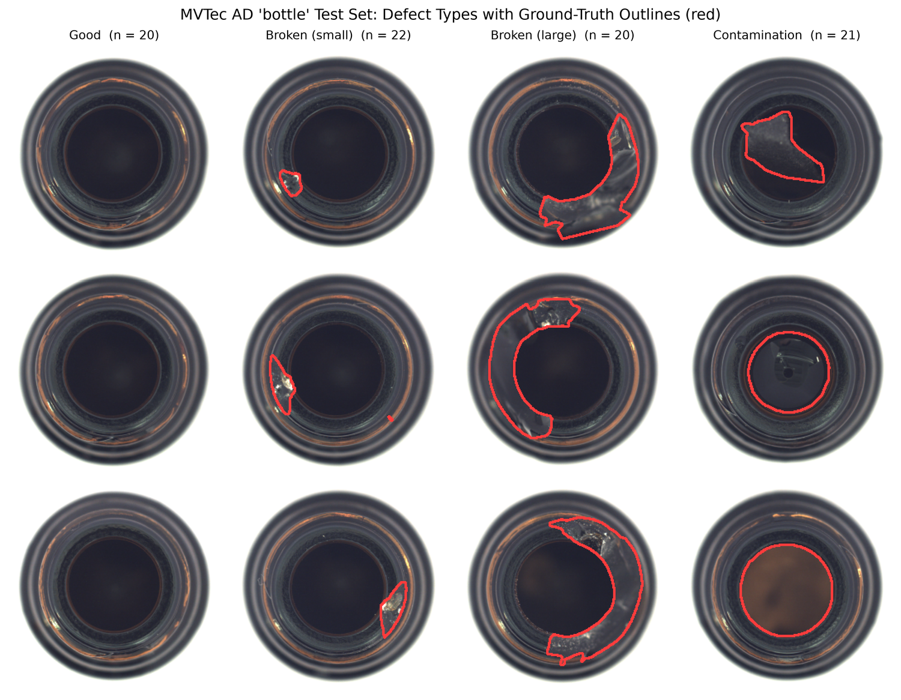
Fig. 2. Test examples per defect type with ground-truth mask outlines.

3.2 Stage 1: features and anomaly score
Colour (60 features), texture/LBP (26) and shape/HOG plus edge density (1,765) descriptors are extracted separately and concatenated (1,851; Fig. 3). One Isolation Forest (300 trees, seed 42) is fitted per representation on normal training images only. Scores are oriented so that higher means more anomalous. The operating threshold is the 95th percentile of normal-training scores (−0.046 for the combined detector), set without defect labels. For the size analysis, defects are split at the median mask-area ratio (0.0572) into Large (n = 31) and Small (n = 32).
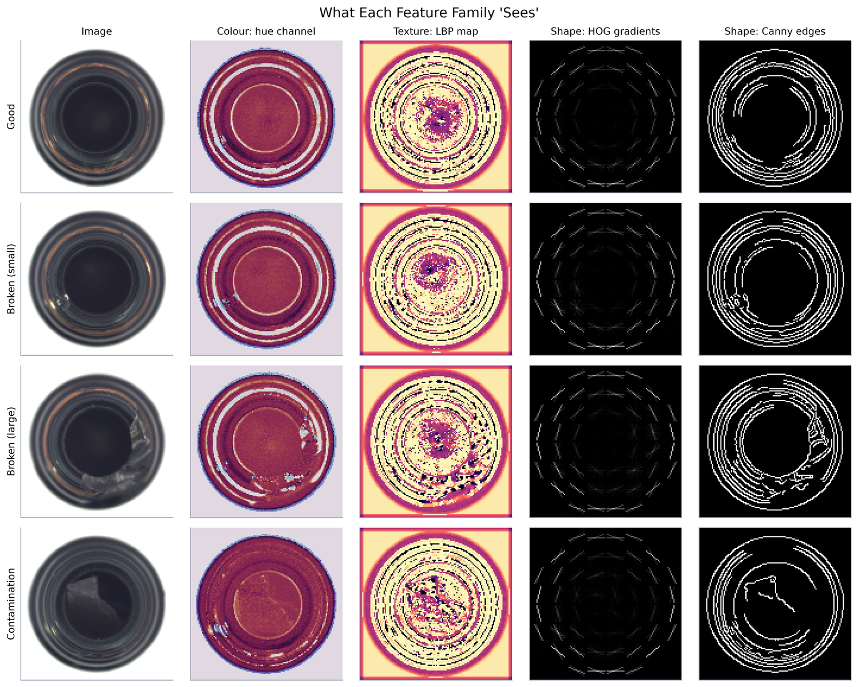
Fig. 3. What each feature family represents: colour, LBP texture, HOG and edge maps.

3.3 Stage 2: decision layer
The 83 test images are split 50/50, stratified by label, into 41 calibration and 42 held-out items (32 defective, 10 good); the detector never trains on either. Scores are mapped to ten quantile states (S0–S9) computed on calibration scores. The agent chooses Accept, Reject or Human Review under the rewards in Table 1 (a miss costs five times a false reject; review costs half a false reject and is assumed correct). Single-step Q-learning, Q(s,a) ← Q(s,a) + α(r − Q(s,a)), uses α = 0.15, ε = 0.20 and 4,000 episodes; the deployed policy is greedy. The comparator is a fixed threshold (reject if the score is at or above the 95th-percentile training score, else accept) with no labels and no review option. Sensitivity: missed-defect penalty (−5, −10, −20) × review cost (−0.5, −1, −2), retraining each time.
Table 1. Reward function.
Action | Item good | Item defective
Accept | +1 | −10 (missed defect)
Reject | −2 (false reject) | +1
Human Review | −1 | −1

Break-even analysis. For a state with defective fraction p, miss penalty M and review cost c, the expected values are Accept = 1 − p − Mp, Reject = 3p − 2 and Review = c. Accept beats Reject when p < 3/(M + 4); Review beats Reject when p < (c + 2)/3 (one-third for c = −1, one-half for c = −0.5, never for c = −2). These follow from Table 1 and are used only to interpret results.

3.4 Evaluation
Stage 1 reports ROC-AUC, accuracy, precision, recall, F1 and average precision (n = 83), a percentile bootstrap CI for ROC-AUC (10,000 resamples), Wilson 95% intervals for proportions, Spearman correlation between defect area and score, and Mann–Whitney and Fisher exact tests. Given the small sample, tests are descriptive. Stage 2 reports average reward, missed defects, false rejects and reviews on the held-out set.

4. Results

4.1 Stage 1: detection performance
Table 2. Detection performance by feature family (n = 83).
Feature set | ROC-AUC | AP | Accuracy | Precision | Recall | F1
All features | 0.947 | 0.981 | 0.916 | 0.967 | 0.921 | 0.943
Shape (HOG + edges) | 0.938 | 0.977 | 0.867 | 0.948 | 0.873 | 0.909
Texture (LBP) | 0.787 | 0.930 | 0.651 | 0.925 | 0.587 | 0.718
Colour | 0.496 | 0.805 | 0.542 | 0.791 | 0.540 | 0.642

The signal is geometric: shape alone reaches 0.938 while colour is at chance (Fig. 4, Fig. 5). Combining families is best on every metric, but shape makes up 1,765 of 1,851 features and no leave-one-family-out ablation was run, so the small gain over shape alone should not be over-interpreted. Positive-class prevalence is 0.76, so average precision should be read against that baseline.
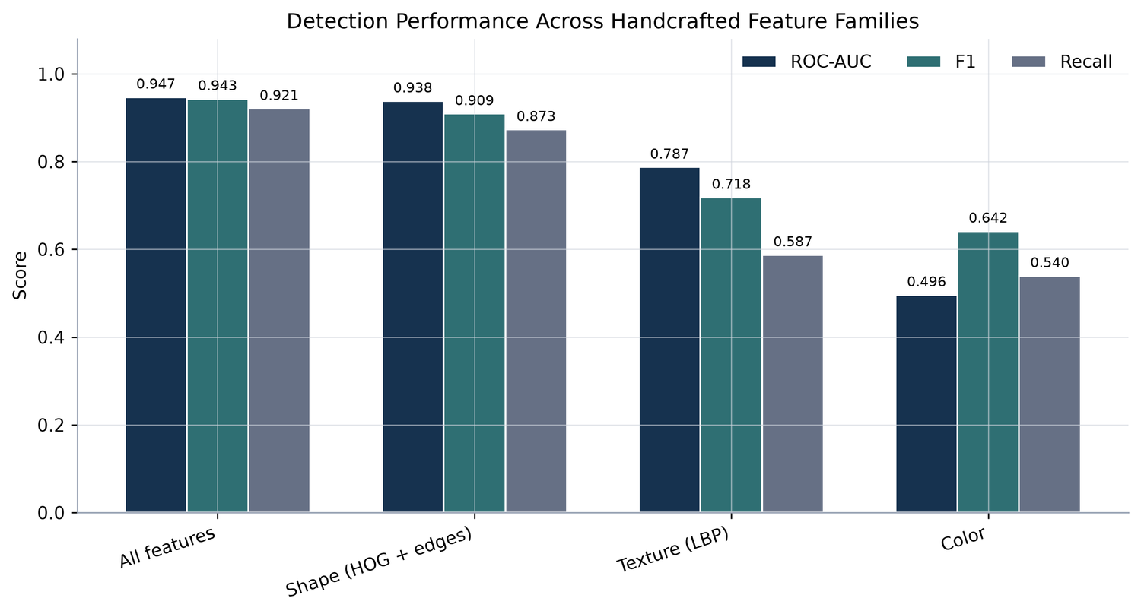
Fig. 4. ROC-AUC, F1 and recall for each feature family.
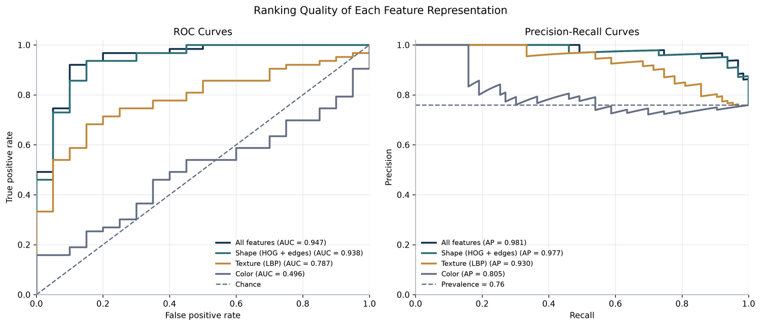
Fig. 5. ROC and precision–recall curves for each feature representation.
The combined ROC-AUC of 0.947 has a 95% bootstrap CI of 0.879–0.993. At the label-free threshold the detector flags 58 of 63 defects (recall 0.921, Wilson CI 0.827–0.966) and 2 of 20 good items (specificity 0.900, CI 0.699–0.972); five defects are missed (Fig. 6, Fig. 7). Mean scores are −0.065 for good and 0.007 for defective items (Mann–Whitney p < 10⁻⁸).
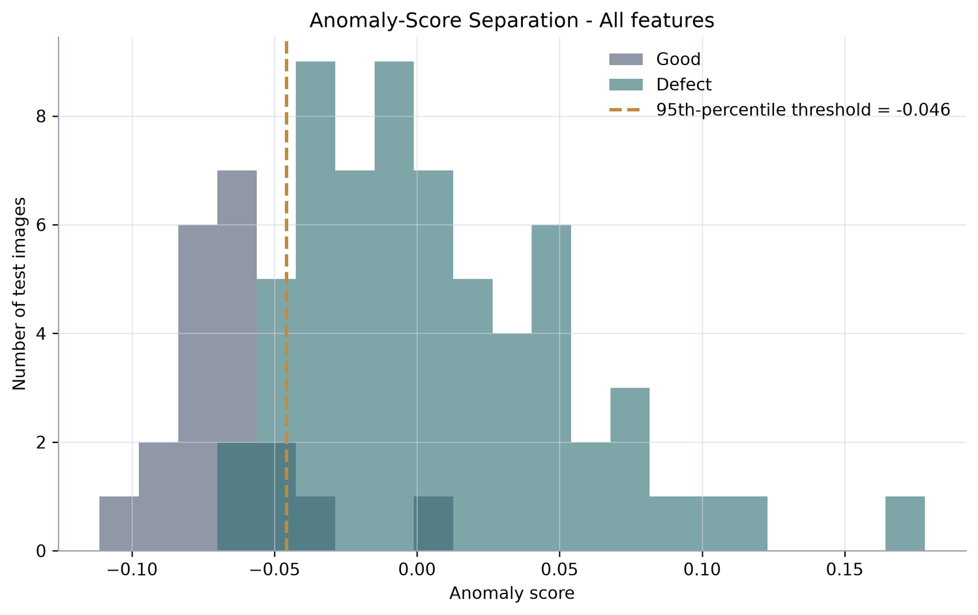
Fig. 6. Anomaly-score distributions for good and defective test images; dashed line is the 95th-percentile threshold.
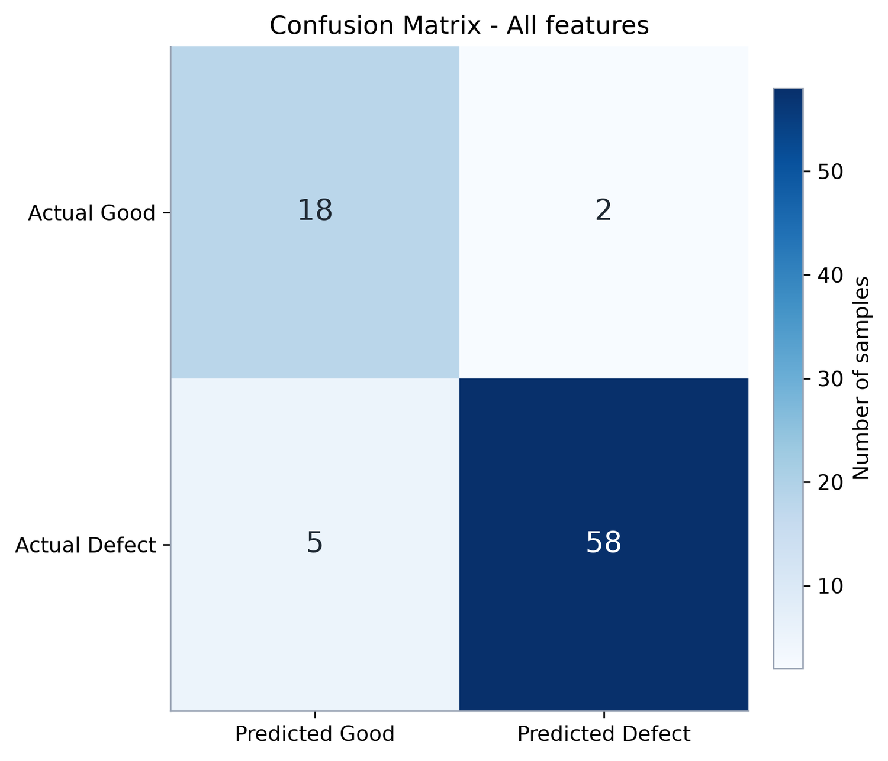
Fig. 7. Confusion matrix of the combined detector (18 TN, 2 FP, 5 FN, 58 TP).
Table 3. Detection by item type (combined features).
Item type | N | Correct | Rate (Wilson 95% CI) | AUC vs good | Mean area ratio
Good (passed) | 20 | 18 | 0.900 (0.699–0.972) | n/a | n/a
Broken-large | 20 | 20 | 1.000 (0.839–1.000) | 0.985 | 0.117
Broken-small | 22 | 20 | 0.909 (0.722–0.975) | 0.941 | 0.031
Contamination | 21 | 18 | 0.857 (0.654–0.950) | 0.917 | 0.085

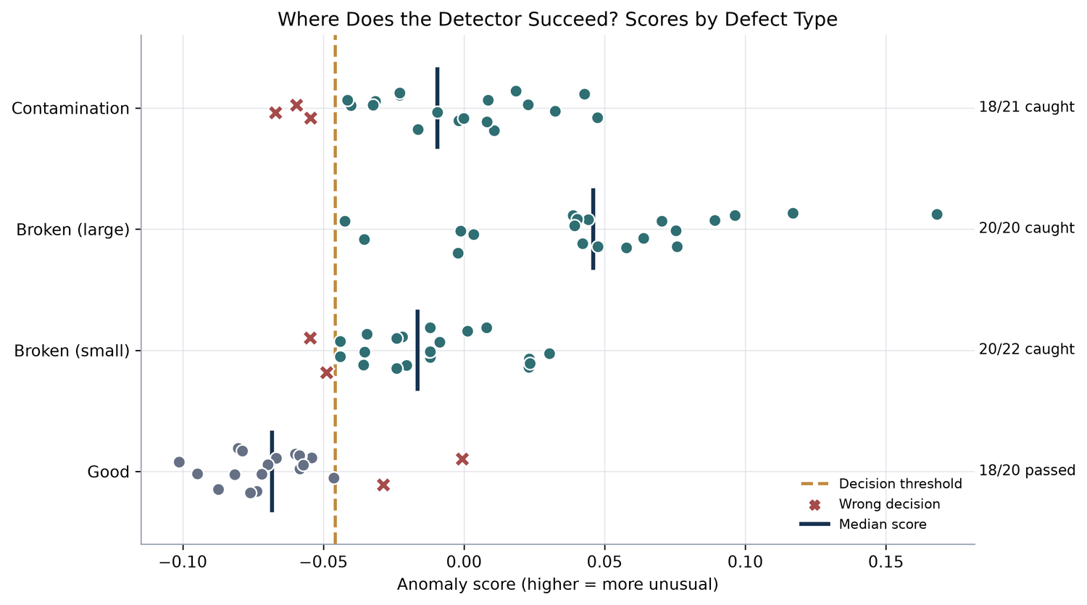
Fig. 8. Anomaly scores by defect type; crosses mark wrong decisions.
Table 4. Detection by defect size (combined features).
Defect size | N | Recall (Wilson 95% CI) | Mean score | AUC vs good
Large | 31 | 1.000 (0.890–1.000) | 0.035 | 0.984
Small | 32 | 0.844 (0.682–0.931) | −0.020 | 0.911

Every miss is a small defect: two broken-small (area ratios 0.009, 0.021) and three contamination cases (0.007, 0.021, 0.033), all below the 0.0572 median (Fig. 9, Fig. 10). Among defective items, score is strongly rank-correlated with area (Spearman ρ = 0.68, p < 10⁻⁸). Recall by area quartile is 12/16, 15/16, 15/15 and 16/16. Score differences by size are significant (Mann–Whitney p ≈ 1.4 × 10⁻⁶) while the recall difference is borderline (Fisher exact p = 0.053). A few-pixel defect barely moves a global descriptor, which is a plausible, untested mechanism.
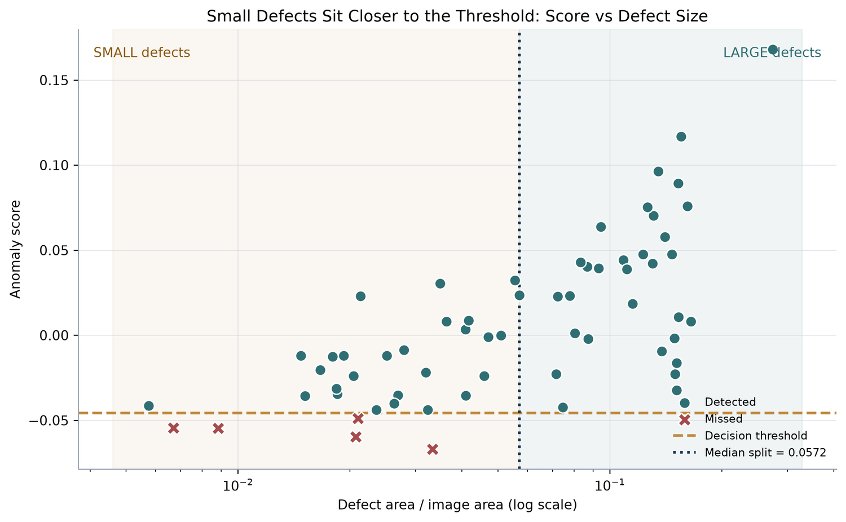
Fig. 9. Anomaly score versus defect area (log scale); missed defects (crosses) cluster at small areas near the threshold.
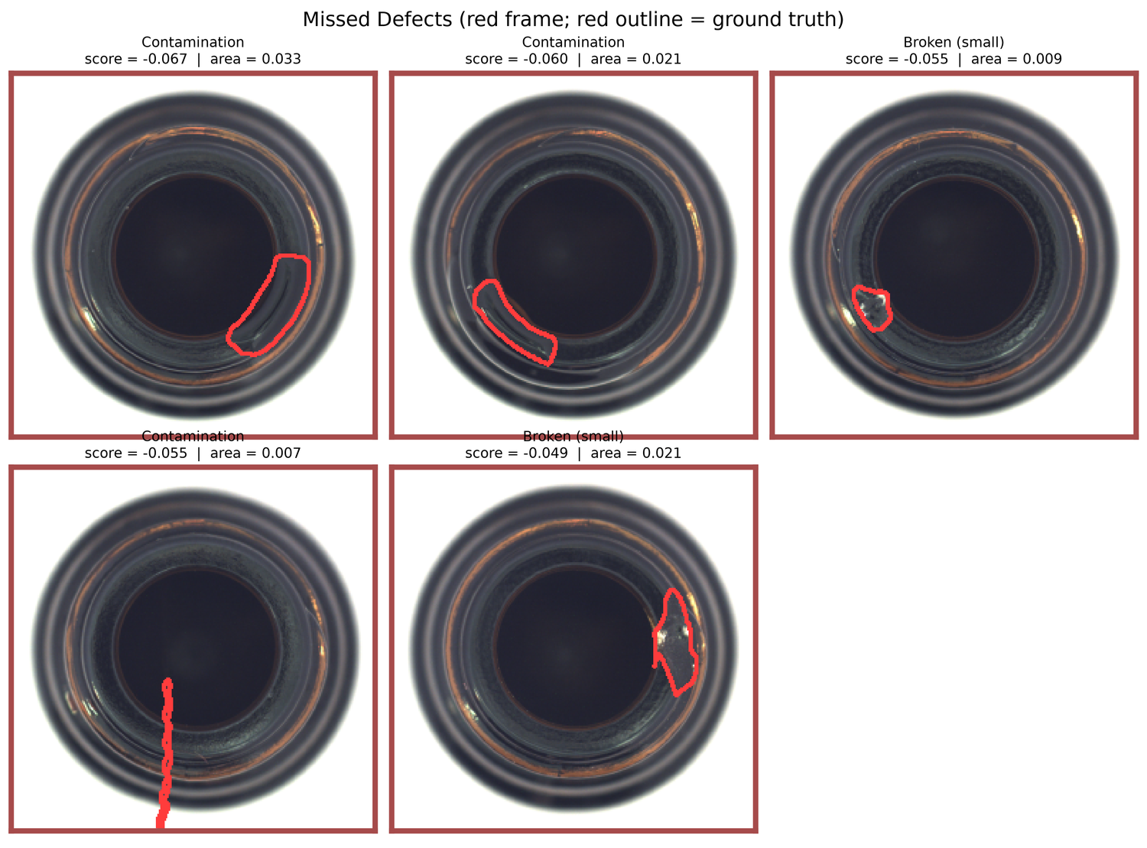
Fig. 10. Missed defects with ground-truth outlines.

4.2 Stage 2: from score to action
Table 5. Held-out decisions (n = 42).
Policy | Avg. reward | Total | Missed | False rejects | Reviews | Review rate
Fixed threshold | 0.143 | 6 | 3 | 1 | 0 | 0.0%
Q-learning | 0.405 | 17 | 0 | 5 | 5 | 11.9%

The learned policy raises the average reward from 0.143 to 0.405 and removes every miss by shifting error toward cheaper categories (Fig. 11, Fig. 12). Of 42 decisions, 32 are correct and automatic (+32), five are false rejects (−10) and five are reviews (−5), totalling 17; the fixed threshold earns +38 but loses 30 on three misses and 2 on one false reject, totalling 6. The five reviews are four good items and one defective item. Five false rejects means half of the ten good evaluation items were scrapped, which the policy accepts because a miss costs five times as much.
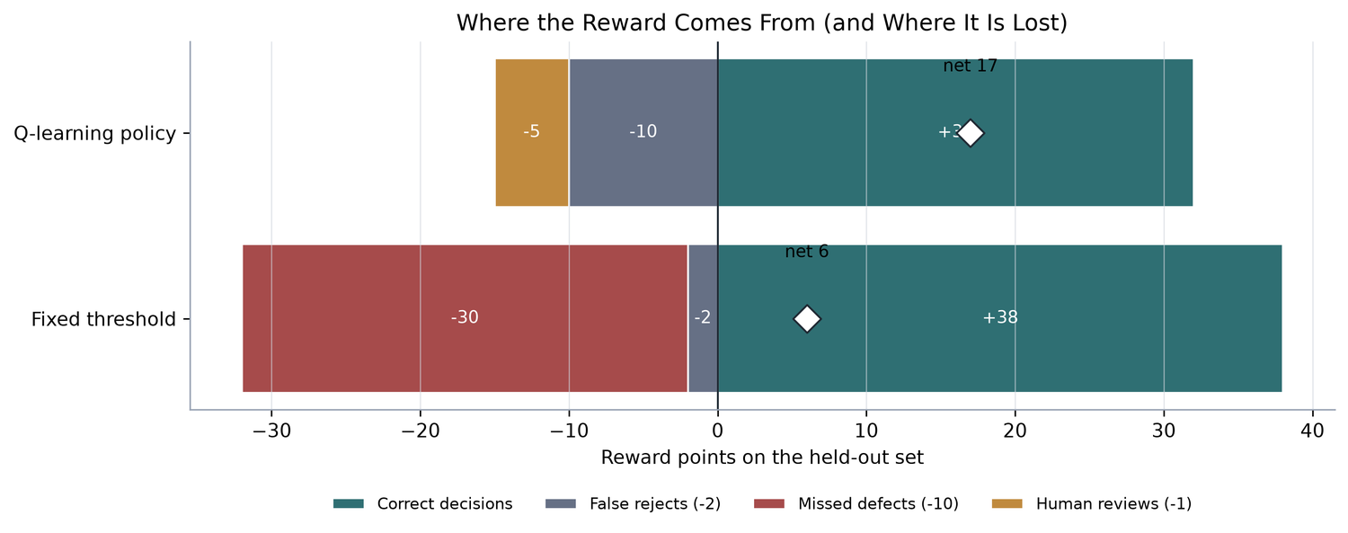
Fig. 11. Decomposition of total held-out reward into gains from correct decisions and losses from false rejects, reviews and misses.
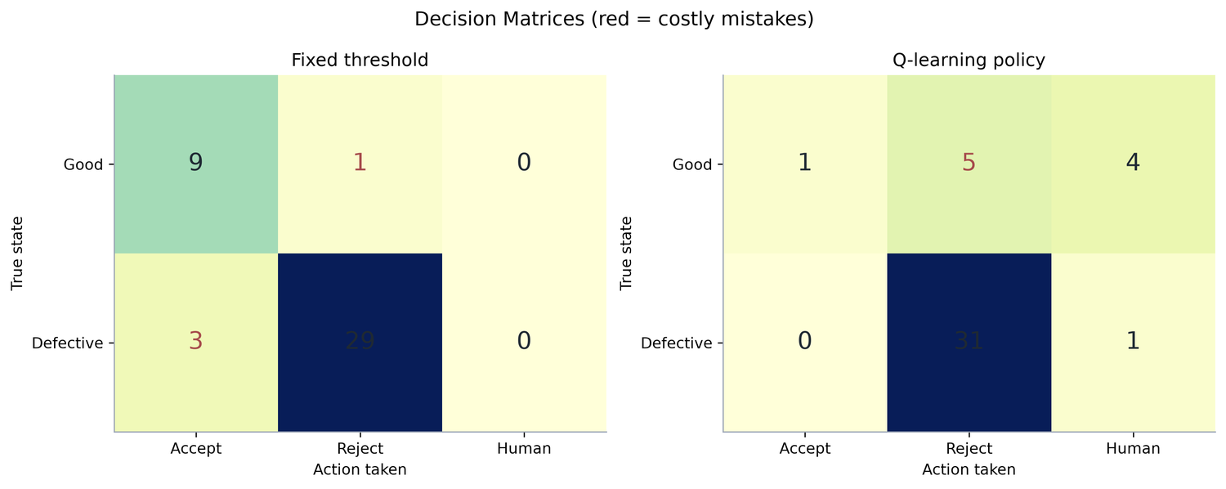
Fig. 12. Decision matrices (true state versus action) for the fixed threshold and the Q-learning policy.
Learned Q-table. The policy accepts only the lowest-score state (S0), reviews the adjacent band (S1) and rejects the rest (Table 6, Fig. 13). Q-values near +1.00 mark pure defective states; 0.14 (S2) and 0.23 (S4) indicate mixed states where good items occasionally appear. From the decision map, the S0/S1 and S1/S2 boundaries lie at scores of −0.079 and −0.059 (the calibration quantile edges, also visible in Fig. 14), below the fixed threshold of −0.046: the policy lowers the rejection threshold and inserts a review band in front of it.
Table 6. Learned policy and Q-values.
State | Action | Q(Accept) | Q(Reject) | Q(Human)
S0 | Accept | 1.000 | −1.975 | −0.988
S1 | Human | −5.145 | −1.114 | −1.000
S2 | Reject | −6.060 | 0.142 | −1.000
S3 | Reject | −9.544 | 1.000 | −0.897
S4 | Reject | −6.671 | 0.234 | −0.994
S5 | Reject | −9.992 | 1.000 | −0.989
S6 | Reject | −9.671 | 1.000 | −0.937
S7 | Reject | −9.828 | 1.000 | −0.988
S8 | Reject | −9.854 | 1.000 | −0.995
S9 | Reject | −9.982 | 1.000 | −0.998

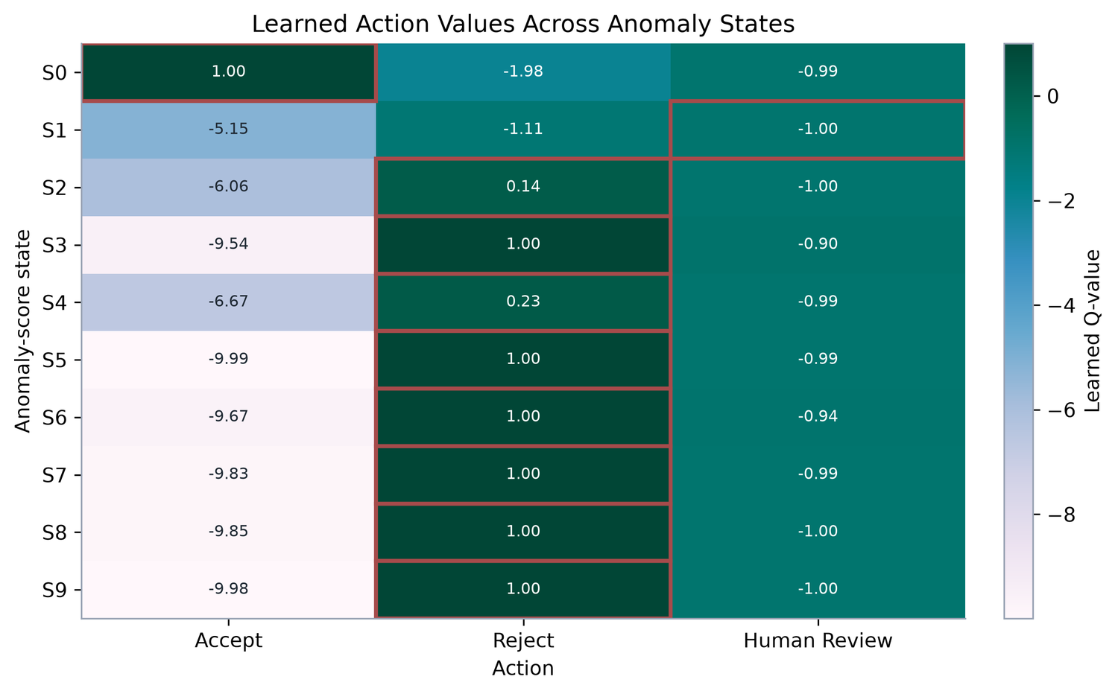
Fig. 13. Learned Q-value table; red boxes mark the chosen action per state.
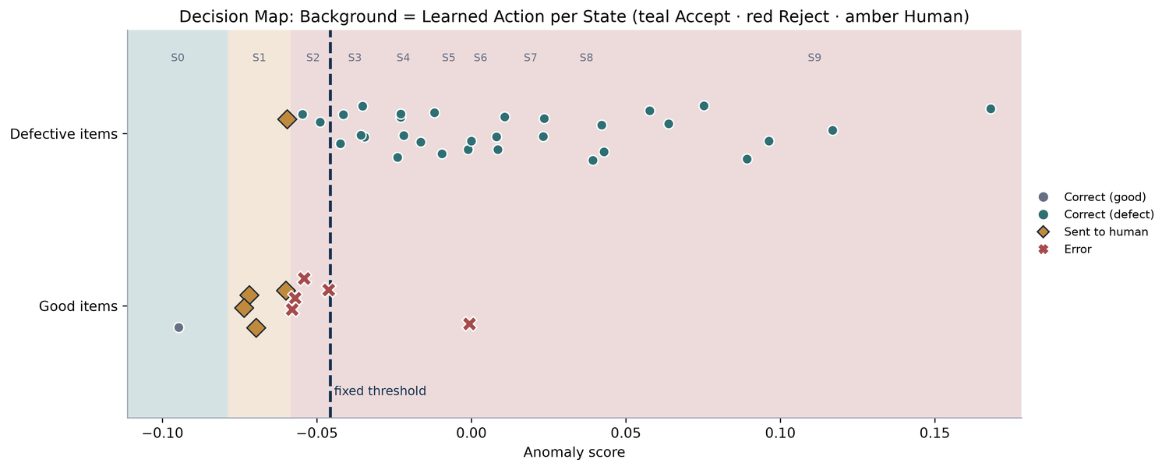
Fig. 14. Held-out items on the anomaly-score axis over the learned action bands (teal Accept, amber Review, red Reject).
Training dynamics. The 200-episode moving-average reward fluctuates between about −0.6 and 0.18 and does not settle monotonically, reflecting 20% exploration and a constant step size on single-step rewards. The greedy action is stable for S0 and S3–S9 from early on, whereas S1 and S2 flip transiently between Review and Reject, and S1 once briefly to Accept (Fig. 15), so boundary-state behaviour may be seed-sensitive; multiple seeds were not run.
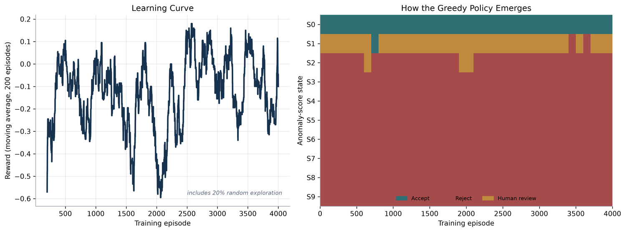
Fig. 15. Training reward (left) and emergence of the greedy policy per state (right).

4.3 Sensitivity to cost assumptions
Table 7. Cost sensitivity on held-out items (identical for miss penalties −5, −10 and −20).
Missed-defect penalty | Review cost | Avg. reward | Missed | False rejects | Reviews
−5 / −10 / −20 | −0.5 | 0.464 | 0 | 5 | 5
−5 / −10 / −20 | −1.0 | 0.405 | 0 | 5 | 5
−5 / −10 / −20 | −2.0 | 0.357 | 0 | 9 | 0

Review cost matters. At −0.5 the policy uses review in the ambiguous band and the reward rises to 0.464; at −2, review equals a false reject for good items and is worse for defective ones, so it vanishes, false rejects rise to nine and the reward falls to 0.357 (Fig. 16–18). The miss penalty did not matter in this range: all three penalties produced identical policies. The calibration bins show why: the defective fraction is 0 in S0 and at least 0.60 in S2–S9, so only S1 (1 defective item in 4, 0.25) lies between the break-even fractions (3/(M+4) = 0.333 for M = 5 to 0.125 for M = 20). For M = 10 and 20 the closed form favours Review in S1 at review costs of −0.5 and −1 (Reject at −2), as learned. For M = 5 and a review cost of −1 it favours Accept (−0.5 against −1.0 for Review and −1.25 for Reject), yet the policy was unchanged, which probably reflects estimation noise from the constant step size and a four-item bin rather than the expected values. This may not hold for a less separable detector or finer bins.
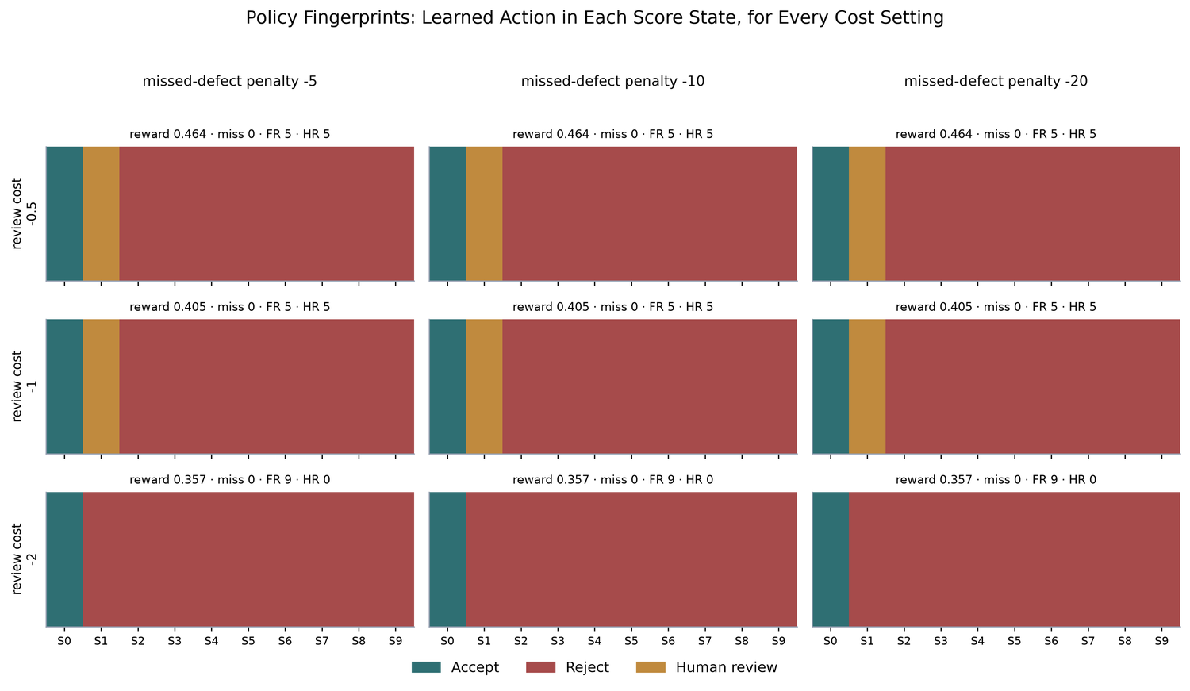
Fig. 16. Learned action per state for all nine cost settings, with held-out outcomes above each panel.
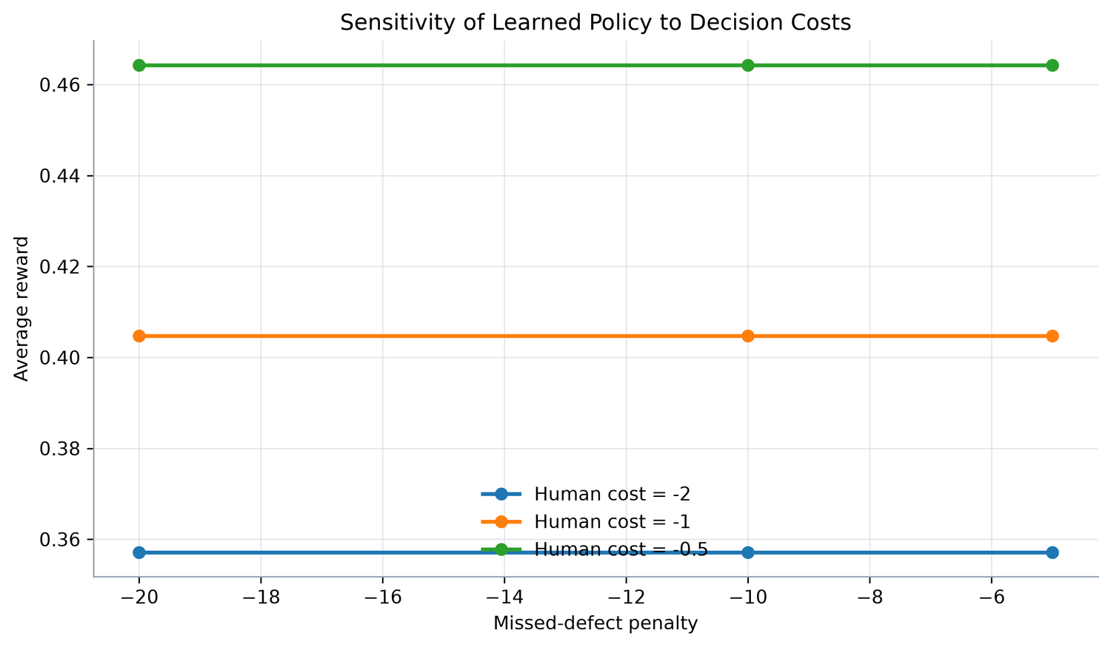
Fig. 17. Average reward across cost settings: only review cost changes the outcome.
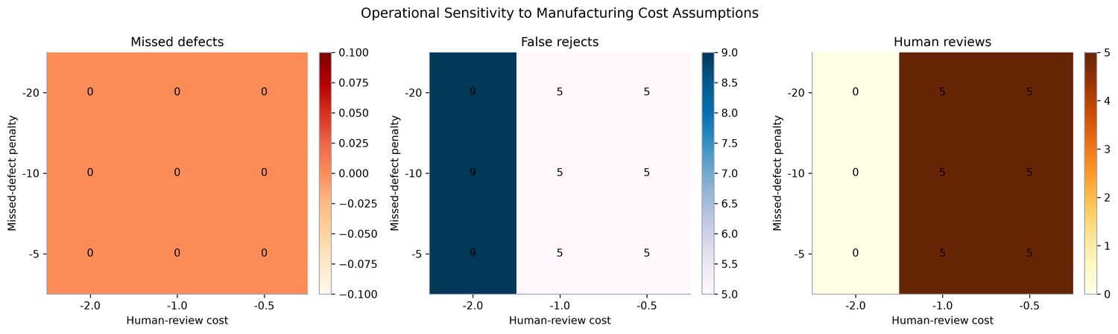
Fig. 18. Missed defects, false rejects and human reviews across the cost grid.
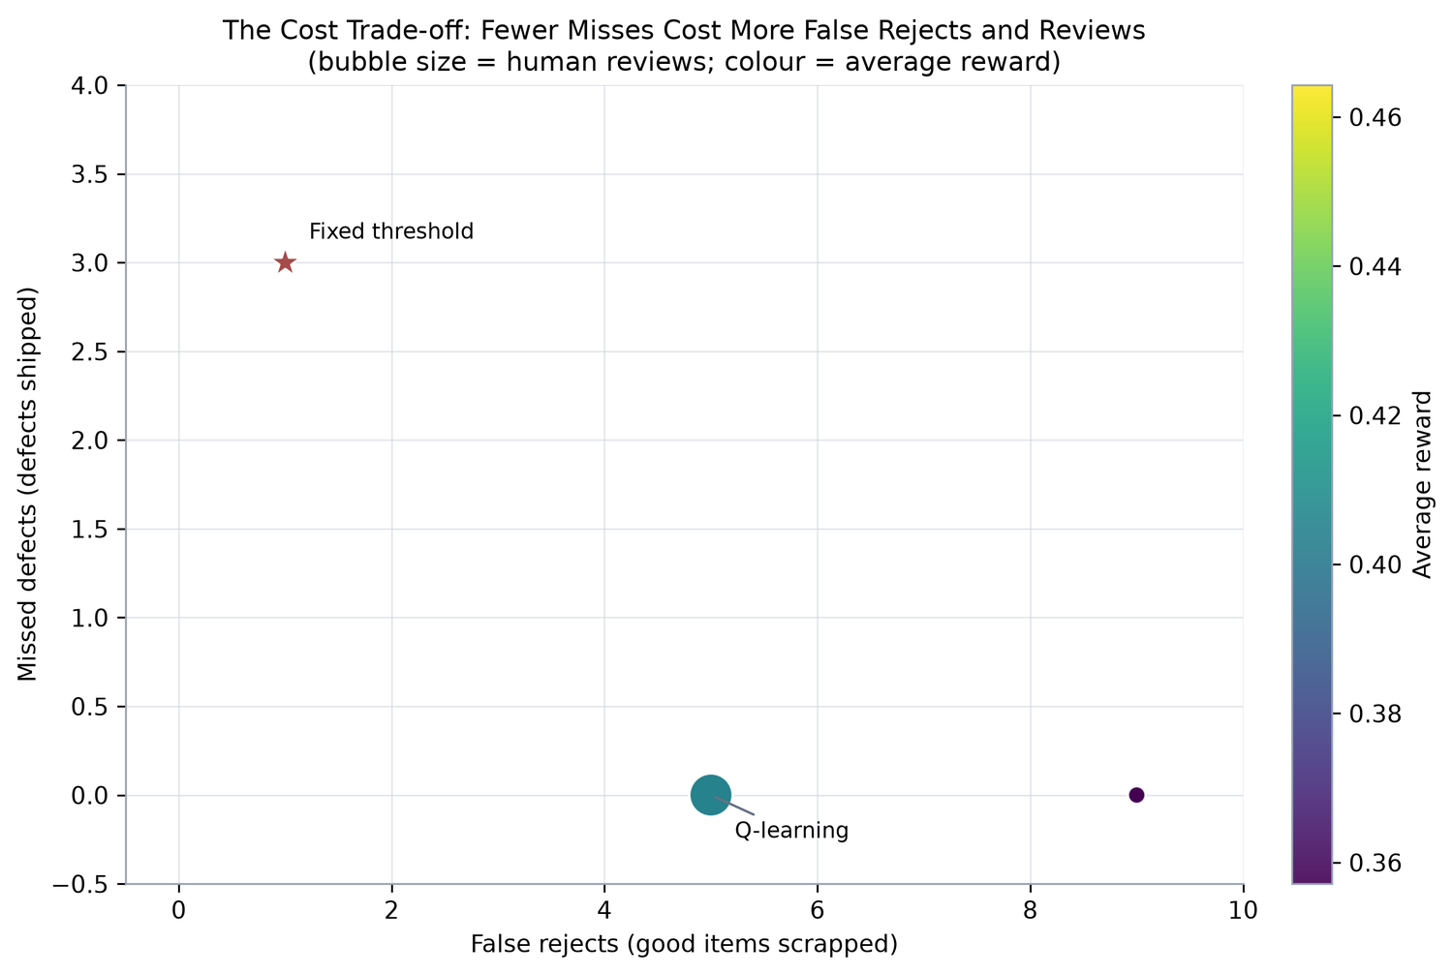
Fig. 19. Trade-off frontier: missed defects versus false rejects (bubble size = reviews, colour = average reward).

4.4 Post-hoc comparison with a cost-tuned threshold
To gauge how much of the gain stems from cost awareness alone, we computed binary thresholds on the saved scores of all 83 test items (in-sample, no review action). Results are indicative only and not comparable with Table 5.
Table 8. Post-hoc binary thresholds on all 83 test items (weighted cost = miss weight × misses + 2 × false rejects).
Threshold rule | Value | Misses | False rejects | Weighted cost
95th percentile of training scores (label-free) | −0.046 | 5 | 2 | 54 (miss = 10)
Cost-tuned, miss : false reject = 5 : 1 | −0.067 | 0 | 10 | 20
Cost-tuned, miss : false reject = 1 : 1 | −0.055 | 2 | 4 | 12 (miss = 2)

Most of the improvement therefore comes from moving the operating point to match the cost ratio. The learned policy adds (i) learning that boundary from reward without an explicit optimisation step, (ii) a review band that lowers false-reject burden when review is cheap, and (iii) an auditable table. A threshold tuned on the calibration split with its own review band is the proper baseline and is left for future work.

5. Discussion
- Detection. A CPU-only, label-free pipeline reaches AUC 0.947 on bottles because defects are largely geometric; colour adds nothing. Conclusions should not be extrapolated to other categories. Global descriptors lose sensitivity as defects shrink; local or patch-level features, or higher resolution, are the natural remedy.
- Decision. Cost awareness removed all misses and more than doubled average reward, at the price of scrapping half of the good evaluation items. Much of this gain is threshold placement (Section 4.4), so the contribution of reinforcement learning itself should be stated cautiously.
- Economics. Offering review pays off only when it costs less than a false reject, with a closed-form break-even. Review cost, not the miss penalty, was the lever worth measuring first.
- Practice. Treat the threshold as a cost decision; price the review step; audit score bands rather than totals; expect size-dependent blind spots; start with a simple interpretable baseline.

6. Limitations
- Scale: one category, one split, one seed; 42 held-out items (10 good), so one or two items change the rates and intervals are wide.
- Assumptions: simulated, always-correct reviewer and hand-set costs not measured in a factory.
- Baseline: the fixed threshold uses no labels or review option; a cost-tuned baseline (Section 4.4) is stronger.
- Formulation: single-step, bandit-like problem with a coarse ten-bin state; unstable boundary states during training.
- Analysis: no leave-one-family-out ablation; significance tests, per-type intervals, area correlation and Table 8 are post hoc and exploratory.
- Scope: offline simulation, not a deployment claim.

7. Conclusion
Anomaly scores become useful when tied to actions and costs. A classical pipeline reached ROC-AUC 0.947 (shape alone 0.938), with recall of 1.000 for large and 0.844 for small defects and all misses confined to small defects. A tabular Q-learning policy raised average reward from 0.143 to 0.405 and cut missed defects from three to zero, at the cost of five false rejects and an 11.9% review rate. Cheaper review lifted the reward to 0.464, costlier review removed reviews and lowered it to 0.357, and the missed-defect penalty had no effect between −5 and −20. Future work: other categories, cost-tuned baselines with a review band, imperfect reviewers, multiple seeds and finer states, and local-feature detectors for small defects.

Reproducibility Statement
MVTec AD is publicly available from MVTec Software GmbH (https://www.mvtec.com/company/research/datasets/mvtec-ad) under the CC BY-NC-SA 4.0 licence [1, 17]. The accompanying script reads the bottle category from a local copy of the dataset, regenerates every table and figure, and prints package versions. All random components use seed 42; no GPU is required.

Supplementary Figures
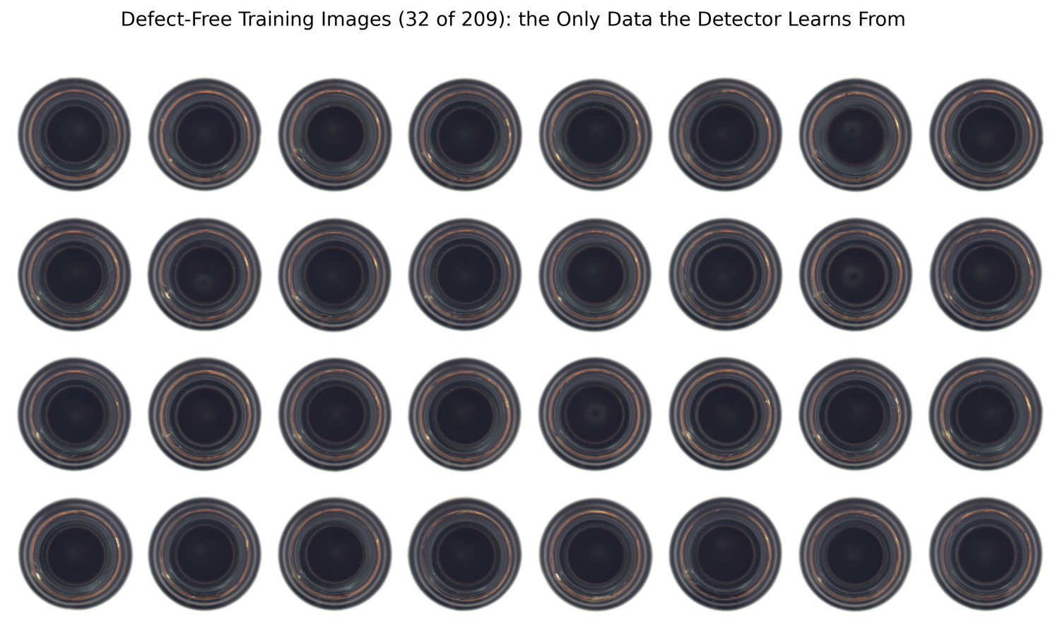
Fig. S1. Mosaic of normal training images.
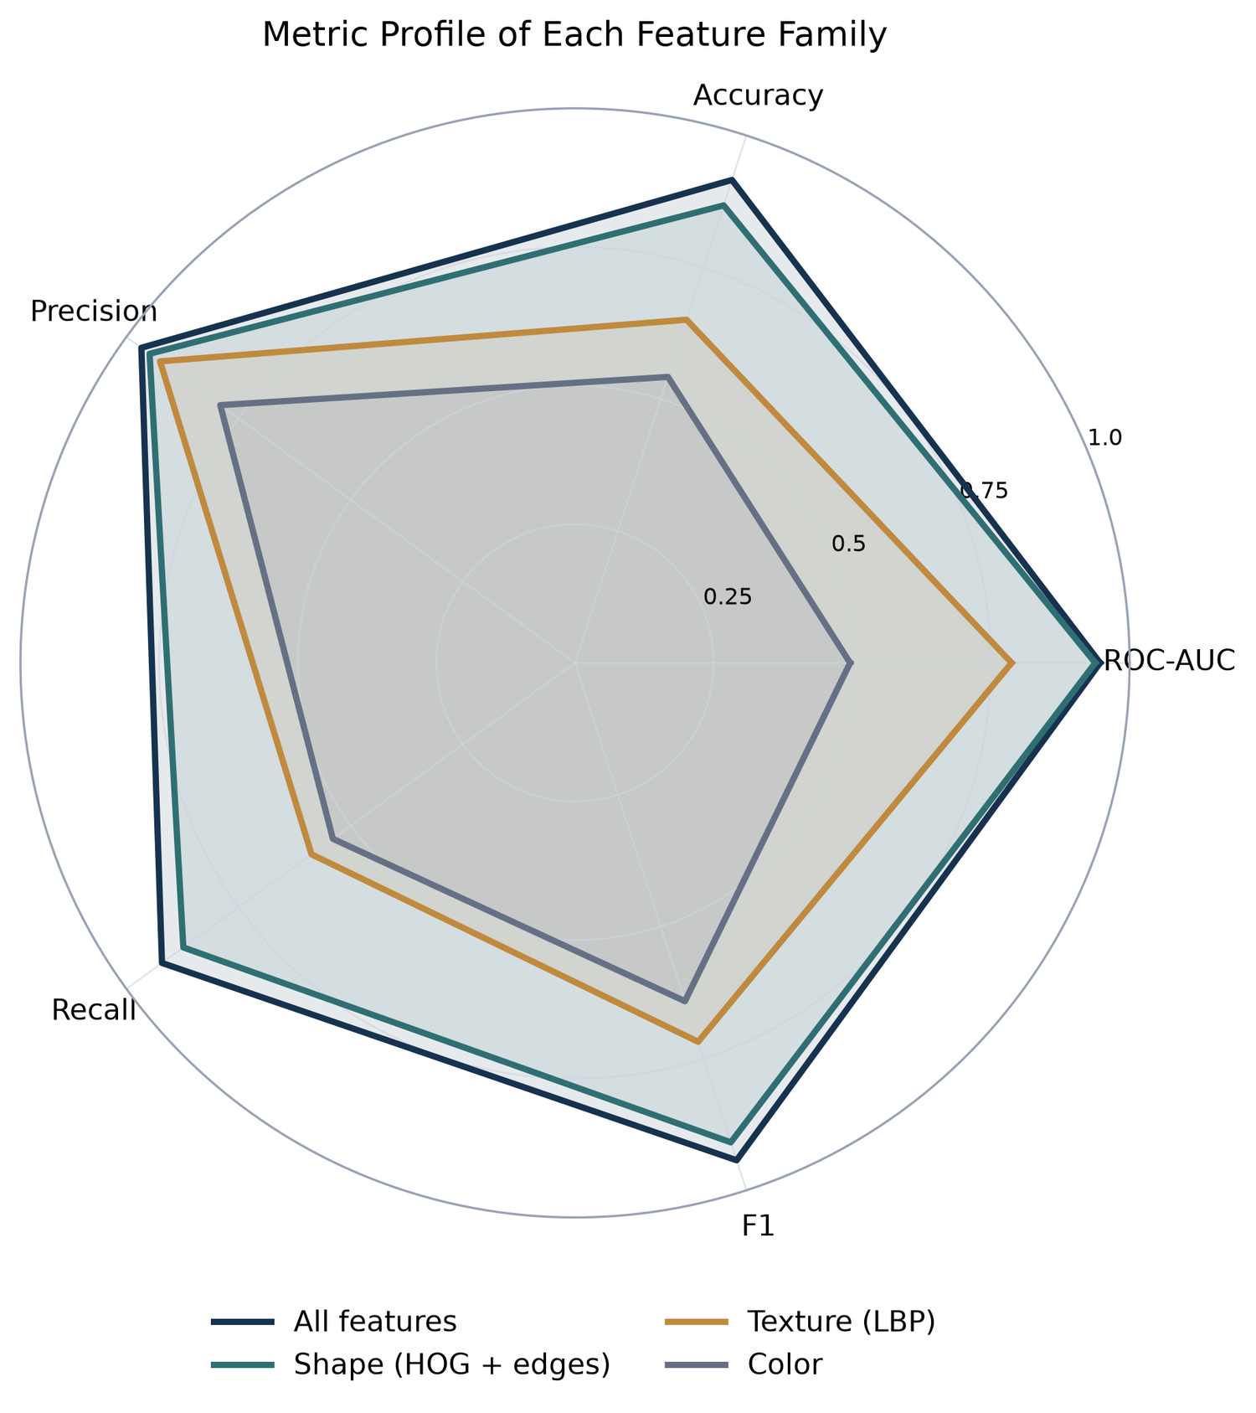
Fig. S2. Radar profile of the five metrics for each feature family.
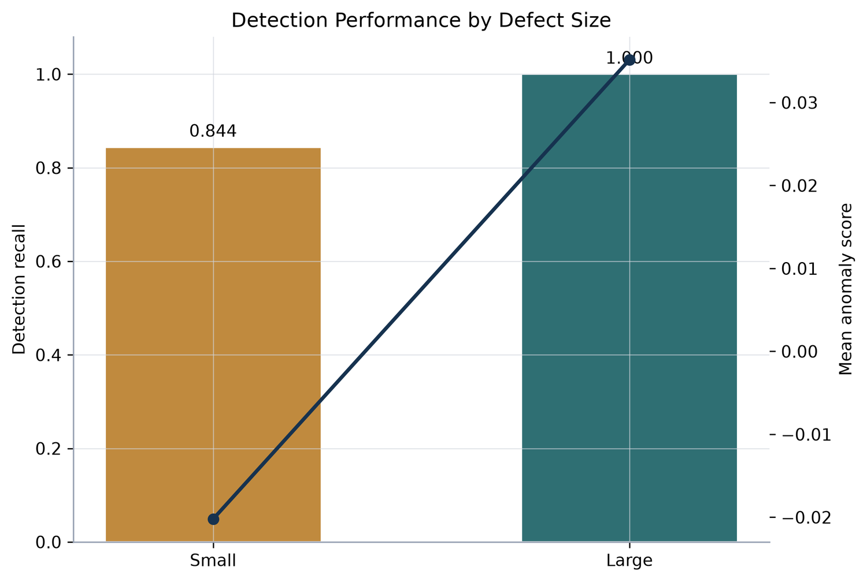
Fig. S3. Recall and mean anomaly score by defect size.
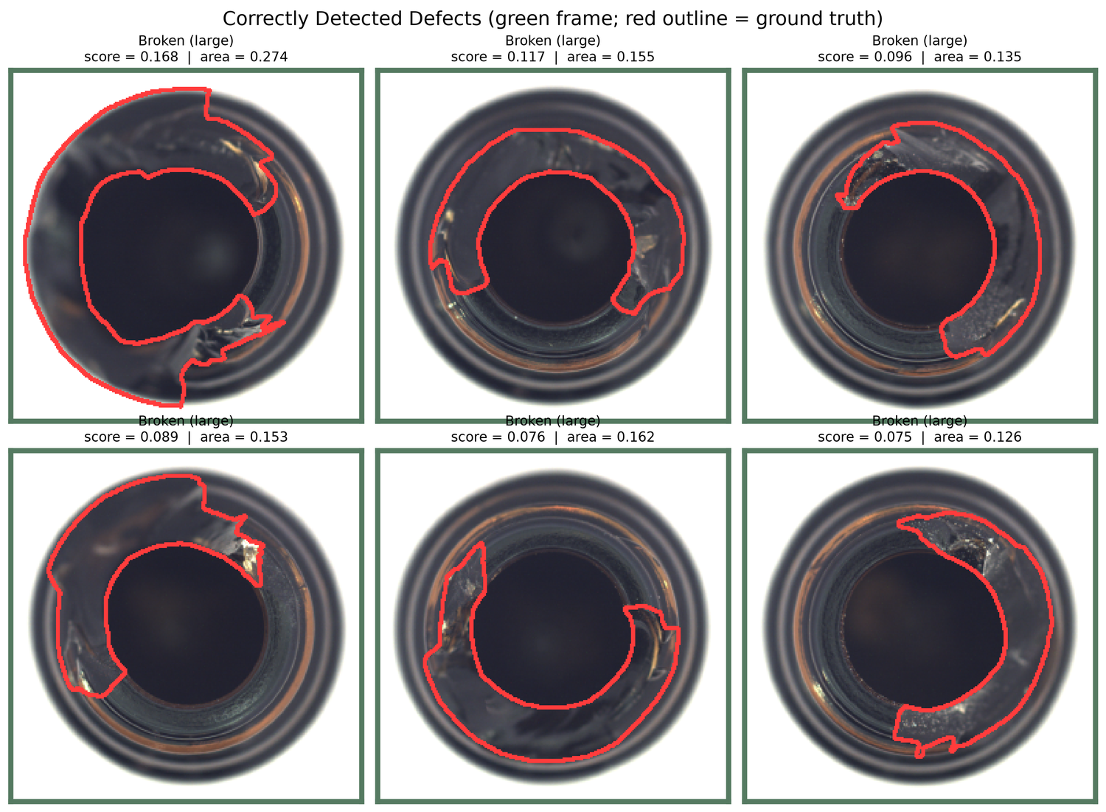
Fig. S4. Detected defects with ground-truth outlines.
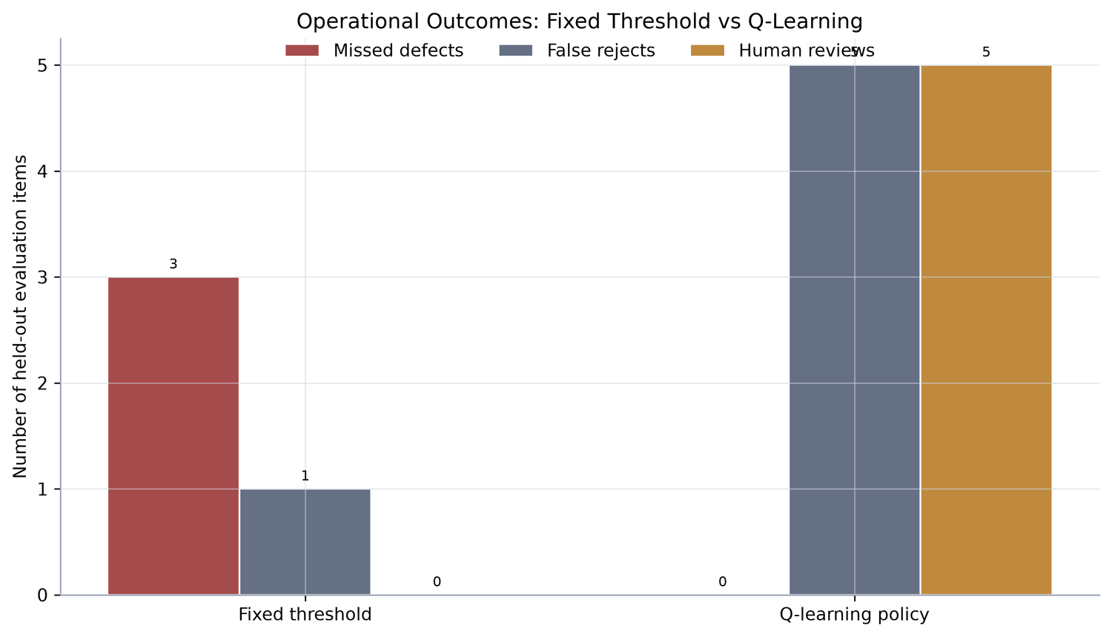
Fig. S5. Missed defects, false rejects and reviews for the fixed threshold and Q-learning policy.

References
[1] Bergmann, P., Fauser, M., Sattlegger, D., Steger, C. MVTec AD – A comprehensive real-world dataset for unsupervised anomaly detection. IEEE/CVF CVPR, 2019, pp. 9592–9600. doi:10.1109/CVPR.2019.00982
[2] Liu, F. T., Ting, K. M., Zhou, Z.-H. Isolation Forest. IEEE ICDM, 2008.
[3] Ojala, T., Pietikainen, M., Maenpaa, T. Multiresolution gray-scale and rotation invariant texture classification with local binary patterns. IEEE TPAMI, 24(7), 2002.
[4] Dalal, N., Triggs, B. Histograms of oriented gradients for human detection. IEEE CVPR, 2005.
[5] Watkins, C. J. C. H., Dayan, P. Q-learning. Machine Learning, 8, 1992.
[6] Sutton, R. S., Barto, A. G. Reinforcement Learning: An Introduction, 2nd ed. MIT Press, 2018.
[7] Elkan, C. The foundations of cost-sensitive learning. IJCAI, 2001.
[8] Pedregosa, F. et al. Scikit-learn: Machine learning in Python. JMLR, 12, 2011.
[9] Bergmann, P., Fauser, M., Sattlegger, D., Steger, C. Uninformed students: Student–teacher anomaly detection with discriminative latent embeddings. IEEE/CVF CVPR, 2020.
[10] Defard, T., Setkov, A., Loesch, A., Audigier, R. PaDiM: A patch distribution modeling framework for anomaly detection and localization. ICPR Workshops, 2021.
[11] Roth, K. et al. Towards total recall in industrial anomaly detection. IEEE/CVF CVPR, 2022.
[12] Ruff, L. et al. A unifying review of deep and shallow anomaly detection. Proceedings of the IEEE, 109(5), 2021.
[13] Chow, C. K. On optimum recognition error and reject tradeoff. IEEE Transactions on Information Theory, 16(1), 1970.
[14] Madras, D., Pitassi, T., Zemel, R. Predict responsibly: Improving fairness and accuracy by learning to defer. NeurIPS, 2018.
[15] Mozannar, H., Sontag, D. Consistent estimators for learning to defer to an expert. ICML, 2020.
[16] Langford, J., Zhang, T. The epoch-greedy algorithm for multi-armed bandits with side information. NeurIPS, 2007.
[17] Bergmann, P., Batzner, K., Fauser, M., Sattlegger, D., Steger, C. The MVTec anomaly detection dataset: A comprehensive real-world dataset for unsupervised anomaly detection. International Journal of Computer Vision, 129(4), 1038–1059, 2021. doi:10.1007/s11263-020-01400-4

