UNIVERSITY OF MILANO-BICOCCA
Department of Informatics, Systems and Communication

Advanced Data Management
Project Report
City Mobility Platform — Data Management System

Academic Year 2025/2026

Instructors: Gloria Lopiano & Andrea Campagner
Student Name: Md Rifatul Haque
Matriculation Number: 947512

Submission Date: 6 June 2026

Table of Contents

Part 1: Relational vs Document Model 3
1.1 Data Modeling 3
Relational Schema — PostgreSQL 3
Document Schema — MongoDB 4
Why Embedding vs Referencing? 4
1.2 Query Implementation 4
Query 1 — Show all trips with user details and station names 5
Query 2 — Show each user with their trip count and average trip duration 6
Query 3 — Show each station with how many trips start and end there 8
Query 4 — Find all trips that have at least one ERROR event 9
Benchmark Results — All 36 Scale Combinations 11
What the Results Tell Us 13
1.3 Schema Evolution — Adding a New Field 13
PostgreSQL — How to add the field 13
MongoDB — How to add the field 14
1.4 Spark Implementation of Query 2 16
Part 2: Graph Model 17
2.1 Graph Schema and Queries 17
Graph Design 17
Cypher Query 1 — All stations reachable by a given user 19
Cypher Query 2 — Top 3 most important stations (by trip count) 19
Neo4j Scalability Benchmark — All 36 Combinations 20
2.2 Spark Graph Queries 21
PageRank — Finding the Most Important Stations 21
Connected Components — Is the Network Connected? 23
Spark Graph Scalability Benchmark — All 36 Combinations 23
Part 3: Partitioning and Replication 24
3.1 Partitioning 25
Strategy A: Partition by user_id 25
Strategy B: Partition by start_station_id 25
Our Recommendation: Partition by user_id 26
3.2 Replication 26
How to Reduce These Risks 27
Conclusion 27

Part 1: Relational vs Document Model
In this part, we build the same database using two different approaches: a traditional relational database (PostgreSQL) and a document database (MongoDB). We then compare how well each one handles our four queries at different data sizes.

1.1 Data Modeling

Relational Schema — PostgreSQL
In PostgreSQL, data is organized into four separate tables that are linked together using foreign keys (like references between tables):
- users — stores each user's name, surname, birthdate, and country
- stations — stores each station's name, city, and maximum vehicle capacity
- trips — stores each trip, linking a user to a start station and end station, with start/end times and cost
- events — stores each event that happened during a trip (GPS, ERROR, BATTERY, or DELAY)
Indexes were added on all linking columns (foreign keys) and on the event type column to make queries faster.
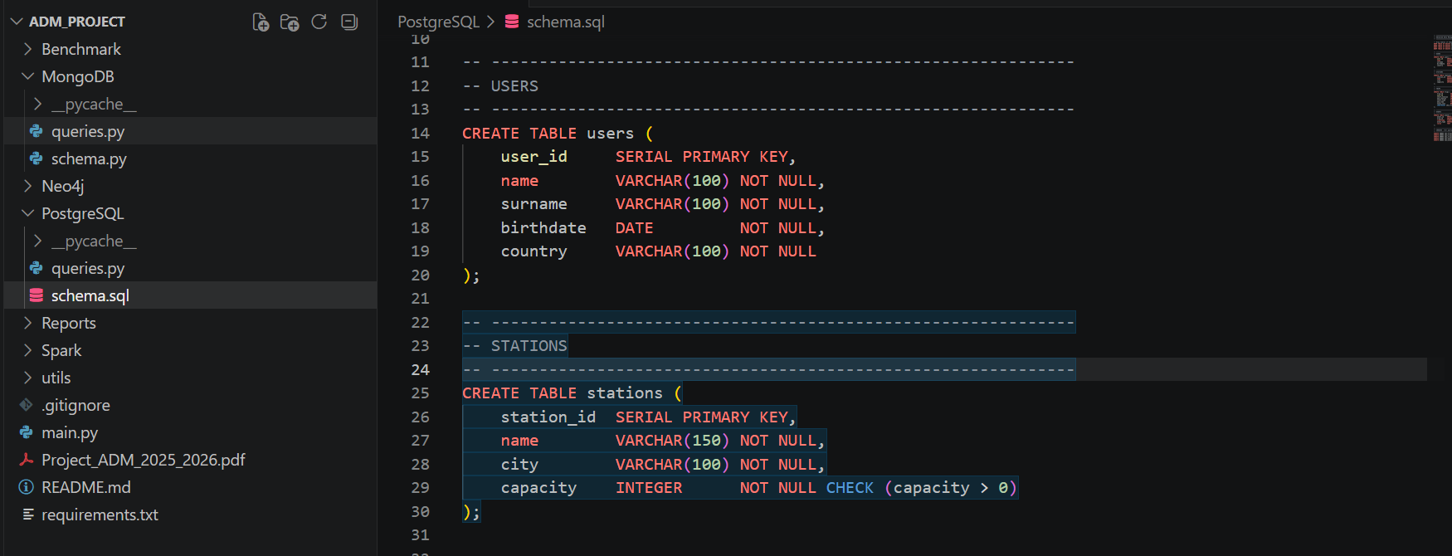
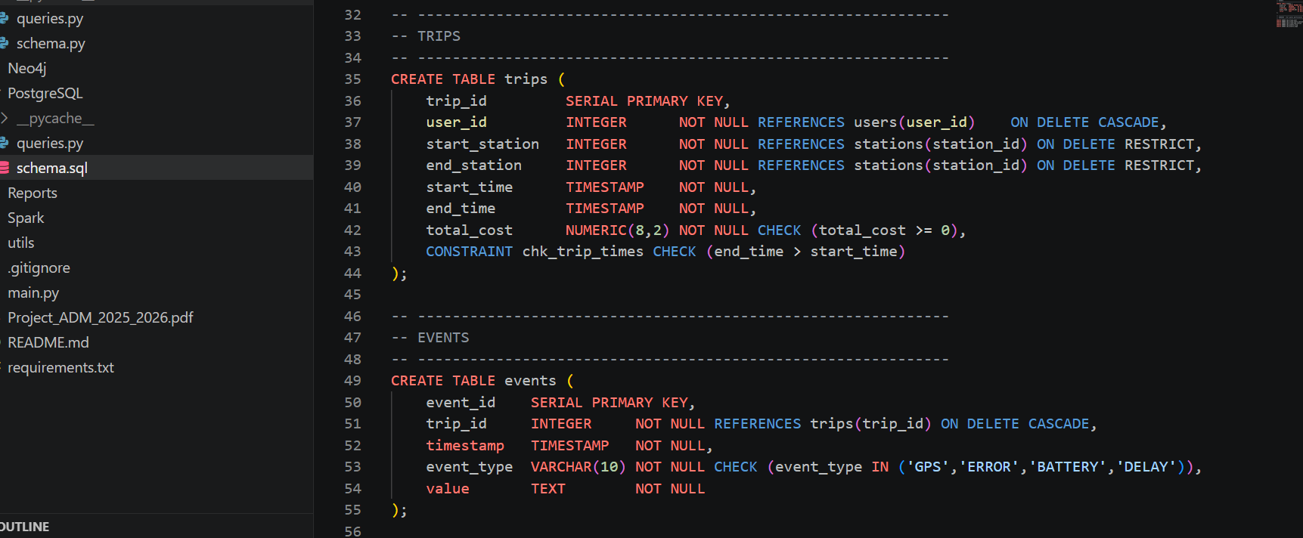
Figure 1: Relational Schema (PostgreSQL)

Document Schema — MongoDB
In MongoDB, data is stored as documents (similar to JSON files). We use three collections:
- users collection — one document per user
- stations collection — one document per station
- trips collection — one document per trip, with all events stored inside the trip document (embedded)
The most important design decision is that events are stored inside their trip document. This is called embedding. Users and stations are stored separately and referenced by ID. This is called referencing.
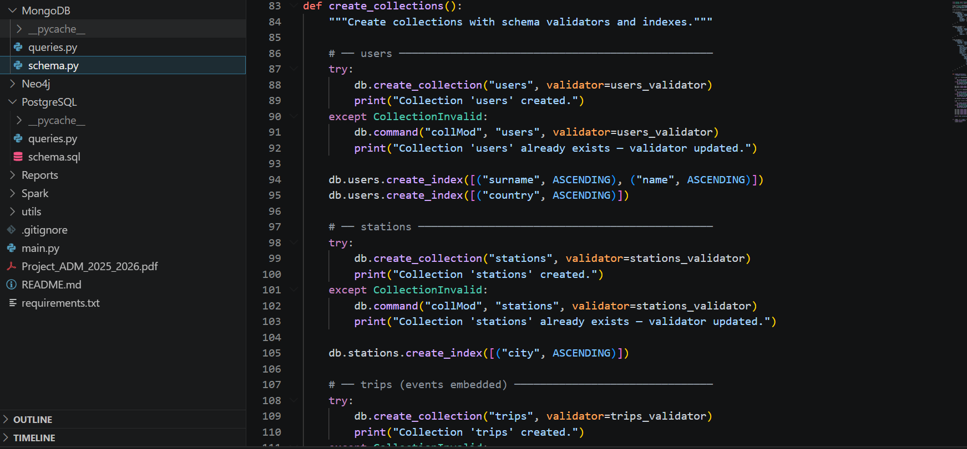
Figure 2: Document Schema (MongoDB)

Why Embedding vs Referencing?
What | Decision | Why
Events | EMBEDDED inside trips | Events only make sense as part of a trip. Storing them inside the trip avoids slow joins.
Users | REFERENCED (separate) | One user can have many trips. If we embedded user info in every trip, we would repeat the same data thousands of times.
Stations | REFERENCED (separate) | Same reason — only ~20 stations serve thousands of trips. Repeating station data would waste space.

1.2 Query Implementation
We implemented the same four queries in both PostgreSQL and MongoDB, then measured how long each one takes at different data sizes.

Query 1 — Show all trips with user details and station names
PostgreSQL Approach: We join three tables together — trips, users, and stations (twice for start and end). Because all linking columns are indexed, this is fast.
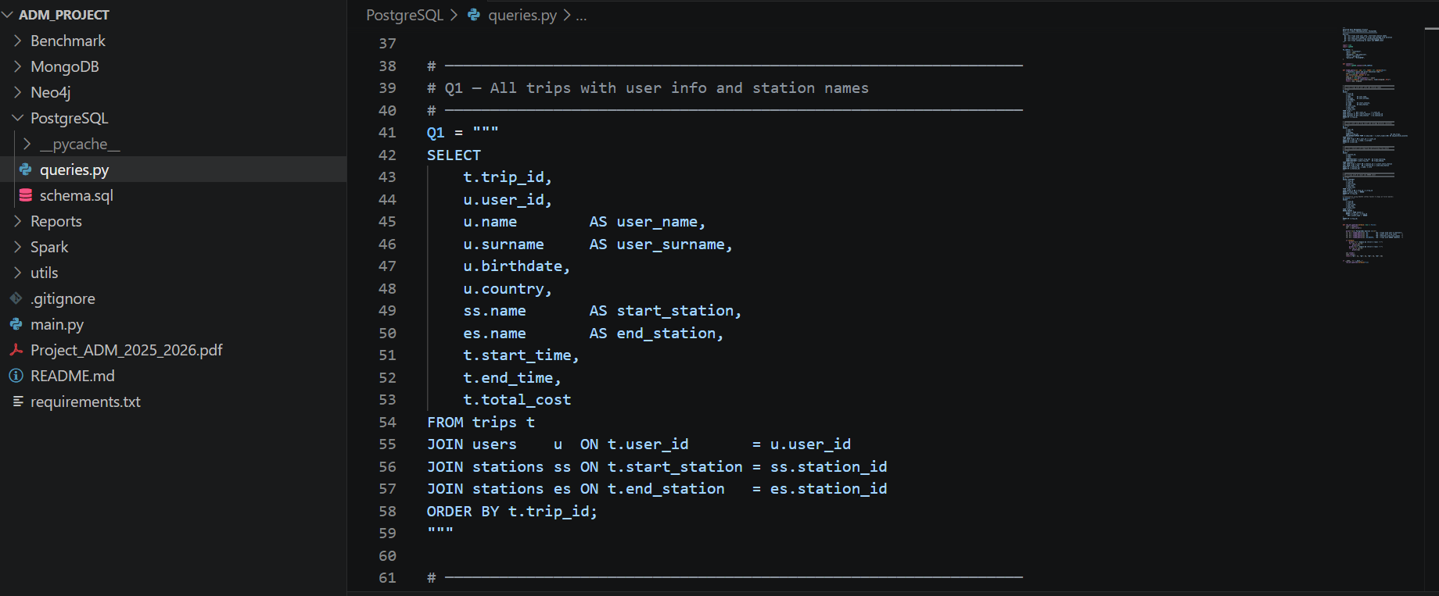
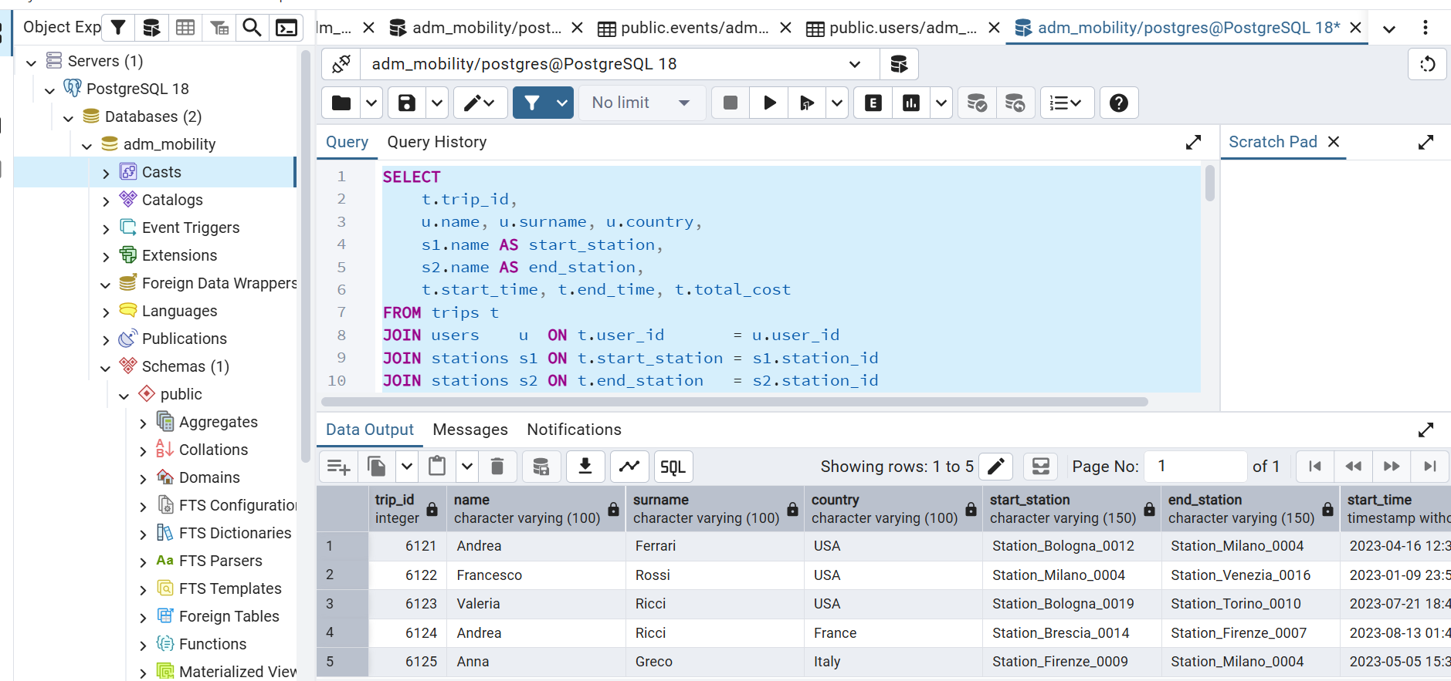
Figure 3: PostgreSQL - Q1: All trips with user information and station names

MongoDB Approach: We use three $lookup operations (similar to joins). This is slower than PostgreSQL because MongoDB has to look up referenced documents separately at query time.
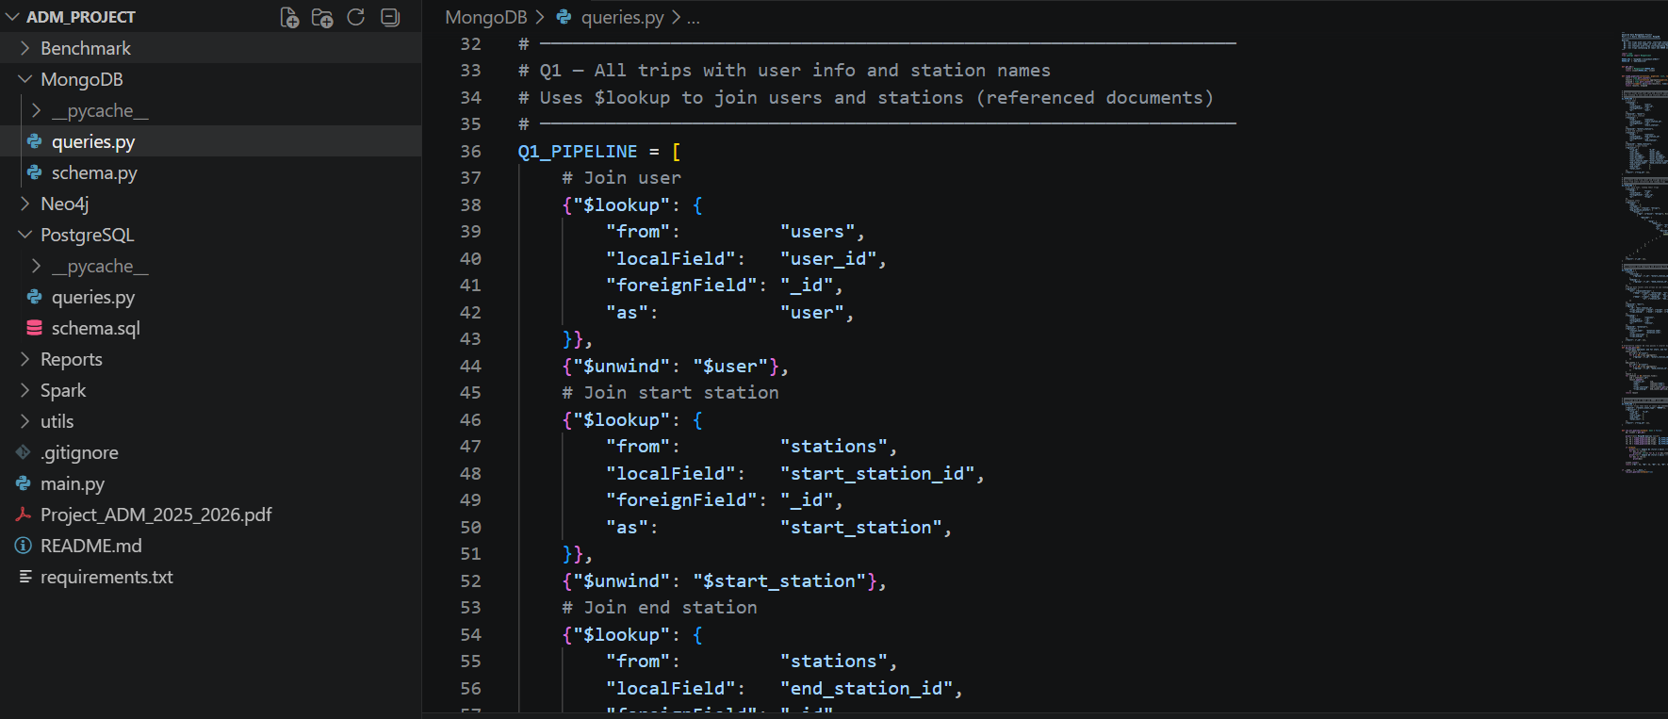
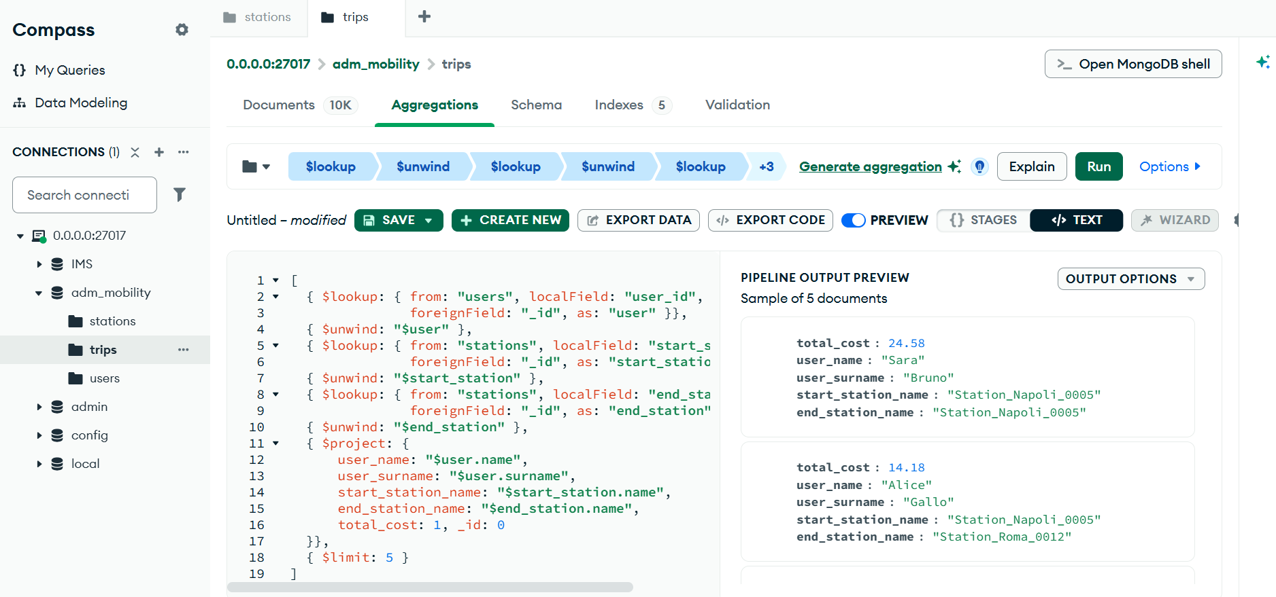
Figure 4: MongoDB - Q1: All trips with user information and station names

Query 2 — Show each user with their trip count and average trip duration
PostgreSQL Approach: Group all trips by user and calculate COUNT and AVG. Very efficient with indexed columns.

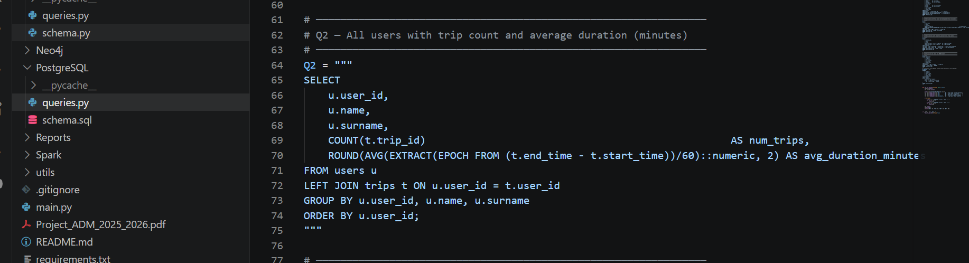
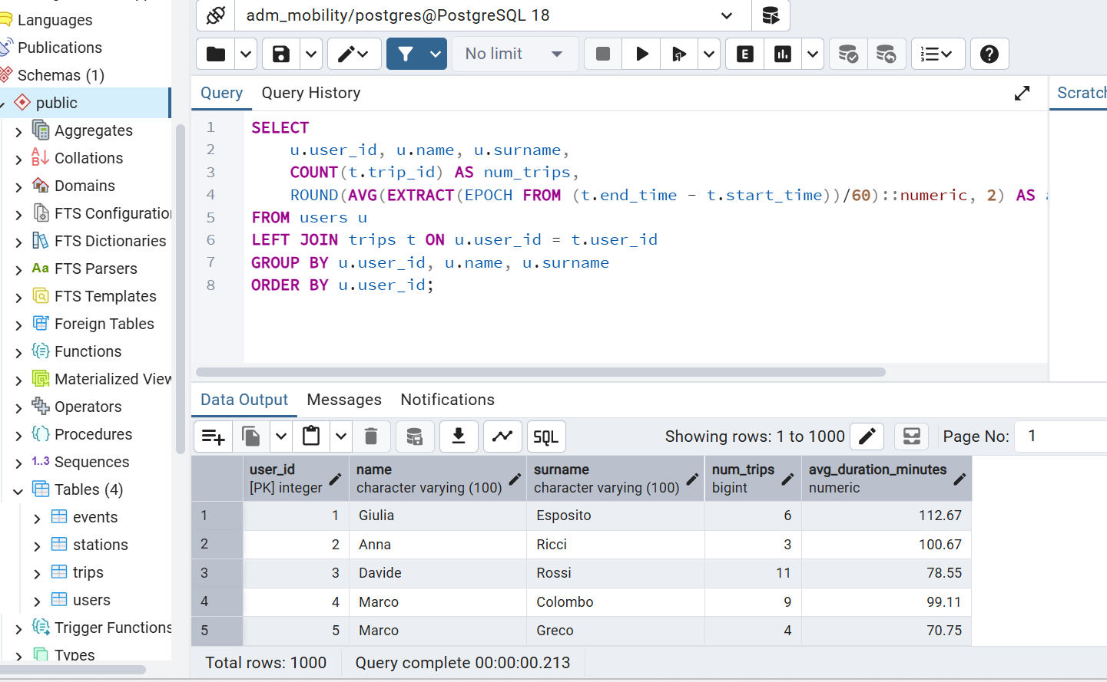
Figure 5: PostgreSQL - Q2: Users with number of trips and average trip duration
MongoDB Approach: Look up each user's trips and compute statistics. Slower when there are many users (50k) because of the lookup overhead.
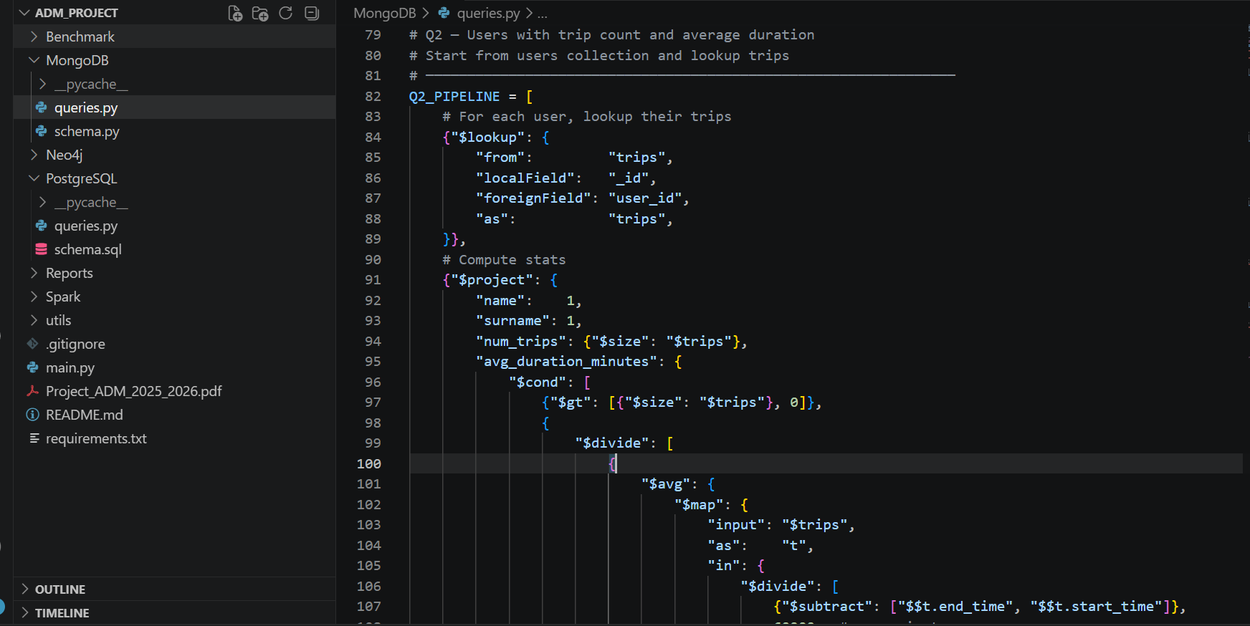
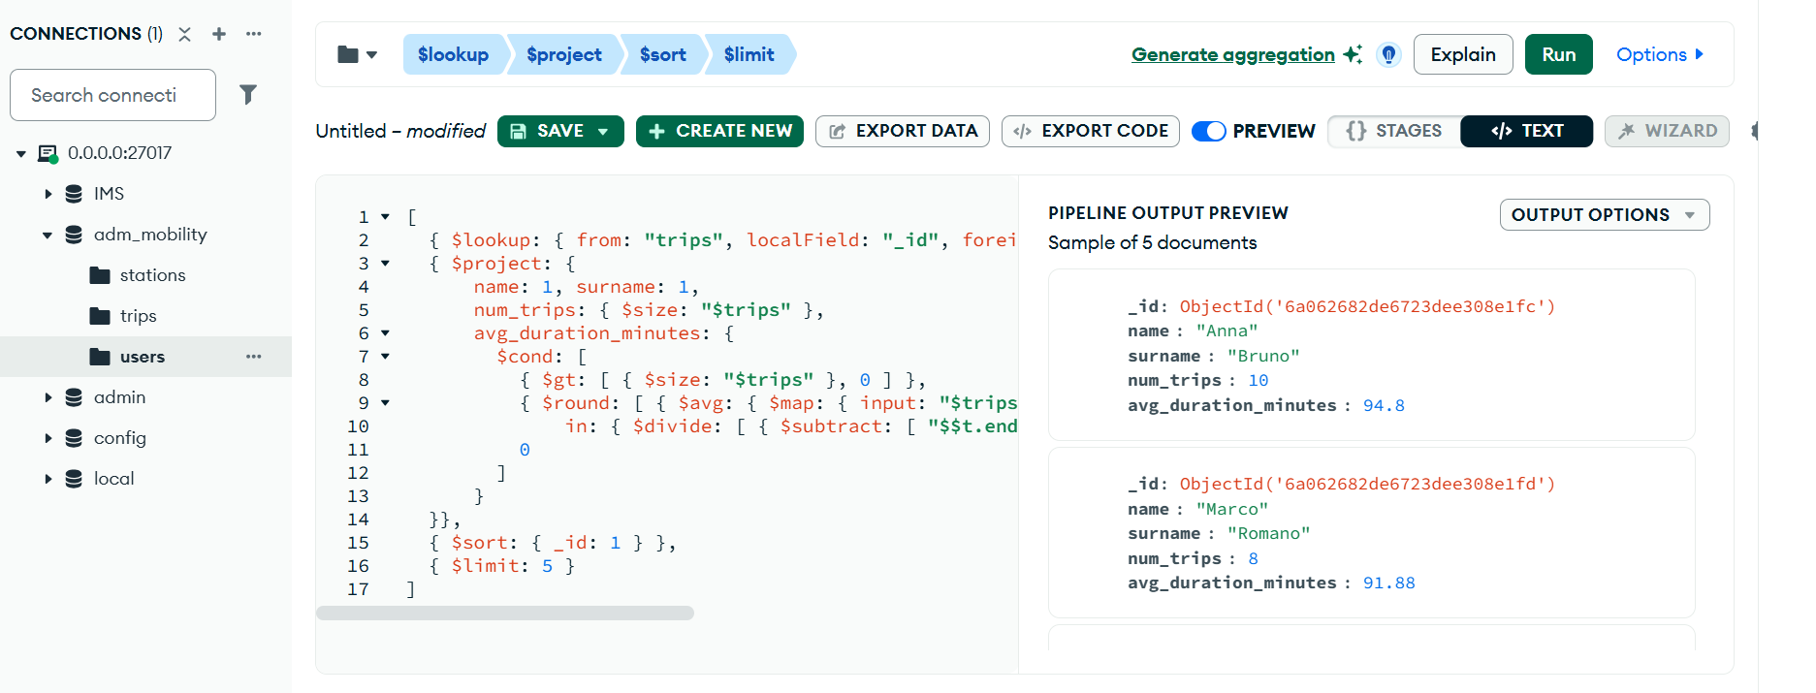
Figure 6: MongoDB - Q2: Users with number of trips and average trip duration

Query 3 — Show each station with how many trips start and end there
PostgreSQL Approach: Join the trips table twice (once for start, once for end). This creates a very large intermediate result, which makes it extremely slow at large scales.
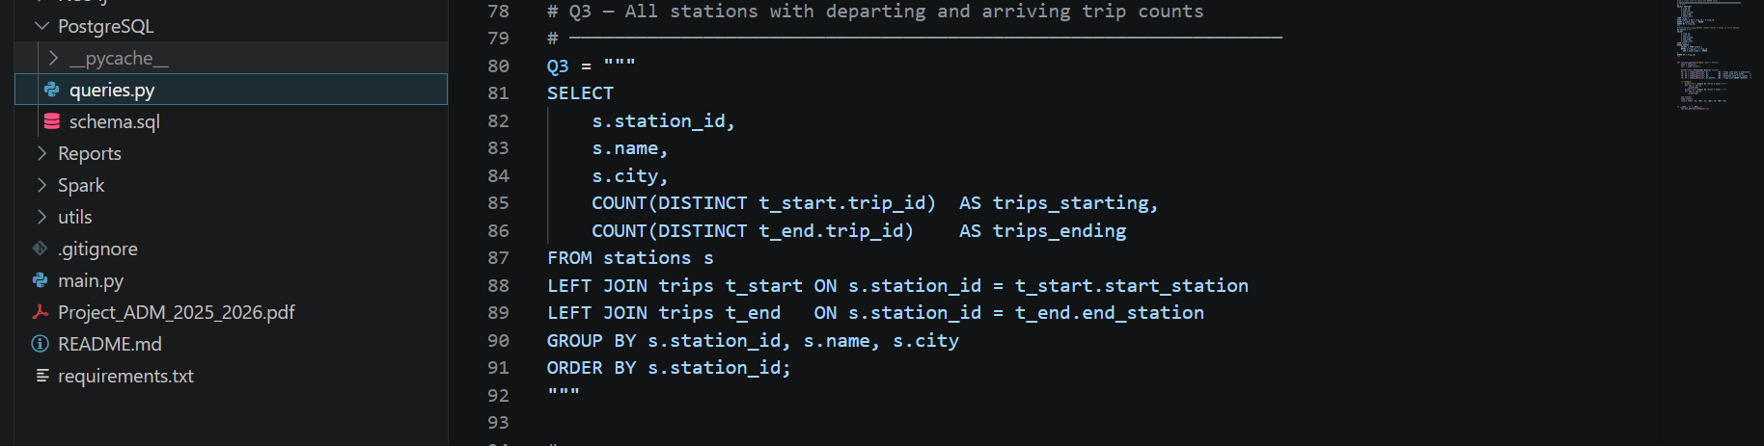
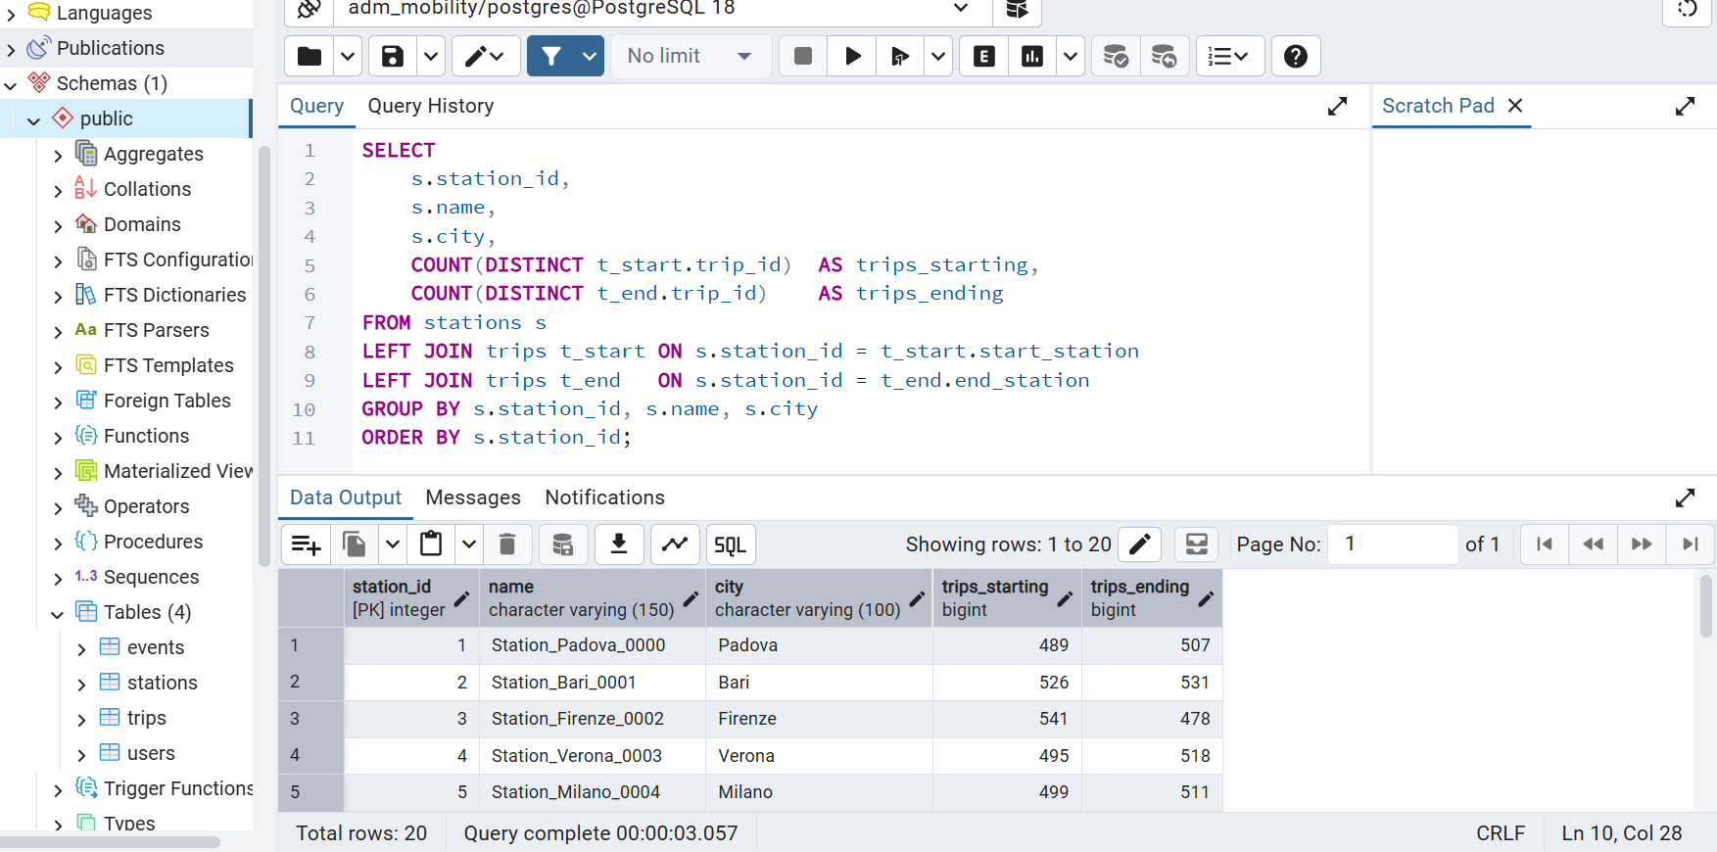
Figure 7: PostgreSQL - Q3: Stations with trips starting and ending there
MongoDB Approach: Use $facet to count start trips and end trips separately and efficiently. This is much, much faster than PostgreSQL at large scales.
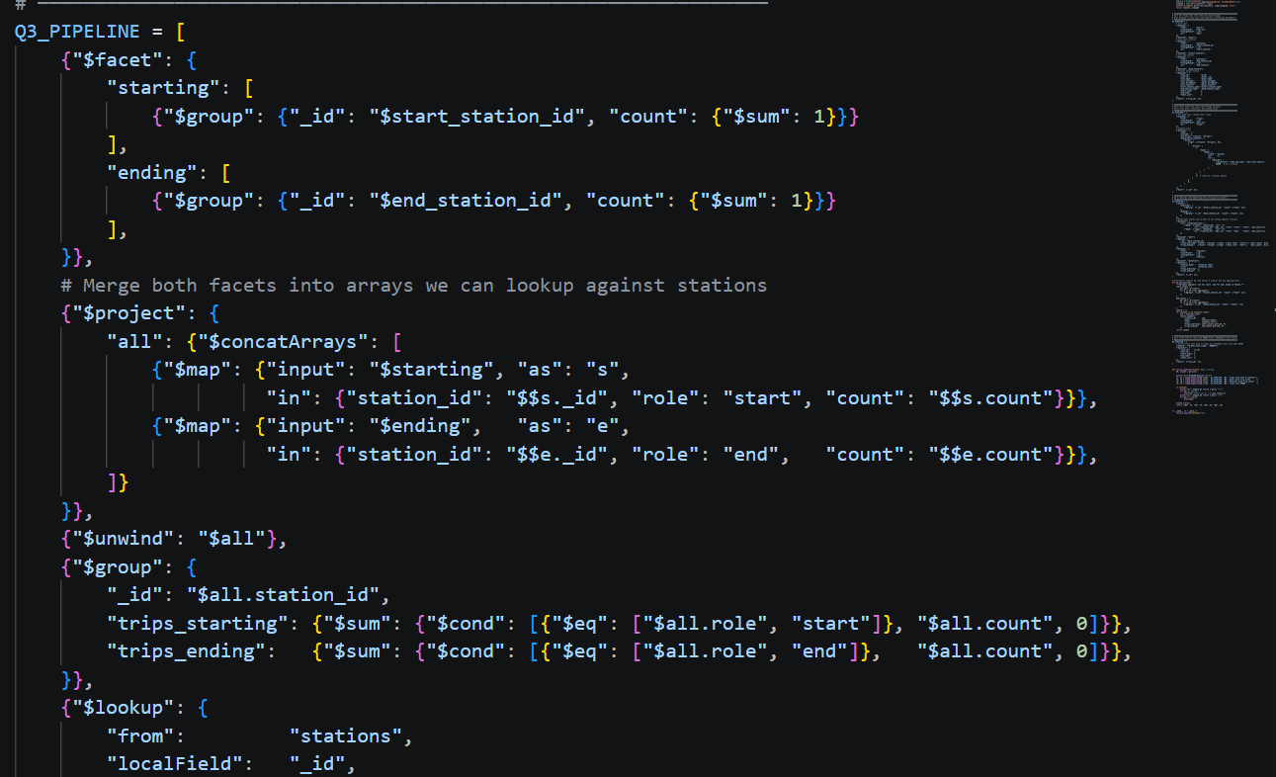
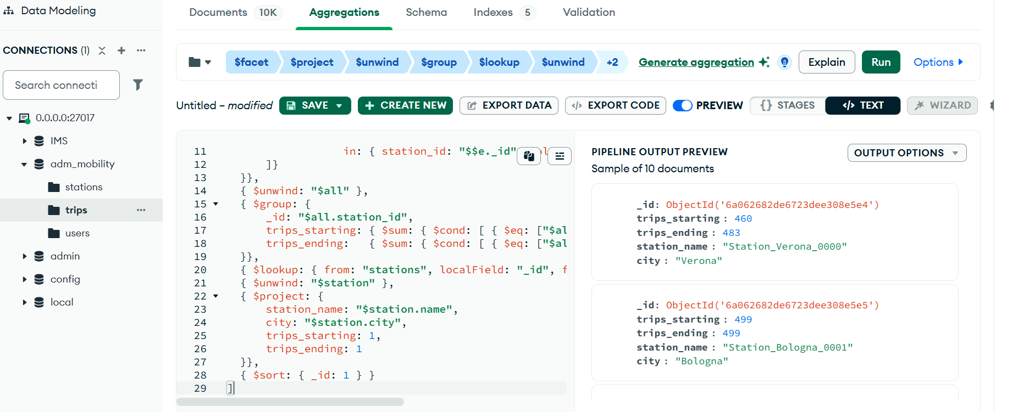
Figure 8: MongoDB -Q3: Stations with trips starting and ending there

Query 4 — Find all trips that have at least one ERROR event
PostgreSQL Approach: Use an EXISTS check on the events table — stops as soon as it finds one matching event, so it is efficient.
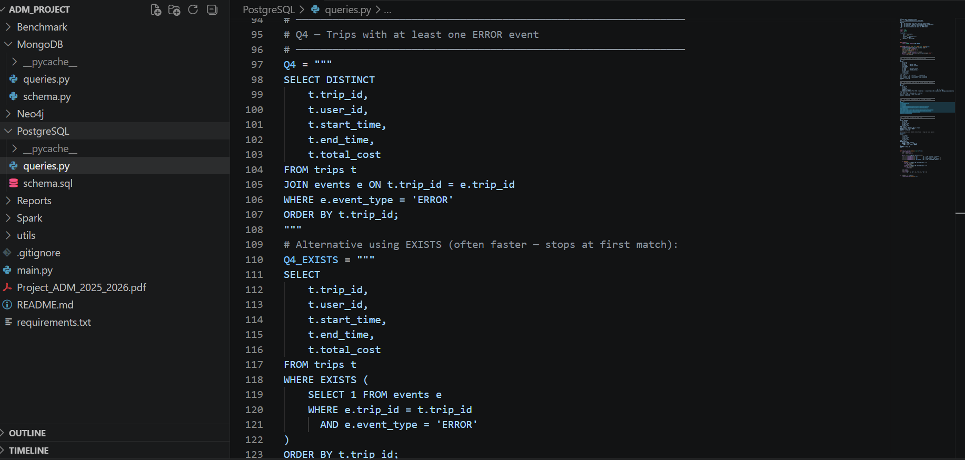
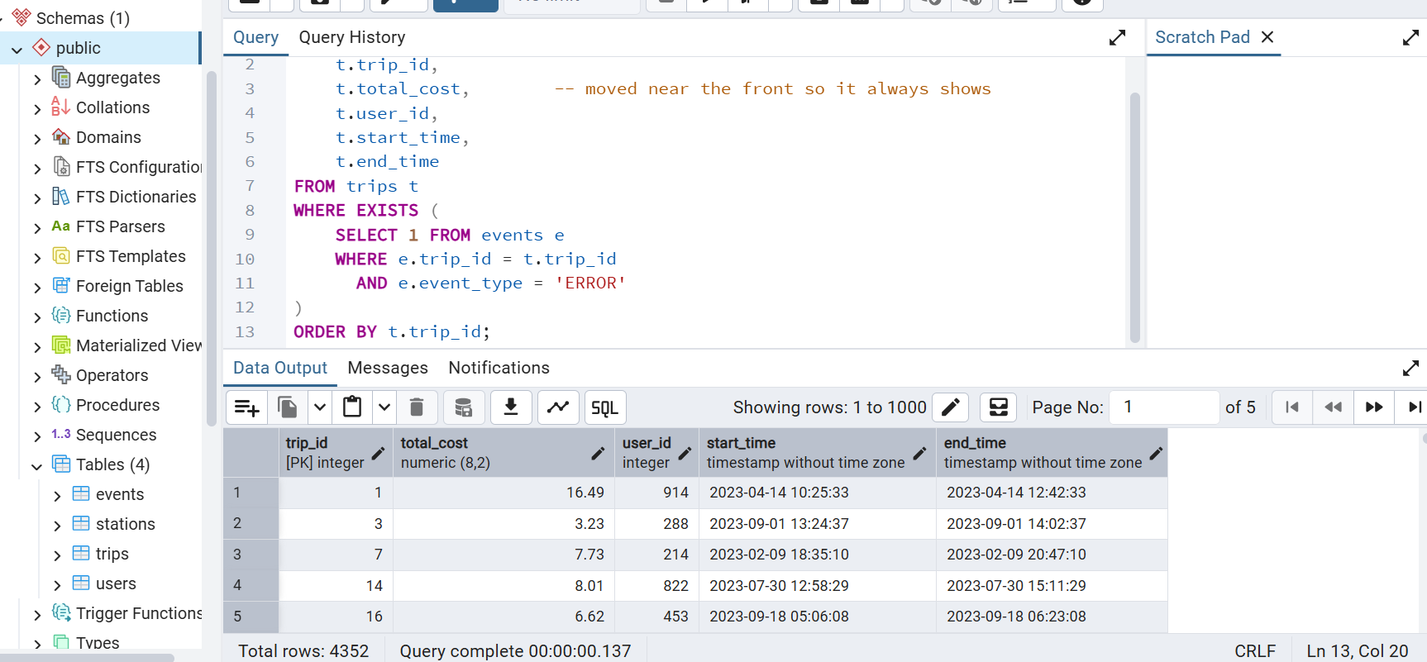
Figure 9: PostgreSQL - Q4: Trips containing at least one ERROR event
MongoDB Approach: Filter directly on the embedded events array. Because events are inside the trip document, no separate table lookup is needed.
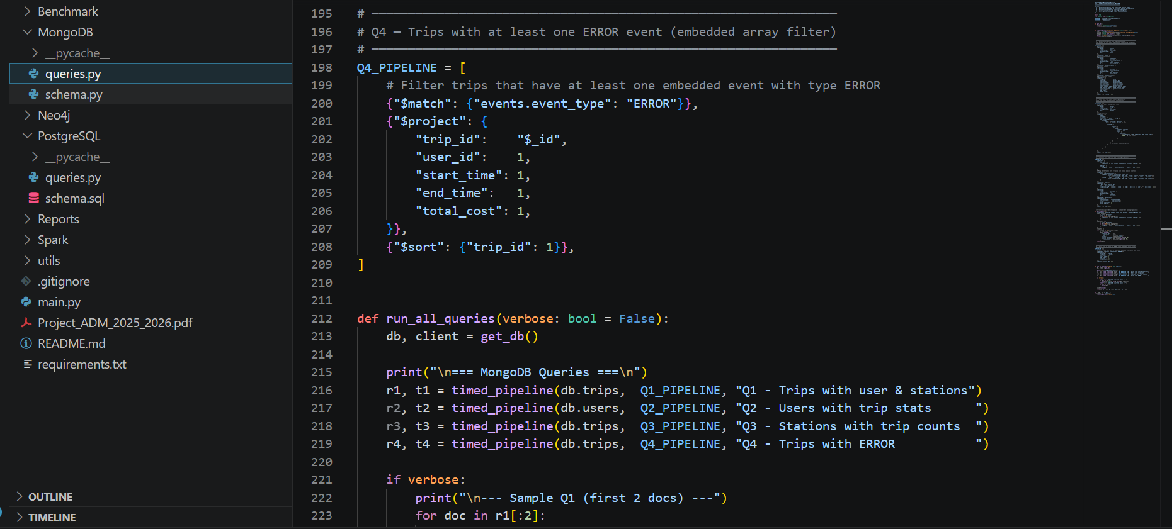
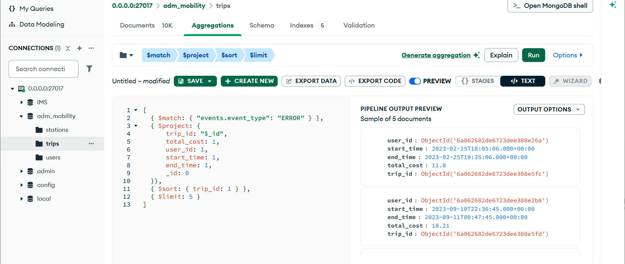
Figure 10: MongoDB - Q4: Trips containing at least one ERROR event

Benchmark Results — All 36 Scale Combinations
We tested every combination of: 1k/10k/50k users × 10k/50k/100k trips × 0/2/5/10 events per trip. Times shown in seconds (lower = faster):

DB | Users | Trips | Events | Q1 (s) | Q2 (s) | Q3 (s) | Q4 (s)
PG | 1k | 10k | 0 | 0.20 | 0.02 | 3.92 | 0.02
MG | 1k | 10k | 0 | 2.02 | 0.06 | 0.02 | 0.01
PG | 1k | 10k | 2 | 0.50 | 0.01 | 3.26 | 0.16
MG | 1k | 10k | 2 | 2.19 | 0.04 | 0.02 | 0.07
PG | 1k | 10k | 5 | 0.58 | 0.02 | 11.71 | 0.64
MG | 1k | 10k | 5 | 2.51 | 0.04 | 0.02 | 0.14
PG | 1k | 10k | 10 | 0.78 | 0.04 | 5.18 | 0.45
MG | 1k | 10k | 10 | 3.58 | 0.14 | 0.04 | 0.16
PG | 1k | 50k | 0 | 3.08 | 0.03 | 146.71 | 0.01
MG | 1k | 50k | 0 | 14.37 | 0.38 | 0.16 | 0.02
PG | 1k | 50k | 2 | 2.94 | 0.07 | 206.13 | 1.08
MG | 1k | 50k | 2 | 17.30 | 0.47 | 0.26 | 0.55
PG | 1k | 50k | 5 | 5.26 | 0.08 | 228.59 | 2.10
MG | 1k | 50k | 5 | 23.36 | 0.55 | 0.15 | 0.79
PG | 1k | 50k | 10 | 3.35 | 0.11 | 214.55 | 2.32
MG | 1k | 50k | 10 | 15.28 | 0.34 | 0.23 | 0.59
PG | 1k | 100k | 0 | 5.21 | 0.12 | 957.68 | 0.01
MG | 1k | 100k | 0 | 21.67 | 0.49 | 0.30 | 0.02
PG | 1k | 100k | 2 | 6.13 | 0.09 | 721.25 | 1.59
MG | 1k | 100k | 2 | 29.55 | 0.99 | 0.42 | 0.68
PG | 1k | 100k | 5 | 5.91 | 0.06 | 770.31 | 1.33
MG | 1k | 100k | 5 | 21.98 | 0.86 | 0.23 | 0.95
PG | 1k | 100k | 10 | 2.18 | 0.05 | 751.89 | 1.34
MG | 1k | 100k | 10 | 32.39 | 1.04 | 0.39 | 1.35
PG | 10k | 10k | 0 | 0.23 | 0.04 | 0.19 | 0.09
MG | 10k | 10k | 0 | 2.55 | 0.25 | 0.05 | 0.02
PG | 10k | 10k | 2 | 0.42 | 0.06 | 0.30 | 0.10
MG | 10k | 10k | 2 | 3.63 | 0.37 | 0.08 | 0.10
PG | 10k | 10k | 5 | 0.41 | 0.04 | 0.29 | 0.37
MG | 10k | 10k | 5 | 4.58 | 0.49 | 0.04 | 0.19
PG | 10k | 10k | 10 | 0.35 | 0.07 | 0.21 | 0.19
MG | 10k | 10k | 10 | 3.50 | 0.52 | 0.11 | 0.20
PG | 10k | 50k | 0 | 1.65 | 0.08 | 19.02 | 0.01
MG | 10k | 50k | 0 | 9.89 | 0.45 | 0.15 | 0.02
PG | 10k | 50k | 2 | 1.43 | 0.15 | 20.73 | 0.51
MG | 10k | 50k | 2 | 16.44 | 0.56 | 0.17 | 0.28
PG | 10k | 50k | 5 | 1.29 | 0.05 | 11.89 | 0.57
MG | 10k | 50k | 5 | 9.76 | 0.68 | 0.12 | 0.48
PG | 10k | 50k | 10 | 1.10 | 0.08 | 11.61 | 0.72
MG | 10k | 50k | 10 | 9.58 | 0.49 | 0.09 | 0.42
PG | 10k | 100k | 0 | 1.91 | 0.08 | 60.55 | 0.00
MG | 10k | 100k | 0 | 27.83 | 0.85 | 0.32 | 0.05
PG | 10k | 100k | 2 | 2.03 | 0.11 | 51.28 | 0.68
MG | 10k | 100k | 2 | 25.27 | 0.77 | 0.32 | 0.71
PG | 10k | 100k | 5 | 2.15 | 0.09 | 55.11 | 1.13
MG | 10k | 100k | 5 | 25.29 | 0.94 | 0.29 | 1.02
PG | 10k | 100k | 10 | 2.22 | 0.24 | 58.63 | 1.34
MG | 10k | 100k | 10 | 20.86 | 0.76 | 0.27 | 0.93
PG | 50k | 10k | 0 | 0.31 | 0.23 | 0.08 | 0.07
MG | 50k | 10k | 0 | 2.04 | 0.89 | 0.12 | 0.02
PG | 50k | 10k | 2 | 0.32 | 0.29 | 0.04 | 0.06
MG | 50k | 10k | 2 | 2.31 | 1.12 | 0.04 | 0.05
PG | 50k | 10k | 5 | 0.26 | 0.14 | 0.04 | 0.11
MG | 50k | 10k | 5 | 2.24 | 1.39 | 0.13 | 0.12
PG | 50k | 10k | 10 | 0.30 | 0.12 | 0.04 | 0.16
MG | 50k | 10k | 10 | 2.34 | 1.15 | 0.03 | 0.11
PG | 50k | 50k | 0 | 1.12 | 0.14 | 0.71 | 0.00
MG | 50k | 50k | 0 | 11.95 | 1.66 | 0.18 | 0.03
PG | 50k | 50k | 2 | 1.16 | 0.17 | 0.79 | 0.29
MG | 50k | 50k | 2 | 10.08 | 1.34 | 0.15 | 0.28
PG | 50k | 50k | 5 | 1.13 | 0.16 | 0.63 | 0.52
MG | 50k | 50k | 5 | 12.41 | 1.88 | 0.18 | 0.50
PG | 50k | 50k | 10 | 1.12 | 0.17 | 0.61 | 0.61
MG | 50k | 50k | 10 | 12.69 | 1.65 | 0.17 | 0.52
PG | 50k | 100k | 0 | 2.28 | 0.34 | 7.39 | 0.00
MG | 50k | 100k | 0 | 27.18 | 2.11 | 0.34 | 0.02
PG | 50k | 100k | 2 | 2.21 | 0.19 | 5.42 | 0.63
MG | 50k | 100k | 2 | 22.61 | 2.01 | 0.41 | 0.42
PG | 50k | 100k | 5 | 2.18 | 0.15 | 4.47 | 0.98
MG | 50k | 100k | 5 | 22.57 | 2.14 | 0.56 | 1.07
PG | 50k | 100k | 10 | 2.09 | 0.18 | 4.93 | 1.27
MG | 50k | 100k | 10 | 20.36 | 1.72 | 0.29 | 0.93

What the Results Tell Us
Query 1 (trips with user and station info): PostgreSQL is clearly faster. At 50k users and 100k trips, PostgreSQL takes 2.09 seconds while MongoDB takes 20.36 seconds. SQL joins on indexed columns are very efficient.
Query 2 (user statistics): PostgreSQL wins again, especially when there are many users. At 50k users and 100k trips, PostgreSQL takes 0.18 seconds vs MongoDB's 1.72 seconds. MongoDB slows down because it must look up each user's trips separately.
Query 3 (station trip counts): MongoDB wins dramatically. The most extreme example: at 1k users and 100k trips, PostgreSQL takes 957 seconds (about 16 minutes!) while MongoDB takes only 0.30 seconds. This is because PostgreSQL's double join creates an enormous temporary result that is very slow to process.
Query 4 (trips with ERROR events): Results depend on event density. With no events, both are very fast. With 10 events per trip, both slow down similarly. MongoDB's embedded events give a slight advantage because no separate table lookup is needed.

1.3 Schema Evolution — Adding a New Field
What happens if we need to add a 'battery_level' field (a number from 0 to 100) to all BATTERY events? Here is how each database handles this change:

PostgreSQL — How to add the field
We need to run this command: ALTER TABLE events ADD COLUMN battery_level INTEGER CHECK (battery_level BETWEEN 0 AND 100);
This adds the column to every existing row with a NULL value (meaning 'no data'). For very large tables, this command can lock the table temporarily, which means no one can use it while the change is being made. The application code also needs to be updated to fill in battery_level for BATTERY events.
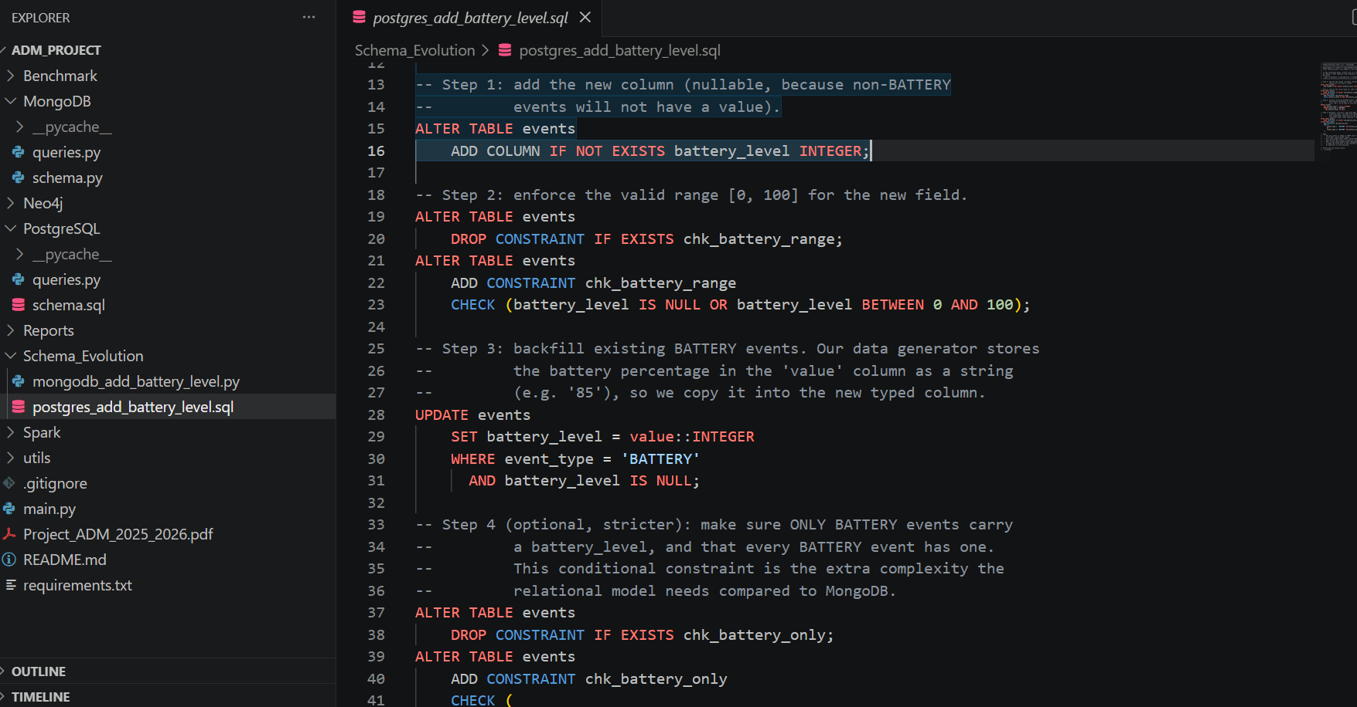
Figure11: PostgreSQL Schema Evolution ALTER TABLE migration adding battery level to BATTERY events
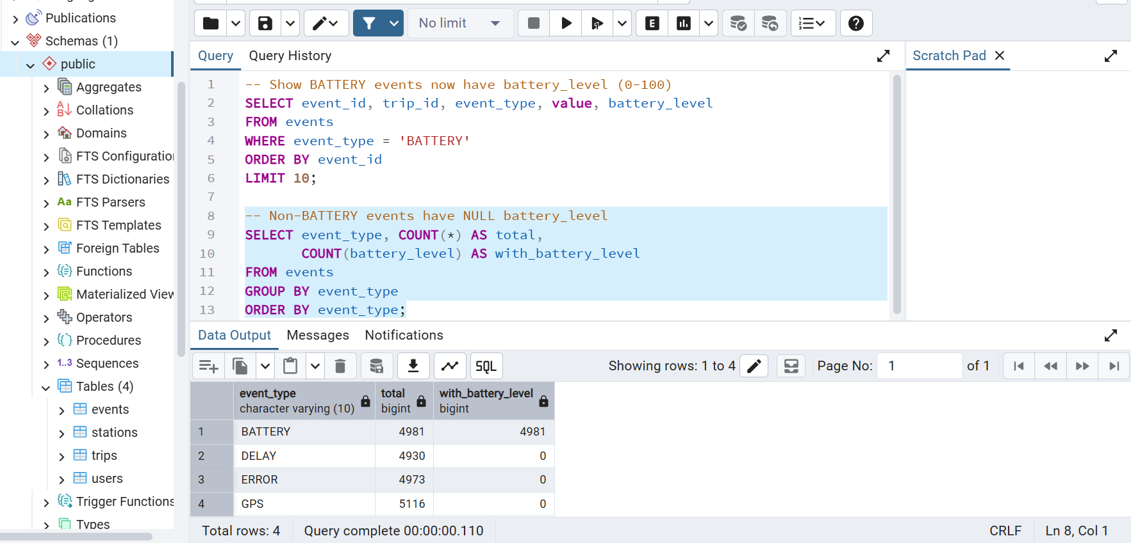
Figure12: PostgreSQL — BATTERY events with the new battery_level field populated

MongoDB — How to add the field
In MongoDB, we do not need to run any migration command at all. We simply start saving new BATTERY event documents with the battery_level field included: { event_type: 'BATTERY', value: '85', battery_level: 85 }. Old documents without the field remain perfectly valid. MongoDB is flexible enough to handle documents with different fields in the same collection.
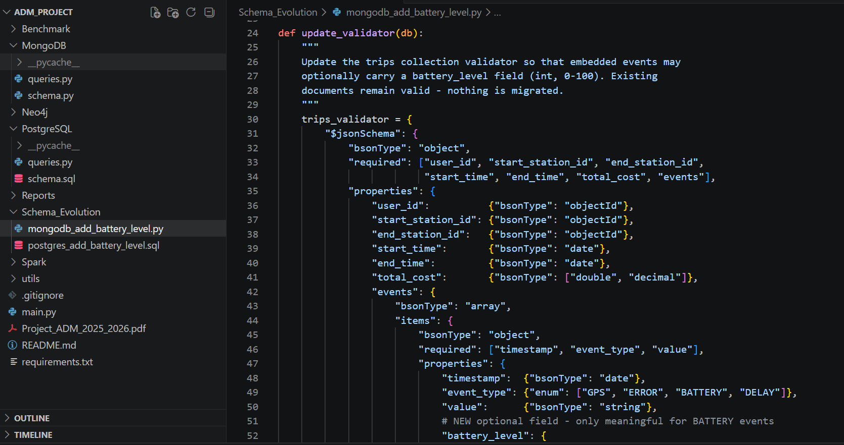
Figure13: MongoDB Schema Evolution -adding battery_level requires only one line in the validator
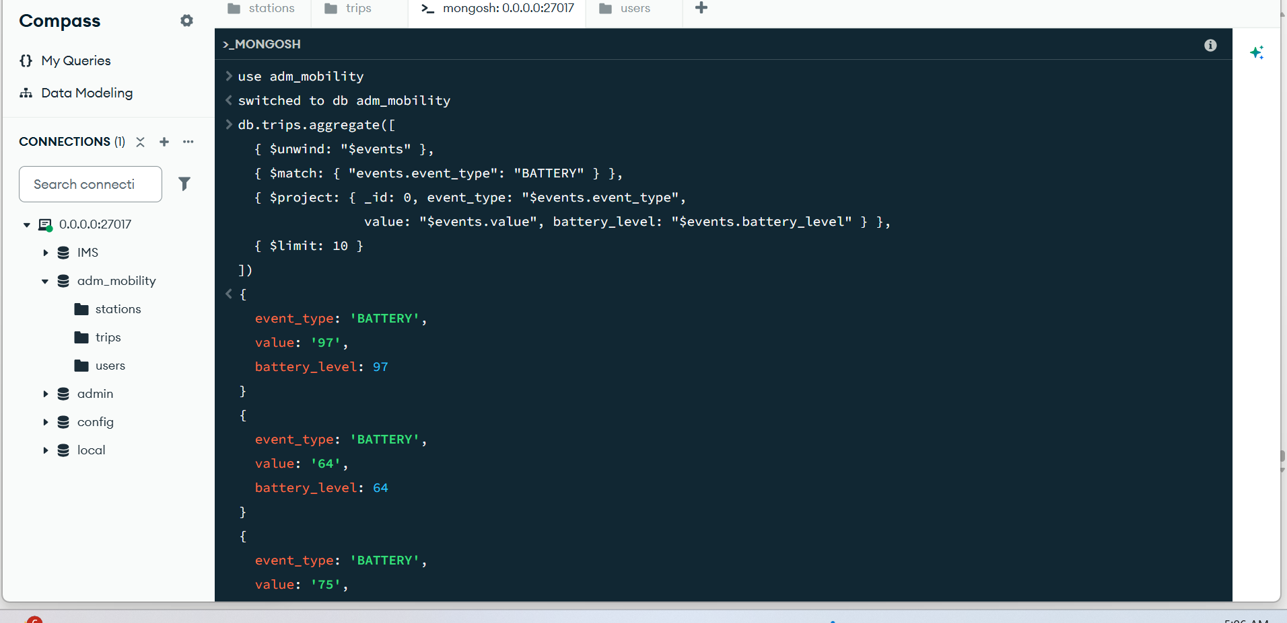
Figure14: MongoDB- embedded BATTERY events now carrying the new battery_level field

Aspect | PostgreSQL | MongoDB
Migration command needed | Yes — ALTER TABLE required | No — nothing needed
Risk during migration | Table lock possible (no access during change) | No risk — zero downtime
Effect on existing data | NULL added to all existing rows | Existing documents unchanged
Validation | CHECK constraint enforces 0-100 range | JSON Schema validator can be updated optionally
Overall verdict | Less flexible (lower evolvability) | More flexible (higher evolvability)

Conclusion: MongoDB is much easier to evolve. Adding optional fields requires no migration, no downtime, and no risk. PostgreSQL requires a planned migration with potential service interruption.

1.4 Spark Implementation of Query 2
We implemented Query 2 (user trip counts and average duration) using PySpark in two ways, and compared both against the native MongoDB implementation:
- RDD approach: load trip data, map each trip to (user_id, count=1, duration), then reduce by user to sum up counts and durations, finally divide to get the average
- DataFrame approach: create a Spark DataFrame from the trip data, use groupBy and aggregate functions (count, avg), then join with user data
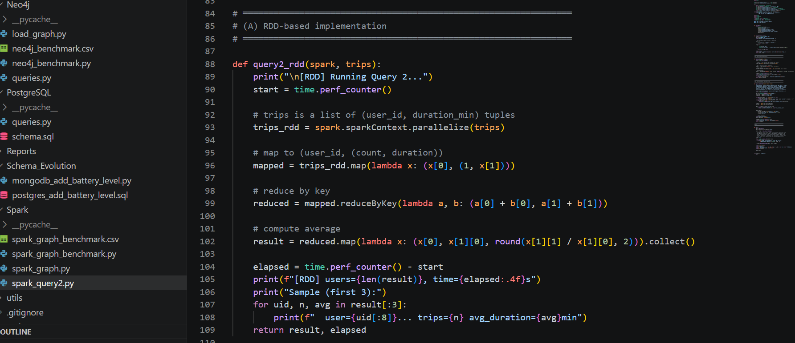
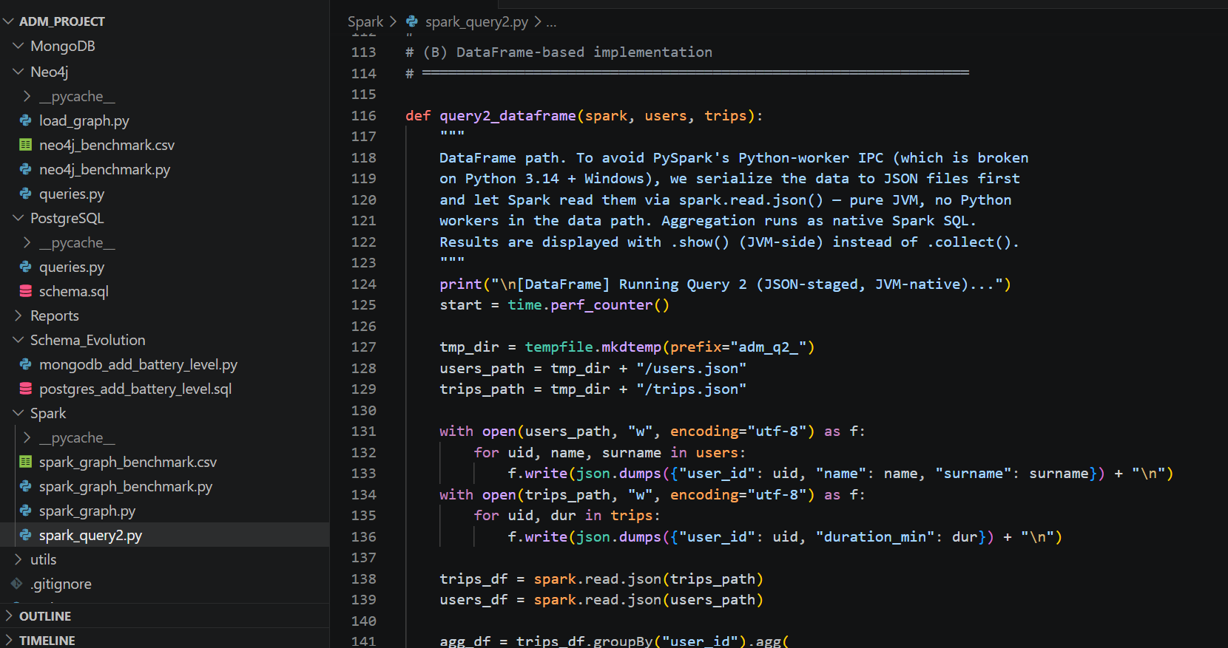
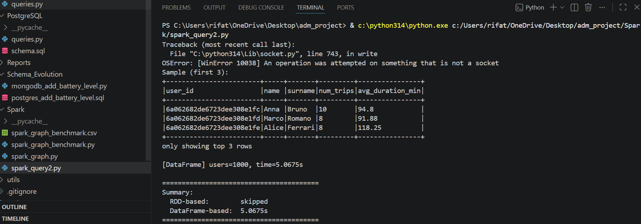
Figure15: Spark Query 2 — RDD and DataFrame implementations

Method | Users | Trips | Events | Time (seconds)
MongoDB native | 1k | 10k | 2 | 0.04
Spark RDD | 1k | 10k | 2 | 3.82
Spark DataFrame | 1k | 10k | 2 | 6.91
MongoDB native | 1k | 100k | 10 | 1.04
Spark RDD | 1k | 100k | 10 | 6.92
Spark DataFrame | 1k | 100k | 10 | 14.24
MongoDB native | 50k | 100k | 10 | 1.72
Spark RDD | 50k | 100k | 10 | 7.15
Spark DataFrame | 50k | 100k | 10 | 15.30

Why is MongoDB faster than Spark? Because Spark has a startup cost (it needs to initialize a computing environment) and has to serialize/deserialize data between Python and Java. For a single query on one machine, the native database engine is always faster. Spark's real advantage appears when data is distributed across many machines in a cluster — at the scale of billions of records. The RDD approach is faster than DataFrame because our data is already in Python format, so the DataFrame's SQL query planning adds unnecessary overhead.

Part 2: Graph Model
In this part, we model the mobility data as a graph using Neo4j. A graph database is excellent for questions like 'which stations can this user reach?' because these are naturally expressed as graph traversals.

2.1 Graph Schema and Queries

Graph Design
The graph has three types of nodes and three types of edges (connections):
- NODE: USER — represents a registered user (stores: user_id, name, surname, country)
- NODE: TRIP — represents a completed trip (stores: trip_id, total_cost)
- NODE: STATION — represents a station (stores: station_id, name, city, capacity)
- EDGE: PERFORMED — connects a USER to a TRIP (meaning: this user took this trip)
- EDGE: STARTS_AT — connects a TRIP to a STATION (meaning: this trip started at this station)
- EDGE: ENDS_AT — connects a TRIP to a STATION (meaning: this trip ended at this station)
This structure makes it easy to answer questions by following the connections. For example, to find all stations a user visited, we simply follow: USER → PERFORMED → TRIP → STARTS_AT/ENDS_AT → STATION.
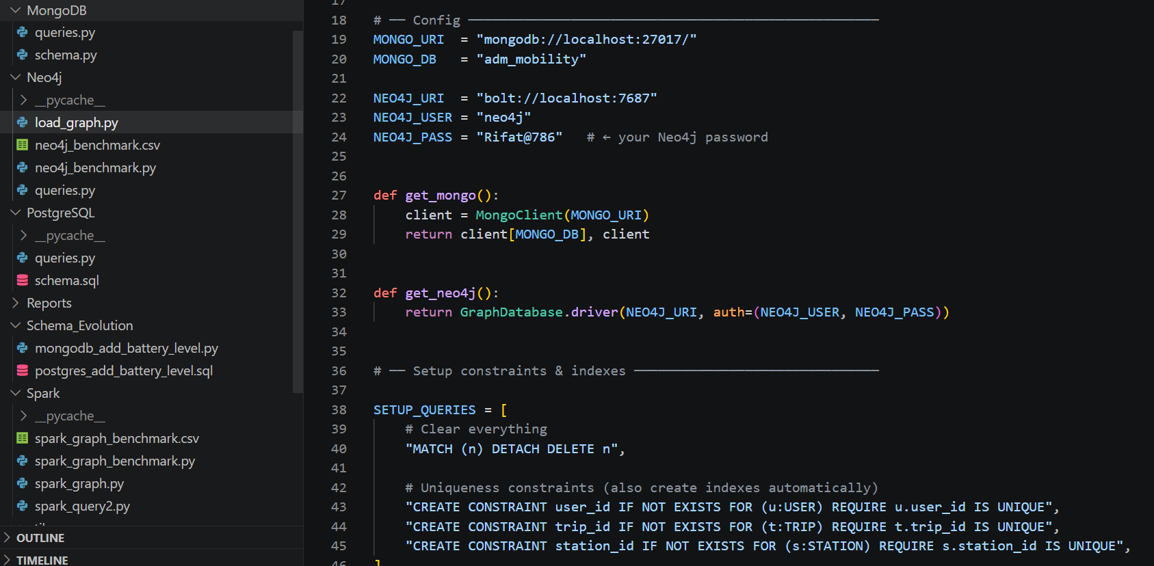
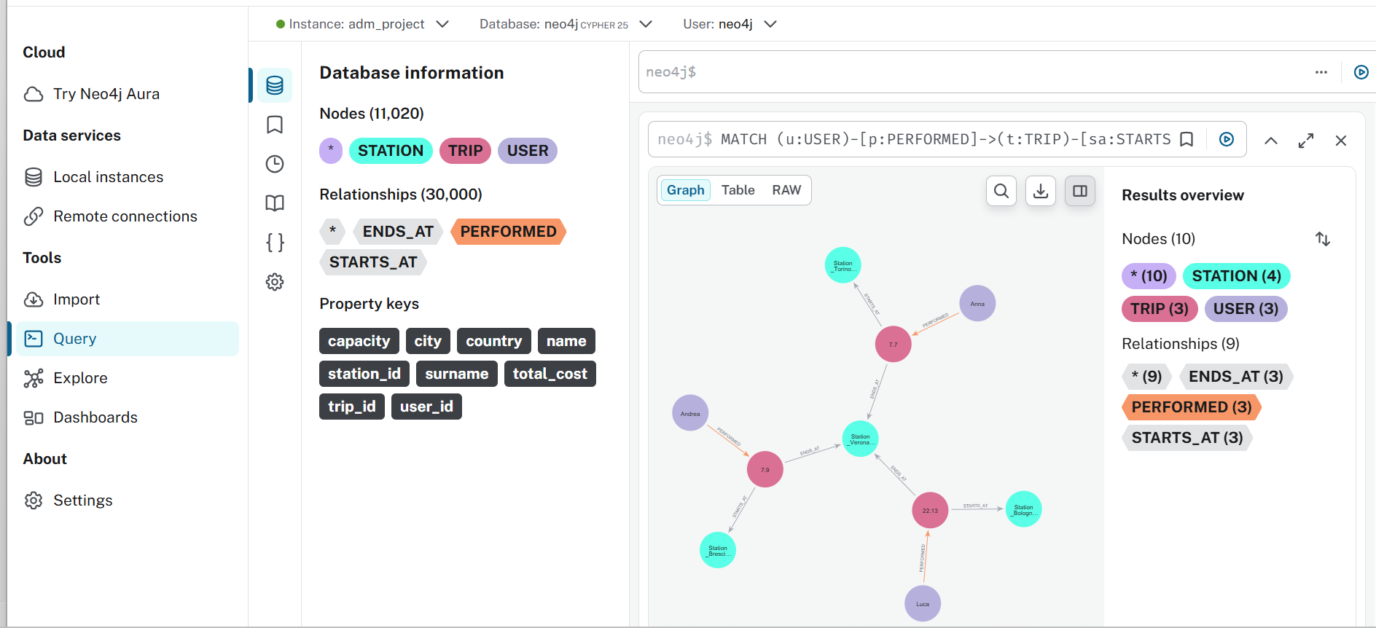
Figure 16: Neo4j - Neo4j — Graph model showing USER, TRIP and STATION nodes with PERFORMED, STARTS_AT and ENDS_AT relationships

Cypher Query 1 — All stations reachable by a given user

This query finds all stations visited by user Anna through her trips. Starting from the USER node where name = "Anna", it follows the PERFORMED relationship to reach all TRIP nodes belonging to her, then follows STARTS_AT and ENDS_AT relationships to reach the connected STATION nodes. The DISTINCT keyword ensures each station appears only once even if Anna visited it multiple times.
Result: The query returns 13 unique stations out of 20 total stations in the database, as shown in Figure 17. This means Anna's trips have covered almost the entire station network. The one missing station was simply never used as a start or end point in her trips.
The key advantage over SQL is that no JOIN operations are needed — Neo4j traverses the relationships directly in a single pattern match. The equivalent PostgreSQL query would require two JOIN operations across three tables.

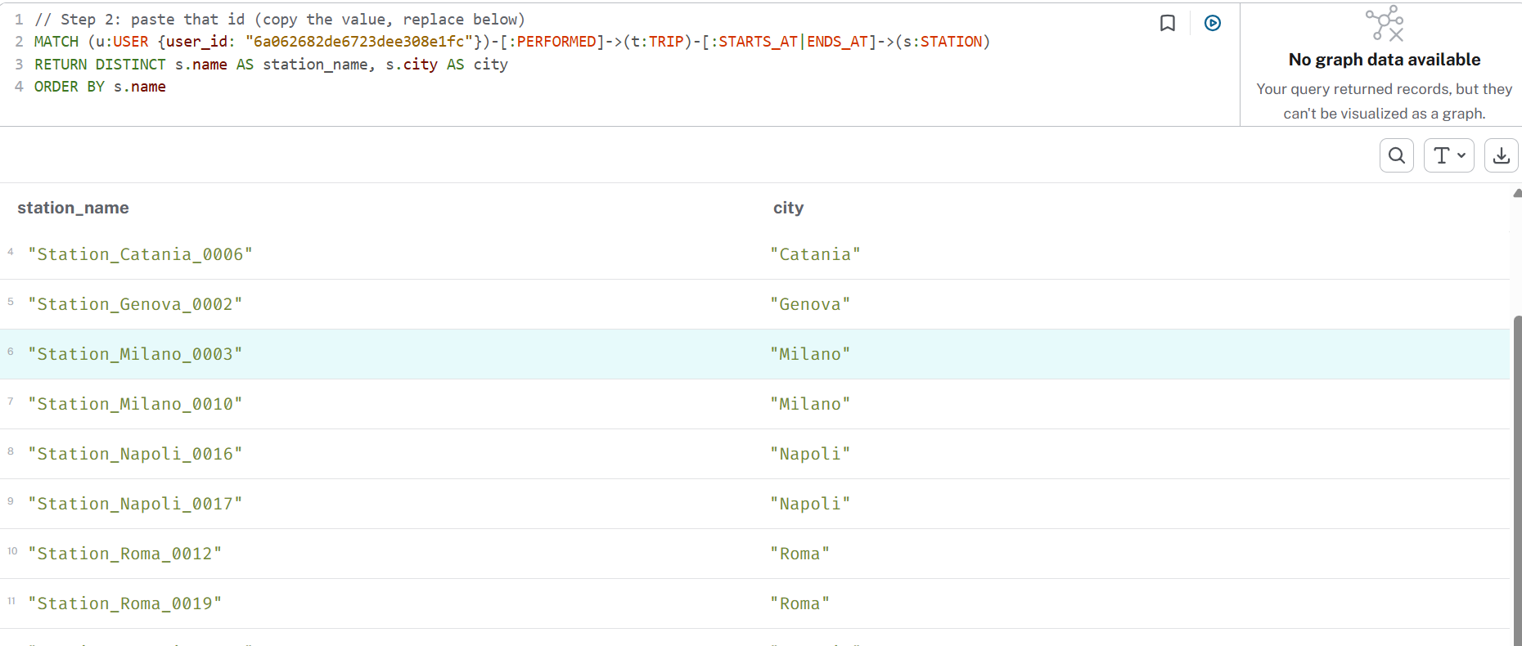
Figure 17: Neo4j - Q1: Stations reachable by user Anna via graph traversal

Cypher Query 2 — Top 3 most important stations (by trip count)

This query identifies the three most important stations in the network based on the total number of trips connected to them. For each STATION node, it counts the number of trips that start there (STARTS_AT relationship) and the number of trips that end there (ENDS_AT relationship) using OPTIONAL MATCH so that stations with zero connections in one direction are still included. The two counts are added together to produce a total_trips score, and the results are ordered from highest to lowest.

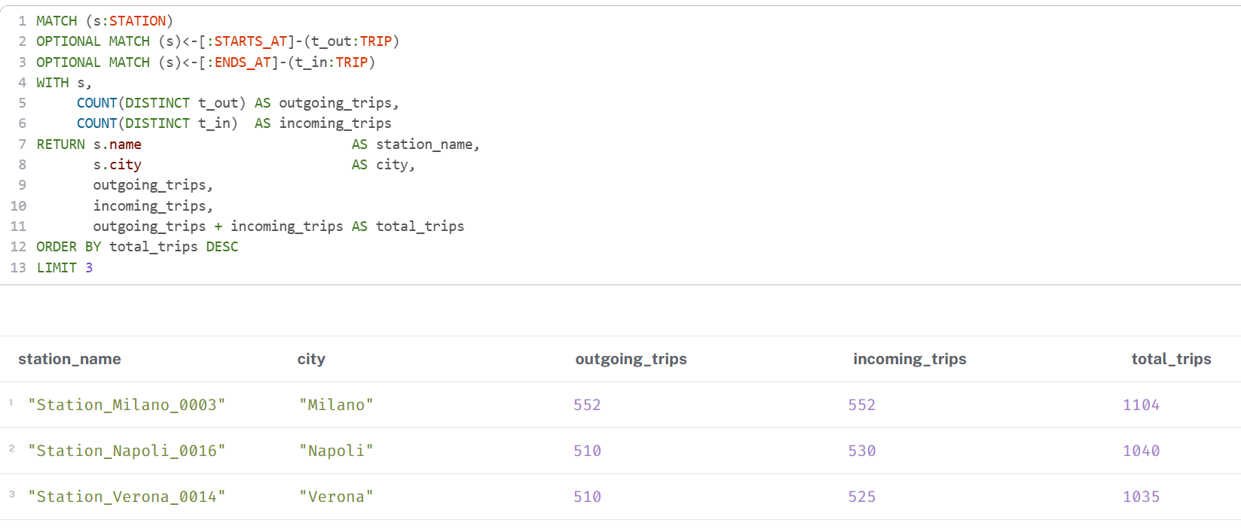
Figure 18: Neo4j - Q2: Top 3 stations by total trip count (incoming + outgoing)

Neo4j Scalability Benchmark — All 36 Combinations
We tested both queries at all required scale combinations. Times in seconds:

Users | Trips | Events | Q1 (s) | Q2 (s)
1k | 10k | 0 | 1.4739 | 3.958
1k | 10k | 2 | 0.0238 | 3.1408
1k | 10k | 5 | 0.0168 | 1.714
1k | 10k | 10 | 0.0230 | 1.4544
1k | 50k | 0 | 0.2435 | 51.271
1k | 50k | 2 | 0.0113 | 40.097
1k | 50k | 5 | 0.0083 | 32.645
1k | 50k | 10 | 0.0151 | 36.122
1k | 100k | 0 | 0.0148 | 146.93
1k | 100k | 2 | 0.0093 | 164.16
1k | 100k | 5 | 0.0171 | 160.33
1k | 100k | 10 | 0.0122 | 185.48
10k | 10k | 0 | 0.2906 | 0.3753
10k | 10k | 2 | 0.0039 | 0.1807
10k | 10k | 5 | 0.0039 | 0.1490
10k | 10k | 10 | 0.0037 | 0.1042
10k | 50k | 0 | 0.3228 | 3.1707
10k | 50k | 2 | 0.0055 | 2.8703
10k | 50k | 5 | 0.0039 | 3.0524
10k | 50k | 10 | 0.0043 | 2.7205
10k | 100k | 0 | 0.0045 | 11.969
10k | 100k | 2 | 0.0035 | 12.483
10k | 100k | 5 | 0.0040 | 14.713
10k | 100k | 10 | 0.0069 | 13.145
50k | 10k | 0 | 0.1245 | 0.1908
50k | 10k | 2 | 0.0031 | 0.0379
50k | 10k | 5 | 0.0050 | 0.0464
50k | 10k | 10 | 0.0056 | 0.0610
50k | 50k | 0 | 0.1718 | 0.7907
50k | 50k | 2 | 0.0042 | 0.5753
50k | 50k | 5 | 0.0033 | 0.5261
50k | 50k | 10 | 0.0043 | 0.5295
50k | 100k | 0 | 0.0036 | 2.0173
50k | 100k | 2 | 0.0055 | 2.1942
50k | 100k | 5 | 0.0082 | 2.7405
50k | 100k | 10 | 0.0033 | 2.3086

Key observations: Query 1 (finding stations for a user) is extremely fast — usually under 0.02 seconds — because following one user's connections is very direct. Query 2 (counting trips per station) is slower and grows with the number of trips, because it must count relationships across all stations. At 1k users and 100k trips, Q2 takes 146-185 seconds because with only 1k users and 100k trips, each user has 100 trips on average, making the relationship counting expensive. With more users (10k or 50k), the trips are spread across more users, so each user has fewer trips and Q2 becomes much faster.

2.2 Spark Graph Queries
We implemented two graph algorithms using PySpark on the station subgraph. In this subgraph, each trip is an edge from its start station to its end station.

PageRank — Finding the Most Important Stations
PageRank is an algorithm originally used by Google to rank web pages. Here, we use it to rank stations by importance. A station gets a higher PageRank if many other important stations send trips to it. We run 20 iterations with a damping factor of 0.85 (standard settings).
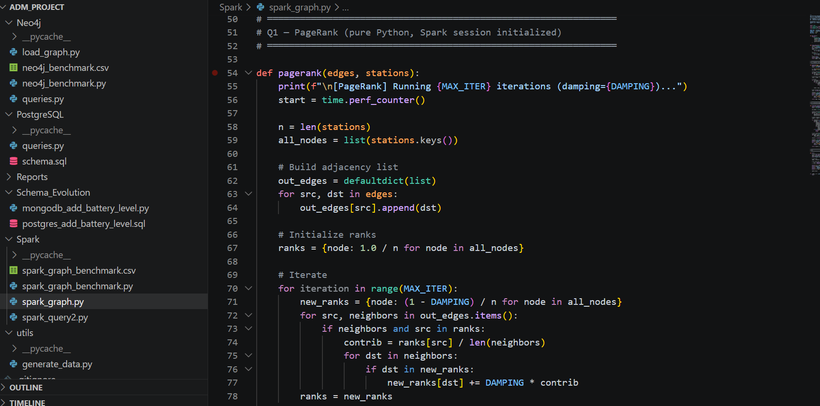
Figure19: Spark Graph — PageRank algorithm implementation (20 iterations, damping 0.85)
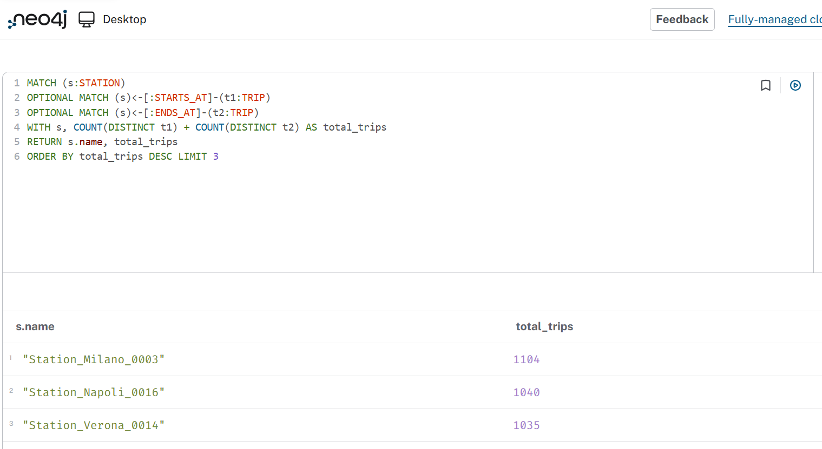
Figure20: Spark Graph — output showing top 3 stations by PageRank and the single connected component
Rank | Station | PageRank Score
#1 | Station_Verona_0003 | 0.052324
#2 | Station_Catania_0015 | 0.052028
#3 | Station_Firenze_0016 | 0.050782

The scores are very similar (all around 0.05) because with only 20 stations and randomly distributed trips, the network is very uniform — no station dominates the others.

Connected Components — Is the Network Connected?
Connected Components finds groups of stations that are reachable from each other. If all stations are in one group, the entire network is connected. We use label propagation: each station starts with its own label, then repeatedly takes the smallest label from its neighbors until no more changes happen.
Result: The algorithm converged after only 2 iterations, finding 1 connected component containing all 20 stations. This means every station in the network can be reached from every other station through trips — the mobility network is fully connected.
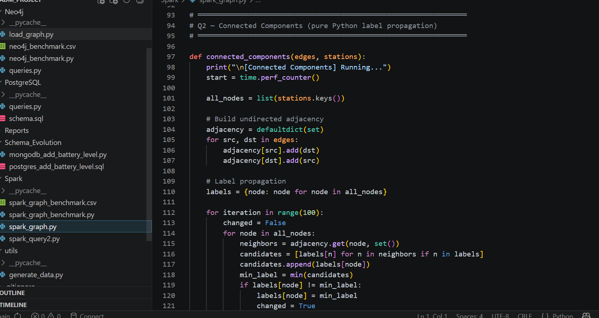
Figure21: Spark Graph — Connected Components via label propagation

Spark Graph Scalability Benchmark — All 36 Combinations
Users | Trips | Events | PageRank (s) | CC (s) | Components
1k | 10k | 0 | 0.042 | 0.003 | 1
1k | 10k | 2 | 0.029 | 0.001 | 1
1k | 10k | 5 | 0.017 | 0.001 | 1
1k | 10k | 10 | 0.032 | 0.001 | 1
1k | 50k | 0 | 0.224 | 0.015 | 1
1k | 50k | 2 | 0.146 | 0.006 | 1
1k | 50k | 5 | 0.102 | 0.006 | 1
1k | 50k | 10 | 0.249 | 0.014 | 1
1k | 100k | 0 | 0.224 | 0.012 | 1
1k | 100k | 2 | 0.345 | 0.013 | 1
1k | 100k | 5 | 0.166 | 0.008 | 1
1k | 100k | 10 | 0.294 | 0.012 | 1
10k | 10k | 0 | 0.020 | 0.007 | 1
10k | 10k | 2 | 0.026 | 0.006 | 1
10k | 10k | 5 | 0.030 | 0.013 | 1
10k | 10k | 10 | 0.029 | 0.016 | 1
10k | 50k | 0 | 0.240 | 0.040 | 1
10k | 50k | 2 | 0.225 | 0.022 | 1
10k | 50k | 5 | 0.275 | 0.051 | 1
10k | 50k | 10 | 0.117 | 0.014 | 1
10k | 100k | 0 | 0.531 | 0.069 | 1
10k | 100k | 2 | 0.875 | 0.087 | 1
10k | 100k | 5 | 0.505 | 0.053 | 1
10k | 100k | 10 | 0.559 | 0.053 | 1
50k | 10k | 0 | 0.064 | 0.014 | 1
50k | 10k | 2 | 0.041 | 0.015 | 1
50k | 10k | 5 | 0.055 | 0.021 | 1
50k | 10k | 10 | 0.084 | 0.059 | 1
50k | 50k | 0 | 0.376 | 0.299 | 1
50k | 50k | 2 | 0.462 | 0.140 | 1
50k | 50k | 5 | 0.264 | 0.114 | 1
50k | 50k | 10 | 0.300 | 0.120 | 1
50k | 100k | 0 | 0.627 | 0.259 | 1
50k | 100k | 2 | 0.396 | 0.192 | 1
50k | 100k | 5 | 0.329 | 0.155 | 1
50k | 100k | 10 | 0.467 | 0.185 | 1

PageRank takes longer as the number of trips (edges) increases, since each iteration processes all edges. Connected Components converges in just 2 iterations at all scales because the 20-station network is always densely connected. Both algorithms remain fast (under 1 second) for all tested combinations.

Part 3: Partitioning and Replication
In this part, we think about how the database would work in a real distributed system — where data is split across multiple servers (partitioning) and copied to multiple servers for reliability (replication).

3.1 Partitioning
Partitioning means splitting the trips collection across multiple servers. We compare two strategies: splitting by user_id (each user's trips go to the same server) or by start_station_id (trips from the same starting station go to the same server).

Strategy A: Partition by user_id
With this strategy, all trips belonging to the same user are stored on the same server. This is very efficient for user-focused queries.
Query | Effect | Reason
Q1 — trips with user info | POSITIVE ✓ | All trips for a user are on one server — no need to search across servers
Q2 — user trip statistics | POSITIVE ✓ | All data needed for one user's statistics is in one place
Q3 — station trip counts | NEGATIVE ✗ | To count trips per station, we must ask ALL servers and combine results (slow scatter-gather)
Q4 — trips with ERROR | NEUTRAL | Must scan all servers regardless — events are per-trip and not grouped by user
Graph Q1 — stations by user | POSITIVE ✓ | All user trips are local — traversal is fast
Graph Q2 — top stations | NEGATIVE ✗ | Must count trips across all servers to find top stations
Spark Q2 — user stats | POSITIVE ✓ | All user trips are on one partition — reduces data shuffling
Spark PageRank | NEGATIVE ✗ | Edges (trips) between stations are scattered — requires heavy data movement between servers

Strategy B: Partition by start_station_id
With this strategy, all trips starting from the same station are stored on the same server.
Query | Effect | Reason
Q1 — trips with user info | NEGATIVE ✗ | One user's trips are spread across many servers — must search everywhere
Q2 — user trip statistics | NEGATIVE ✗ | Must collect data from all servers to find all trips for each user
Q3 — station trip counts | PARTIAL ✓ | Outgoing trip counts (start) are local; incoming trip counts (end) still need scatter-gather
Q4 — trips with ERROR | NEUTRAL | No benefit — ERROR events not related to station grouping
Graph Q1 — stations by user | NEGATIVE ✗ | User trips scattered across all servers
Graph Q2 — top stations | PARTIAL ✓ | Outgoing counts are local; incoming counts scattered
Spark PageRank | PARTIAL ✓ | Source edges grouped together — reduces some shuffling in each iteration
Spark CC | NEUTRAL | Only 20 station nodes — partition strategy irrelevant at this small scale

Our Recommendation: Partition by user_id
We recommend partitioning by user_id for these reasons:
- Most common operations (Q1, Q2, Graph Q1, Spark Q2) are user-focused — they become faster with user partitioning
- The platform is user-centric: users book trips, view their history, and check their statistics — all these are per-user operations
- Q3 (station counts) is slower with user partitioning, but it is an administrative/reporting query that runs infrequently, not a user-facing query
- With 1k to 50k users, the data is spread evenly across partitions — no single user dominates (no hotspots)

3.2 Replication
Replication means keeping copies of the data on multiple servers for reliability. We use single-leader asynchronous replication: one primary server handles all writes, and two secondary servers receive copies of the data shortly after. Reads can come from any server.
The key risk: because replication is asynchronous, secondary servers might be slightly behind the primary. If a user just completed a trip and immediately checks their statistics, a secondary server might not have the new trip yet — showing them outdated data.

Query | Risk Level | What Could Go Wrong
Q1 — all trips with user info | MEDIUM | A user might not see their most recently completed trip if it hasn't been replicated yet
Q2 — user trip statistics | MEDIUM-HIGH | Trip count or average duration could be wrong if new trips are not yet on the secondary server
Q3 — station trip counts | LOW | Station counts change slowly — being slightly behind by a few seconds is acceptable
Q4 — trips with ERROR | LOW | ERROR events are rare and not time-critical — slightly stale data is fine
Graph Q1 — stations by user | MEDIUM | A newly visited station might not appear if the trip wasn't replicated to Neo4j yet
Graph Q2 — top stations | LOW | Station rankings change slowly — small lag doesn't affect the top 3
Spark Q2 — user stats | MEDIUM-HIGH | Same risk as Q2 — computed averages could be based on incomplete data
Spark PageRank | LOW | PageRank scores change very slowly — minor data lag doesn't change the ranking
Spark CC | LOW | The network is always fully connected — adding or missing a few trips doesn't change this

How to Reduce These Risks
- Read-your-writes: After a user completes a trip, send their next query to the primary server (not a secondary), so they always see their own latest data
- Session tokens: Track what each user has written, and make sure secondary servers confirm they have that data before serving reads to that user
- Semi-synchronous replication for critical queries: For Q2 (user statistics), require at least one secondary to confirm it has the data before telling the user the write was successful
- Monotonic reads: Make sure a user always reads from the same server within one session, so they never see data go backward (seeing older data after newer data)

Conclusion
This project built a complete data management system for a city e-vehicle sharing platform using three different types of databases. Here is what we learned from each:

Database | Best For | Weakness
PostgreSQL | Joins and structured queries (Q1: 2.09s vs MongoDB 20.36s at large scale) | Query 3: catastrophically slow at scale (957 seconds for 100k trips!)
MongoDB | Flexible schemas and embedded data (Q3: 0.30s vs PostgreSQL 957s) | Query 1 is 10x slower than PostgreSQL due to $lookup overhead
Neo4j | Network traversal — finding connected stations in milliseconds | Q2 slows significantly when trips are concentrated on few users

PySpark is slower than native database engines for single-machine workloads because of startup and data transfer overhead. Spark becomes valuable at truly massive scale — billions of records distributed across many servers in a cluster.
For partitioning, we recommend user-based partitioning because the platform is user-centric and most queries operate per-user. For replication, asynchronous single-leader replication is acceptable for most queries, but user statistics (Q2) need special handling (read-your-writes) to prevent users from seeing outdated data immediately after completing a trip.

