**EEE141 ALL LAB THEORIES**

**LAB – 1**

**Ohm’s Law:**

According to Ohm’s law the current going through a conductor between two points is directly proportional to the voltage across the two points.

V ∝ I

So, the amount of current, I flowing through the resistor is proportional to the voltage, V across the circuit where the resistance works as the proportionality constant for the resistor. So, the mathematical equation stands as,

V = IR

And this resistance R is what resists the flow of current in a circuit which is measured in ohms.

Now using this formula from ohm’s law, we can find the voltage or current or resistance of a circuit if any two of the three values are given.

**Voltage Divider Rule:**

If a series circuit has more than one resistor then their voltage gets divided among the resistors and the higher the resistance the higher voltage drop will occur at that resistor.

And to calculate the voltage drop among the resistors we can use the Voltage Divider Rule where you multiply the resistance of the resistor with the source voltage of the circuit and divide it with the total resistance of the circuit. So, the equation would stand as,

Vm = x Vs

Where, VS is the source voltage, Rm indicates the resistor we’re trying to find the voltage (Vm) at and n indicates the total number of resistors.

Now for example if we want to find the voltage across the two resistors of Figure-1 we can calculate it like this,

V1 = x VS

V2 = x VS

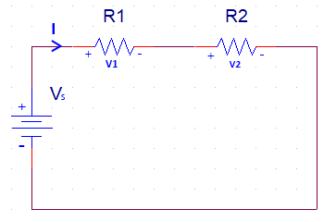

Figure - 1

**Kirchhoff’s Voltage Law (KVL):**

Kirchhoff’s voltage law states that the algebraic sum of all the voltages around a closed loop is zero. Which basically means that the sum of voltage rises and drops should be zero in a closed loop.

Now, according to KVL the sum of total voltage running across the circuit given in Figure-2 is zero.

Applying KVL on Figure-2 we get,

-V1 + V2 + V3 + V4 = 0

=> V1 = V2 + V3 + V4

**؞** According to KVL this indicates that the voltage rise in V1 is equal to the voltage drops in V2, V3 and V4.

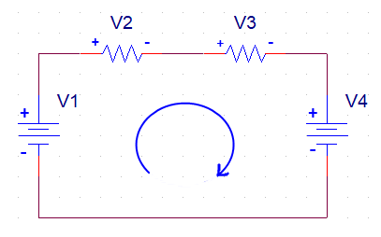

Figure - 2

**LAB – 2**

**Kirchhoff’s Current Law (KCL):**

Kirchhoff’s current law states that the algebraic sum of all the currents entering and exiting a node or a closed loop circuit is zero.

Alternatively, it could also be said that the total amount of currents entering a node is equal to the currents exiting from that node.

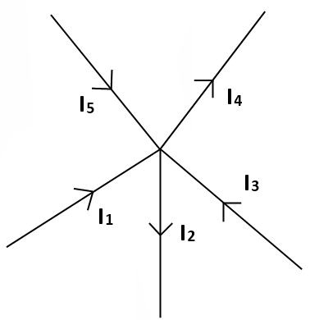

Figure – 1

For example, if we apply KCL to Figure-1 the algebraic sum of all the currents entering and exiting should be equal to zero. And if we consider the currents exiting from the node as negative, we get,

I1 + I3 + I5 - I2 - I4 = 0

Or, if we consider the alternative form of KCL the sum of the currents entering the node (I1, I3, I5) there should be equal to the currents exiting (I2, I4) from it. So,

I1 + I3 + I5 = I2 + I4

**Current Division Rule:**

The current division rule states that the current entering the node of a parallel circuit is divided into the resistors of the branches in inverse proportion to their resistances.

So, when the current is flowing in a circuit if it encounters parallel branches, it’ll get divided into the resistors in those branches of the circuit.

For a circuit with two resistors in parallel the current flowing through each resistor will be, “the resistance in the opposite branch divided by the total resistance and multiplied by the total current” and the formula to calculate the currents divided into the resistor will be as following,

I1 = x IS

I2 = x IS

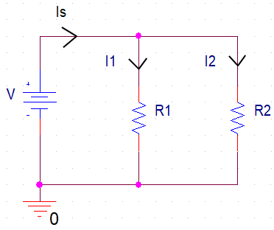

Figure – 2

For a circuit with three resistors in parallel the formula to calculate the currents divided into the resistors is a bit different from the formulas used for the circuit with two parallel resistors. They’ll be,

Req =

I1 = x IS

I2 = x I S

I3 = x IS

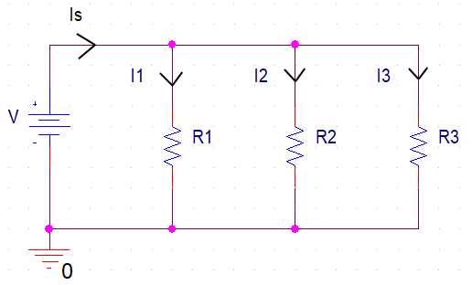

Figure – 3

So, the technique is to take the total resistance in the parallel circuit and divide it by the resistance of the resistor that we’re trying to find the current flow of and multiply it with the total current.

**Ladder Circuit:**

A ladder circuit is the kind of circuit that we commonly use which is a mixture of both series and parallel circuits unlike the previous circuits we’ve seen where it’s either only series or only parallel connections.

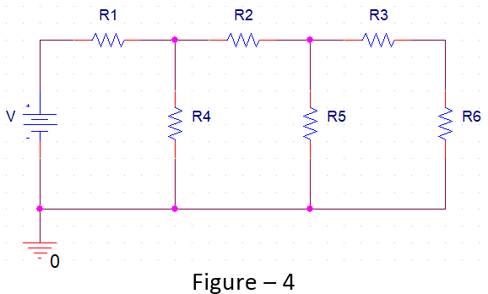

**LAB – 3**

**Voltage Divider Rule:**

If two or more resistors are connected in a series circuit, then the source voltage gets divided among the resistors and the higher the resistance the higher voltage drop will occur at that resistor.

For example, in figure − 1 the R1 and R2 resistors are connected in a series circuit so the source voltage E will get divided among them as V1 and V2.

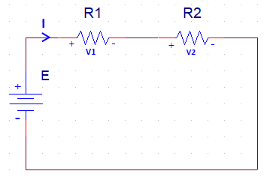

Figure – 1

And the way to calculate the voltage drops in a 2 resistor series circuit is,

V1 = × E

V2 = × E

And if we want to calculate the voltage drops for a circuit with more than 2 resistors connected in series, we can follow a similar approach,

Vx = x E

Where, E is the source voltage, RX indicates the resistor we’re trying to find the voltage drop (VX) at and n indicates the total number of resistors.

**Loading Effect:**

Due to some extra load on a circuit the impact or the change in the electrical properties is called the loading effect.

For example, if we add a parallel load resistor to R2 in figure – 2 (A) the voltage output of R2 resistor will change because of the extra added load and this change is called loading effect.

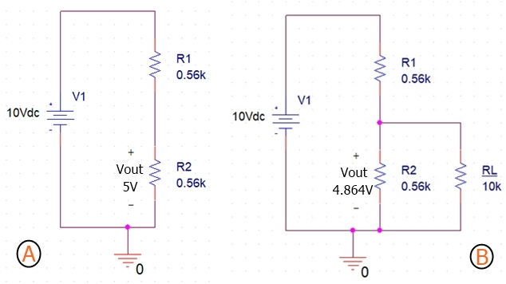

Figure – 2: (A) 2 Resistor Series Circuit,

(B) Added a Load Resistor to R2 of the same circuit

**LAB – 4**

**Delta-Wye Conversion:**

The Delta-Wye (∆-Y) conversion is a special technique used to handle complex circuits that cannot be handled by the usual series, parallel combinations, where we’re not sure if the resistors are connected in series or parallel.

This transformation allows us to replace three resistors in a ‘∆’ configuration into a ‘Y’ configuration and the other way around.

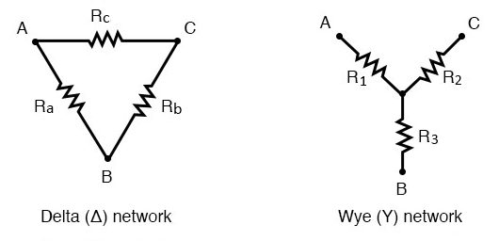

Figure: ∆-Y Network Configuration

These configurations can be redrawn to square up the resistors which is why this ∆-Y conversion is also called Pi-T (π-T) conversion. And the π-T configurations looks like the following figure.

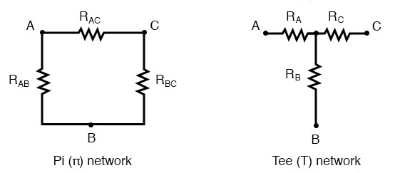

Figure: π-T Network Configuration

**Delta (∆) → Wye (Y) Transformation:**

The equations to transform a ∆ network into a Y network are,

R1 =

R2 =

R3 =

However, transforming a ∆ network into a Y network introduces one additional node in the circuit. And these equations also apply for the π-T configuration as that’s nothing but a redrawn state of the ∆-Y transformation.

Now, there’s a shortcut to the ∆-Y conversion. If the ∆ configuration has the three resistors with the same amount of resistance then we can calculate the resistances for Y configuration just by dividing any of the Ra/Rb/Rc by 3 and that’ll be the resistance of R1=R2=R3.

؞Y = 1/3 ∆

* ∆ = 3Y

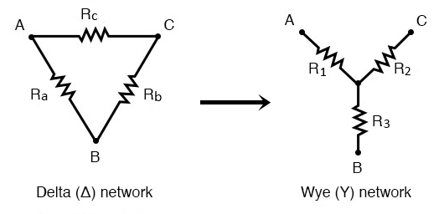

Figure: Delta (∆) to Wye (Y) Conversion

**Wye (Y) → Delta (∆) Transformation:**

And now the equations to transform from Y configuration to ∆ configuration,

Ra = $\frac{R1R2+R2R3+R3R1}{R2}$

Rb = $\frac{R1R2+R2R3+R3R1}{R1}$

Rc = $\frac{R1R2+R2R3+R3R1}{R3}$

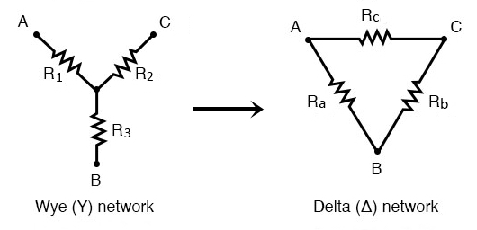

Figure: Wye (Y) to Delta (∆) Conversion

**LAB – 5**

**Superposition Theorem:**

If a circuit has two or more independent sources (voltage or current), then to determine the value of a specific variable, according to the superposition theorem we determine the contribution of each independent source to the variable and then add them up.

The main reason we use superposition theorem is because when we work with one independent source the circuit becomes much simpler and manageable and that way, we can get the values of a variable for each independent source much more easily and then just add them all to get the result.

We always need to remember two things while applying superposition theorem:

* We always consider one independent source for the circuit and turn rest of the sources off. For voltage sources we use a short circuit so that the voltage gets replaced with 0V and for current sources we use open circuit which replaces the current source with 0A value.
* Dependent sources are left intact as they are controlled by circuit variables.

**Application of Superposition Theorem:**

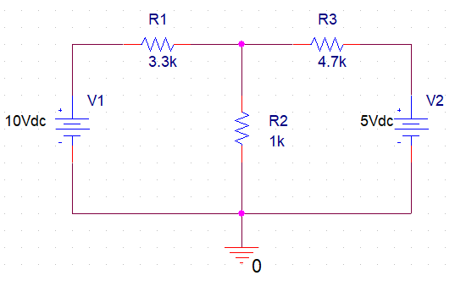

Figure – 1

So, if we have a circuit with more than one independent source like the one in figure – 1 and we want to find the value of the current going through the R2 resistor using superposition theorem then first we have to short the V2 voltage source in the circuit and calculate the current going through R2 and then again from the original circuit we have to short the V1 voltage source and this time we have to keep V2 voltage source alive and find the current going through R2.

After getting the values of the current going through R2 resistor for each voltage source we need to add them up and that’ll be the original amount of current going through the circuit with both V1 and V2 voltage source alive.

**LAB – 6**

**Thevenin’s Theorem:**

According to Thevenin’s theorem we can simplify any linear circuit, no matter how complex, to an equivalent circuit with just a single voltage source and series resistance connected to a load resistance.

The Thevenin equivalent circuit has one dc voltage source called Thevenin voltage, VTH and a single fixed resistor called Thevenin resistance, RTH.

**Norton’s Theorem:**

According to Norton’s theorem we can simplify any linear circuit, no matter how complex, to an equivalent circuit with just a one current source and parallel resistance connected to a load resistance.

The Norton equivalent circuit has one current source called Norton Current, IN and a single fixed resistor called Norton resistance, RN.

**Usefulness of Thevenin & Norton Theorem:**

In Figure – 1 R2 is a load resistor and if want to find the voltage and current going through it we can apply mesh analysis or nodal analysis or we can use superposition theorem but if the load resistor is not fixed and varies from time to time, we can’t be doing all those calculations again and again that’s where Thevenin and Norton theorem shines. We can simplify a circuit to Thevenin or Norton equivalence circuit and then just calculate everything according to the change of load resistor.

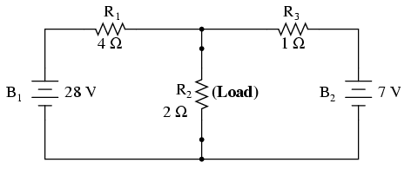

Figure – 1

**Calculating the Thevenin voltage:**

We first remove the load resistance from the circuit then calculate the open-circuit voltage at the terminals of the load resistance to calculate the Thevenin voltage of the circuit.

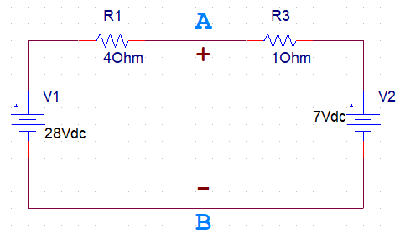

**Calculating the Thevenin/Norton Resistance:**

After removing the load resistance, we short the circuit for all the independent voltage sources and calculate the resistance at the terminals of the load resistor to get out Thevenin resistance.

And Norton resistance needs to be calculated the same way as Thevenin resistance so they’re equal.

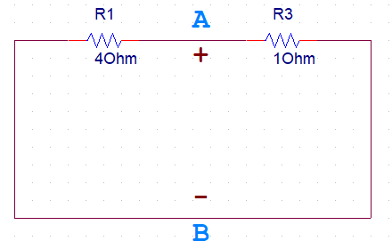

**Thevenin Norton Equivalence:**

Both Thevenin and Norton equivalent circuits are intended to behave the same as the original network supplying voltage and current to the load resistor. In other words, both Thevenin and Norton equivalent circuits should produce the same voltage across the load terminals with no load attached.

Thevenin and Norton resistance both needs to be calculated the same way and are equal. So,

RThevenin = RNorton

VThevenin = INorton RThevenin

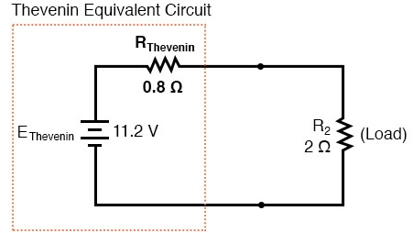

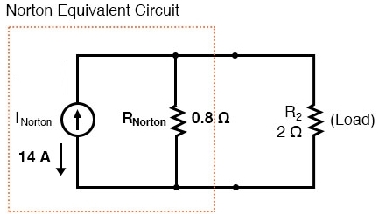

**Calculating the Norton Current:**

Thevenin and Norton are both equivalent circuits so to calculate Norton current, IN we can use VTH,

INorton = VThevenin / RNorton

=> INorton = VThevenin / RThevenin

**Maximum Power Theorem:**

Maximum power theorem states that maximum power will be delivered to the load when that load resistance is equal to the Thevenin/Norton resistance of the network supplying the power. If the load resistance is lower or higher than the Thevenin or Norton resistance then the power dissipated will be less than maximum.

In a Thevenin or Norton Equivalent circuit,

IL = VTH / (RTH + RL)

For maximum power RL = RTH,

IL = VTH / (RTH + RTH) = VTH / 2RTH

**؞** PMax = IL2 RL = VTH2 / 4RTH

**LAB – 7**

**DC:**

When an electric charge flows in a constant direction and does not vary with time then it is called Direct current (DC). And as it flows in a constant direction it does not have any frequency which means its frequency is zero.

**AC:**

A current that varies sinusoidally with time is called Alternating current (AC). As it changes with time its frequency can be found from its time period (T).

**Capacitor:**

An electric component that stores electric charge is called Capacitor.

Capacitor Construction:A capacitor is made using 2 close plates that are separated by a dielectric material, which is a poor conductor or sometimes an insulator.

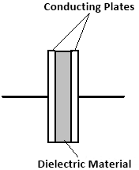

When the two conducting plates are connected to power supply an electric field is generated between the plates making one plate positively charged and the other negatively charged. And a capacitors relation with charge and potential difference can be denoted as,

C = $\frac{Q}{V}$

And the capacitance of a capacitor is the amount of charge stored in the capacitor per unit voltage and its unit is Farad. Capacitance is denoted as,

XC =

Where, w is the angular frequency = 2πf. So, here if f was 0 then that would mean the angular frequency is 0 then,

XC = = = ∞

And the capacitor is open circuit in DC circuits and short circuit in AC circuits. That’s why we’ll be using AC source for this experiment.

**Time Period:**

The time required for a current to complete 1 cycle is called time period. And the relation between time period and frequency is, T = $\frac{1}{f}$

**Frequency:**

The number of cycles completed in a second is called frequency. Frequency is denoted by, f = $\frac{1}{T}$

**Time Varying Signal:**

A signal whose values changes with time. There could be three types of signal Sin wave, Square wave and Triangular Wave.

We can generate these signals using a device called signal generator.

Here’s what a square wave looks like:



Where, V0 is the maximum voltage of amplitude and T is the time period of the signal.

**Peak Voltage:**

The maximum voltage of a signal is called the peak voltage and it’s denoted by VP.

**RC Charging:**

A circuit made of a resistor and a capacitor is called a RC circuit.

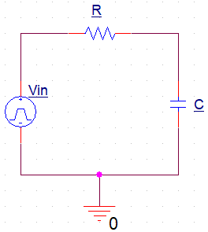

In a circuit when the input is positive the capacitor will charge gradually through the resistor until the voltage across the capacitor equals the supply voltage.

Here, the amount of time required for the capacitor to fully charge is equivalent to 5 time constants or 5[𝜏.](https://www.compart.com/en/unicode/U+1D70F)

And Voltage, VC across the capacitor varies with time according to the formula,

VC(t) = V0 (1 – e–t/RC)

Where, V0 is the amplitude of the input signal and RC is the time constant which is also denoted by 𝜏.

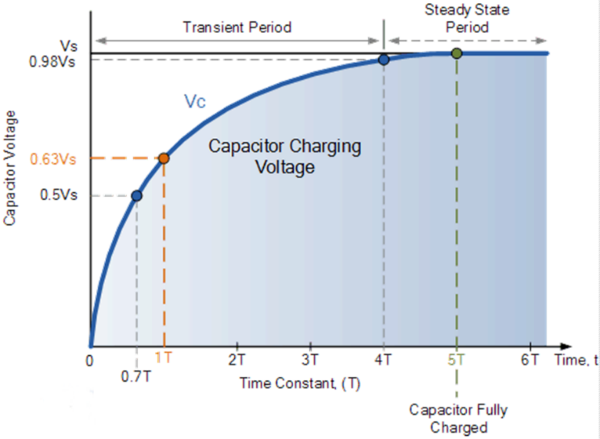

Figure: Capacitor Charging Graph

**RC Discharging:**

If the input signal becomes negative the capacitor starts discharging itself back through the resistor. And for a discharging circuit the voltage across the capacitor, VC with respect to time is defined as,

VC(t) = V0 e–t/RC

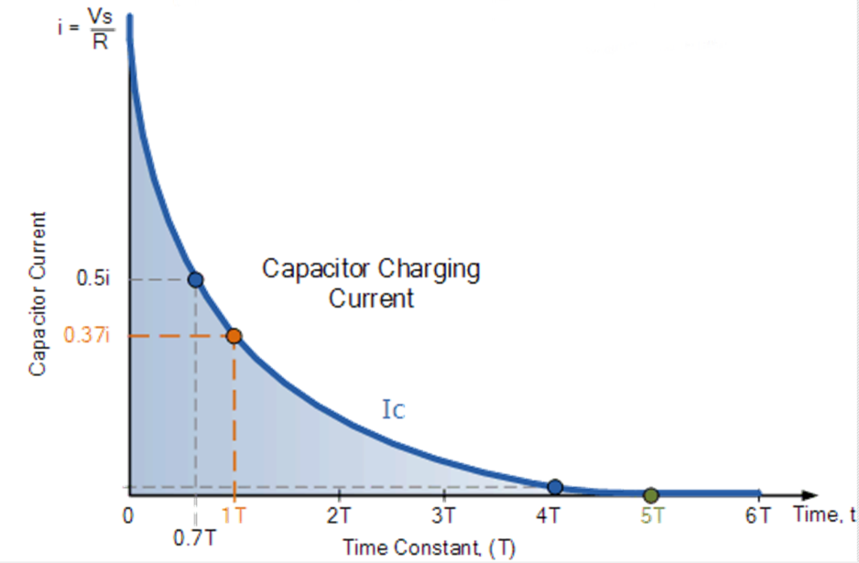

Figure: Capacitor Discharging Graph

Now if combine both Charging and Discharging graph, we can get the full charging-discharging graph of a capacitor.

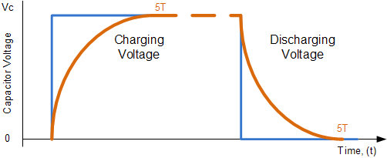

Figure: Capacitor Charging-Discharging Graph