1)First the Customer will register

2)now we will do the operations for the new added customer like: Add(POST),edit(PUT),delete(DELETE),get(GET) Or else we can do the operations on the existing customers like: edit(PUT),delete(DELETE),get(GET)

Add customer transaction

Edit customer transaction

Get Customer Transaction

Delete Customer transaction

3)Then customer will login. After Successfully logged in It will generate JWT token.

4)After successfully logged in that particular customer is able to get their rewardpoints month and year wise or all the points throughout month and year.

To access these apis we have to put Bearer Token in Authorization.

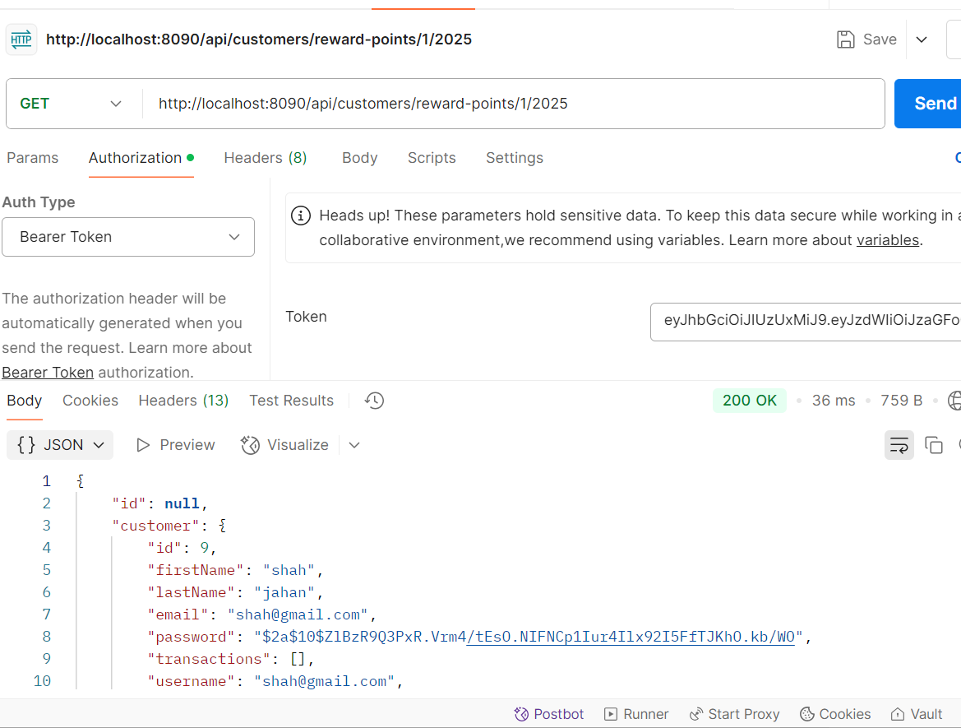

For all the months and year for the particular user, suing authentication token.

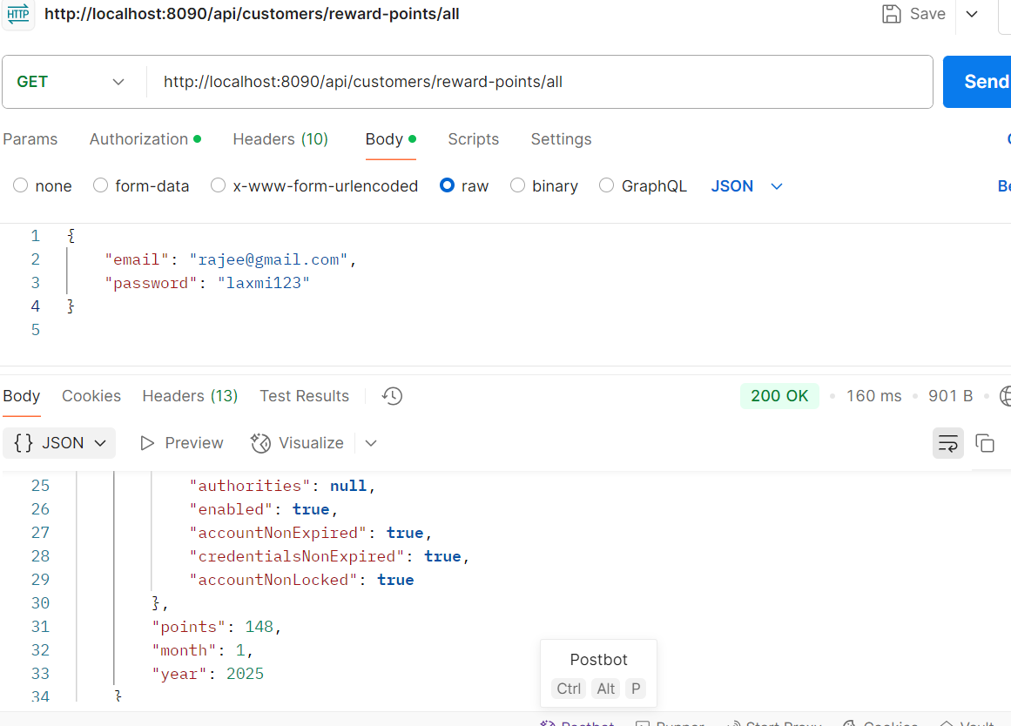

5) logged out

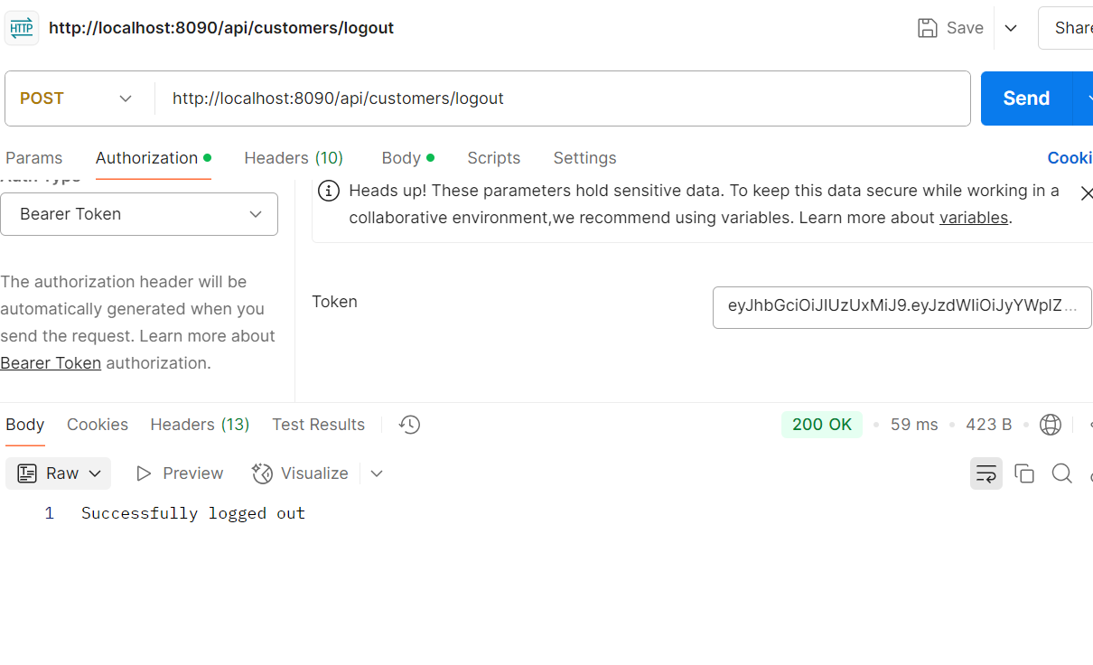

Check if same bearer token is allowing again?

