1. When we run the program, it will be like this.

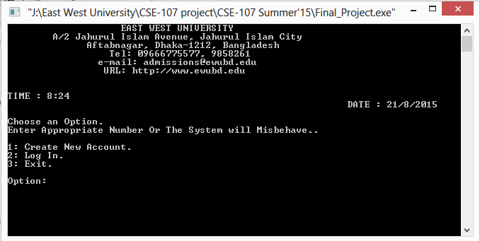

2. Press 1 to create an account and it will take student and family information’s. Type information’s correctly.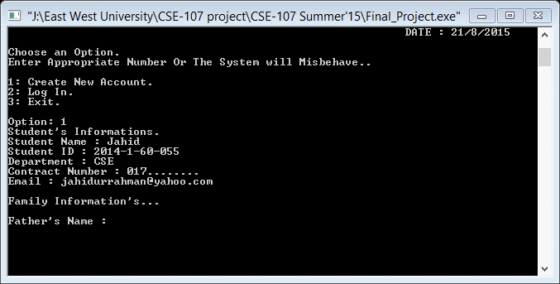

3. Press 2 for log in (if you have an account in this system). It will take your user name and password. If user name and password match in the file then you can go to your profile.

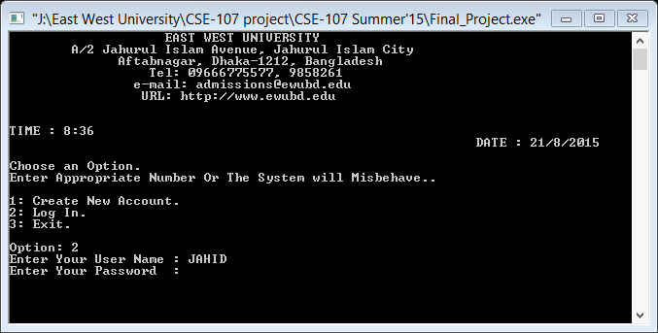

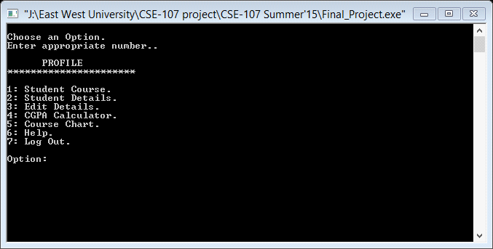

4.

5. If you press 2, it will show details of you. (except user name and password).

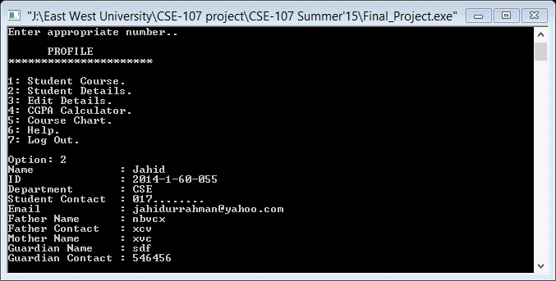

6. Press 3 for edits your information (restricted for some information’s). If you want to skip editing then press 0 to back to your profile.

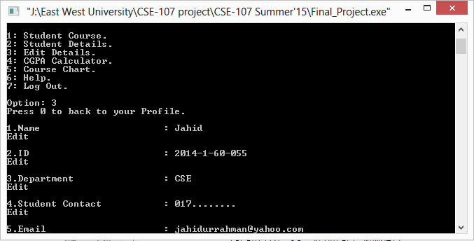

7. Press 4 to calculate your CGPA. For that you should input your subject grade and credit and then you can see your CGPA. If you are in privation this system will suggest what you will do and how can you get help.

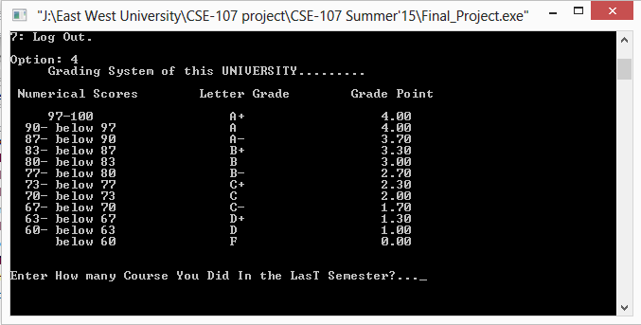

After input:

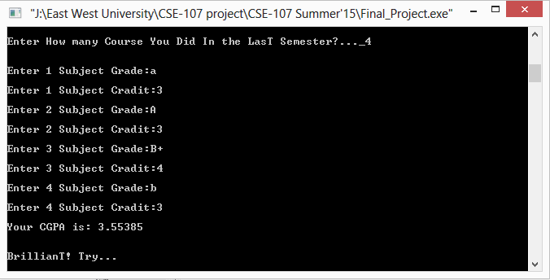

8. Press 5 for you course flow chart. Then it will ask for your department, if you select a department then system will show you the flow chart of selected department. Press 13 back to your profile.

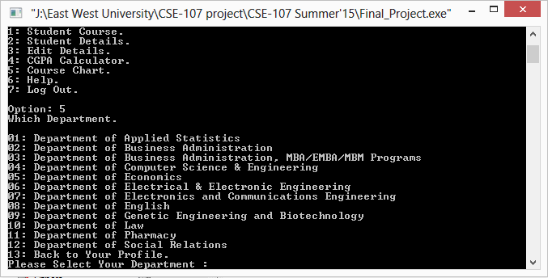

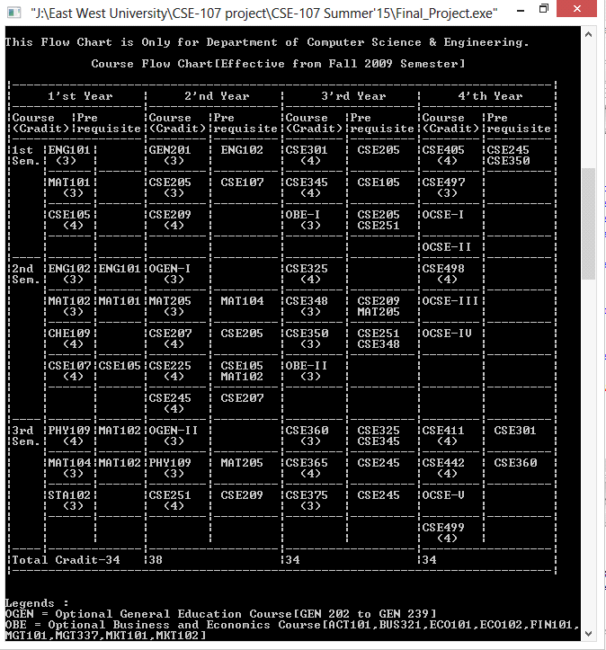

9. Press 6 for help from your advisor or instructors. It will ask for your department. If you select your department it will show the entire active faculty member name. If you select your advisor or faculty name, the system will show that faculty’s URL, Email and Room no.

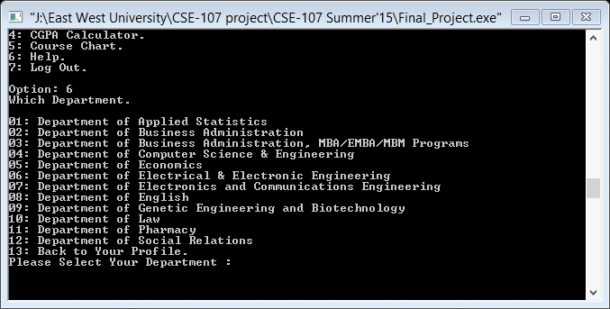

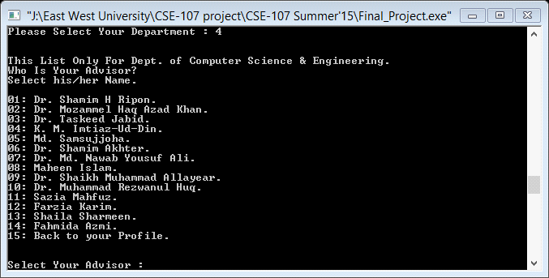

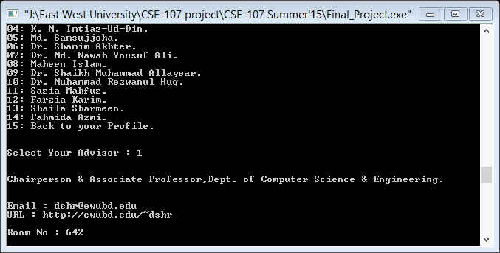

10. Press 7 for Log Out from your account and return to the main menu.

11. Press 3 in main menu for exit from the system.