**LAPORAN PENGERJAAN UJI KOMPETENSI KEJURUAN**

**SMK MAHARDHIKA BATUJAJAR**

**TAHUN PELAJARAN 2022-2023**

KOMPETENSI KEAHLIAN : Rekayasa Perangkat Lunak

KELAS : XII RPL 2

NAMA LENGKAP : Rifqi Surya Putra

NIS : 2122.10.423

PAKET SOAL : Aplikasi Perpustakaan Digital

JENIS APLIKASI : Web

ALOKASI WAKTU : 24 Jam

# 1. PENJADWALAN KEGIATAN

# 2. PERSIAPAN PERANGKAT KERAS

● Machine name: PC01

● Operating System: Windows 7 Ultimate 64-bit (6.1, Build 7601) Service Pack 1

(7601.win7sp1_ldr_escrow.210105-1105)

● Language: Indonesian (Regional Setting: Indonesian)

● System Manufacturer: To be filled by O.E.M.

● System Model: To be filled by O.E.M.

● BIOS: BIOS Date: 12/30/20 10:23:08 Ver: 04.06.05

● Processor: Intel® Core™ i5-3470 CPU @ 3.20GHz (4 CPUs), ~3.2GH

● Memory: 4096MB RAM

● Available OS Memory: 3986MB RAM

● Monitor: SPC

● Keyboard: Logitech

● Mouse: Logitech

# 3. PERSIAPAN PERANGKAT LUNAK

*●* Visual Studio Code

● Astah

● Browser

● Microsoft Office (Word, Excel)

● XAMPP

● Balsamiq

● Browser

# 4. PERANCANGAN ALGORITMA APLIKASI

* **Peminjaman** 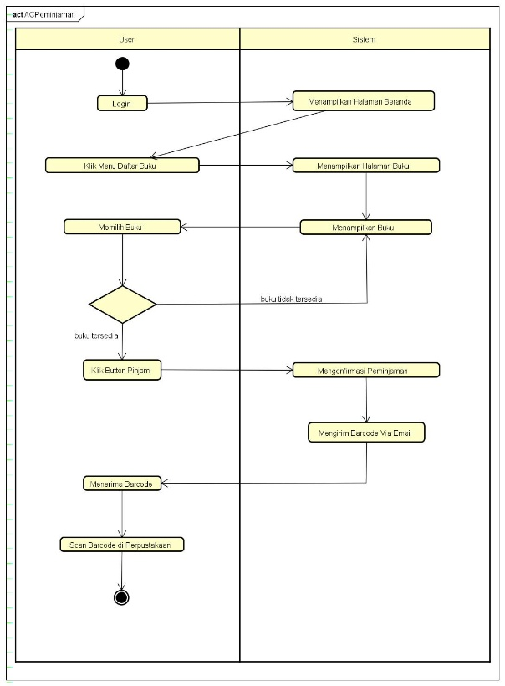
* **Pengembalian**

# Login

# Logout

* Register

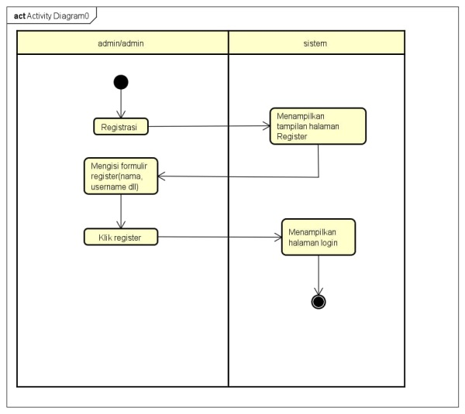

# 5. PERANCANGAN DESAIN BASIS DATA

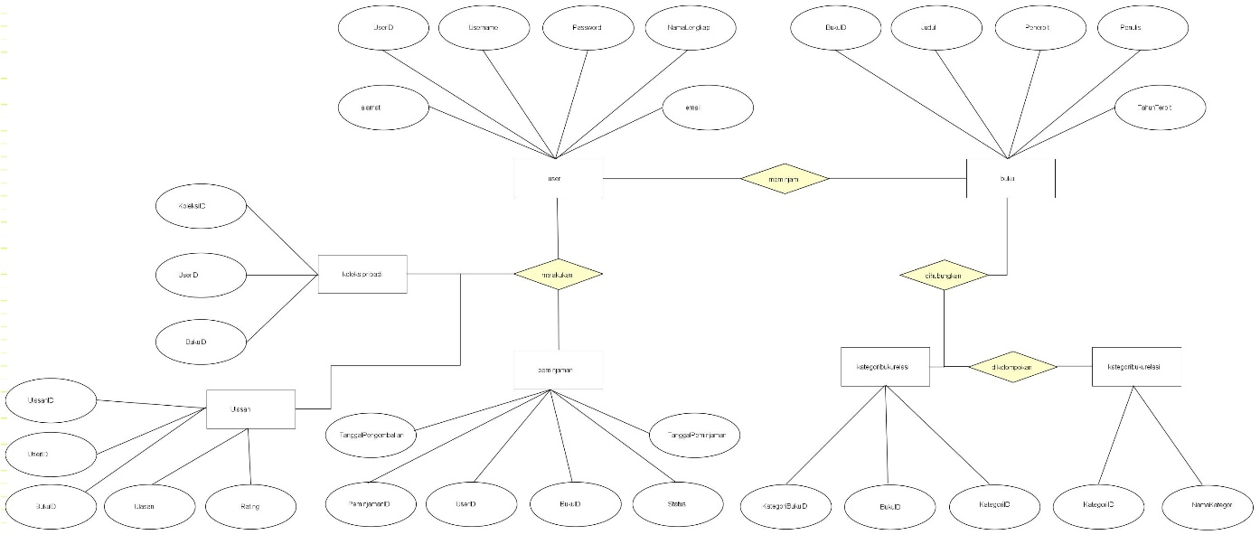

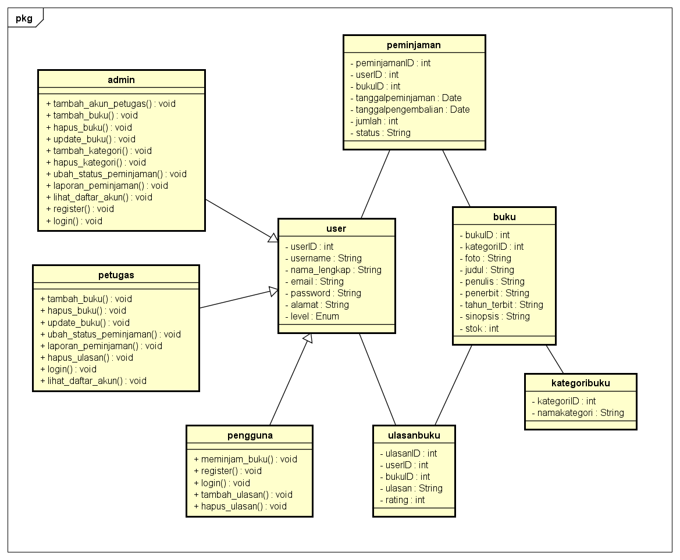

# 6. DUMMY DATA

* Daftar User

|  |  |  |  |  |  |  |
| --- | --- | --- | --- | --- | --- | --- |
| **No** | **ID User** | **Password** | **Email** | **Nama lengkap** | **Alamat** | **Level** |
| 1 | 1 | admin | admin | admin@gmail.com | admin | Padalarang |
| 2 | 5 | petugas | petugas | petugas@gmail.com | petugas | Bandung |
| 3 | 6 | pengguna | pengguna | pengguna@gmail.com | pengguna | Cimareme |
| 4 | 8 | pengguna1 | pengguna1 | pengguna1@gmail.com | Pengguna1 | Earth |
| 5 | 9 | Sans | 12345 | sans@gmail.com | Ihsan Agus | Batujajar |
| 6 | 10 | Lianmi | lianmi | fahmikurniawan@gmail.com | Fahmi Kurniawan | Leuwi Gajah |
| 7 | 11 | Fairlyy | 12345 | rizqylawu@gmail.com | Rizqy Lawu Saputra | Cibodas |
| 8 | 12 | Mikan | mikan | chikaaqours@gmail.com | Chika Takami | Numazu |
| 9 | 13 | Honk | muse | honokamuse@gmail.com | Honoka Kousaka | Japan |
| 10 | 14 | Yousorooo | 12345 | youaqours@gmail.com | You Watanabe | Numazu |
| 11 | 15 | Rangga | 12345 | rangga@gmail.com | Rangga Surya Putra | Padalarang |

* Daftar Buku

|  |  |  |  |  |  |
| --- | --- | --- | --- | --- | --- |
| **No** | **Judul** | **Penulis** | **Penerbit** | **Tahun Terbit** | **Stok** |
| 1 | Naruto | Masashi Kishimoto | Shueisha | 1999 | 10 |
| 2 | Jujutsu Kaisen | Gege Akutami | Shueisha | 2018 | 4 |
| 3 | Hujan | Tereliye | PT. GRAMEDIA PUSTAKA UTAMA | 2016 | 4 |
| 4 | How To Slap Someone Through Internet | Rifqi | Oonga Boonga | 2024 | 15 |
| 5 | How to Breath | Rifqi | Oonga Boonga | 2023 | 15 |
| 6 | My Wife is Very CUNNY(Cute and Funny) | Rifqi | Oonga Boonga | 2015 | 1 |
| 7 | Necronomicon | H.P Lovecraft | H.P Lovecraft | 1938 | 2 |
| 8 | Ensiklopedia Antariksa | James Trefil | KT. NEA Publishing | 2018 | 2 |
| 9 | Belajar HTML Dan CSS Dasar | Diki Alfarabi Hadi | Malasngoding | 2020 | 10 |
| 10 | Belajar HTML Dan CSS Dasar 2 | Diki Alfarabi Hadi | Malasngoding | 2020 | 12 |

* Daftar Kategori

|  |  |  |
| --- | --- | --- |
| **No** | **ID Kategori** | **Nama Kategori** |
| 1 | 1 | Novel |
| 2 | 2 | Komik |
| 3 | 3 | Buku Pelajaran |
| 4 | 4 | Ensiklopedia |
| 5 | 6 | Panduan |
| 6 | 7 | Biografi |
| 7 | 8 | Kamus |
| 8 | 9 | Cerpen/Dongeng |
| 9 | 10 | Majalah |
| 10 | 11 | Atlas |

* Daftar Peminjaman

# 7. PEMBUATAN BASIS DATA (MySQL Code)

* Buku

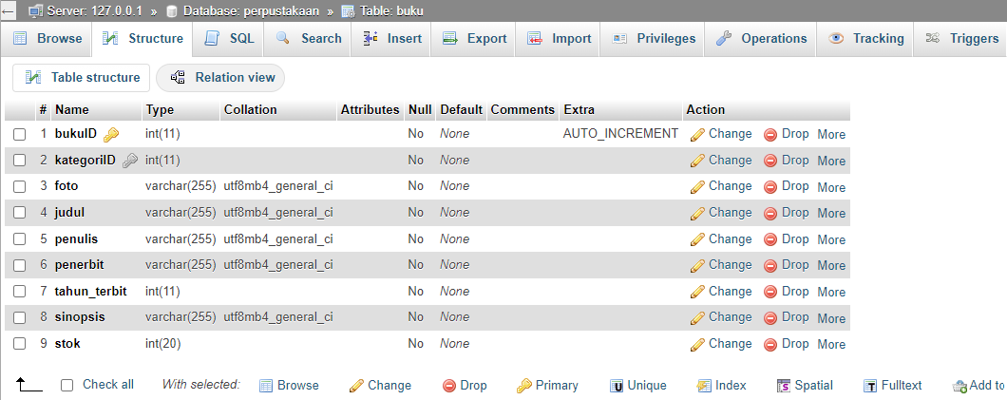

* Kategori

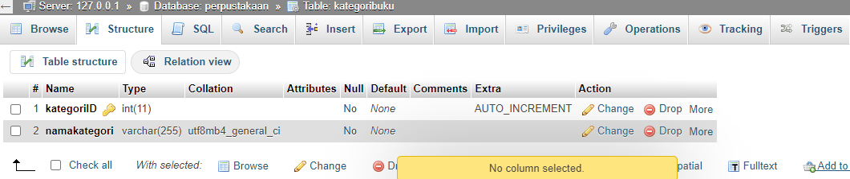

* Koleksi

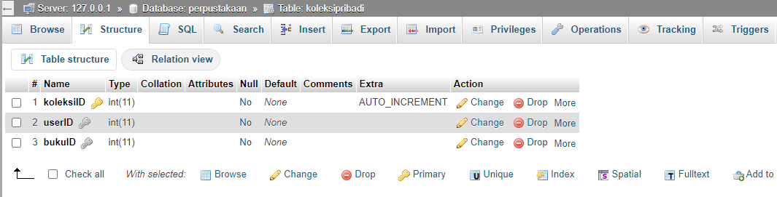

* Peminjaman

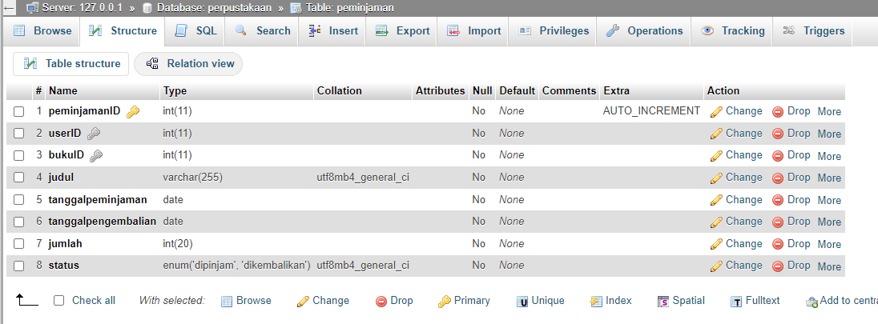

* Ulasan

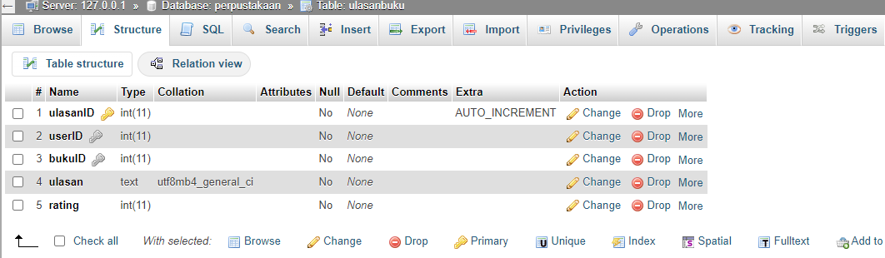

* User

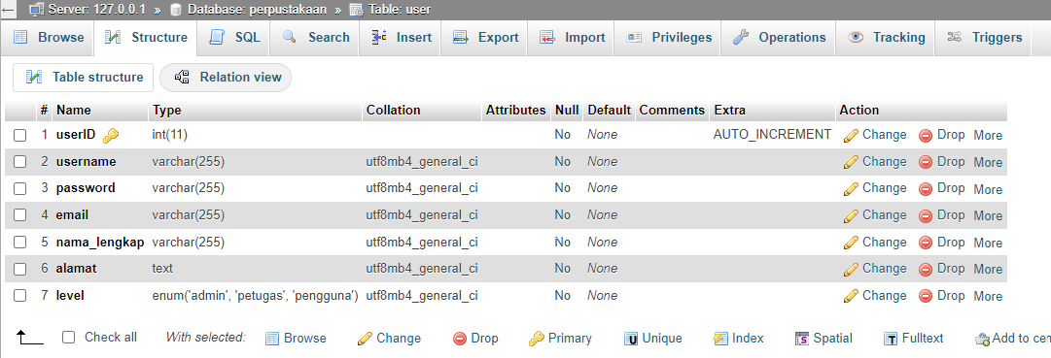

**8. PERANCANGAN TAMPILAN ANTARMUKA (UI) WEB**

# ✓ Aplikasi Perpustakaan Digital

## Silahkan gambarkan use case diagram aplikasi yang kamu buat

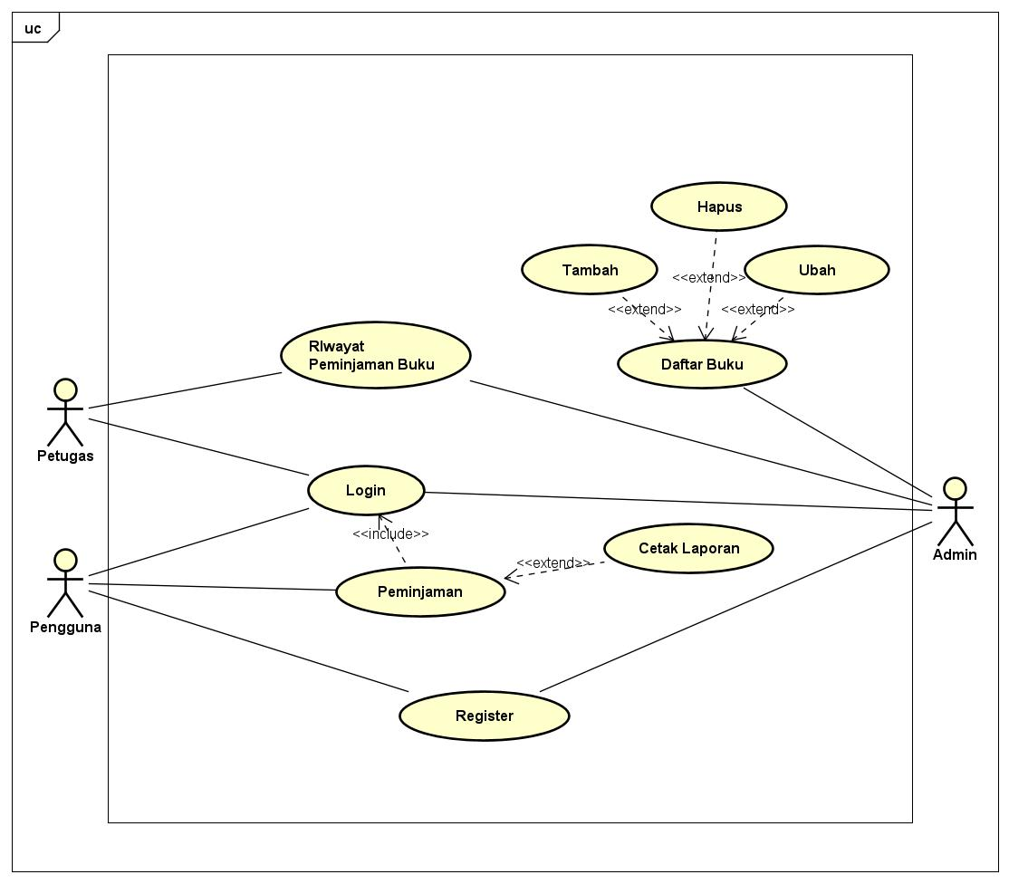

1. **Tampilan Admin**
   1. Index

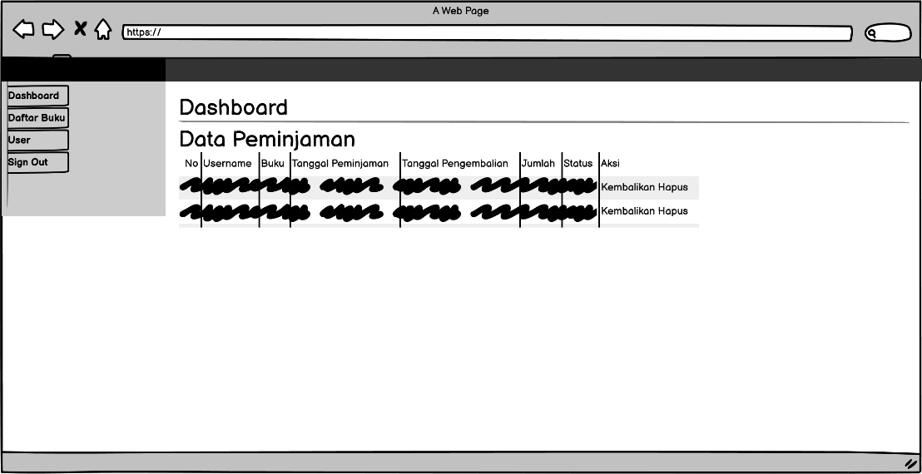

* 1. Login

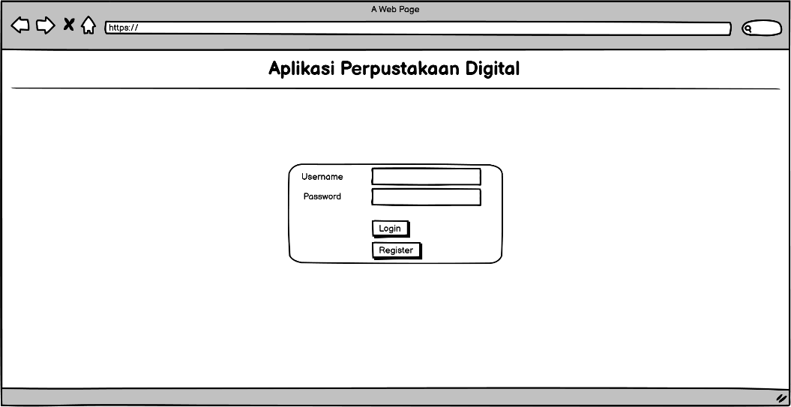

* 1. Register

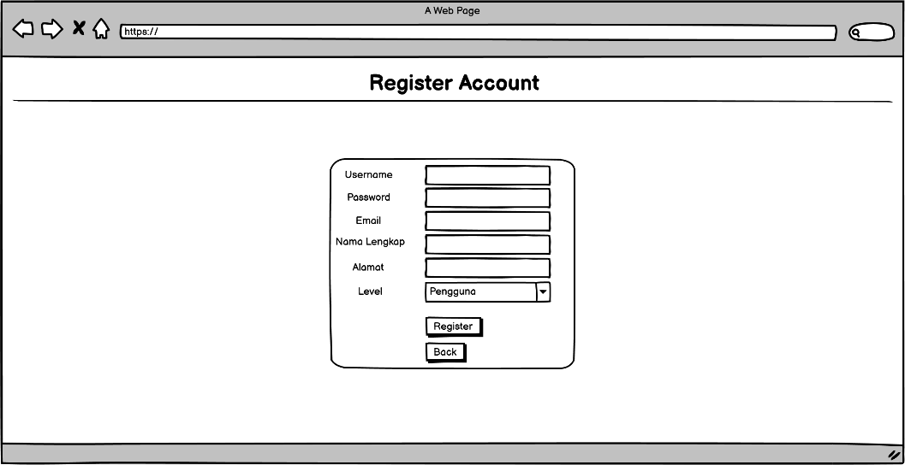

* 1. Daftar Buku

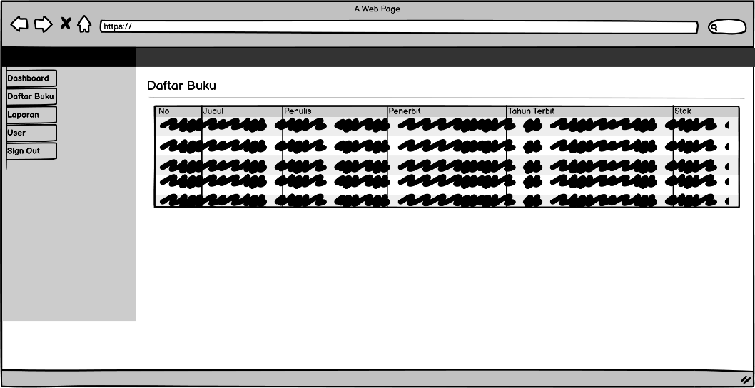

1. **Tampilan Pengguna**
2. Index

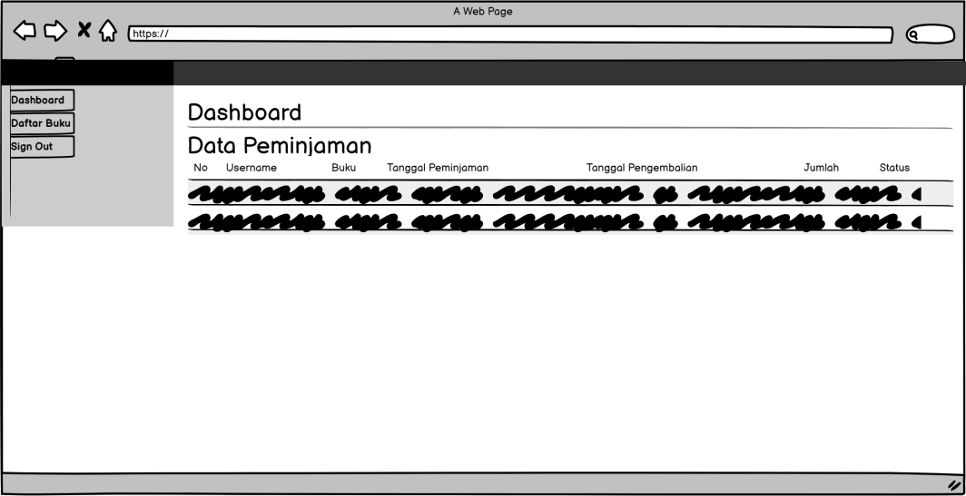

1. Daftar Buku

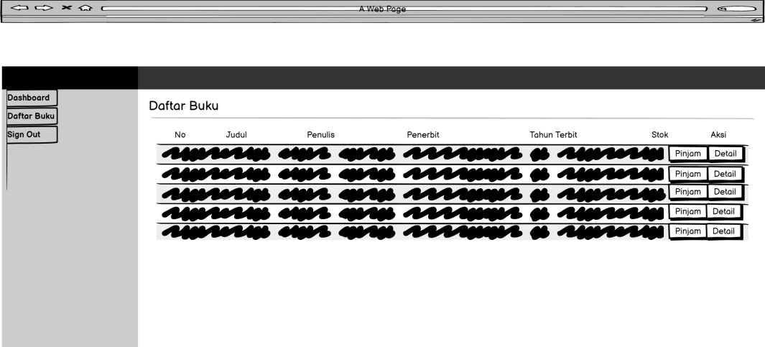

1. Pinjam Buku

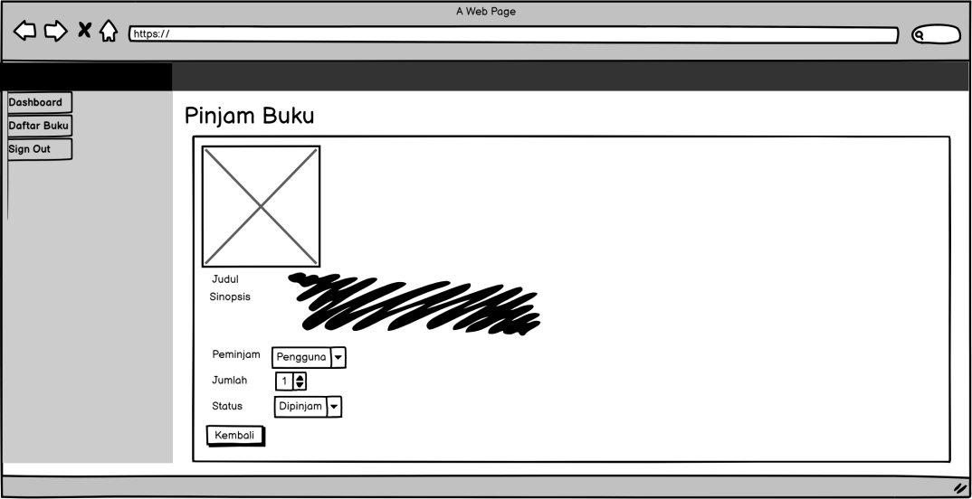

1. Detail Buku

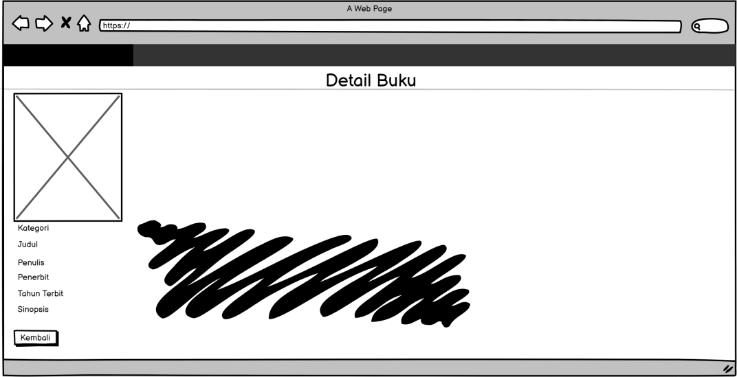

# 9. PEMBUATAN STRUKTUR WEB (HTML)

|  |
| --- |
| <!<!DOCTYPE html>  <html>  <head>  <title>Aplikasi Perpustakaan Digital</title>  <style>  body {  font-family: verdana;  font-size: 15px;  }  a {  text-decoration: none;  color: blue;  }  a:hover {  color: green;  }  .container{  background-color: transparent;  width: 25%;  margin: 15% 37%;  border: 1px solid black;  border-radius: 10px;    }  table{  border-collapse: collapse;  text-align: center;  margin: 15px;    }  input[type=submit]{  width: 55px;  cursor: pointer;  margin: 4px 0;  padding: 7px 6px;  border: none;  }  input{  border-radius:10px;  background-color: transparent;  }  </style>  </head>  <body>  <h1 align="center">Aplikasi Perpustakaan Digital</h1>  <hr>    <div class="container">  <table width="300" border="0" align="center">  <form action="login-proses.php" method="post">  <tr>  <td width="150">Username</td>  <td>  <input type="text" name="username" required autofocus>  </td>  </tr>  <tr>  <td width="150">Password</td>  <td>  <input type="password" name="password" required autofocus>  </td>  </tr>  <tr>  <td colspan = "2">  <input type="submit" value="login" required>  </td>  </tr>  </form>  <tr>  <form action="register.php">  <td colspan = "2">  <input type="submit" value="Register">  </td>  </form>  </tr>    </table>  </div>    </body>  </html> |

1. PEMBUATAN STYLE WEB (CSS)

|  |
| --- |
| #grad, body {  font-family: 'Times New Roman', Times, serif;  background-image: linear-gradient(to right, #87CEEB, #FFFFFF);  }  table{  width : 100%;  border-collapse: collapse;  }  .container {  text-align: center;  }  th, td {  border-bottom: 1px solid #ddd;  background-image: linear-gradient(to bottom, #87CEEB, #87CEEB);  }  .bi {  display: inline-block;  width: 1rem;  height: 1rem;  }    /*  * Sidebar  */    @media (min-width: 768px) {  .sidebar .offcanvas-lg {  position: -webkit-sticky;  position: sticky;  top: 48px;  }  .navbar-search {  display: block;  }  }    .sidebar .nav-link {  font-size: .875rem;  font-weight: 500;  }    .sidebar .nav-link.active {  color: #2470dc;  }    .sidebar-heading {  font-size: .75rem;  }    /*  * Navbar  */    .navbar-brand {  padding-top: .75rem;  padding-bottom: .75rem;  background-color: rgba(0, 0, 0, .25);  box-shadow: inset -1px 0 0 rgba(0, 0, 0, .25);  }    .navbar .form-control {  padding: .75rem 1rem;  } |

1. PEMBUATAN KODE WEB (PHP/JS)

File index.php

|  |
| --- |
| <?php  session_start();  $login =isset( $_SESSION ['login']);  if ($login == 1) {  include "koneksi.php";  $cookie_name = "user";  $cookie_value = "user";  Setcookie ($cookie_name, $cookie_value, time()+1000, "/");  ?>  <!doctype html>  <html lang="en" data-bs-theme="auto">  <head>  <meta charset="utf-8">  <meta name="viewport" content="width=device-width, initial-scale=1">  <meta name="description" content="">  <meta name="author" content="Mark Otto, Jacob Thornton, and Bootstrap contributors">  <meta name="generator" content="Hugo 0.118.2">  <title>Aplikasi Perpustakaan Digital</title>  <link rel="canonical" href="https://getbootstrap.com/docs/5.3/examples/dashboard/">    <link rel="stylesheet" href="https://cdn.jsdelivr.net/npm/@docsearch/css@3">  <link href="assets/css/bootstrap.min.css" rel="stylesheet">  <style>  .bd-placeholder-img {  font-size: 1.125rem;  text-anchor: middle;  -webkit-user-select: none;  -moz-user-select: none;  user-select: none;  }  @media (min-width: 768px) {  .bd-placeholder-img-lg {  font-size: 3.5rem;  }  }  .b-example-divider {  width: 100%;  height: 3rem;  background-color: rgba(0, 0, 0, .1);  border: solid rgba(0, 0, 0, .15);  border-width: 1px 0;  box-shadow: inset 0 .5em 1.5em rgba(0, 0, 0, .1), inset 0 .125em .5em rgba(0, 0, 0, .15);  }  .b-example-vr {  flex-shrink: 0;  width: 1.5rem;  height: 100vh;  }  .bi {  vertical-align: -.125em;  fill: currentColor;  }  .nav-scroller {  position: relative;  z-index: 2;  height: 2.75rem;  overflow-y: hidden;  }  .nav-scroller .nav {  display: flex;  flex-wrap: nowrap;  padding-bottom: 1rem;  margin-top: -1px;  overflow-x: auto;  text-align: center;  white-space: nowrap;  -webkit-overflow-scrolling: touch;  }  .btn-bd-primary {  --bd-violet-bg: #712cf9;  --bd-violet-rgb: 112.520718, 44.062154, 249.437846;  --bs-btn-font-weight: 600;  --bs-btn-color: var(--bs-white);  --bs-btn-bg: var(--bd-violet-bg);  --bs-btn-border-color: var(--bd-violet-bg);  --bs-btn-hover-color: var(--bs-white);  --bs-btn-hover-bg: #6528e0;  --bs-btn-hover-border-color: #6528e0;  --bs-btn-focus-shadow-rgb: var(--bd-violet-rgb);  --bs-btn-active-color: var(--bs-btn-hover-color);  --bs-btn-active-bg: #5a23c8;  --bs-btn-active-border-color: #5a23c8;  }  .bd-mode-toggle {  z-index: 1500;  }  .bd-mode-toggle .dropdown-menu .active .bi {  display: block !important;  }  </style>    <!-- Custom styles for this template -->  <link href="https://cdn.jsdelivr.net/npm/bootstrap-icons@1.10.5/font/bootstrap-icons.min.css" rel="stylesheet">  <!-- Custom styles for this template -->  <link href="assets/css/dashboard.css" rel="stylesheet">  </head>  <body>  <svg xmlns="http://www.w3.org/2000/svg" class="d-none">  <symbol id="calendar3" viewBox="0 0 16 16">  <path d="M14 0H2a2 2 0 0 0-2 2v12a2 2 0 0 0 2 2h12a2 2 0 0 0 2-2V2a2 2 0 0 0-2-2zM1 3.857C1 3.384 1.448 3 2 3h12c.552 0 1 .384 1 .857v10.286c0 .473-.448.857-1 .857H2c-.552 0-1-.384-1-.857V3.857z"/>  <path d="M6.5 7a1 1 0 1 0 0-2 1 1 0 0 0 0 2zm3 0a1 1 0 1 0 0-2 1 1 0 0 0 0 2zm3 0a1 1 0 1 0 0-2 1 1 0 0 0 0 2zm-9 3a1 1 0 1 0 0-2 1 1 0 0 0 0 2zm3 0a1 1 0 1 0 0-2 1 1 0 0 0 0 2zm3 0a1 1 0 1 0 0-2 1 1 0 0 0 0 2zm3 0a1 1 0 1 0 0-2 1 1 0 0 0 0 2zm-9 3a1 1 0 1 0 0-2 1 1 0 0 0 0 2zm3 0a1 1 0 1 0 0-2 1 1 0 0 0 0 2zm3 0a1 1 0 1 0 0-2 1 1 0 0 0 0 2z"/>  </symbol>  <symbol id="cart" viewBox="0 0 16 16">  <path d="M0 1.5A.5.5 0 0 1 .5 1H2a.5.5 0 0 1 .485.379L2.89 3H14.5a.5.5 0 0 1 .49.598l-1 5a.5.5 0 0 1-.465.401l-9.397.472L4.415 11H13a.5.5 0 0 1 0 1H4a.5.5 0 0 1-.491-.408L2.01 3.607 1.61 2H.5a.5.5 0 0 1-.5-.5zM3.102 4l.84 4.479 9.144-.459L13.89 4H3.102zM5 12a2 2 0 1 0 0 4 2 2 0 0 0 0-4zm7 0a2 2 0 1 0 0 4 2 2 0 0 0 0-4zm-7 1a1 1 0 1 1 0 2 1 1 0 0 1 0-2zm7 0a1 1 0 1 1 0 2 1 1 0 0 1 0-2z"/>  </symbol>  <symbol id="chevron-right" viewBox="0 0 16 16">  <path fill-rule="evenodd" d="M4.646 1.646a.5.5 0 0 1 .708 0l6 6a.5.5 0 0 1 0 .708l-6 6a.5.5 0 0 1-.708-.708L10.293 8 4.646 2.354a.5.5 0 0 1 0-.708z"/>  </symbol>  <symbol id="door-closed" viewBox="0 0 16 16">  <path d="M3 2a1 1 0 0 1 1-1h8a1 1 0 0 1 1 1v13h1.5a.5.5 0 0 1 0 1h-13a.5.5 0 0 1 0-1H3V2zm1 13h8V2H4v13z"/>  <path d="M9 9a1 1 0 1 0 2 0 1 1 0 0 0-2 0z"/>  </symbol>  <symbol id="file-earmark" viewBox="0 0 16 16">  <path d="M14 4.5V14a2 2 0 0 1-2 2H4a2 2 0 0 1-2-2V2a2 2 0 0 1 2-2h5.5L14 4.5zm-3 0A1.5 1.5 0 0 1 9.5 3V1H4a1 1 0 0 0-1 1v12a1 1 0 0 0 1 1h8a1 1 0 0 0 1-1V4.5h-2z"/>  </symbol>  <symbol id="file-earmark-text" viewBox="0 0 16 16">  <path d="M5.5 7a.5.5 0 0 0 0 1h5a.5.5 0 0 0 0-1h-5zM5 9.5a.5.5 0 0 1 .5-.5h5a.5.5 0 0 1 0 1h-5a.5.5 0 0 1-.5-.5zm0 2a.5.5 0 0 1 .5-.5h2a.5.5 0 0 1 0 1h-2a.5.5 0 0 1-.5-.5z"/>  <path d="M9.5 0H4a2 2 0 0 0-2 2v12a2 2 0 0 0 2 2h8a2 2 0 0 0 2-2V4.5L9.5 0zm0 1v2A1.5 1.5 0 0 0 11 4.5h2V14a1 1 0 0 1-1 1H4a1 1 0 0 1-1-1V2a1 1 0 0 1 1-1h5.5z"/>  </symbol>  <symbol id="gear-wide-connected" viewBox="0 0 16 16">  <path d="M7.068.727c.243-.97 1.62-.97 1.864 0l.071.286a.96.96 0 0 0 1.622.434l.205-.211c.695-.719 1.888-.03 1.613.931l-.08.284a.96.96 0 0 0 1.187 1.187l.283-.081c.96-.275 1.65.918.931 1.613l-.211.205a.96.96 0 0 0 .434 1.622l.286.071c.97.243.97 1.62 0 1.864l-.286.071a.96.96 0 0 0-.434 1.622l.211.205c.719.695.03 1.888-.931 1.613l-.284-.08a.96.96 0 0 0-1.187 1.187l.081.283c.275.96-.918 1.65-1.613.931l-.205-.211a.96.96 0 0 0-1.622.434l-.071.286c-.243.97-1.62.97-1.864 0l-.071-.286a.96.96 0 0 0-1.622-.434l-.205.211c-.695.719-1.888.03-1.613-.931l.08-.284a.96.96 0 0 0-1.186-1.187l-.284.081c-.96.275-1.65-.918-.931-1.613l.211-.205a.96.96 0 0 0-.434-1.622l-.286-.071c-.97-.243-.97-1.62 0-1.864l.286-.071a.96.96 0 0 0 .434-1.622l-.211-.205c-.719-.695-.03-1.888.931-1.613l.284.08a.96.96 0 0 0 1.187-1.186l-.081-.284c-.275-.96.918-1.65 1.613-.931l.205.211a.96.96 0 0 0 1.622-.434l.071-.286zM12.973 8.5H8.25l-2.834 3.779A4.998 4.998 0 0 0 12.973 8.5zm0-1a4.998 4.998 0 0 0-7.557-3.779l2.834 3.78h4.723zM5.048 3.967c-.03.021-.058.043-.087.065l.087-.065zm-.431.355A4.984 4.984 0 0 0 3.002 8c0 1.455.622 2.765 1.615 3.678L7.375 8 4.617 4.322zm.344 7.646.087.065-.087-.065z"/>  </symbol>  <symbol id="graph-up" viewBox="0 0 16 16">  <path fill-rule="evenodd" d="M0 0h1v15h15v1H0V0Zm14.817 3.113a.5.5 0 0 1 .07.704l-4.5 5.5a.5.5 0 0 1-.74.037L7.06 6.767l-3.656 5.027a.5.5 0 0 1-.808-.588l4-5.5a.5.5 0 0 1 .758-.06l2.609 2.61 4.15-5.073a.5.5 0 0 1 .704-.07Z"/>  </symbol>  <symbol id="house-fill" viewBox="0 0 16 16">  <path d="M8.707 1.5a1 1 0 0 0-1.414 0L.646 8.146a.5.5 0 0 0 .708.708L8 2.207l6.646 6.647a.5.5 0 0 0 .708-.708L13 5.793V2.5a.5.5 0 0 0-.5-.5h-1a.5.5 0 0 0-.5.5v1.293L8.707 1.5Z"/>  <path d="m8 3.293 6 6V13.5a1.5 1.5 0 0 1-1.5 1.5h-9A1.5 1.5 0 0 1 2 13.5V9.293l6-6Z"/>  </symbol>  <symbol id="list" viewBox="0 0 16 16">  <path fill-rule="evenodd" d="M2.5 12a.5.5 0 0 1 .5-.5h10a.5.5 0 0 1 0 1H3a.5.5 0 0 1-.5-.5zm0-4a.5.5 0 0 1 .5-.5h10a.5.5 0 0 1 0 1H3a.5.5 0 0 1-.5-.5zm0-4a.5.5 0 0 1 .5-.5h10a.5.5 0 0 1 0 1H3a.5.5 0 0 1-.5-.5z"/>  </symbol>  <symbol id="people" viewBox="0 0 16 16">  <path d="M15 14s1 0 1-1-1-4-5-4-5 3-5 4 1 1 1 1h8Zm-7.978-1A.261.261 0 0 1 7 12.996c.001-.264.167-1.03.76-1.72C8.312 10.629 9.282 10 11 10c1.717 0 2.687.63 3.24 1.276.593.69.758 1.457.76 1.72l-.008.002a.274.274 0 0 1-.014.002H7.022ZM11 7a2 2 0 1 0 0-4 2 2 0 0 0 0 4Zm3-2a3 3 0 1 1-6 0 3 3 0 0 1 6 0ZM6.936 9.28a5.88 5.88 0 0 0-1.23-.247A7.35 7.35 0 0 0 5 9c-4 0-5 3-5 4 0 .667.333 1 1 1h4.216A2.238 2.238 0 0 1 5 13c0-1.01.377-2.042 1.09-2.904.243-.294.526-.569.846-.816ZM4.92 10A5.493 5.493 0 0 0 4 13H1c0-.26.164-1.03.76-1.724.545-.636 1.492-1.256 3.16-1.275ZM1.5 5.5a3 3 0 1 1 6 0 3 3 0 0 1-6 0Zm3-2a2 2 0 1 0 0 4 2 2 0 0 0 0-4Z"/>  </symbol>  <symbol id="plus-circle" viewBox="0 0 16 16">  <path d="M8 15A7 7 0 1 1 8 1a7 7 0 0 1 0 14zm0 1A8 8 0 1 0 8 0a8 8 0 0 0 0 16z"/>  <path d="M8 4a.5.5 0 0 1 .5.5v3h3a.5.5 0 0 1 0 1h-3v3a.5.5 0 0 1-1 0v-3h-3a.5.5 0 0 1 0-1h3v-3A.5.5 0 0 1 8 4z"/>  </symbol>  <symbol id="puzzle" viewBox="0 0 16 16">  <path d="M3.112 3.645A1.5 1.5 0 0 1 4.605 2H7a.5.5 0 0 1 .5.5v.382c0 .696-.497 1.182-.872 1.469a.459.459 0 0 0-.115.118.113.113 0 0 0-.012.025L6.5 4.5v.003l.003.01c.004.01.014.028.036.053a.86.86 0 0 0 .27.194C7.09 4.9 7.51 5 8 5c.492 0 .912-.1 1.19-.24a.86.86 0 0 0 .271-.194.213.213 0 0 0 .039-.063v-.009a.112.112 0 0 0-.012-.025.459.459 0 0 0-.115-.118c-.375-.287-.872-.773-.872-1.469V2.5A.5.5 0 0 1 9 2h2.395a1.5 1.5 0 0 1 1.493 1.645L12.645 6.5h.237c.195 0 .42-.147.675-.48.21-.274.528-.52.943-.52.568 0 .947.447 1.154.862C15.877 6.807 16 7.387 16 8s-.123 1.193-.346 1.638c-.207.415-.586.862-1.154.862-.415 0-.733-.246-.943-.52-.255-.333-.48-.48-.675-.48h-.237l.243 2.855A1.5 1.5 0 0 1 11.395 14H9a.5.5 0 0 1-.5-.5v-.382c0-.696.497-1.182.872-1.469a.459.459 0 0 0 .115-.118.113.113 0 0 0 .012-.025L9.5 11.5v-.003a.214.214 0 0 0-.039-.064.859.859 0 0 0-.27-.193C8.91 11.1 8.49 11 8 11c-.491 0-.912.1-1.19.24a.859.859 0 0 0-.271.194.214.214 0 0 0-.039.063v.003l.001.006a.113.113 0 0 0 .012.025c.016.027.05.068.115.118.375.287.872.773.872 1.469v.382a.5.5 0 0 1-.5.5H4.605a1.5 1.5 0 0 1-1.493-1.645L3.356 9.5h-.238c-.195 0-.42.147-.675.48-.21.274-.528.52-.943.52-.568 0-.947-.447-1.154-.862C.123 9.193 0 8.613 0 8s.123-1.193.346-1.638C.553 5.947.932 5.5 1.5 5.5c.415 0 .733.246.943.52.255.333.48.48.675.48h.238l-.244-2.855zM4.605 3a.5.5 0 0 0-.498.55l.001.007.29 3.4A.5.5 0 0 1 3.9 7.5h-.782c-.696 0-1.182-.497-1.469-.872a.459.459 0 0 0-.118-.115.112.112 0 0 0-.025-.012L1.5 6.5h-.003a.213.213 0 0 0-.064.039.86.86 0 0 0-.193.27C1.1 7.09 1 7.51 1 8c0 .491.1.912.24 1.19.07.14.14.225.194.271a.213.213 0 0 0 .063.039H1.5l.006-.001a.112.112 0 0 0 .025-.012.459.459 0 0 0 .118-.115c.287-.375.773-.872 1.469-.872H3.9a.5.5 0 0 1 .498.542l-.29 3.408a.5.5 0 0 0 .497.55h1.878c-.048-.166-.195-.352-.463-.557-.274-.21-.52-.528-.52-.943 0-.568.447-.947.862-1.154C6.807 10.123 7.387 10 8 10s1.193.123 1.638.346c.415.207.862.586.862 1.154 0 .415-.246.733-.52.943-.268.205-.415.39-.463.557h1.878a.5.5 0 0 0 .498-.55l-.001-.007-.29-3.4A.5.5 0 0 1 12.1 8.5h.782c.696 0 1.182.497 1.469.872.05.065.091.099.118.115.013.008.021.01.025.012a.02.02 0 0 0 .006.001h.003a.214.214 0 0 0 .064-.039.86.86 0 0 0 .193-.27c.14-.28.24-.7.24-1.191 0-.492-.1-.912-.24-1.19a.86.86 0 0 0-.194-.271.215.215 0 0 0-.063-.039H14.5l-.006.001a.113.113 0 0 0-.025.012.459.459 0 0 0-.118.115c-.287.375-.773.872-1.469.872H12.1a.5.5 0 0 1-.498-.543l.29-3.407a.5.5 0 0 0-.497-.55H9.517c.048.166.195.352.463.557.274.21.52.528.52.943 0 .568-.447.947-.862 1.154C9.193 5.877 8.613 6 8 6s-1.193-.123-1.638-.346C5.947 5.447 5.5 5.068 5.5 4.5c0-.415.246-.733.52-.943.268-.205.415-.39.463-.557H4.605z"/>  </symbol>  <symbol id="search" viewBox="0 0 16 16">  <path d="M11.742 10.344a6.5 6.5 0 1 0-1.397 1.398h-.001c.03.04.062.078.098.115l3.85 3.85a1 1 0 0 0 1.415-1.414l-3.85-3.85a1.007 1.007 0 0 0-.115-.1zM12 6.5a5.5 5.5 0 1 1-11 0 5.5 5.5 0 0 1 11 0z"/>  </symbol>  </svg>  <header class="navbar sticky-top bg-dark flex-md-nowrap p-0 shadow" data-bs-theme="dark">  <a class="navbar-brand col-md-3 col-lg-2 me-0 px-3 fs-6 text-white" href="#">Perpustakaan Digital</a>  <ul class="navbar-nav flex-row d-md-none">  <li class="nav-item text-nowrap">  <button class="nav-link px-3 text-white" type="button" data-bs-toggle="collapse" data-bs-target="#navbarSearch" aria-controls="navbarSearch" aria-expanded="false" aria-label="Toggle search">  <svg class="bi"><use xlink:href="#search"/></svg>  </button>  </li>  <li class="nav-item text-nowrap">  <button class="nav-link px-3 text-white" type="button" data-bs-toggle="offcanvas" data-bs-target="#sidebarMenu" aria-controls="sidebarMenu" aria-expanded="false" aria-label="Toggle navigation">  <svg class="bi"><use xlink:href="#list"/></svg>  </button>  </li>  </ul>  <div id="navbarSearch" class="navbar-search w-100 collapse">  <input class="form-control w-100 rounded-0 border-0" type="text" placeholder="Search" aria-label="Search">  </div>  </header>  <div class="container-fluid">  <div class="row">  <div class="sidebar border border-right col-md-3 col-lg-2 p-0 bg-body-tertiary">  <div class="offcanvas-md offcanvas-end bg-body-tertiary" tabindex="-1" id="sidebarMenu" aria-labelledby="sidebarMenuLabel">  <div class="offcanvas-header">  <h5 class="offcanvas-title" id="sidebarMenuLabel">Perpustakaan Digital</h5>  <button type="button" class="btn-close" data-bs-dismiss="offcanvas" data-bs-target="#sidebarMenu" aria-label="Close"></button>  </div>  <div class="offcanvas-body d-md-flex flex-column p-0 pt-lg-3 overflow-y-auto">  <ul class="nav flex-column">  <li class="nav-item">  <a class="nav-link d-flex align-items-center gap-2 active" aria-current="page" href="#">  <svg class="bi"><use xlink:href="#house-fill"/></svg>  Dashboard  </a>  </li>  <li class="nav-item">  <a class="nav-link d-flex align-items-center gap-2" href="d_buku.php">  <svg class="bi"><use xlink:href="#cart"/></svg>  Daftar Buku  </a>  </li>  <?php  if($_SESSION ['level'] != 'pengguna'){  ?>  </li>  </ul>  <?php  if($_SESSION ['level'] == 'admin'){  ?>  <ul class="nav flex-column mb-auto">  <li class="nav-item">  <a class="nav-link d-flex align-items-center gap-2" href="d_kategori.php">  <svg class="bi"><use xlink:href="#plus-circle"/></svg>  Kategori  </a>  </li>  <?php  }  ?>  <ul class="nav flex-column mb-auto">  <li class="nav-item">  <a class="nav-link d-flex align-items-center gap-2" href="d_user.php">  <svg class="bi"><use xlink:href="#people"/></svg>  User  </a>  </li>  <?Php  }  ?>  <li class="nav-item">  <a class="nav-link d-flex align-items-center gap-2" href="logout.php">  <svg class="bi"><use xlink:href="#door-closed"/></svg>  Sign out  </a>  </li>  </ul>  </div>  </div>  <div class="sb-sidenav-footer">  <div class="small">Login sebagai <?php echo $_SESSION['username']?></div>  </div>  </div>  <main class="col-md-9 ms-sm-auto col-lg-10 px-md-4">  <div class="d-flex justify-content-between flex-wrap flex-md-nowrap align-items-center pt-3 pb-2 mb-3 border-bottom">  <h1 class="h2">Dashboard</h1>  <div class="btn-toolbar mb-2 mb-md-0">  <div class="btn-group me-2">  <a href="laporan.php" class="btn btn-outline-secondary">Print</a>  </div>    </div>  </div>  <h2>Data Peminjaman</h2>  <?php  if(isset($_SESSION['level'])){ ?>  <div class="table-responsive small">  <table class="table table-striped table-sm">  <thead>  <tr>  <th scope="col">No</th>  <th scope="col">Username</th>  <th scope="col">Buku</th>  <th scope="col">Tanggal Peminjaman</th>  <th scope="col">Tanggal Pengembalian</th>  <th scope="col">Jumlah</th>  <th scope="col">Status</th>  <?php  if($_SESSION ['level'] != 'pengguna'){  ?> <th scope="col">Aksi</th> <?Php  }  ?>  </tr>  </thead>  <tbody>  <?php  include "koneksi.php";  $query = mysqli_query ($koneksi, "SELECT * FROM peminjaman LEFT JOIN user ON peminjaman.userID = user.userID LEFT JOIN buku ON peminjaman.bukuID = buku.bukuID");  $no=0;  while($data = mysqli_fetch_array($query)){  $no++  ?>  <tr>  <td><?php echo $no ?>  <td><?php echo $data['username'] ?></td>  <td><?php echo $data['judul'] ?></td>  <td><?php echo $data['tanggalpeminjaman'] ?></td>  <td><?php echo $data['tanggalpengembalian'] ?></td>  <td><?php echo $data['jumlah'] ?></td>  <td><?php echo $data['status'] ?></td>  <?php  if($_SESSION ['level'] != 'pengguna'){  ?>  <td><a href="pengembalian.php?peminjamanID=<?php echo $data['peminjamanID'];?>" class="btn btn-secondary">Kembalikan</a>  <a href="hapus_peminjaman.php?peminjamanID=<?php echo $data['peminjamanID'];?>" class="btn btn-danger" onClick = "return confirm ('Yakin Ingin Hapus Peminjaman?')" >Hapus</a></td><?Php  }  ?>  </tr>  <?php  }  ?>  </tbody>  </table>  </div>  <?php  }  ?>  </main>    </div>  </div>  <script src="assets/js/bootstrap.bundle.min.js"></script>  <script src="https://cdn.jsdelivr.net/npm/chart.js@4.3.2/dist/chart.umd.js"  integrity="sha384-eI7PSr3L1XLISH8JdDII5YN/njoSsxfbrkCTnJrzXt+ENP5MOVBxD+l6sEG4zoLp"  crossorigin="anonymous"></script><script src="assets/js/dashboard.js"></script></body>  </html>  <?php  } else {  include "login.php";  } |

File koneksi.php

|  |
| --- |
| <?php  $koneksi = mysqli_connect('localhost', 'root', '', 'perpustakaan');  ?> |

1. CRUD File

* Insert

|  |
| --- |
| <?php  //menghubungkan php dengan database  include "koneksi.php";  //menangkap data yg dikirim dari form login  $kategori = $_POST['kategoriID'];  $foto = $_POST['foto'];  $judul = $_POST['judul'];  $penulis = $_POST['penulis'];  $penerbit= $_POST['penerbit'];  $tahun= $_POST['tahunterbit'];  $sinopsis= $_POST['sinopsis'];  $stok = $_POST['stok'];  $input = mysqli_query($koneksi, "INSERT INTO buku VALUES('', '$kategori', '$foto', '$judul', '$penulis', '$penerbit', '$tahun', '$sinopsis', '$stok')");  if(!empty($input)){  echo '<script>  alert("Daftar Berhasil");  window.location = "d_buku.php";  </script>';  }  ?> |

* Delete

|  |
| --- |
| <?php  include 'koneksi.php';  if(isset($_GET['bukuID'])){  $id = $_GET ['bukuID'];  $query = "DELETE FROM `buku` WHERE bukuID = '$id'";  $hasil = mysqli_query($koneksi, $query);  echo '<script>  alert("Data Terhapus");  window.location = "d_buku.php";  </script>';  }  ?> |

* Update

|  |
| --- |
| <?php  //menghubungkan php dengan database  include "koneksi.php";  if(isset($_POST['submit'])){  $bukuID = $_POST['bukuID'];  $judul = $_POST['judul'];  $penulis = $_POST['penulis'];  $penerbit= $_POST['penerbit'];  $tahun= $_POST['tahunterbit'];  $sinopsis = $_POST['sinopsis'];  $stok = $_POST['stok'];  $input = mysqli_query($koneksi,"UPDATE buku SET judul='$judul',  penulis='$penulis',  penerbit='$penerbit',  tahun_terbit='$tahun',  sinopsis='$sinopsis',  stok='$stok' WHERE bukuID='$bukuID'");  }  if(!empty($input)){  echo '<script>  alert("Data Telah di Edit");  window.location = "d_buku.php";  </script>';  }    ?> |

1. Ujicoba

REVISI

1. PENENTUAN DOMAIN DAN HOSTING

1. UPLOAD WEB KE HOSTING

1. UPLOAD WEB KE GITHUB

1. PEMBUATAN USER GUIDANCE