進捗報告_別紙
亀田ゼミ
M2 中田雄大
- 図1，2の詳細
別紙_表1 図1，2の詳細（Airplane）
 | DCT Only |  |  |  | Hybrid
Qレート | Entropy | PSNR | SSIM | Block | Entropy | PSNR | SSIM | Block | 選出基底数
100 | 5.09 | 49.54 | 0.997 | 1019 | 5.01 | 49.54 | 0.997 | 5 | 3
90 | 2.74 | 36.36 | 0.961 | 987 | 2.67 | 36.37 | 0.961 | 37 | 3
80 | 2.00 | 33.25 | 0.936 | 937 | 1.96 | 33.27 | 0.936 | 87 | 3
70 | 1.67 | 31.65 | 0.916 | 868 | 1.65 | 31.67 | 0.915 | 156 | 3
60 | 1.46 | 30.54 | 0.896 | 793 | 1.45 | 30.60 | 0.896 | 231 | 3
50 | 1.29 | 29.85 | 0.884 | 709 | 1.29 | 29.95 | 0.885 | 315 | 3
40 | 1.12 | 29.09 | 0.868 | 679 | 1.13 | 29.20 | 0.869 | 345 | 3
30 | 0.95 | 28.26 | 0.847 | 700 | 0.95 | 28.37 | 0.848 | 324 | 2
20 | 0.72 | 26.85 | 0.809 | 599 | 0.72 | 27.05 | 0.809 | 425 | 0
10 | 0.43 | 24.32 | 0.727 | 462 | 0.45 | 24.78 | 0.735 | 562 | 0

- Barbaraの符号化性能

別紙_図1 BarbaraのPSNR対Entropy





別紙_図2 BarbaraのSSIM対Entropy

別紙_表2 グラフの詳細（Barbara）
 | DCT Only |  |  |  | Hybrid
Qレート | Entropy | PSNR | SSIM | Block | Entropy | PSNR | SSIM | Block | 選出基底数
100 | 5.37 | 49.5 | 0.998 | 1024 | 5.30 | 49.5 | 0.998 | 0 | 0
90 | 3.06 | 36.9 | 0.973 | 1019 | 3.01 | 36.9 | 0.973 | 5 | 3
80 | 2.33 | 33.6 | 0.951 | 1009 | 2.29 | 33.6 | 0.951 | 15 | 3
70 | 1.99 | 31.6 | 0.930 | 1004 | 1.97 | 31.7 | 0.930 | 20 | 3
60 | 1.78 | 30.3 | 0.909 | 999 | 1.75 | 30.3 | 0.909 | 25 | 3
50 | 1.57 | 29.2 | 0.890 | 991 | 1.54 | 29.3 | 0.890 | 33 | 3
40 | 1.35 | 28.2 | 0.865 | 981 | 1.32 | 28.2 | 0.866 | 43 | 3
30 | 1.11 | 26.9 | 0.828 | 953 | 1.09 | 26.9 | 0.829 | 71 | 3
20 | 0.79 | 25.1 | 0.755 | 868 | 0.79 | 25.3 | 0.760 | 156 | 3
10 | 0.41 | 22.4 | 0.596 | 646 | 0.44 | 22.6 | 0.594 | 378 | 0

- Cameramanの符号化性能

別紙_図3 CameramanのPSNR対Entropy





別紙_図4 CameramanのSSIM対Entropy

別紙_表3 グラフの詳細（Cameraman）
 | DCT Only |  |  |  | Hybrid
Qレート | Entropy | PSNR | SSIM | Block | Entropy | PSNR | SSIM | Block | 選出基底数
100 | 4.92 | 49.55 | 0.997 | 1017 | 4.84 | 49.56 | 0.997 | 7 | 3
90 | 2.60 | 36.29 | 0.954 | 978 | 2.53 | 36.30 | 0.954 | 46 | 3
80 | 1.86 | 32.96 | 0.922 | 853 | 1.81 | 32.98 | 0.922 | 171 | 3
70 | 1.53 | 31.32 | 0.900 | 753 | 1.51 | 31.36 | 0.899 | 271 | 3
60 | 1.32 | 30.24 | 0.881 | 706 | 1.29 | 30.30 | 0.881 | 318 | 3
50 | 1.15 | 29.41 | 0.866 | 583 | 1.13 | 29.52 | 0.868 | 441 | 3
40 | 0.99 | 28.70 | 0.852 | 592 | 0.98 | 28.82 | 0.854 | 432 | 3
30 | 0.83 | 27.80 | 0.830 | 590 | 0.82 | 27.95 | 0.833 | 434 | 3
20 | 0.63 | 26.47 | 0.792 | 450 | 0.63 | 26.71 | 0.802 | 574 | 3
10 | 0.39 | 24.24 | 0.722 | 316 | 0.43 | 24.74 | 0.737 | 708 | 0

- Mandrillの符号化性能

別紙_図5 MandrillのPSNR対Entropy





別紙_図6 MandrillのSSIM対Entropy

別紙_表4 グラフの詳細（Mandrill）
 | DCT Only |  |  |  | Hybrid
Qレート | Entropy | PSNR | SSIM | Block | Entropy | PSNR | SSIM | Block | 選出基底数
100 | 6.33 | 49.44 | 0.999 | 1024 | 6.26 | 49.44 | 0.999 | 0 | 0
90 | 4.00 | 33.14 | 0.948 | 1024 | 3.94 | 33.14 | 0.948 | 0 | 0
80 | 2.93 | 29.40 | 0.891 | 1023 | 2.88 | 29.40 | 0.891 | 1 | 3
70 | 2.43 | 27.72 | 0.846 | 1019 | 2.39 | 27.73 | 0.846 | 5 | 3
60 | 2.08 | 26.67 | 0.805 | 1020 | 2.04 | 26.67 | 0.805 | 4 | 3
50 | 1.81 | 26.02 | 0.773 | 1009 | 1.77 | 26.03 | 0.773 | 15 | 3
40 | 1.53 | 25.41 | 0.740 | 987 | 1.50 | 25.41 | 0.739 | 37 | 3
30 | 1.22 | 24.62 | 0.686 | 974 | 1.20 | 24.63 | 0.686 | 50 | 3
20 | 0.85 | 23.62 | 0.610 | 892 | 0.84 | 23.66 | 0.610 | 132 | 3
10 | 0.40 | 21.90 | 0.457 | 623 | 0.43 | 22.08 | 0.452 | 401 | 0

- 入力画像
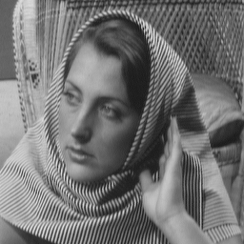
別紙_図7.2 Barbara（原画像）
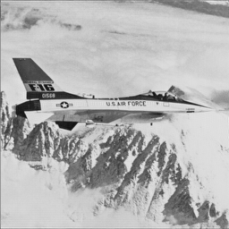
別紙_図7.1 Airplane（原画像）

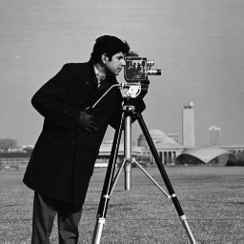
別紙_図7.3 Cameraman（原画像）
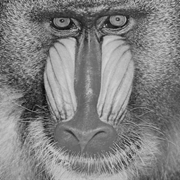
別紙_図7.3 Mandrill（原画像）

