library(tidyverse)

data()

?BOD

ggplot(BOD,aes(time, demand))+

geom_point(size = 3)+

geom_line(colour = "red")

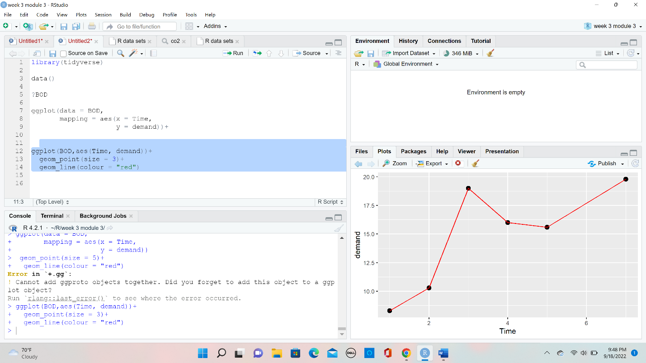

View(co2)

co2 %>%

ggplot(aes(conc, uptake,

colour = Treatment))+

geom_point(size = 3, alpha = 0.5)+

geom_smooth(method = 1m,se = F)+

facet_wrap(~type)+

labs(title = "concentration of co2")+

theme_bw()

co2 %>%

ggplot(aes(Treatment, update))+

geom_boxplot()+

geom_point(aes(size = conc,

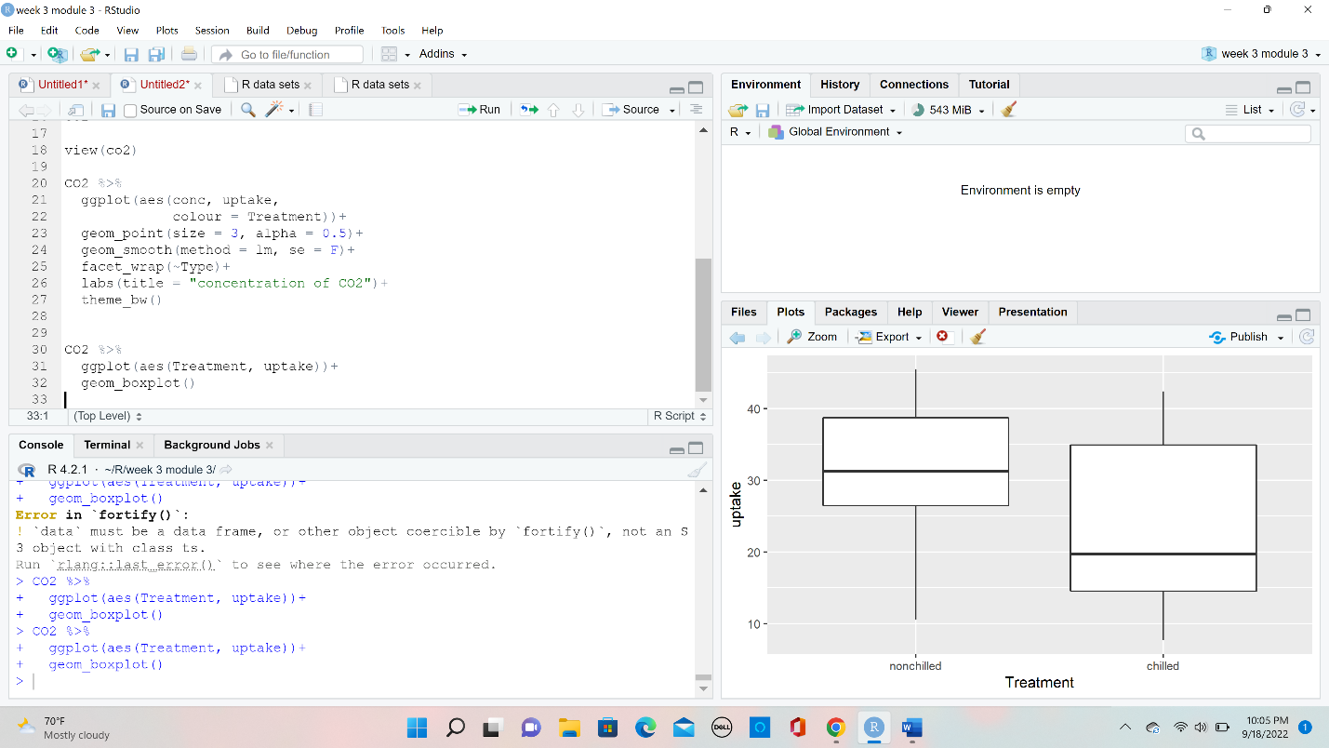

colour = plant))+

facet_wrap(~Type)+

coord_flip()+

theme_bw()+

labs(title = "chilled vs Non-chilled")

View(mpg)

mpg %>%

ggplot(aes(displ, cty))+

geom_point(aes(colour = drv,

size = trans),

alpha = 0.5)+

geom_smooth(method = 1m)+

facet_wrap(~year, nrow = 1)+

labs(x = "Engine Size",

Y = "MPG in the city",

title = "Fuel efficiency")+

theme_bw()

