**Documentation**

NAMES OF GROUP MEMBERS**: Sinovuyo Sondara, Thanyani Mulaudzi ,Phoku Gratitude, Nhlanhla Nwariwe , Kamogelo Seale**

LANGUAGE: **HTML, CSS, JAVASCRIPT**

DBMS: **FireBase**

**Physical Data Model**

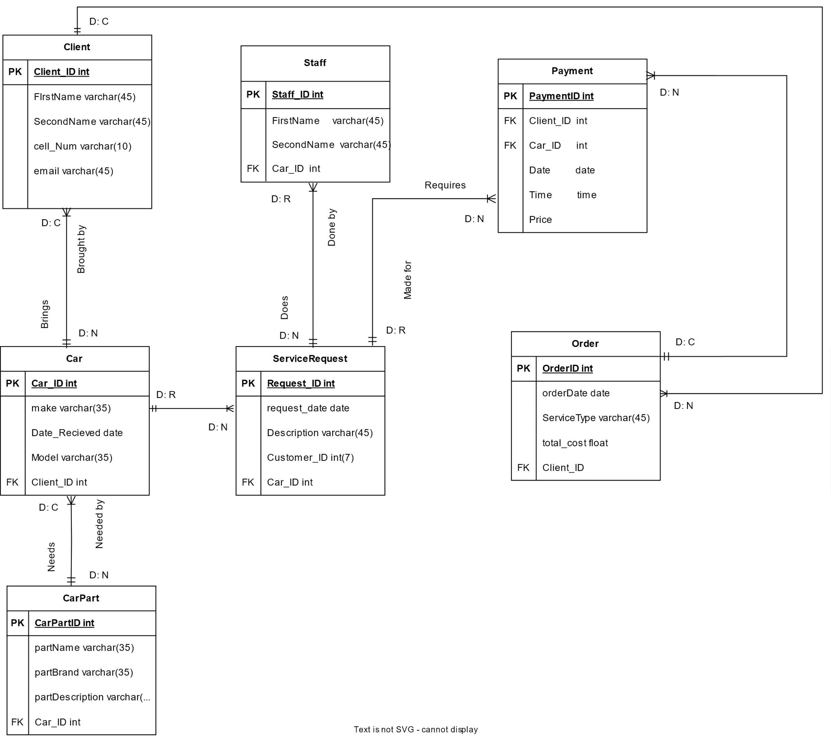

**Physical Process Model**

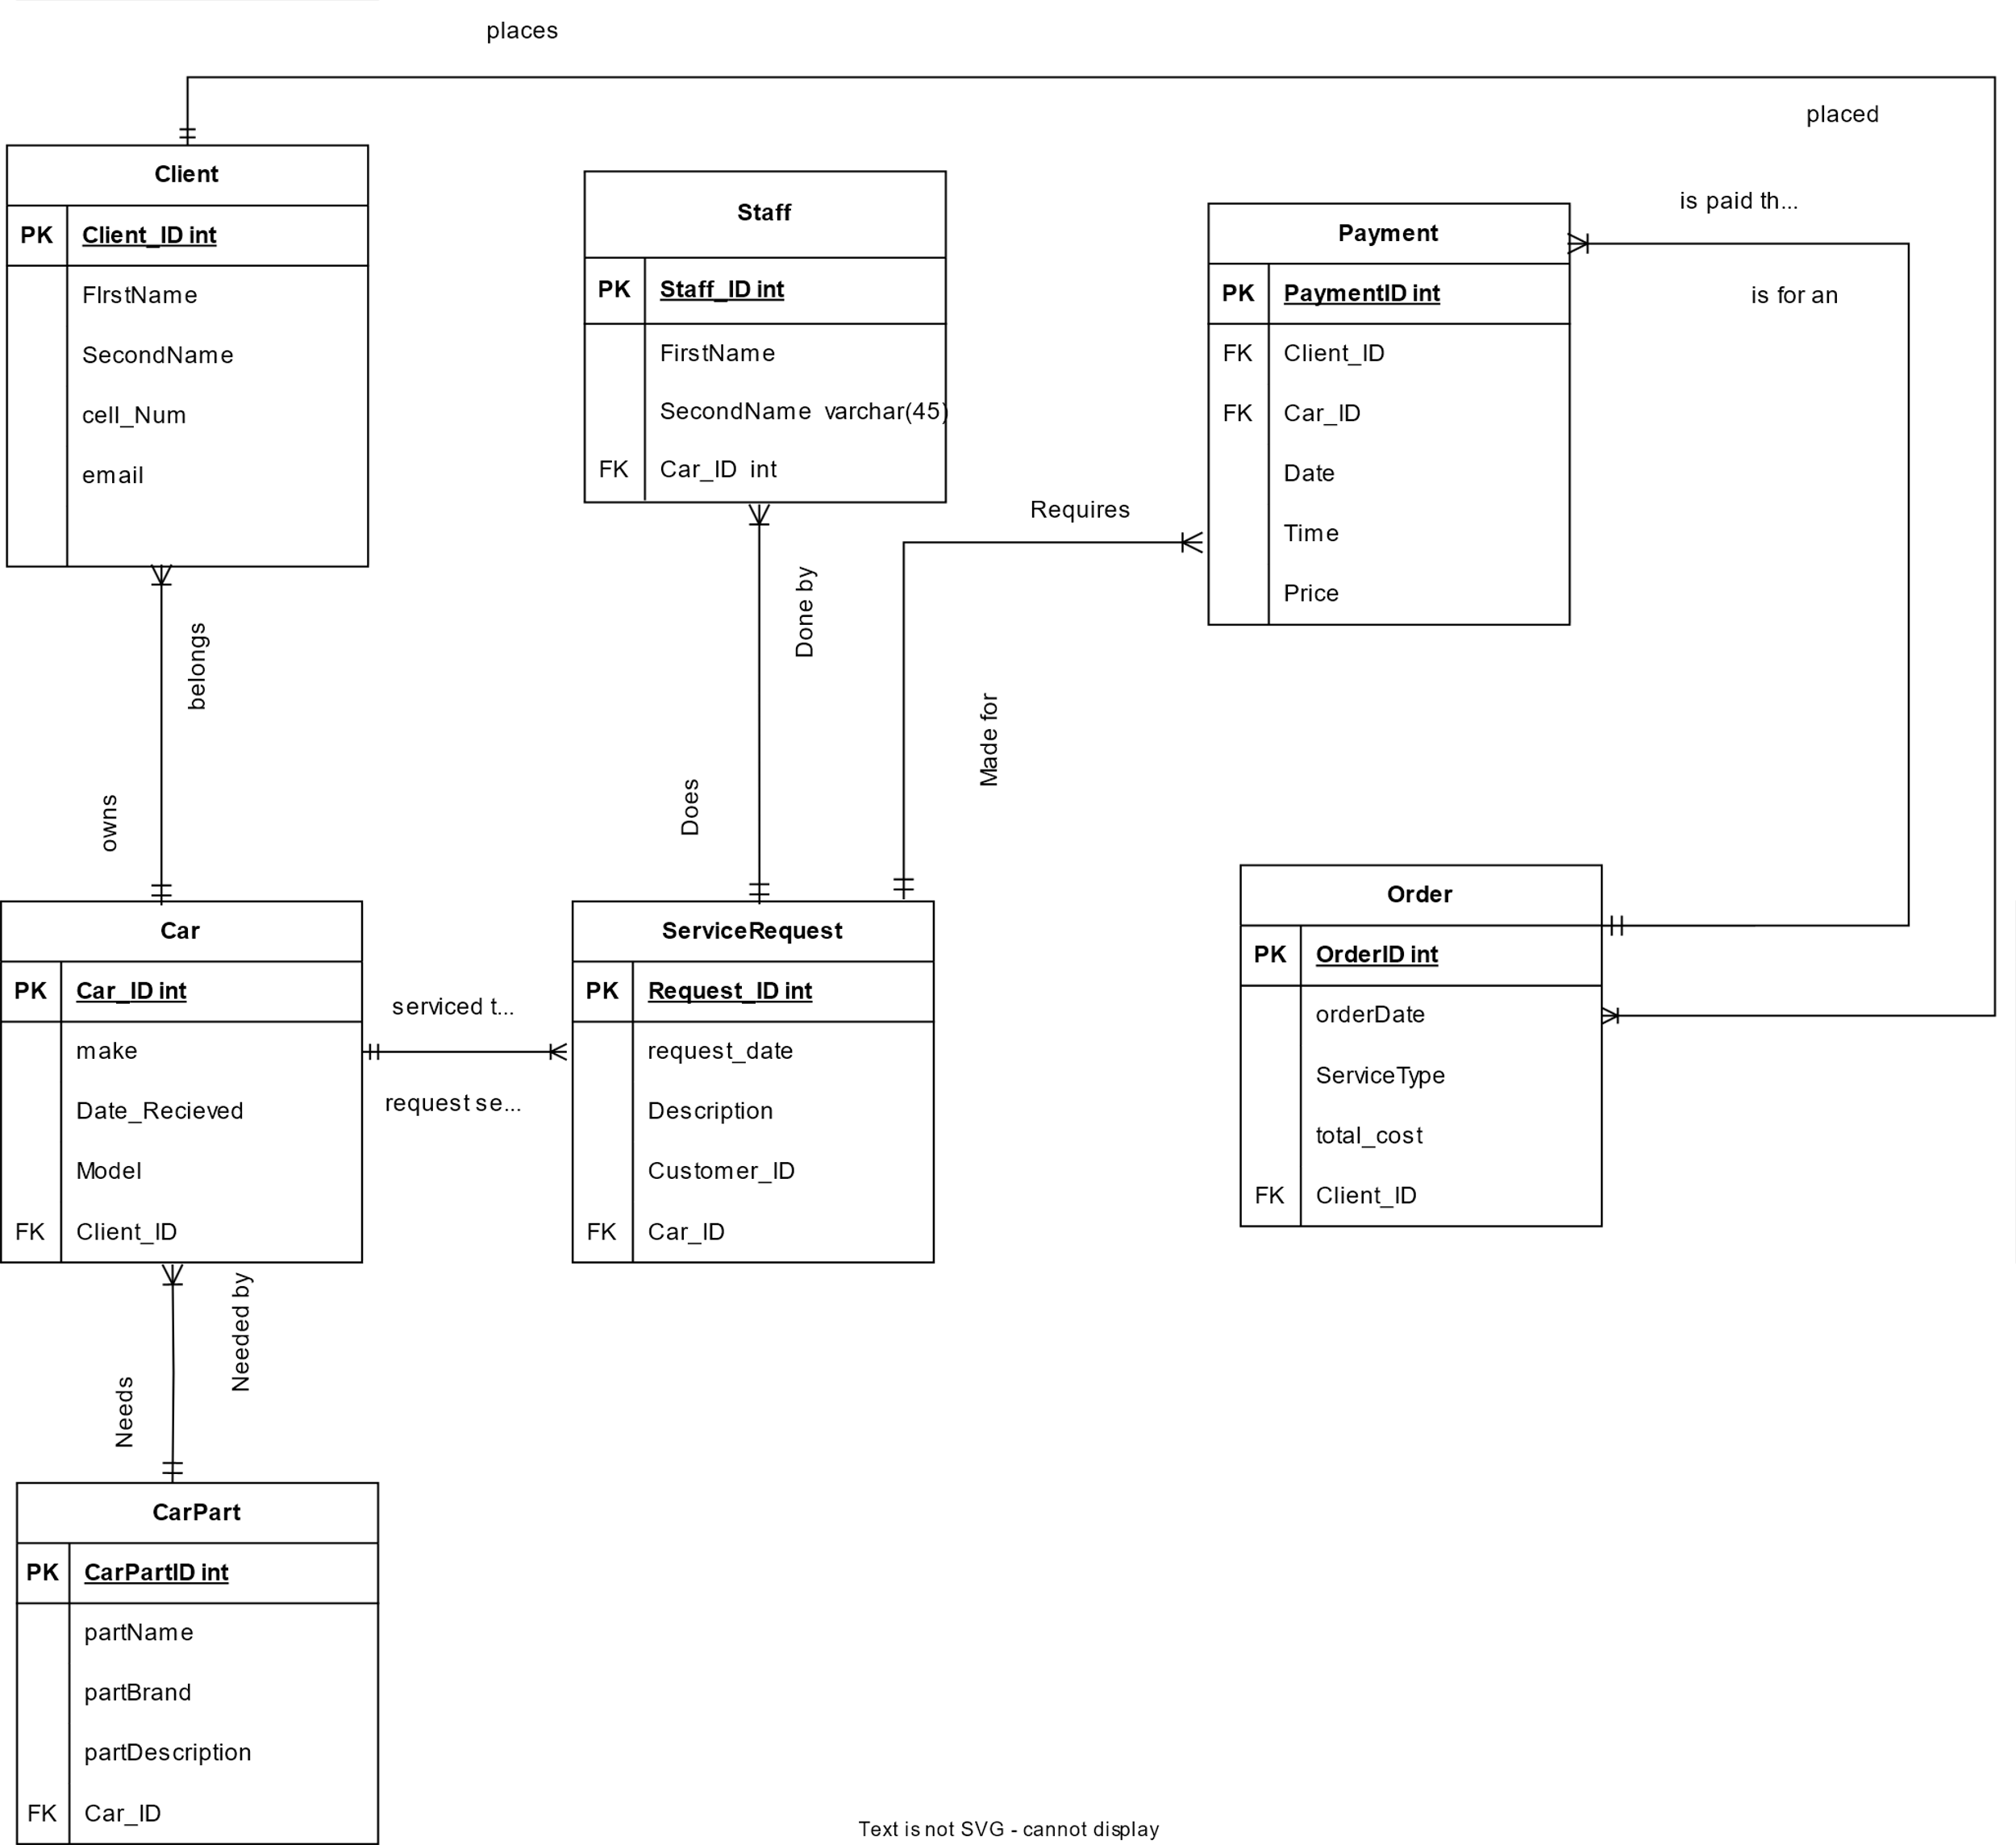

**Project Diary: Time Spent by Each Member on CarServpro**

**Team Members:**

* Sinovuyo Sondara – Frontend Developer
* Thanyani Mulaudzi – Backend Developer
* Phoku Gratitude – Project Manager
* Nhlanhla Nwariwe – Full-Stack Developer
* Kamogelo Seale – UX/UI Designer

**Week 1: Initial Planning and Setup**

**Whole Team:**

* Task: Brainstorm and set up the initial homepage design.
* Time Spent: 5 Days
* Summary: Collaboratively created the basic layout and wireframe for CarServpro's homepage. Experimented with various fonts, color palettes, and user flows to shape the overall look and feel of the platform.

Orinea & Kamogelo :

* Task: Database architecture.
* Time Spent: 4 Days
* Summary: Designed the core database schema to handle customer records and vehicle inventory efficiently. Collaborated closely with Phoku Gratitude to ensure smooth integration with the front-end elements. ----------------------------------------------------------------------------------------------------- Week 2: Menu Development and Functionalities

Phoku Gratitude:

* Task: Sidebar menu with dropdown functionality.
* Time Spent: 2 days
* Summary: Developed an interactive sidebar menu featuring dropdown options for parts inventory. Added a dynamic car brand selection tool to enhance the platform's customization features.

Sinovuyo Sondara:

* Task: Designing the user experience.
* Time Spent: 3 Days
* Summary: Focused on refining the user experience by optimizing the navigation and flow. Added subtle hover effects on buttons and improved the overall usability of the interface.

--------------------------------------------------------------------

Week 3: Backend Integration and Testing

Nhlanhla Nwariwe:

* Task: Linking backend API to frontend.
* Time Spent: 4 days
* Summary: Integrated the backend APIs to dynamically load parts inventory and customer data into the dashboard, enhancing real-time interactions.

Phoku Gratitude:

* Task: Project management and overseeing integration.
* Time Spent: 2 Days
* Summary: Oversaw task execution across teams and led the testing phase, ensuring smooth integration between frontend and backend components.

-------------------------------------------------------------------------

Week 4: Final Touches and Deployment

Whole Team:

* Task: Polishing the front end and bug fixes.
* Time Spent: 4 Days
* Summary: Collaborated to refine UI elements and fix minor bugs. Finalized the car brand selection feature and ensured all modules functioned smoothly across different devices.

Whole Team:

* Task: Final backend checks and deployment.
* Time Spent: 5 Days
* Summary: Carried out extensive testing on the backend, ensuring all features were functional and secure before deployment.

-------------------------------------------------------------------

Week 4: Documentation Activity

Orinea Mulaudzi:

* Task: Frontend documentation.
* Time Spent: 2.5 Hours
* Summary: Documented the frontend architecture, including design decisions, layout choices, and any troubleshooting steps needed for future updates.

Nhlanhla Nwariwe:

* Task: Backend and deployment documentation.
* Time Spent: 3 Days
* Summary: Compiled comprehensive documentation for the backend logic, API endpoints, and deployment procedures to ensure future maintainability and ease of understanding.

Kamogelo Seale:

* Task: UX/UI design documentation.
* Time Spent: 2–3 Days
* Summary: Documented the rationale behind UX/UI design choices, wireframes, and style guides to ensure a consistent design language and ease future updates to the platform.

----------------------------------------------------------------------------------------------

With the perfect blend of creativity, diligence, and teamwork, CarServpro is now nearing completion, standing as a testament to the hard work and dedication of each team member. The journey has been both challenging and rewarding, as the team has consistently pushed forward to create a professional and user-friendly platform!

**Car Website Dashboard User Manual**

**Getting Started**

1. **Accessing the Website:**
   * **Launch your preferred web browser (Safari, Firefox, or Chrome).**
   * **Visit the website's URL, log in with your login information, or register for a new account if you do not already have one.**
2. **Technical Requirements:**
   * **RAM: Minimum 4 GB (Recommended: 8 GB)**
   * **Browser: Latest versions of Chrome, Firefox, Safari, or Edge.**
   * **Internet Connection: Stable broadband connection for optimal performance.**

**Section 1: Dashboard Overview**

**The website dashboard offers an overview of key features and direct access to frequently used functions.**

**• Welcome Section: Name, profile picture, and fast access to account settings are displayed here. Quick Links: Direct shortcuts to:**

* + **View Appointments: Instantly access your upcoming and past service appointments.**
  + **Check Vehicle History: Review maintenance records of your registered vehicles.**
  + **Make Payments: Securely pay outstanding balances.**
  + **View Invoices: Access both paid and pending invoices with a single click.**
* **Notifications: Important alerts like overdue services, unpaid invoices, or system updates.**

**Section 2: Customer Records**

**Manage your profile and track your vehicle details.**

* **Profile Management:**
  + **Contact Information: Update your email, phone number, and address.**
  + **Vehicle Ownership: Track your registered vehicles and their details.**
  + **Service History: Review the services performed on your vehicles.**
* **Search and Add Vehicles:**
  + **Search Vehicles: Filter by vehicle make, model, or VIN to quickly find your vehicle details.**
  + **Add New Vehicle: Register a new vehicle by entering its details (registration number, type, etc.).**

**Section 3: Appointments**

**Manage your appointments with ease.**

* **Upcoming Appointments: View your scheduled appointments with details like date, time, and type of service.**
* **Schedule New Appointment: Book new appointments by selecting available dates and services.**
* **Appointment Management: View, reschedule, or cancel appointments directly from the website.**

**Section 4: Vehicle History**

**Monitor detailed maintenance history for all your registered vehicles.**

* **Vehicle List: Displays all vehicles registered under your account.**
* **Vehicle Details: Includes make, model, year, VIN, and past maintenance records.**

**Section 5: Invoices and Payments**

**Manage and track your payments online.**

* **Invoice List: Filter invoices to view paid, unpaid, and overdue ones.**
* **Make Payments: Use secure payment methods such as credit card or bank transfer to settle outstanding balances.**
* **Payment History: Review past payments, including transaction details and payment methods used.**

**Section 6: Parts Inventory**

**Browse and order vehicle parts directly through the website.**

* **Parts Catalog: Browse available parts, sorted by category, price, or availability.**
* **Search Parts: Use keywords or part numbers to find specific parts (e.g., filters, brake pads).**
* **Order Parts: Add parts to your cart and complete the order by selecting delivery details.**

**Section 7: Notifications**

**Receive alerts and reminders related to your account and vehicle maintenance.**

* **System Alerts: Notifications regarding important updates or new features.**
* **Appointment Reminders: Get notified of upcoming appointments to avoid missing them.**
* **Maintenance Alerts: Receive reminders for routine vehicle maintenance based on mileage or service history.**

**Section 8: Cart**

**Manage items added for purchase and complete transactions.**

* **View Cart: Displays the items you intend to purchase, including parts and service packages.**
* **Checkout: Securely process your payment and select delivery or pick-up options.**

**Section 9: Settings**

**Adjust your personal and business preferences.**

* **User Settings: Update personal profile information like name, email, and password.**
* **Business Settings: For business accounts, configure company information, such as address, operating hours, and staff profiles.**
* **Integration Settings: Set up integrations with third-party services, such as accounting or customer relationship management tools.**

**Section 10: Reports and Analytics**

**Access business or personal data insights (for businesses or advanced users).**

* **Sales Reports: Generate sales reports based on various periods.**
* **Service Reports: Analyze the number of services performed, categorized by type.**
* **Customer Insights: View trends related to service history, customer satisfaction, and retention.**

**Interactive Features**

* **Search Bar: Quickly search for customers, vehicles, invoices, or parts from any page on the site.**
* **Filtering Options: Use filters to refine search results based on categories like date, status (paid/unpaid), or vehicle type.**
* **Export Data: Download reports or lists in formats such as CSV, Excel, or PDF for offline use.**

**Best Practices**

* **Keep Information Updated: Regularly update your profile and vehicle details to ensure accurate service records.**
* **Secure Payments: Use secure payment methods to protect your financial data.**
* **Monitor Notifications: Stay on top of notifications to avoid missing critical updates or appointments.**

**Troubleshooting**

* **Common Issues: Resolve problems such as scheduling errors or payment issues.**
* **Browser Compatibility: Use a supported browser (e.g., Chrome, Firefox, Safari) for smooth functionality.**
* **Technical Support: For technical help, contact support via email or phone. A live chat option is available during business hours.**