**Data Structure:** can be defined as the group of data elements which provides an efficient way of storing and organizing data in the computer so that it can be used efficiently. Some examples of Data Structures are arrays, Linked List, Stack, Queue, etc.

**Need of Data Structures**

As applications are getting complexed and amount of data is increasing day by day, there may arrise the following problems:

**Processor speed:** To handle very large amout of data, high speed processing is required, but as the data is growing day by day to the billions of files per entity, processor may fail to deal with that much amount of data.

REPORT THIS AD

**Data Search:** Consider an inventory size of 106 items in a store, If our application needs to search for a particular item, it needs to traverse 106 items every time, results in slowing down the search process.

**Multiple requests:** If thousands of users are searching the data simultaneously on a web server, then there are the chances that a very large server can be failed during that process

in order to solve the above problems, data structures are used. Data is organized to form a data structure in such a way that all items are not required to be searched and required data can be searched instantly.

**Advantages of Data Structures**

**Efficiency:** Efficiency of a program depends upon the choice of data structures. For example: suppose, we have some data and we need to perform the search for a perticular record. In that case, if we organize our data in an array, we will have to search sequentially element by element. hence, using array may not be very efficient here. There are better data structures which can make the search process efficient like ordered array, binary search tree or hash tables.

**Reusability:** Data structures are reusable, i.e. once we have implemented a particular data structure, we can use it at any other place. Implementation of data structures can be compiled into libraries which can be used by different clients.

**Abstraction:** Data structure is specified by the ADT which provides a level of abstraction. The client program uses the data structure through interface only, without getting into the implementation details.

### Operations on data structure

1) **Traversing:** Every data structure contains the set of data elements. Traversing the data structure means visiting each element of the data structure in order to perform some specific operation like searching or sorting.

**Example:** If we need to calculate the average of the marks obtained by a student in 6 different subject, we need to traverse the complete array of marks and calculate the total sum, then we will devide that sum by the number of subjects i.e. 6, in order to find the average.

2) **Insertion:** Insertion can be defined as the process of adding the elements to the data structure at any location.

If the size of data structure is **n** then we can only insert **n-1** data elements into it.

3) **Deletion:**The process of removing an element from the data structure is called Deletion. We can delete an element from the data structure at any random location.

If we try to delete an element from an empty data structure then **underflow** occurs.

4) **Searching:** The process of finding the location of an element within the data structure is called Searching. There are two algorithms to perform searching, Linear Search and Binary Search. We will discuss each one of them later in this tutorial.

5) **Sorting:** The process of arranging the data structure in a specific order is known as Sorting. There are many algorithms that can be used to perform sorting, for example, insertion sort, selection sort, bubble sort, etc.

6) **Merging:** When two lists List A and List B of size M and N respectively, of similar type of elements, clubbed or joined to produce the third list, List C of size (M+N), then this process is called merging

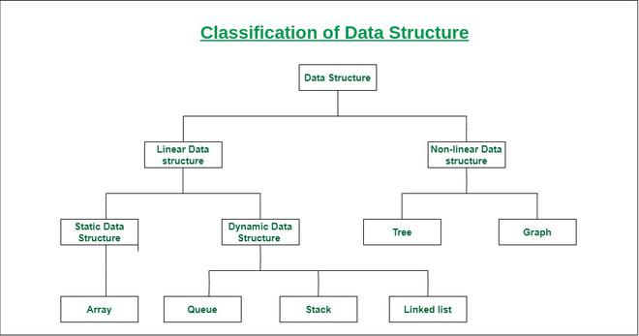

**A linear**[**data structure**](https://www.javatpoint.com/data-structure-tutorial) **and Non linear datastructure**

 is a structure in which the elements are stored sequentially, and the elements are connected to the previous and the next element. As the elements are stored sequentially, so they can be traversed or accessed in a single run. The implementation of linear data structures is easier as the elements are sequentially organized in memory. The data elements in an array are traversed one after another and can access only one element at a time.

* **Array:** An array consists of data elements of a same data type. For example, if we want to store the roll numbers of 10 students, so instead of creating 10 integer type variables, we will create an array having size 10. Therefore, we can say that an array saves a lot of memory and reduces the length of the code.
* **Stack:** It is linear data structure that uses the LIFO (Last In-First Out) rule in which the data added last will be removed first. The addition of data element in a stack is known as a push operation, and the deletion of data element form the list is known as pop operation.
* **Queue:** It is a data structure that uses the FIFO rule (First In-First Out). In this rule, the element which is added first will be removed first. There are two terms used in the queue **front** end and **rear** The insertion operation performed at the back end is known ad enqueue, and the deletion operation performed at the front end is known as dequeue.
* **Linked list:** It is a collection of nodes that are made up of two parts, i.e., data element and reference to the next node in the sequence.

What is a Non-linear data structure?

A non-linear data structure is also another type of data structure in which the data elements are not arranged in a contiguous manner. As the arrangement is nonsequential, so the data elements cannot be traversed or accessed in a single run. In the case of linear data structure, element is connected to two elements (previous and the next element), whereas, in the non-linear data structure, an element can be connected to more than two elements.

**Trees** and **Graphs** are the types of non-linear data structure.

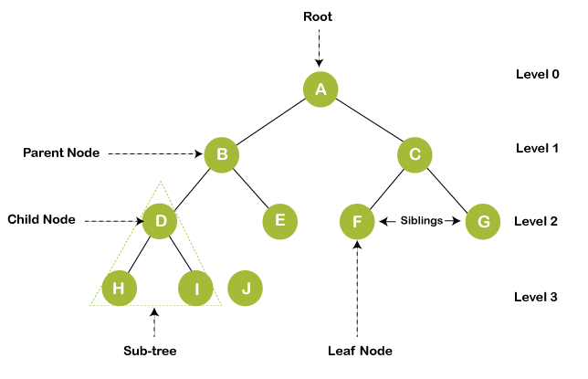

* **Graph**

A graph is a non-linear data structure that has a finite number of vertices and edges, and these edges are used to connect the vertices. The vertices are used to store the data elements, while the edges represent the relationship between the vertices. A graph is used in various real-world problems like telephone networks, circuit networks, social networks like LinkedIn, Facebook. In the case of facebook, a single user can be considered as a node, and the connection of a user with others is known as edges.

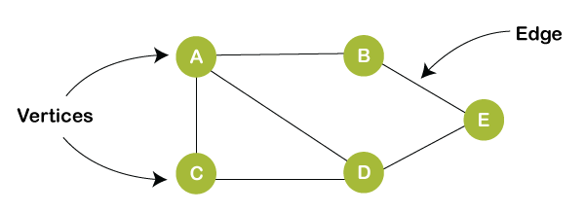

## ****Applications of Data Structures:****

* **Arrays**: Arrays are used to store a collection of homogeneous elements in contiguous memory locations. They are commonly used to implement other data structures, such as stacks and queues, and to represent matrices and tables.
* **Linked** **lists**: Linked lists are used to store a collection of heterogeneous elements with dynamic memory allocation. They are commonly used to implement stacks, queues, and hash tables.
* **Trees**: Trees are used to represent hierarchical data structures, such as file systems, organization charts, and network topologies. Binary search trees are commonly used to implement dictionaries and symbol tables.
* **Graphs**: Graphs are used to represent complex relationships between data elements, such as social networks, transportation networks, and computer networks. They are commonly used to implement shortest path algorithms and graph traversal algorithms.
* **Hash** **tables**: Hash tables are used to implement associative arrays, which store key-value pairs. They provide fast access to data elements based on their keys.
* **Stacks**: Stacks are used to store a collection of elements in a last-in-first-out (LIFO) order. They are commonly used to implement undo-redo functionality, recursive function calls, and expression evaluation.
* **Queues**: Queues are used to store a collection of elements in a first-in-first-out (FIFO) order. They are commonly used to implement waiting lines, message queues, and job scheduling.

