**Components of Hashing**

There are majorly three components of hashing:

1. **Key:** A **Key** can be anything string or integer which is fed as input in the hash function the technique that determines an index or location for storage of an item in a data structure.
2. **Hash Function:**The **hash function** receives the input key and returns the index of an element in an array called a hash table. The index is known as the**hash index**.
3. **Hash Table:**Hash table is a data structure that maps keys to values using a special function called a hash function. Hash stores the data in an associative manner in an array where each data value has its own unique index.

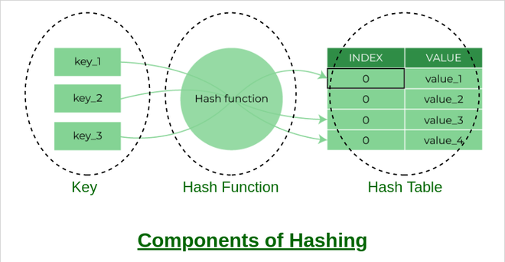

### Complexity of calculating hash value using the hash function

* Time complexity: O(n)
* Space complexity: O(1)

## What is collision?

The hashing process generates a small number for a big key, so there is a possibility that two keys could produce the same value. The situation where the newly inserted key maps to an already occupied, and it must be handled using some collision handling technology.

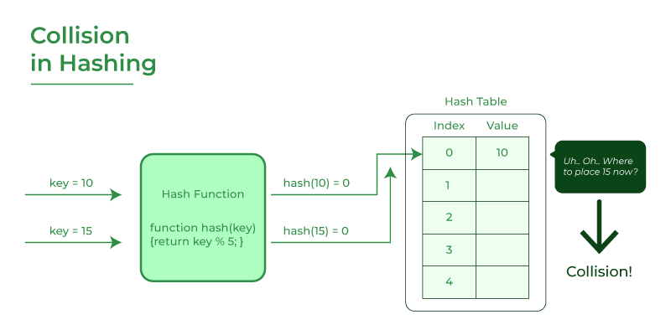

**How to handle Collisions?**

There are mainly two methods to handle collision:

1. Separate Chaining:
2. Open Addressing:

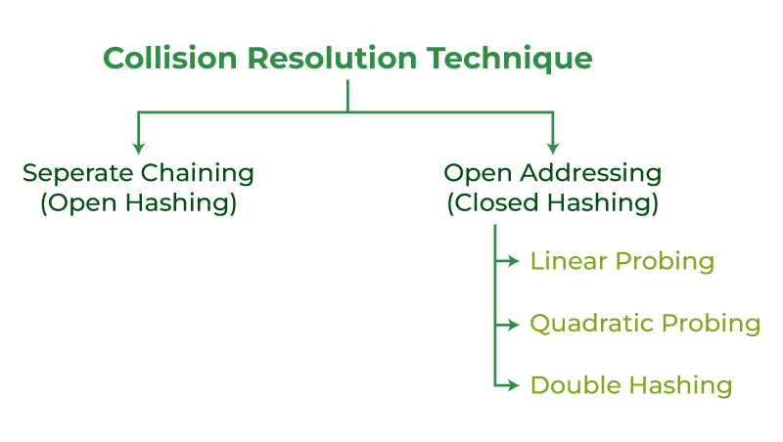

**Separate Chaining-**

To handle the collision,

* This technique creates a linked list to the slot for which collision occurs.
* The new key is then inserted in the linked list.
* These linked lists to the slots appear like chains.
* That is why, this technique is called as **separate chaining**.

## ****Problem-****

Using the hash function ‘key mod 7’, insert the following sequence of keys in the hash table-

50, 700, 76, 85, 92, 73 and 101

Use separate chaining technique for collision resolution.

### ****Step-01:****

* Draw an empty hash table.
* For the given hash function, the possible range of hash values is [0,6].
* So, draw an empty hash table consisting of 7 buckets as-

### ****Step-02:****

* Insert the given keys in the hash table one by one.
* The first key to be inserted in the hash table = 50.
* Bucket of the hash table to which key 50 maps = 50 mod 7 = 1.
* So, key 50 will be inserted in bucket-1 of the hash table as-

### ****Step-03:****

* The next key to be inserted in the hash table = 700.
* Bucket of the hash table to which key 700 maps = 700 mod 7 = 0.
* So, key 700 will be inserted in bucket-0 of the hash table as-

### ****Step-04:****

* The next key to be inserted in the hash table = 76.
* Bucket of the hash table to which key 76 maps = 76 mod 7 = 6.
* So, key 76 will be inserted in bucket-6 of the hash table as-

### ****Step-05:****

* The next key to be inserted in the hash table = 85.
* Bucket of the hash table to which key 85 maps = 85 mod 7 = 1.
* Since bucket-1 is already occupied, so collision occurs.
* Separate chaining handles the collision by creating a linked list to bucket-1.
* So, key 85 will be inserted in bucket-1 of the hash table as-

### ****Step-06:****

* The next key to be inserted in the hash table = 92.
* Bucket of the hash table to which key 92 maps = 92 mod 7 = 1.
* Since bucket-1 is already occupied, so collision occurs.
* Separate chaining handles the collision by creating a linked list to bucket-1.
* So, key 92 will be inserted in bucket-1 of the hash table as

### ****Step-07:****

* The next key to be inserted in the hash table = 73.
* Bucket of the hash table to which key 73 maps = 73 mod 7 = 3.
* So, key 73 will be inserted in bucket-3 of the hash table as-

### ****Step-08:****

* The next key to be inserted in the hash table = 101.
* Bucket of the hash table to which key 101 maps = 101 mod 7 = 3.
* Since bucket-3 is already occupied, so collision occurs.
* Separate chaining handles the collision by creating a linked list to bucket-3.
* So, key 101 will be inserted in bucket-3 of the hash table as

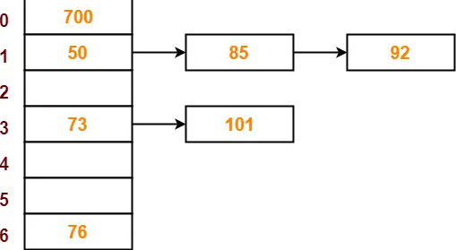

**. Linear Probing-**

In linear probing,

* When collision occurs, we linearly probe for the next bucket.
* We keep probing until an empty bucket is found.

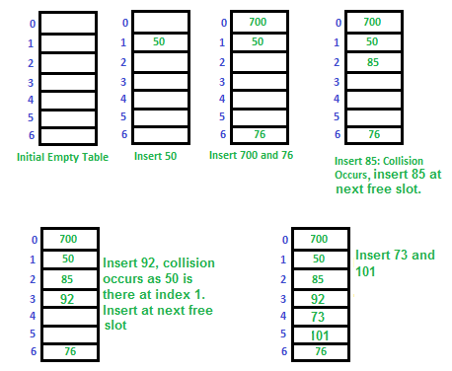

**2. Quadratic Probing-**

**In quadratic probing,**

* When collision occurs, we probe for i2‘th bucket in ith iteration.
* We keep probing until an empty bucket is found.

**How Quadratic Probing is done?**

Let hash(x) be the slot index computed using the hash function.

* If the slot hash(x) % S is full, then we try (hash(x) + 1*1) % S.
* If (hash(x) + 1*1) % S is also full, then we try (hash(x) + 2*2) % S.
* If (hash(x) + 2*2) % S is also full, then we try (hash(x) + 3*3) % S.
* This process is repeated for all the values of i until an empty slot is found.

**For example:** Let us consider a simple hash function as “key mod 7” and  sequence of keys as 50, 700, 76, 85, 92, 73, 101

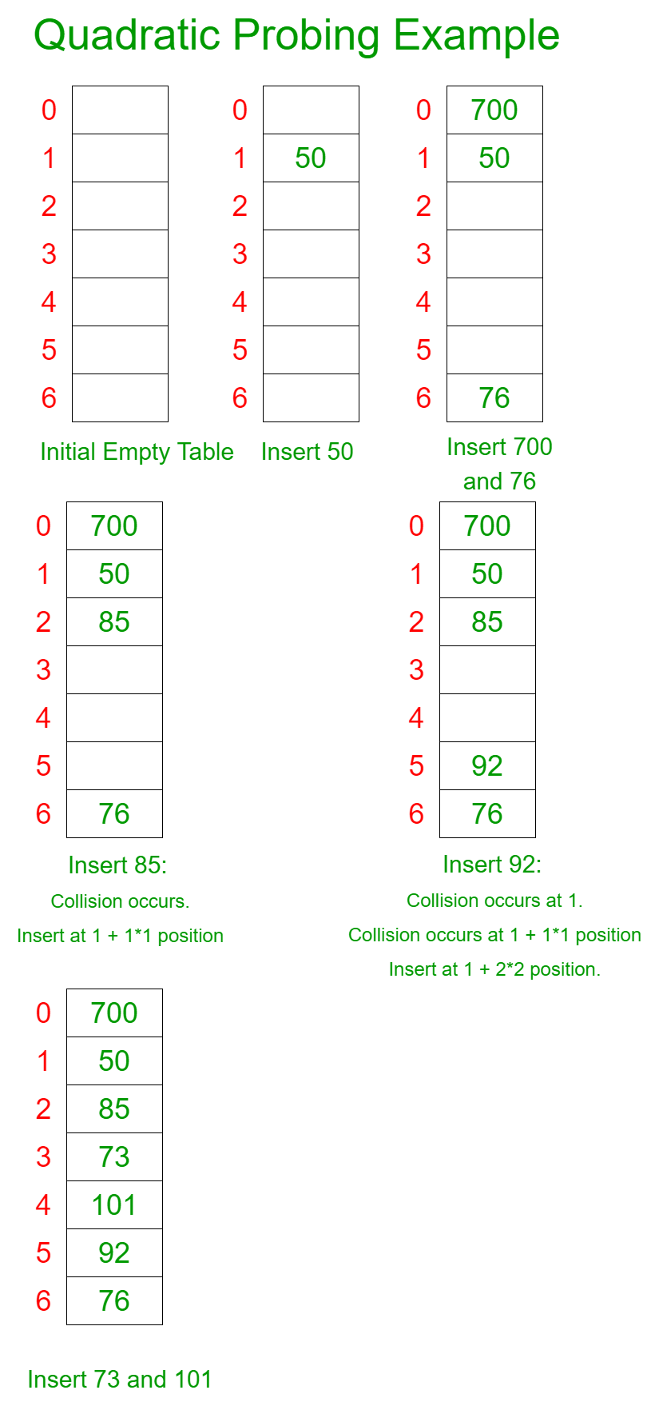

**3. Double Hashing-**

Double hashing is a collision resolution technique used in hash tables. It works by using two hash functions to compute two different hash values for a given key. The first hash function is used to compute the initial hash value, and the second hash function is used to compute the step size for the probing sequence.

Double hashing has the ability to have a low collision rate, as it uses two hash functions to compute the hash value and the step size. This means that the probability of a collision occurring is lower than in other collision resolution techniques such as linear probing or quadratic probing.

However, double hashing has a few drawbacks. First, it requires the use of two hash functions, which can increase the computational complexity of the insertion and search operations. Second, it requires a good choice of hash functions to achieve good performance. If the hash functions are not well-designed, the collision rate may still be high.