Beyond the Menu: Mapping Restaurant Success in India’s IT Capital
By- Rihan Ghosh
  - Overview
Bengaluru, often hailed as the "Silicon Valley of India," boasts one of the most vibrant and fast-paced food-tech ecosystems in the world. With thousands of restaurants ranging from street-side stalls to high-end microbreweries, the competition for consumer attention is immense. This project performs an in-depth Exploratory Data Analysis (EDA) on the Zomato Bangalore dataset to uncover the underlying patterns that drive restaurant success, customer loyalty, and market equilibrium.

  - Problem Statement
The primary challenge for stakeholders in the food-tech industry including restaurant owners, investors, and platform aggregators like Zomato is the high rate of market saturation and the difficulty of identifying "value" in a noisy marketplace. Traditional metrics like "total votes" often favour established giants, leaving high-potential "Hidden Gems" undiscovered. This analysis seeks to bridge that gap by applying data science techniques to geographical density, pricing structures, and customer sentiment.

- Description of features in the Dataset(zomato.csv)
- Core Identifiers & Location
Column Name | Description | Data Type | Usage / Notes
name | Official name of the restaurant | Categorical (Text) | Used to identify popular brands, analyze chain dominance, and study market share of major restaurant groups
location | Specific neighborhood within Bengaluru | Categorical | Crucial for spatial analysis, identifying high-density areas, and evaluating location-wise performance
listed_in(city) | Broader city or zone under which the restaurant is listed | Categorical | Often overlaps with location; mainly useful for high-level regional grouping or filtering
- Operational Features
Column | Description | Data Type | Usage / Notes
online_order | Whether the restaurant accepts digital orders. | Boolean (Yes/No) | Used to compare delivery trends against traditional walk-ins.
book_table | Availability of reservation services. | Boolean (Yes/No) | Helps determine if table booking correlates with higher luxury or ratings.
rest_type | The style of the establishment (e.g., Café, Casual Dining). | Categorical | Used to segment the market and compare performance by category.
listed_in(type) | The primary service offered (e.g., Delivery, Dine-out). | Categorical | Helps analyze the business model and service-specific ratings.

- Performance Metrics
Column | Description | Data Type | Usage / Notes
rate | The average customer rating (out of 5.0). | Float | Primary Performance Metric. Requires cleaning to remove "/5" formatting.
votes | The total volume of customer ratings. | Integer | Serves as a proxy for popularity and the statistical reliability of the rate.
approx_cost | Estimated cost for a meal for two people. | Integer | Used for affordability analysis and "Price vs. Quality" correlations.

- Textual and Low Utility Data
Column | Description | Data Type | Usage / Notes
cuisines | Types of food served (e.g., North Indian, Chinese). | Text/List | Useful for identifying trending food types and regional popularity.
dish_liked | Specific dishes praised by customers. | Text | High sparsity (many nulls); often excluded from basic EDA.
reviews_list | Raw customer feedback and comments. | Text | Primary source for Sentiment Analysis (NLP); usually dropped for EDA.
menu_item | List of specific items on the menu. | Text | Often sparse or inconsistently formatted; rarely used in high-level analysis.

- Data Wrangling & Pre-processing Pipeline
Before conducting the analysis, a rigorous cleaning pipeline was executed to transform the raw, "noisy" Zomato dataset into a structured format suitable for numerical and categorical study.

  - Feature Selection & Dimensionality Reduction
To focus the analysis on business performance and consumer trends, high-cardinality and non-analytical columns were dropped. This included URL, Address, Phone, menu_item, reviews_list, and dish_liked. Removing these irrelevant features reduced memory usage and allowed the study to focus strictly on quantitative metrics and key categorical drivers.

  - Integrity & Duplicate Management
Redundancy was eliminated by identifying and deleting duplicate restaurant entries. This ensures that a single restaurant’s metrics do not disproportionately skew the average ratings or pricing distributions of a specific neighbourhood.

  - Numerical Transformation of Ratings
The rate column presented a significant cleaning challenge, as it contained non-numeric entries such as "NEW" (unrated) and "-" (missing data).
- Action: These entries were removed to prevent bias in the statistical mean.
- Standardization: Ratings were stripped of the "/5" string and converted into float64 numerical values (e.g., "4.1/5" became 4.1).

  - Currency Cleaning & Pricing Standardization
The approx_cost(for two people) column contained string-based values with commas (e.g., "1,200"). These were cleaned using string replacement and cast to numerical formats. This was a critical step in enabling the calculation of our custom Value Score.

  - Categorical Engineering & Bucketing
To improve the interpretability of the results and reduce data sparsity, two main transformations were performed:
- Grouping: Restaurant types were consolidated into broader, more meaningful categories (e.g., combining various cafe types into a single "Cafes" segment).
- Rating Buckets: To simplify customer satisfaction analysis, ratings were binned into a new feature, Rating_Category:
Rating Range | Classification
< 3.0 | Poor
3.0 – 3.9 | Average
≥ 4.0 | Excellent

- Key Insights with Data Visualization
4.1. Market Overview & Portfolio Mix
i. Service Availability and Table Booking Availability:
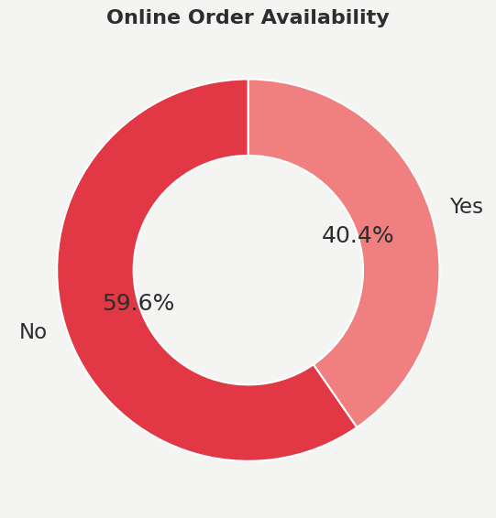
* Observation: The market is heavily skewed towards "Online Delivery" services. A significant majority of restaurants offer online ordering, reflecting the city’s high digital adoption rate.

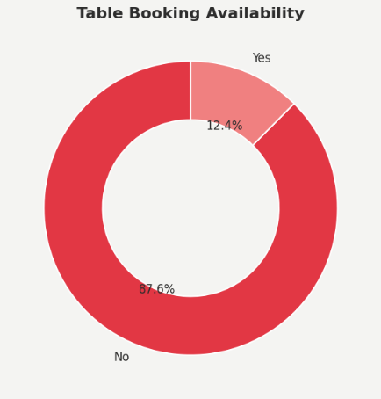

* Impact: Restaurants that offer both Online Ordering and Table Booking see a distinct advantage in brand visibility, but the "Delivery Only" model dominates the lower-cost segment. This also indicates strong digital adoption but relatively lower dine-in reservation readiness.
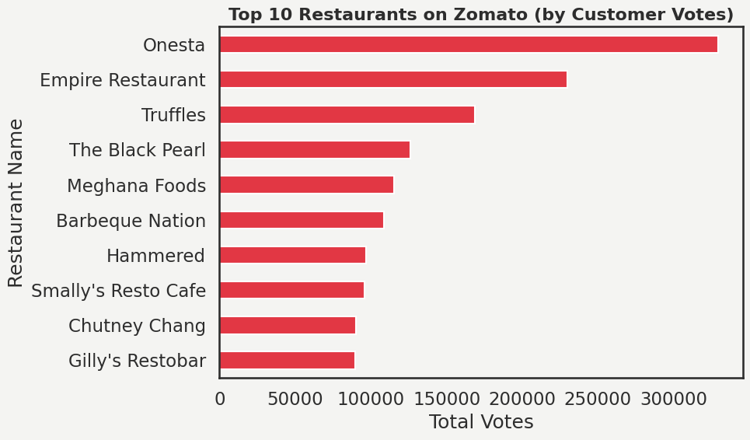
ii. Top 10 Restaurants

Dominant Market Leader: The outlier for this category is Onesta, which leads all others far ahead with a considerably larger number of votes (exceeding 300,000) than others. This is indicative of a substantially large number of consumer bases or a highly successful business model.
“Big Three” Gap: This is an evident chasm in popularity. Truffles and Empire Restaurant constitute the second level after Onesta. The difference between 1st and 2nd positions differs in size compared to the difference between 4th and 10th positions.
Competitive Mid-Tier: From The Black Pearl to Chutney Chang, restaurants display a more or less incremental variation when it comes to vote differences. This points to a rather competitive sector when it comes to traditional restaurants and buffets such as Barbeque Nation and Meghana Foods.
Brand Type Distribution: The list is largely comprised of casual dining chains and so-called "restobars," indicating that high engagement on Zomato is a function of multi-brand and social dining establishments.

4.2. Geographical & Customer Insights
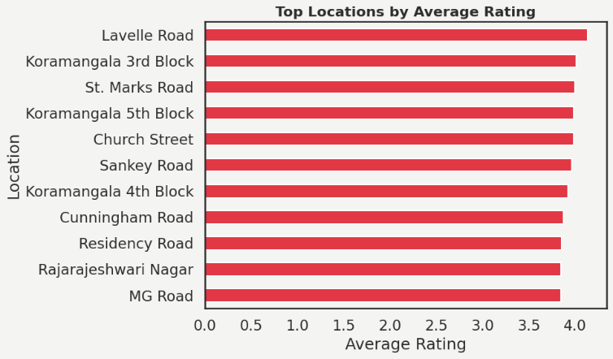
Based on the geographical distribution analysis, we explored how performance varies across different clusters in Bengaluru and evaluated premium clusters.
The Premium Hub: Lavelle Road is the only location in the market to surpass the 4.0 average rating barrier. This suggests a high concentration of upscale restaurants or establishments that provide reliable service.
Koramangala's Dominance: Take note of Koramangala's three appearances in the top list (3rd, 4th, and 5th Blocks). This shows that Koramangala is the most dependable "foodie" hub for quality in several different zones.
High Consistency, Low Variance: There is only a slight difference (roughly 4.1 vs. 3.8) between the first and tenth locations. This implies that the best restaurants are fiercely competitive and uphold a very similar level of quality.
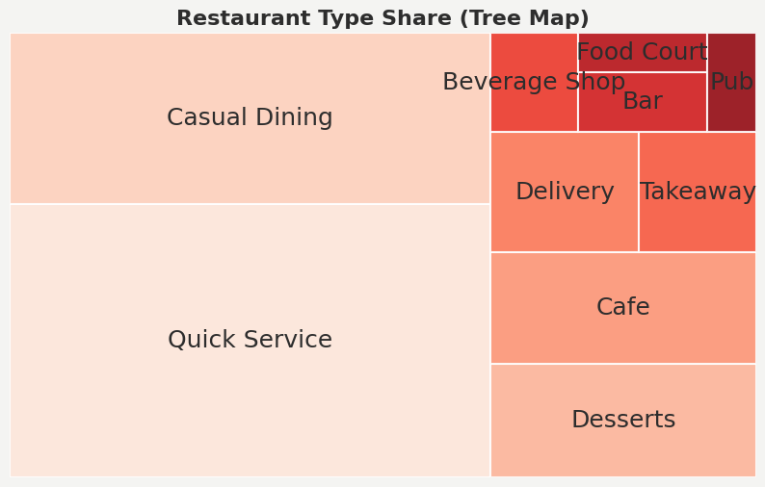
According to the Tree Map analysis, the market is clearly bottom-heavy, with Quick Service and Casual Dining serving as the main pillars and holding more than half of the market share. Specialized sectors like pubs, bars, and food courts have much smaller footprints than high-volume formats like delivery, takeout, and cafes, which maintain a strong secondary presence to support the convenience economy. According to this distribution, the physical landscape is dominated by high-friction, mass-appeal models intended for speed and regular dining, even though premium or social hubs like Lavelle Road may lead in quality ratings. For a new entrant, the Cafe and Dessert segments appear to be the "sweet spot", large enough to have a proven market but less saturated than the massive Quick Service and Casual Dining blocks.
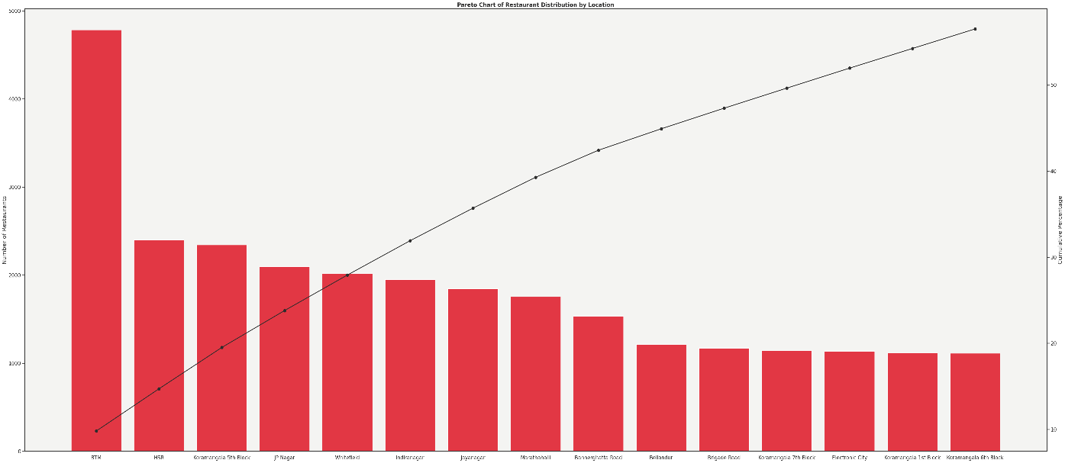
A strong concentration of restaurants in a few key locations is depicted in this Pareto chart. Major food hubs are indicated by BTM alone dominating the distribution, followed by Koramangala (5th Block), HSR, and JP Nagar. A small subset of locations accounts for a disproportionate share of restaurants, while the remaining areas contribute incrementally, according to the cumulative curve, which rises sharply early. This is indicative of traditional 80/20 behavior, in which demand, competition, and operational focus are concentrated in desirable areas rather than dispersed equally throughout the city.
To drive higher customer engagement (votes), Zomato should target expansion or deeper partnerships in premium-rating areas like Lavelle Road. While these areas may have lower density than "mass-market" hubs, their higher rating profile suggests a more satisfied and potentially higher-spending loyal customer base, which aligns with your goal of identifying "partnerships and promotional strategies".
4.3. Customer Engagement

Customer engagement varies significantly across locations. While high-density areas attract more restaurants, some locations show higher vote distributions per restaurant, indicating stronger customer interaction and demand despite having fewer outlets.
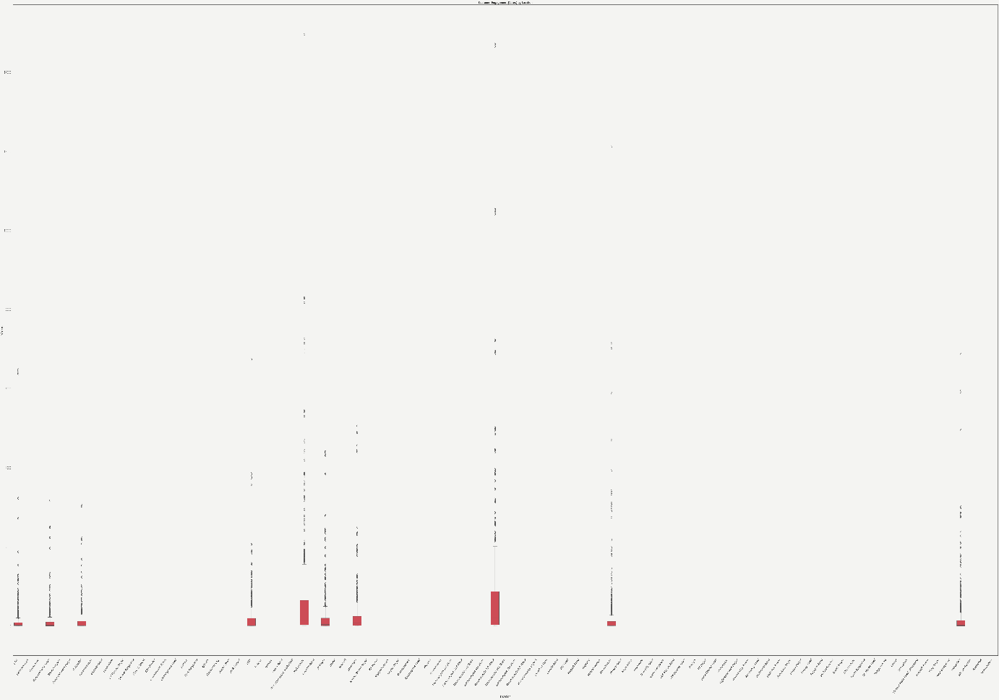
4.4. Customer Preference & Demand Analysis
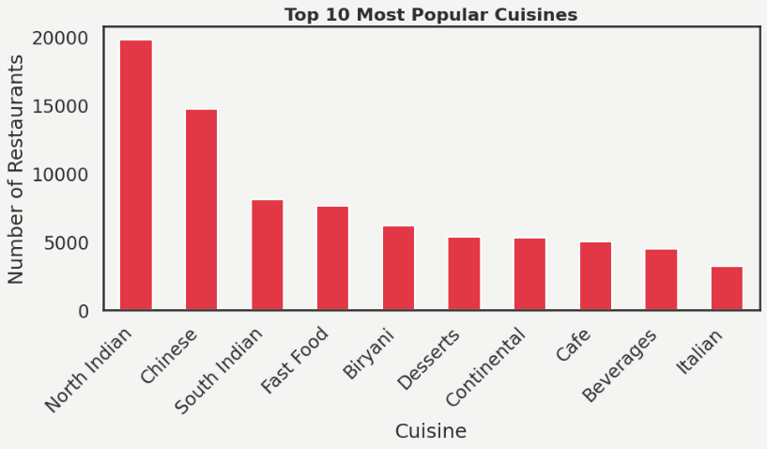
The graph displays a highly skewed cuisine popularity, with North Indian and Chinese accounting for a significant portion of restaurants, suggesting widespread acceptance and mass market demand. Fast food and South Indian food make up a robust second tier that reflects regular consumption habits. On the other hand, Biryani, Desserts, Continental, Café, Beverages, and Italian lag considerably, indicating a more specialized positioning or selective demand. All things considered, the market is highly concentrated around staple foods, with long-tail diversity as opposed to uniformly distributed popularity.
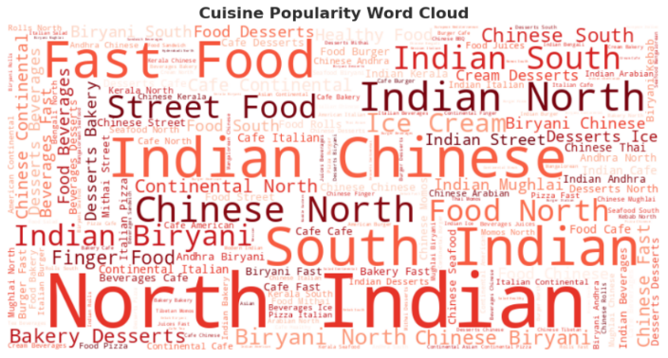
Take a look at the word cloud, and you get a quick sense of what’s going on in Bangalore’s food scene. The bigger and bolder a word, the more popular that cuisine is on Zomato. North Indian, Chinese, and South Indian jump right out—they’re everywhere, really, and they’ve become the go-to choices for most people in the city. You can tell folks crave those flavors. Then you spot words like Fast Food, Beverages, and Desserts—these aren’t quite as dominant, but they’re still huge. Clearly, people love grabbing something quick or sweet on the move. And if you look closer, you’ll find smaller names like Italian, Continental, or Thai tucked around the edges. They’re not as common, but they add a nice mix to the market, showing that there’s plenty of room for more niche tastes too.
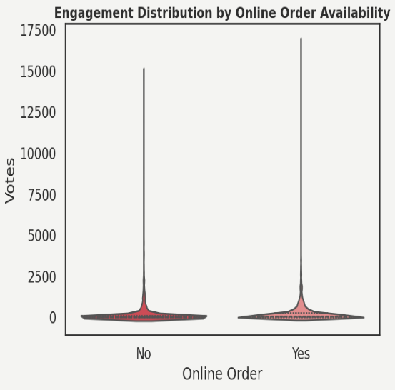
Restaurants that offer online ordering pull in way more customer engagement. You can see it in the jump in total votes—they get a lot more than places that stick to dine-in only. The ratings? Those don’t really change much. Both types of restaurants sit at about the same average rating, so online ordering doesn’t seem to sway that. What really stands out is the spike in activity. Delivery options let restaurants reach a bigger, more price-sensitive crowd. Plus, these spots usually keep the average cost per plate lower—around ₹462, compared to ₹533 at dine-in-only places. That makes them an easy pick for people who order often, which keeps the digital buzz going.
So, sure, dine-in restaurants might get more of those high-quality, “special night out” votes. But online ordering keeps the momentum going and makes a huge difference in how visible and active these restaurants stay on the platform. It’s the engine behind steady, volume-driven engagement.
4.5. Pricing Strategy & Affordability
1. Price Distribution of Restaurants
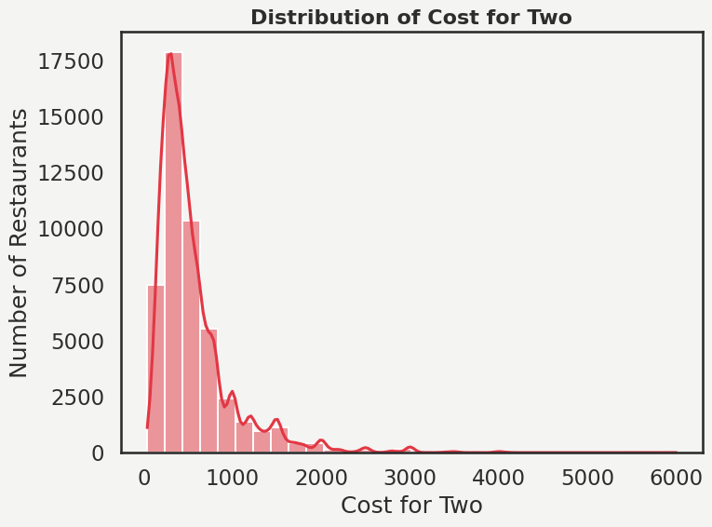
Most restaurants stick to lower prices—usually about ₹300 to ₹400 for two people. You see tons of places in that range. It’s all about making things affordable and pulling in more customers. Sure, you’ll find some fancy or luxury spots, but honestly, they’re rare. The majority just go for the Quick Service or Casual Dining route because people are pretty sensitive to price, and that’s where the big crowd is.
2. Price varying by restaurant type.
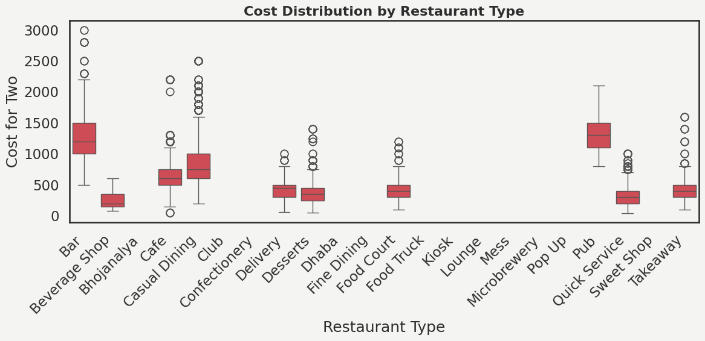
There is evident market segmentation as pricing varies substantially across restaurant types. With numerous high-end outliers, Bars, Pubs, Clubs, and Fine Dining have the highest median costs and the widest spreads, indicating premium positioning and a variety of pricing strategies. With moderate variability and a mid-to-high range, Casual Dining reflects a wider appeal. On the other hand, Quick Service, Takeaway, Sweet Shops, Beverage Shops, and Dhaba exhibit standardized, affordability-driven pricing and are closely grouped at the low-cost end. Overall, the boxplots show that there is significant price differentiation by format, with venues that prioritize experience charging much more than those that prioritize convenience.
4.6. Rating & Customer Satisfaction
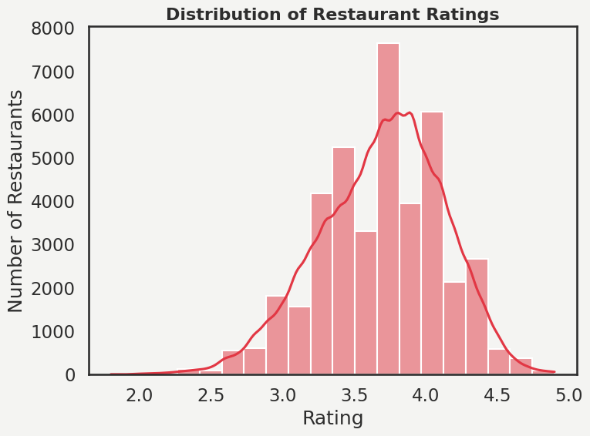
1. Overall rating distribution
The overall rating distribution for the restaurant market typically follows a bell-shaped curve that centers around a mean of 3.9, indicating a generally positive sentiment where the majority of establishments are considered "good" to order from. This normal distribution reveals that approximately 68% of ratings are clustered within one standard deviation of the peak, highlighting a high level of service consistency across the city's diverse dining landscape. Interestingly, while most restaurants maintain an average score, higher ratings often correlate with the provision of additional services like online ordering and table booking, which significantly boost customer convenience and engagement. This pattern suggests that the market is mature, with a well-defined standard of quality, leaving high-end excellence (ratings > 4.5) and significant underperformance (ratings < 2.5) as the rare, statistical outliers.
- Is there a relationship between votes and ratings?
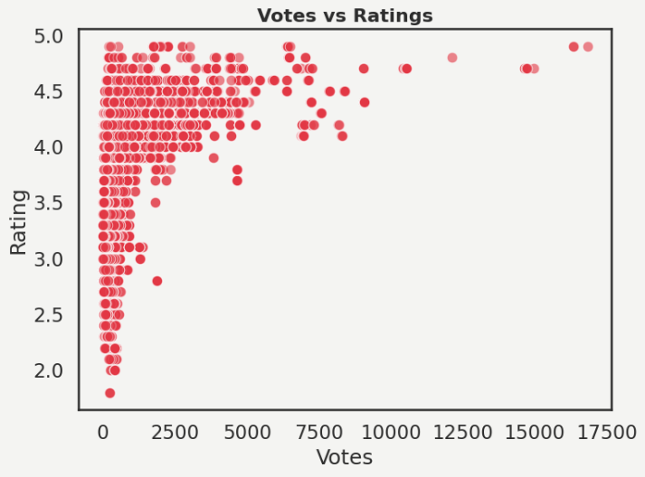
Looking at the scatter plot, you can see a weak positive link between votes and ratings, but it’s not like you need a certain number of votes to be successful. There’s this dense patch of restaurants with anywhere from 0 to 2,500 votes, and their ratings are all over the place—some as low as 1.8, others all the way up to 4.9. But once a restaurant gets past 5,000 votes, the story changes. Their ratings settle down and almost never dip below 3.7. So, sure, a place can score high even with just a handful of votes—sometimes that’s just a small group of super fans. But when you see thousands of people weighing in and the rating still holds up, it says something. It means the restaurant isn’t just getting lucky—they’re delivering solid quality over and over, and people keep coming back because of it.
4.7. Competitive Positioning — Value for Money
Restaurants delivering the best value. Cost vs Rating (Coloured by Restaurant Type): To move beyond basic descriptive analysis, a new feature was engineered - value_score = rating / cost. This normalized the performance of restaurants regardless of their price bracket, allowing for a fair comparison between a high-end steakhouse and a local QSR.
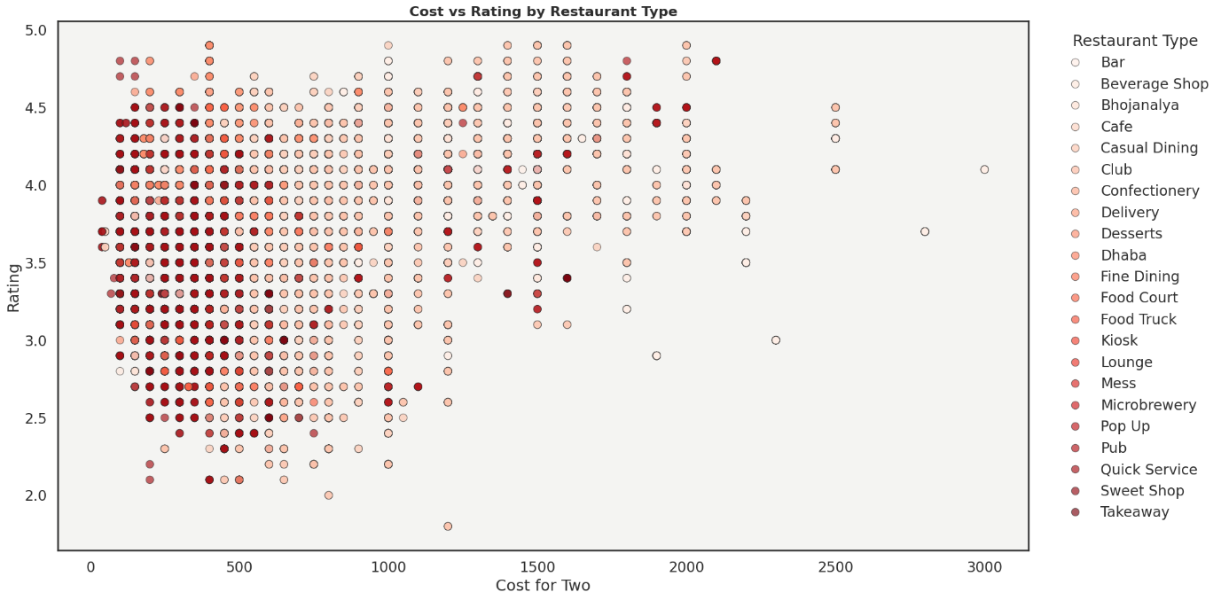
Quick service, takeout, and casual dining offer the best value for the money. According to the scatter, at low-to-mid costs (₹200–₹600), these types consistently receive ratings of ~3.5–4.2, indicating high customer satisfaction without high spend. On the other hand, cafes and dessert establishments display moderate ratings at inflated prices, while fine dining, clubs, and lounges cluster at significantly higher costs with only slight rating improvements. Value is maximized overall when ratings are high and expenses are kept low, obviously favouring Quick Service-focused formats.
5. Conclusion
This analytical study of the Zomato Bengaluru restaurant dataset provides a comprehensive understanding of the city’s food service ecosystem, customer preferences, and competitive dynamics. By systematically cleaning and transforming a large dataset of over 50,000 records, the analysis ensured reliable insights free from duplication, missing values, and inconsistent formatting. Exploratory data analysis revealed that restaurant distribution across Bengaluru is highly concentrated, with a limited number of locations accounting for a majority of listings, indicating market saturation in key areas and potential expansion opportunities in underrepresented zones.
The study also highlighted the dominance of quick-service and casual dining formats on the platform, reflecting strong demand for affordable and convenient dining options. Digital adoption emerged as a crucial factor, as restaurants offering online ordering and table booking consistently showed higher customer engagement in terms of ratings and votes. Pricing analysis demonstrated a wide cost distribution, while value-based metrics identified certain restaurant types that deliver better value for money by combining strong ratings with moderate pricing. Additionally, the presence of highly rated but low-vote restaurants pointed to “hidden gems” that could benefit from greater visibility.
Overall, this report illustrates how data-driven insights can support strategic decisions related to market expansion, partner onboarding, pricing strategy, and customer engagement. The findings reinforce the importance of location strategy, digital readiness, and value perception in shaping success within Bengaluru’s competitive restaurant landscape.

