**You are required to provide a detailed report answering the questions below :**

**A) Marketing:**The marketing team wants to launch some campaigns, and they need your help with the following

1. **Rewarding Most Loyal Users:** People who have been using the platform for the longest time.  
   Your Task: Find the 5 oldest users of the Instagram from the database provided

SELECT * FROM ig_clone.users

order by created_at

limit 5;

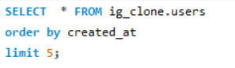 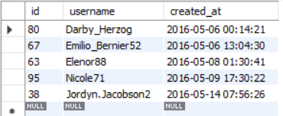

1. **Remind Inactive Users to Start Posting:** By sending them promotional emails to post their 1st photo.  
   Your Task: Find the users who have never posted a single photo on Instagram

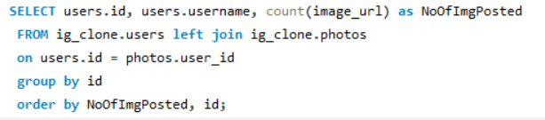

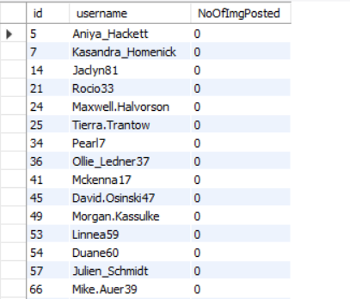

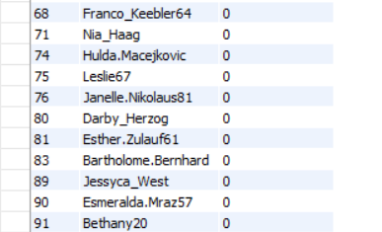

SELECT users.id, users.username, count(image_url) as NoOfImgPosted

FROM ig_clone.users left join ig_clone.photos

on users.id = photos.user_id

group by id

order by NoOfImgPosted, id;

1. **Declaring Contest Winner:** The team started a contest and the user who gets the most likes on a single photo will win the contest now they wish to declare the winner.  
   Your Task: Identify the winner of the contest and provide their details to the team

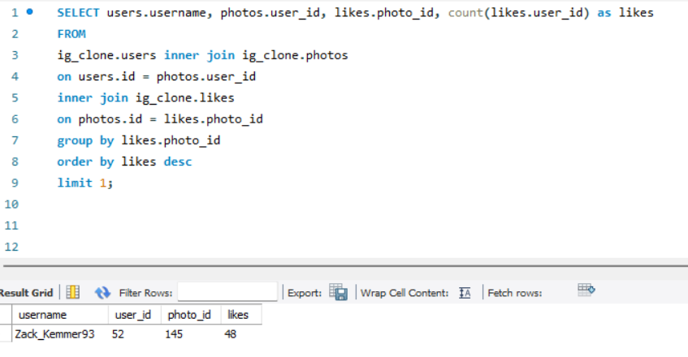

SELECT users.username, photos.user_id, likes.photo_id, count(likes.user_id) as likes

FROM

ig_clone.users inner join ig_clone.photos

on users.id = photos.user_id

inner join ig_clone.likes

on photos.id = likes.photo_id

group by likes.photo_id

order by likes desc

limit 1;

1. **Hashtag Researching:** A partner brand wants to know, which hashtags to use in the post to reach the most people on the platform.  
   Your Task: Identify and suggest the top 5 most commonly used hashtags on the platform

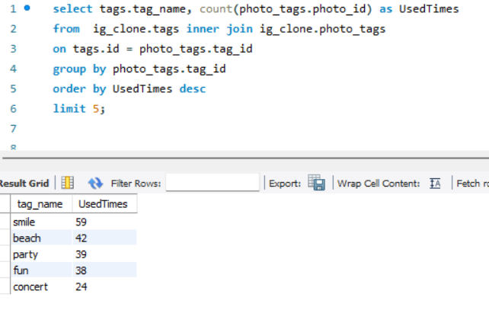

select tags.tag_name, count(photo_tags.photo_id) as UsedTimes

from ig_clone.tags inner join ig_clone.photo_tags

on tags.id = photo_tags.tag_id

group by photo_tags.tag_id

order by UsedTimes desc

limit 5;

1. **Launch AD Campaign:** The team wants to know, which day would be the best day to launch ADs.  
   Your Task: What day of the week do most users register on? Provide insights on when to schedule an ad campaign

SELECT

weekdays, count(weekdays) AS NoOfDays

FROM

(

SELECT MAX(DAYNAME(CREATED_AT)) AS weekdays

FROM USERS

GROUP BY CREATED_AT

) t

GROUP BY weekdays

ORDER BY NoOfDays DESC;

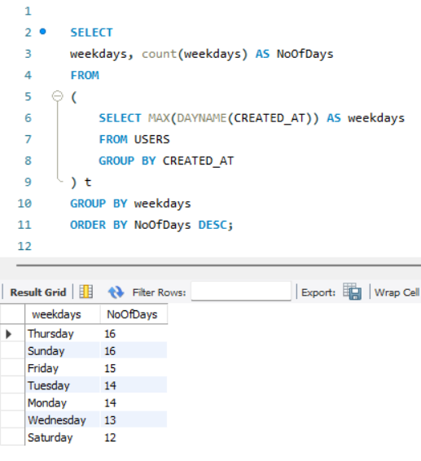

**B) Investor Metrics:**Our investors want to know if Instagram is performing well and is not becoming redundant like Facebook, they want to assess the app on the following grounds

1. **User Engagement:** Are users still as active and post on Instagram or they are making fewer posts  
   Your Task: Provide how many times does average user posts on Instagram. Also, provide the total number of photos on Instagram/total number of users

SELECT

AVG(ImgPosts1) as AvgPost

FROM

(

SELECT users.id, users.username,

count(image_url) as ImgPosts, COUNT(image_url) AS ImgPosts1

FROM ig_clone.users left join ig_clone.photos

ON users.id = photos.user_id

group by users.id

) t ;

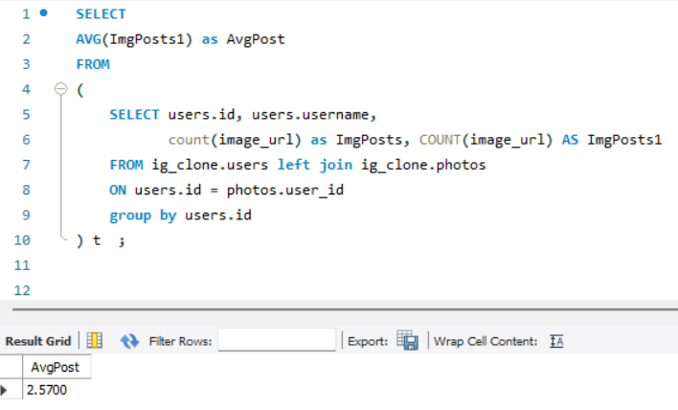

SELECT

count(photos.image_url) / count(distinct users.id) as CalCu

FROM ig_clone.users left join ig_clone.photos

ON users.id = photos.user_id;

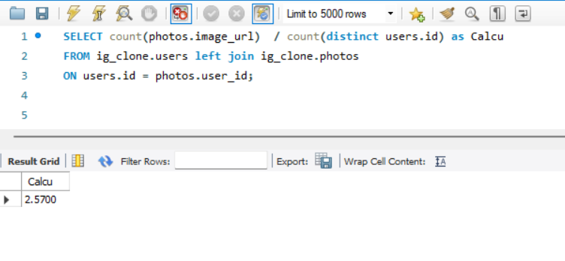

1. **Bots & Fake Accounts:** The investors want to know if the platform is crowded with fake and dummy accounts  
   Your Task: Provide data on users (bots) who have liked every single photo on the site (since any normal user would not be able to do this).

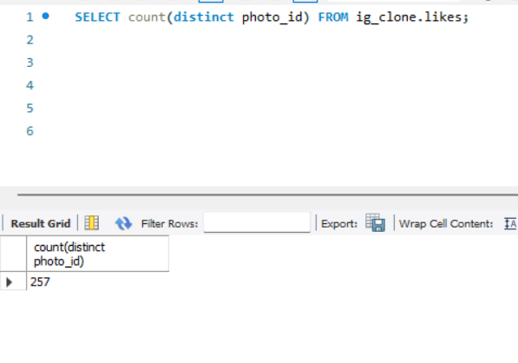

SELECT count(distinct photo_id) FROM ig_clone.likes;

SELECT users.username, user_id, count(photo_id) as Liked

FROM ig_clone.users inner join ig_clone.likes

ON users.id = likes.user_id

group by user_id

order by Liked desc;

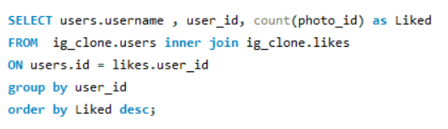

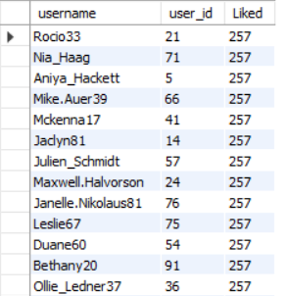

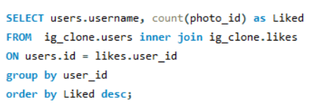

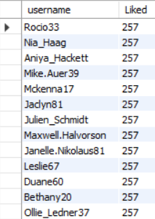

SELECT users.username as BotAccount, user_id, count(photo_id) as Liked

FROM ig_clone.users inner join ig_clone.likes

ON users.id = likes.user_id

group by user_id

order by Liked desc;

