1. **Hiring:** Process of intaking of people into an organization for different kinds of positions.  
   **Your task:** How many males and females are Hired ?







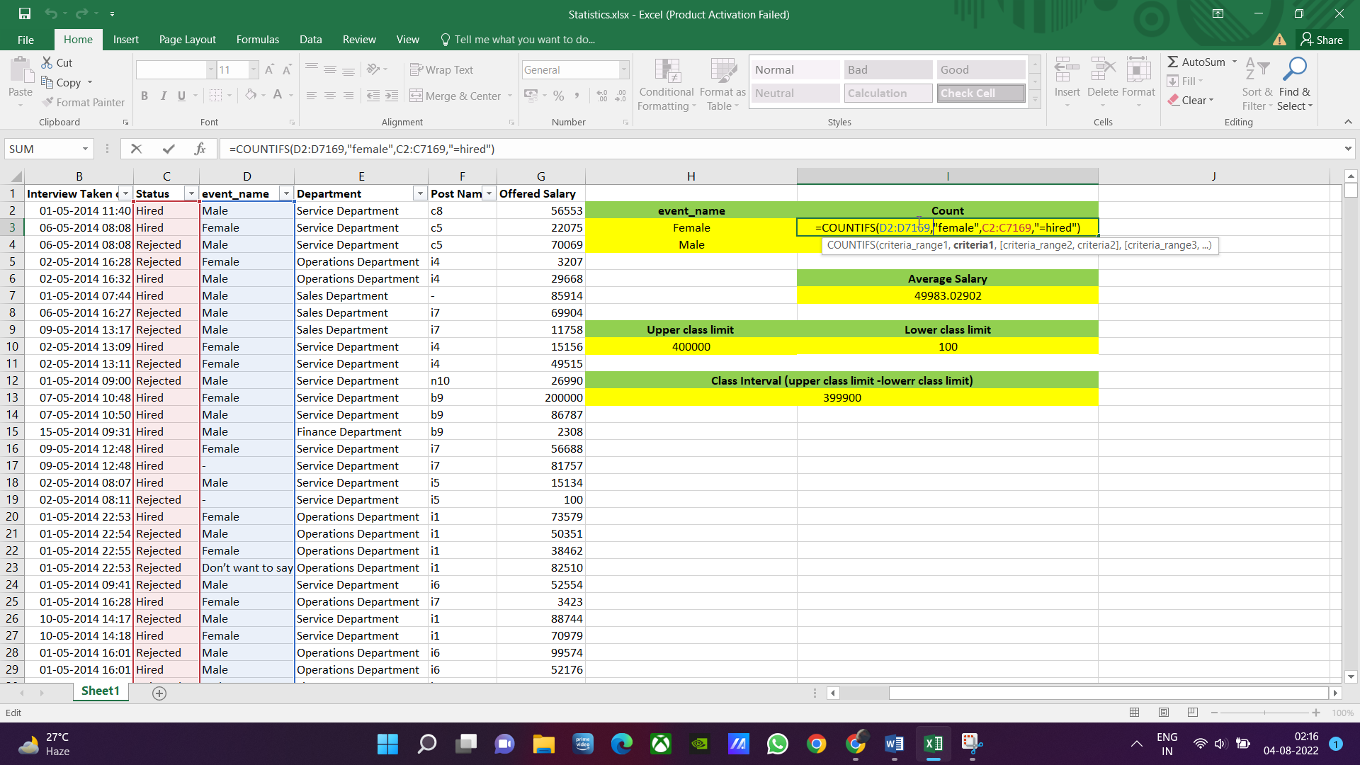

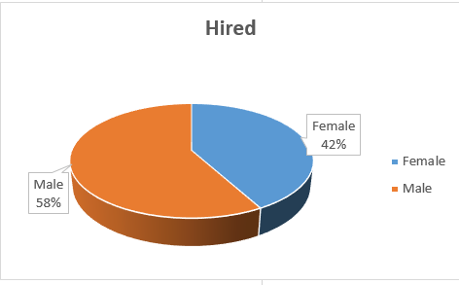

1. **Average Salary:** Adding all the salaries for a select group of employees and then dividing the sum by the number of employees in the group.  
   **Your task:** What is the average salary offered in this company?







1. **Class Intervals:** The class interval is the difference between the upper class limit and the lower class limit.  
   **Your task:**Draw the class intervals for salary in the company?











1. **Charts and Plots:**This is one of the most important part of analysis to visualize the data.  
   **Your task:**Draw Pie Chart / Bar Graph (or any other graph) to show proportion of people working different department ?



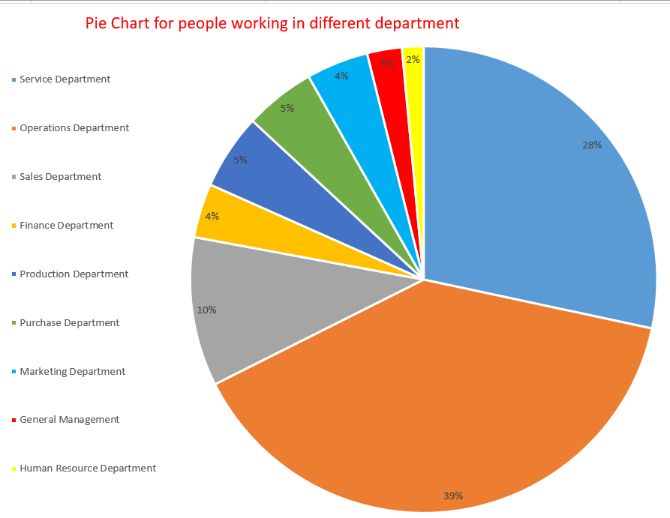

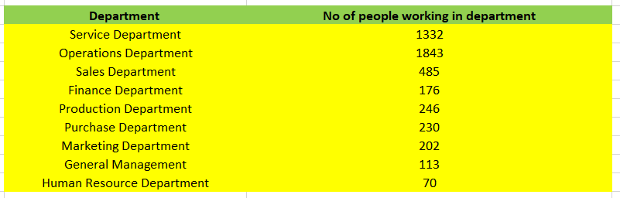



















 

1. **Charts:**Use different charts and graphs to perform the task representing the data.  
   **Your task:**Represent different post tiers using chart/graph?

