1A · Pipeline JSON → VH → 14-class QA shard
What given:
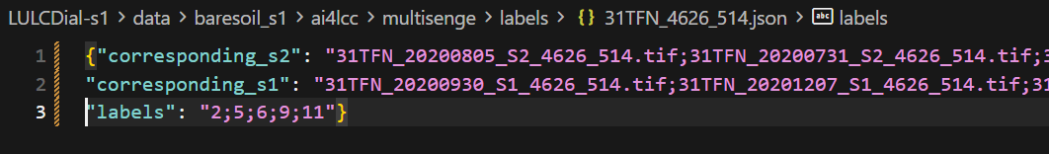
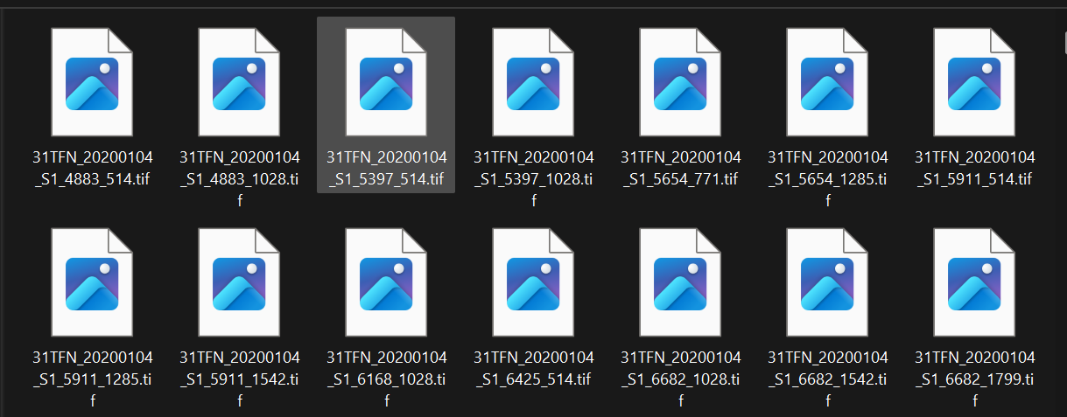
And ground truth
What Created: (Used: label and .tiff)
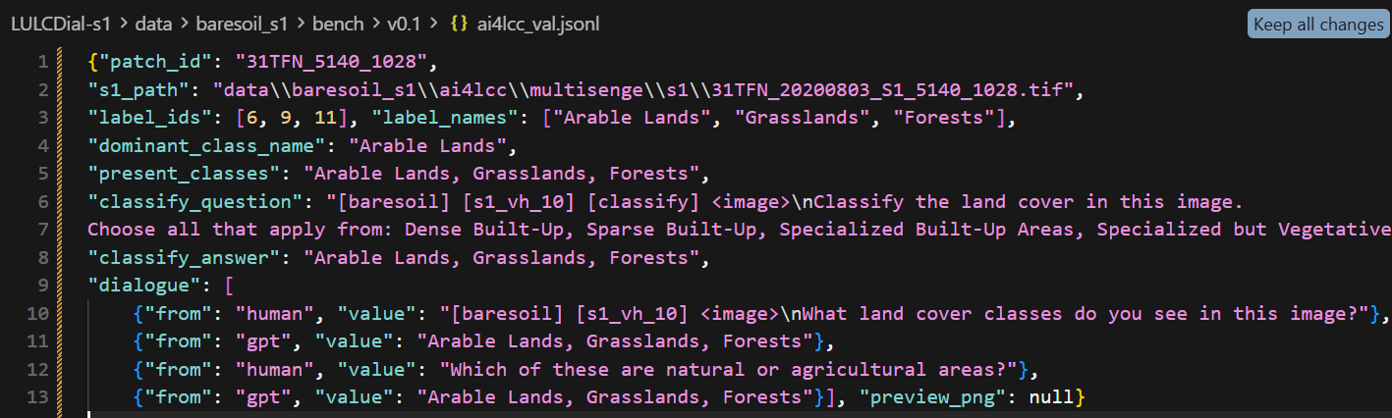
Split: 90/10
 | No of patches | Shards
MultiSenGE | 8157
Train | 7355 | 14710 rows
Test | 801 | 1602 rows

MultiSenNA:15 Class
MultiSenGE:14 Class
1B · Baseline ZS & 1C · Fine-tune
Dataset | No. of Patches |  | Classification:F1 | Dialogue: Set Match
 | Train | Test |  | T1 | T2
MultiSenGE | Zero shot | 801 | 0.019 | 0 | 0
MultiSenGE | ~25 | 801 | 0.782 | 0.10 | 0.38
MultiSenGE | ~50 | 801 | 0.783 | 0.12 | 0.38
MultiSenGE | 100 | 801 | 0.799 | 0.122 | 0.37
MultiSenNA | (Regional Transfer) | ~12k | 0.67 | 0.018 | 0.081

Novelty:
 | Claim
N1 | First VLM instruction + eval protocol on AI4LCC S1 VH with official 14-class OCSGE (classify + dialogue)
N2 | Data scaling: big jump by ~25%; flat after under fixed 1-epoch
N3 | Regional transfer GE→NA without NA FT (F1 ≈ 0.670)

2. MultiSenGE: Details about previous publication:
- Base Paper of dataset: Wenger et al., MultiSenGE: A Multimodal and Multitemporal Benchmark Dataset…, ISPRS Annals V-3-2022, 635–640.

Setup (baseline in the dataset paper)
Item | Value
Focus | Urban semantic segmentation (classes 1–5 + aggregated other)
Area | Metz, Sentinel-2 tile T31UGQ
Input | Single-date S2 IRRG (± indices for second model) — not full S1 LULC VLM
Models | U-Net + VGG-16

Numbers (Metz test)
Model | Weighted F1
U-Net-IRRG (ImageNet init) | 0.7364
U-Net-Index (IRRG + NDVI/NDBI/eNDVI, random init) | 0.7214
Example hard classes | Dense built-up F1 ≈ 0.52; roads (class 5) ≈ 0.59 (IRRG)
~~ even with optical S2, fine urban classes are hard. The paper’s main gift is the dataset; heavy multitemporal S1+S2 CNNs came in follow-ups.
- Remote Sensing 2023: ConvLSTM + Inception on MultiSenGE
Paper: Wenger et al., Multimodal and Multitemporal LULC Semantic Segmentation on S1 and S2…, Remote Sensing 15(1):151, 2023. (https://doi.org/10.3390/rs15010151)
Item | Detail
Model | ConvLSTM+Inception-S1S2 (U-Net-style + temporal + spectral fusion)
Input | Multi-date Sentinel-1 + Sentinel-2
Classes | Experiments with 6 and 10 (some OCSGE classes merged)
Reported highlight | Best 6-class weighted F1 up to ≈ 0.90 (ConvLSTM-S1S2 / +Inception variants in their tables)
10-class | Lower global weighted F1 (harder taxonomy; paper reports e.g. ~0.64 weighted F1 range for best 10-class setups — Table 7)

3. MultiSenna: Details about previous pulication
a. Remote Sensing Letters 2025 — CNN cross-region fine-tuning
Paper: Wenger, Puissant, Forestier, Multitemporal and Multimodal Cross-Region Fine-Tuning: MultiSenGE and MultiSenNA Applications, Remote Sensing Letters, 2025. (https://germain-forestier.info/publis/rsl2025.pdf)
They use ConvLSTM+Inception-S1S2 and fine-tune across regions (train/pretrain on one, adapt on the other).
Selected results (their Table 2 — CNN pixel metrics):
 | Region tested | Accuracy | Weighted F1
Fine-tune all layers, weights from MultiSenGE → MultiSenNA (test 5) | NA | 81.90% | 83.17%
Fine-tune, weights from MultiSenNA → MultiSenGE (test 6) | GE | 85.55% | 86.47%
Urban only (classes 1–5) weighted F1, full data | GE / NA | — | 60.44% / 53.54%

Contrast with you:
 | Wenger RSL 2025 | LULCDial-S1
On MultiSenNA | Fine-tune / train on NA (with GE pretrain) | No NA training — GE model only
Task | CNN segmentation (pixel maps) | VLM patch dialogue / multi-label text
Claim | Transfer learning with NA adaptation reduces carbon vs train-from-scratch | Regional zero-shot transfer of a dialogue VLM

Comparision between prior work and my contribution
 | Prior AI4LCC CNN papers | My work (LULCDial-S1)
Task | Semantic segmentation (label every pixel) | Patch-level multi-label set + 2-turn dialogue (text)
Output | Class map / raster | Natural-language class lists
Sensors | Mostly S2 IRRG, or S1+S2 multi-date | S1 VH only, one median date
Classes | Often urban 1–5 + other, or 6 / 10 merged | Official 14 OCSGE names (NA: +15 Beaches)
Metric | Weighted F1 / Accuracy / Kappa on pixels | example F1 + exact set-match on patches
Model family | U-Net, ConvLSTM+Inception (CNN) | EarthDial_4B_MS → LULCDial-S1 (VLM)
Split | Geographic tile splits (e.g. Metz / Strasbourg tiles) | Your 90/10 MD5 patch split → 801 GE val patches

4. Metrics:
(not ccomparable)
Work | Task | Input | Metric | Score
ISPRS 2022 U-Net-IRRG | Urban seg (Metz) | S2 IRRG | Weighted F1 | 0.74
RS 2023 ConvLSTM+Inception | LULC seg (6-cls highlight) | S1+S2 multi-date | Weighted F1 | ~0.90
RSL 2025 FT on NA | LULC seg | S1+S2 multi-date | Acc / wF1 | 81.9% / 83.2%
LULCDial-S1 GE | Patch multi-label + dialogue | S1 VH | example F1 | 0.799
LULCDial-S1 NA | Same, no NA FT | S1 VH | example F1 | 0.670

