A5 Phase Plan — Layer-wise TL then Neural Head on MultiSenGE
Base model: U-TAE · Method: breast-paper pattern · Data: S1+S2, 4 dates, geographic split

0. Verdict
U-TAE is suitable for layer-wise features → neural head → full fine-tune.
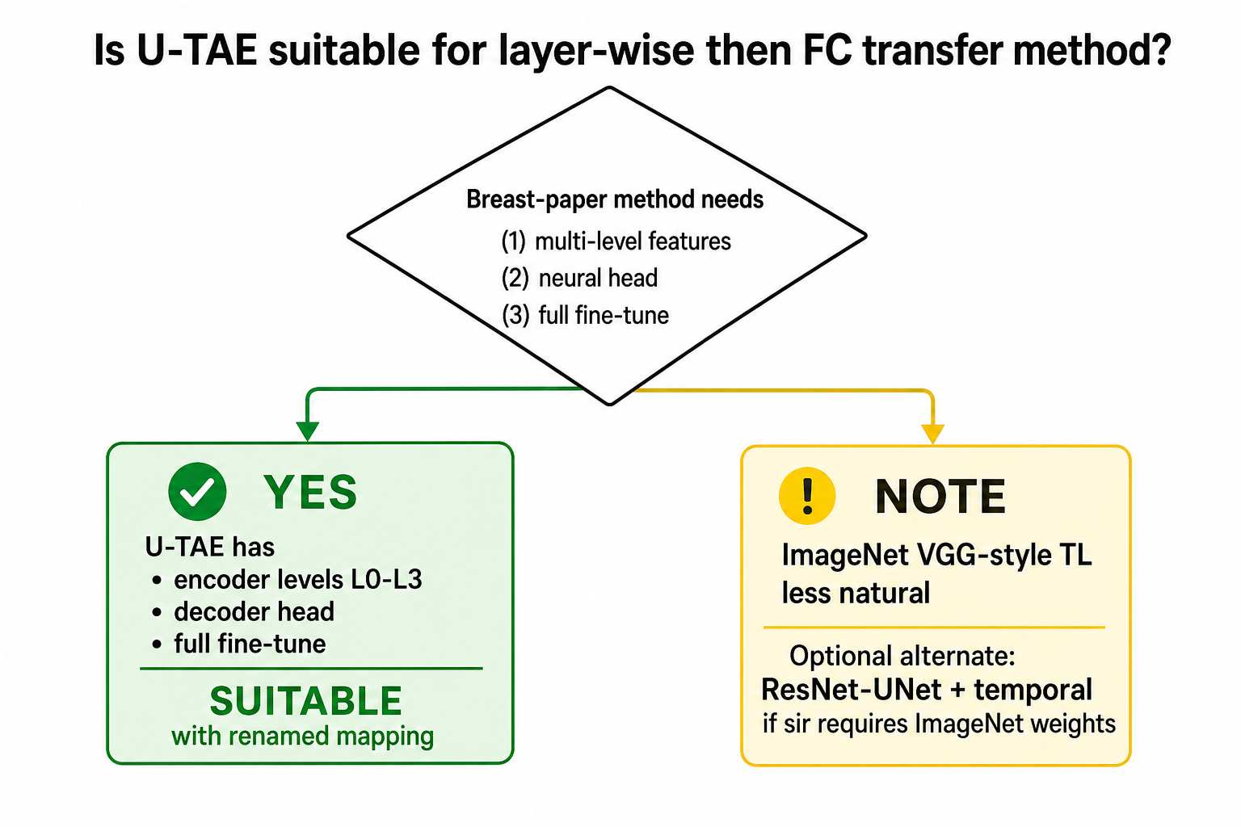
Phase overview

1. Method order
Step | Breast paper | U-TAE plan
1 | Layer-wise VGG + RF | L1/L2/L3 + RF + linear probe
2 | Train dense/FC head | Freeze encoder; train decoder + out_conv
3 | Retrain full net | Full fine-tune U-TAE (main report)

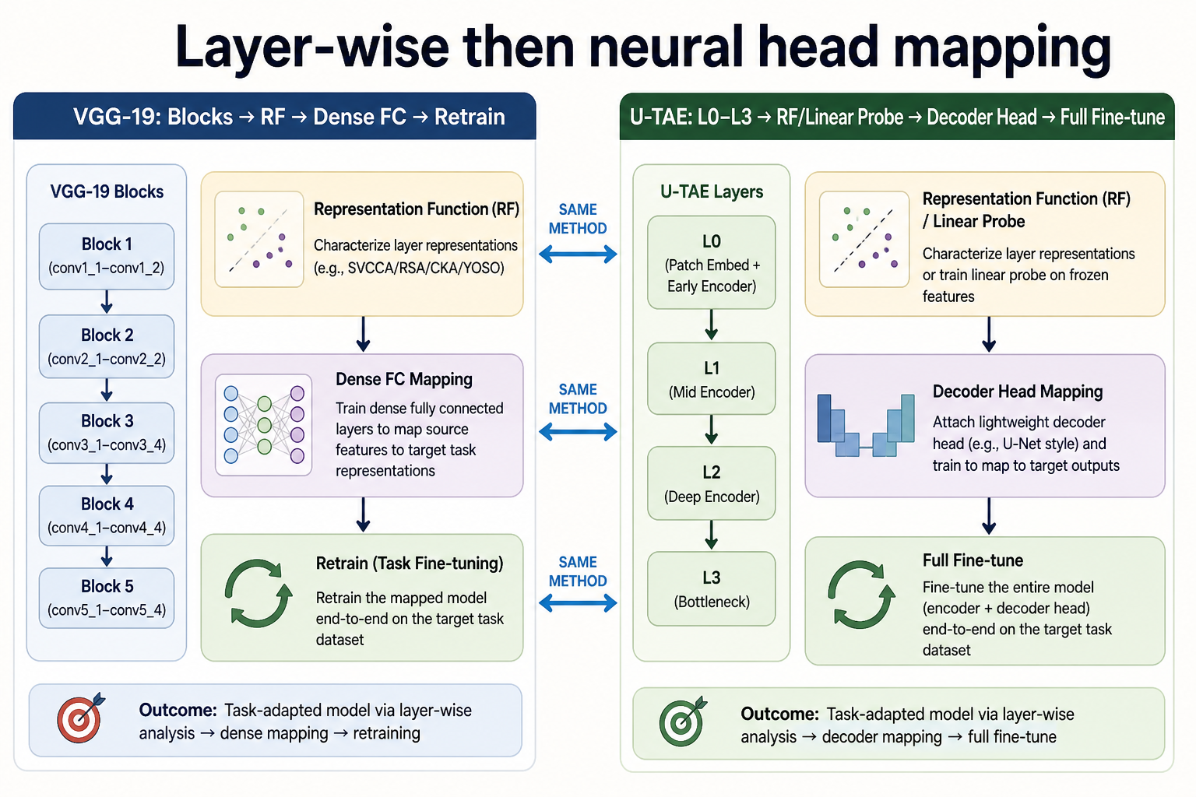
Method transfer map

2. U-TAE architecture
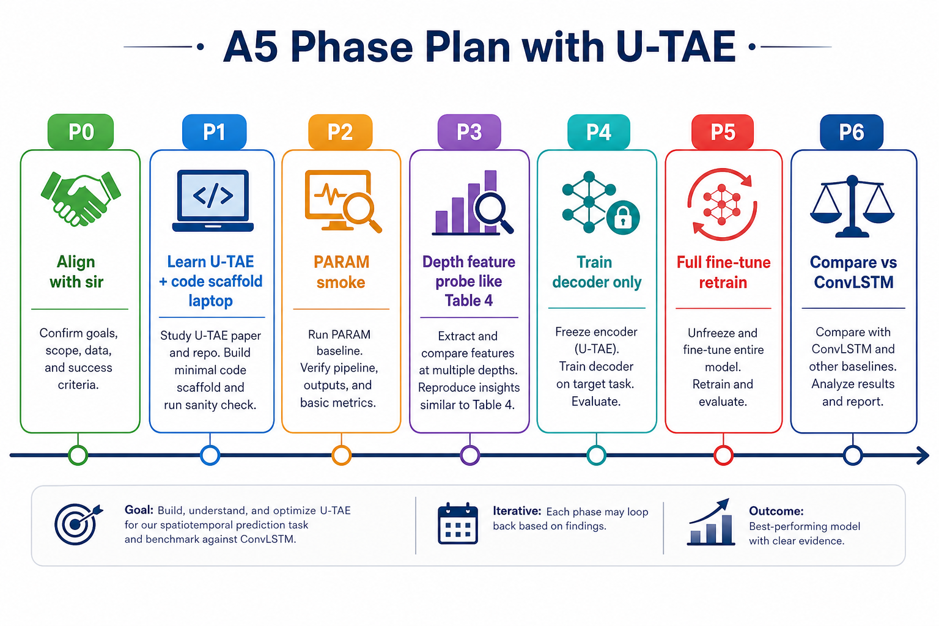
U-TAE architecture
- Spatial encoder: CNN U-Net levels L0–L3 (default channels [64,64,64,128])
- Temporal: L-TAE self-attention over T=4 dates
- Decoder + out_conv: pixel logits (6 or 10 classes)
- Input: B×T×C×H×W, C ≈ S2(10)+S1(2)

3. Data & protocol
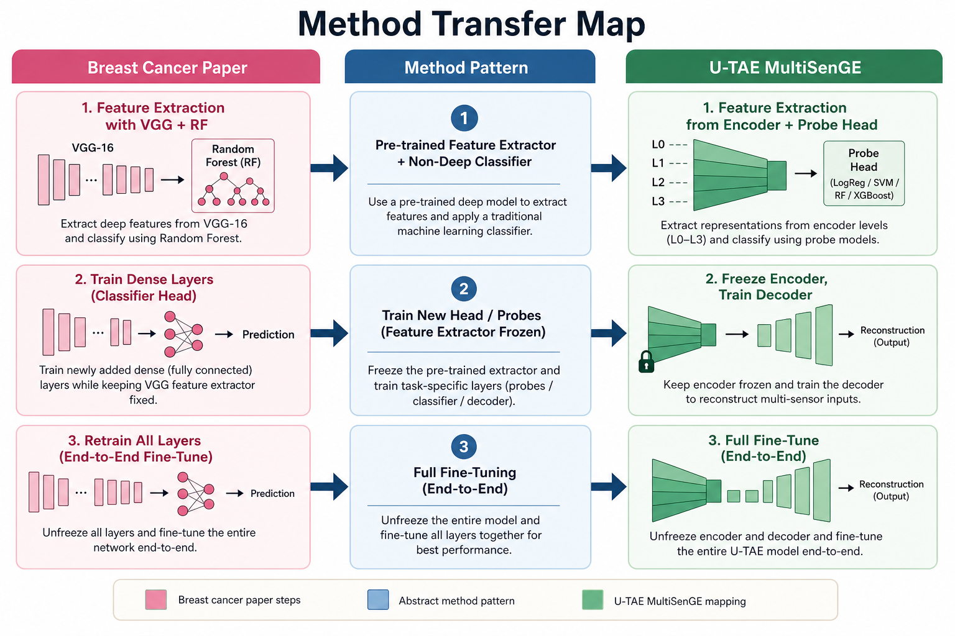
Data pipeline
- Train 8 tiles / val 31UFP+31UGP / test 31UEQ
- 6-class first; baseline ConvLSTM W-F1 0.9037

4. Phases
Phase | Task | Machine
P0 | Sir alignment | Laptop
P1 | U-TAE scaffold + loader | Laptop
P2 | Smoke 1 epoch | PARAM
P3 | Layer-wise L1/L2/L3 probe (FIRST) | PARAM
P4 | Train decoder only (SECOND) | PARAM
P5 | Full fine-tune (THIRD, main) | PARAM
P6 | Compare vs A4 ConvLSTM | Laptop

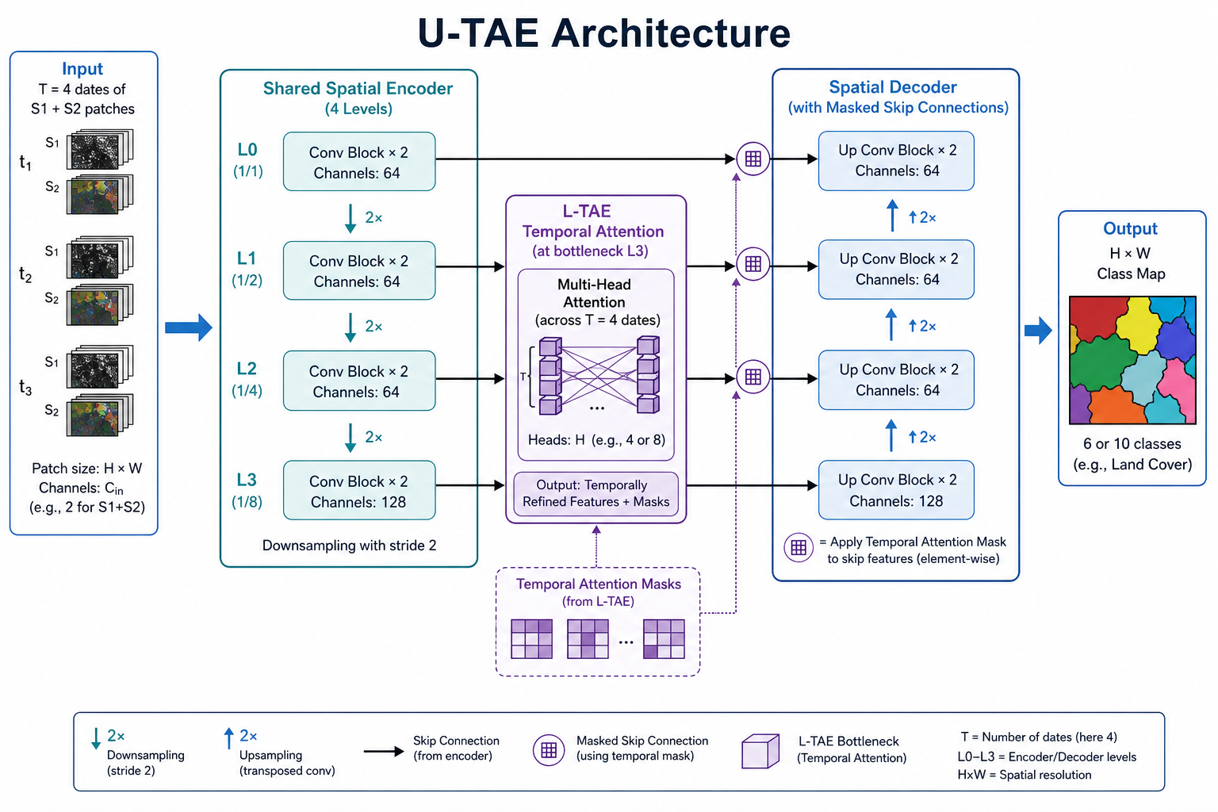
Feature levels
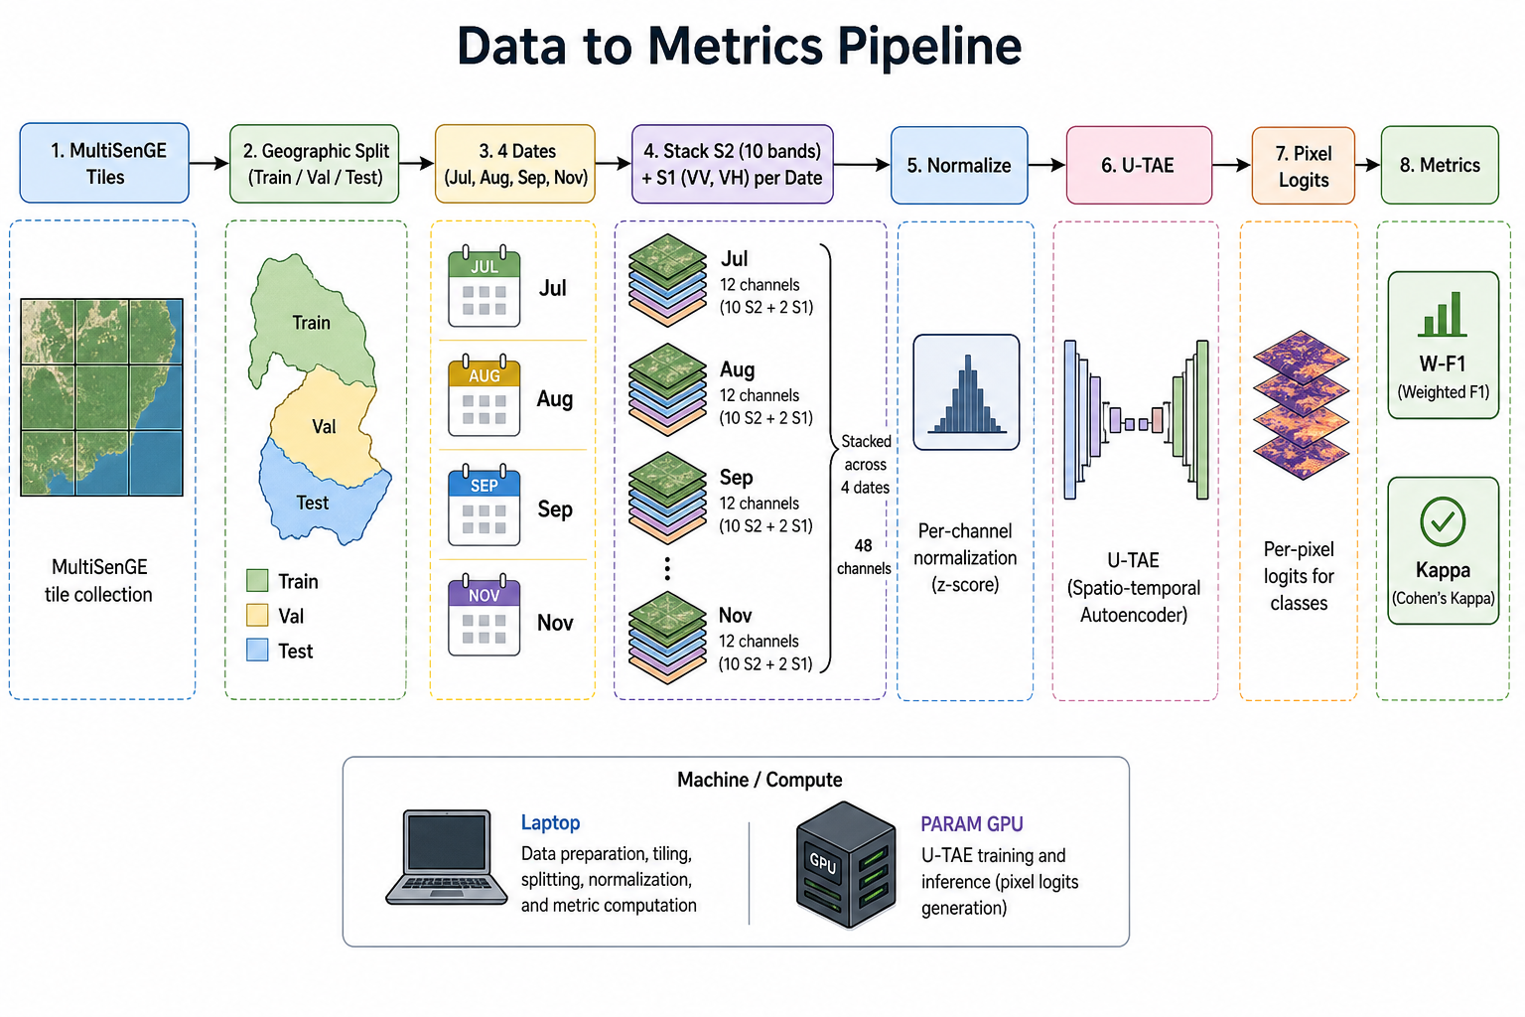
Train decoder vs full fine-tune

Appendix A — U-TAE vs ViT: why U-TAE is primary (and when ViT makes sense)
Transformers are dominant in LLMs and in many vision papers. This appendix explains why the primary A5 model is still U-TAE, what a ViT alternative would look like, and why “use ViT because LLMs use transformers” is not automatically correct for MultiSenGE.
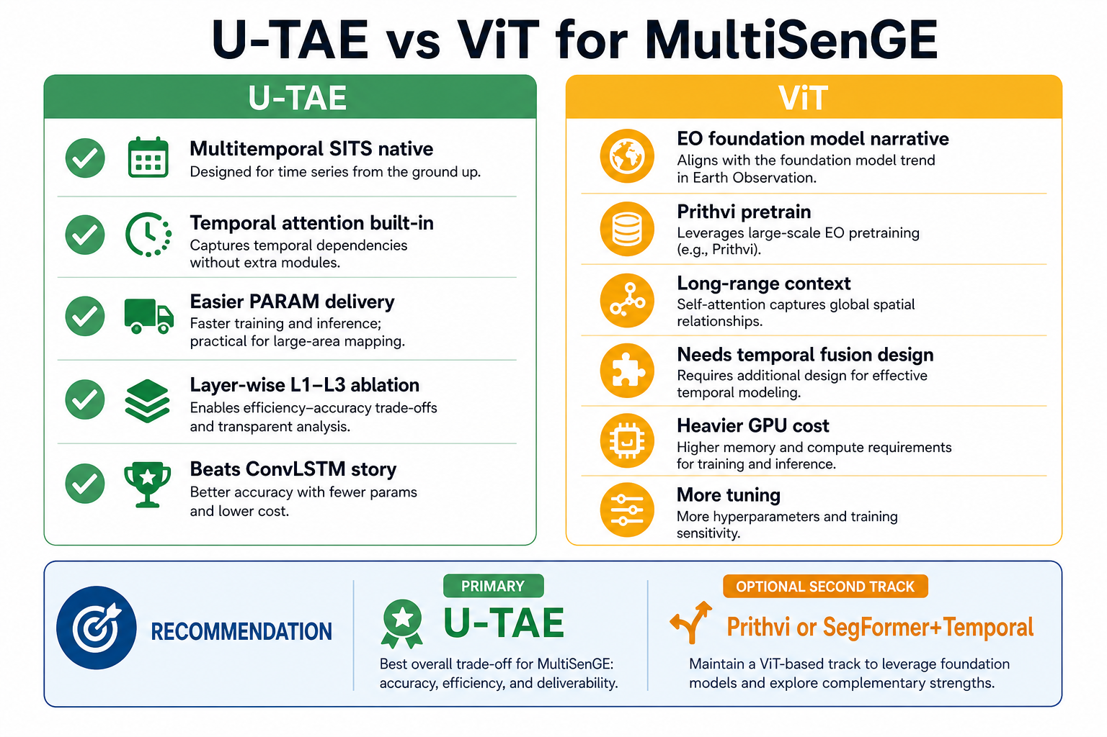
Figure A1 — U-TAE vs ViT comparison

A.1 What each model actually is
Model | Spatial path | Temporal path | Transformer?
A4 ConvLSTM + U-Net (done) | CNN (VGG-16) | ConvLSTM (recurrent) | No
U-TAE (A5 primary) | CNN U-Net encoder/decoder | L-TAE temporal self-attention | Partly — temporal only
ViT route (optional) | Patch self-attention (ViT/SegFormer/Prithvi) | Must be added (attention, ConvLSTM, etc.) | Yes — spatial transformer

U-TAE is not “no transformer.” It uses attention on the time axis. A full ViT replaces the spatial CNN with patch attention. Those are different design choices.

A.2 Pros and cons — U-TAE
Pros
- Built specifically for multitemporal satellite segmentation (PASTIS / SITS literature).
- Temporal attention is included — no separate temporal module to design.
- Easier to connect to the existing MultiSenGE loader (B×T×C×H×W).
- Clear layer-wise ablation at encoder levels L1, L2, L3 (matches breast-paper Table 4 idea).
- Lower risk to finish on PARAM before the thesis deadline.
- Simple story vs the frozen ConvLSTM baseline: “modern SITS encoder vs ConvLSTM.”
Cons
- Less trendy branding than “ViT” or “foundation model” in a thesis title.
- Spatial path remains CNN — not a full Vision Transformer over patches.
- Weaker “large-scale EO pretrain” narrative unless PASTIS weights are used.

A.3 Pros and cons — ViT (Prithvi / SegFormer + temporal)
Pros
- Strong research narrative: transformer / foundation model / EO pretraining.
- Can load EO-pretrained weights (e.g. Prithvi on HLS) — closer to classic ImageNet→target transfer learning.
- May capture long-range spatial context on larger patches.
- Good if the supervisor explicitly wants ViT or foundation-model wording in the thesis.
Cons
- Not plug-and-play for S1 + S2 + 4 dates — temporal fusion and SAR/optical fusion must be designed.
- More hyperparameter tuning (patch size, learning rate, augmentation, memory).
- Heavier GPU use; MultiSenGE has only ~5,890 patches — ViTs can overfit without careful pretrain and regularization.
- Layer-wise transfer-learning story is messier (ViT blocks ≠ VGG-style blocks).
- More engineering before the first usable result — higher schedule risk.

A.4 ViT options if a second track is required
Option | Type | Notes for MultiSenGE
Prithvi (NASA-IBM) | EO-pretrained ViT | Best “foundation model” story; adapt channels + add temporal head
SegFormer (MiT) | Efficient ViT encoder + decoder | Strong segmentation; add temporal fusion for 4 dates
Swin-UNet | Hierarchical ViT + U-Net | Good spatial model; temporal module still required
Generic ImageNet ViT | Natural-image pretrain | Poor default for SAR + multitemporal LULC — not recommended alone
U-TAE | CNN + temporal attention | Recommended primary — already SITS-native

A.5 Why not “just use ViT because LLMs use transformers”?
LLM transformers and Vision Transformers solve different problems. Copying the LLM architecture story without matching the data and task often wastes time.
Aspect | LLM transformer | MultiSenGE task
Input | Long text token sequences | Short stack of T=4 image tensors
Pretraining scale | Billions of tokens | ~5,890 geographic patches, imbalanced classes
Output | Next-token prediction | Per-pixel 6/10-class segmentation map
Modality | Single modality (text) | Sentinel-2 optical + Sentinel-1 SAR
Physics | Language statistics | Seasonal reflectivity, speckle, urban structure

Implications:
- With only T=4 dates, a dedicated temporal attention module (U-TAE L-TAE) is often more appropriate than a huge spatial ViT designed for single images or long video.
- A generic ImageNet ViT does not understand SAR VV/VH or seasonal crop signals without EO-specific pretraining.
- Small geographic datasets punish over-parameterized models unless pretrain + regularization are handled carefully.

A.6 Decision rule (what to tell the supervisor)
If… | Then…
Goal = finish sir’s breast-paper method on MultiSenGE on time | Primary: U-TAE (layer-wise → decoder → full fine-tune)
Goal = explicit “ViT / foundation model” thesis angle | Add Plan B: Prithvi or SegFormer + temporal fusion after U-TAE smoke
Goal = beat ConvLSTM with lowest risk | U-TAE first; compare numbers on test tile 31UEQ
Goal = maximum novelty only | ViT track — accept longer PARAM tuning and integration work

Recommended path: run U-TAE as the main A5 experiment. Treat Prithvi/SegFormer+temporal as an optional second model only if the supervisor requires a full spatial ViT comparison. Do not replace U-TAE with a generic ImageNet ViT.

Appendix B — One-paragraph summary for sir
The previous MultiSenGE replicate used CNN + ConvLSTM, not transformers. The proposed A5 model U-TAE already introduces temporal self-attention while keeping a proven U-Net spatial path for segmentation. A full ViT (e.g. Prithvi or SegFormer) is possible as a secondary track for a foundation-model narrative, but it requires custom S1/S2 and temporal fusion, more GPU tuning, and is riskier on a ~5.9k-patch dataset. Therefore U-TAE remains the primary choice; ViT is optional, not a drop-in replacement motivated by LLM trends alone.

End of document · U-TAE code: https://github.com/VSainteuf/utae-paps

