Imbalanced Breast Cancer Classification Using Transfer Learning — Paper Notes
Singh et al., IEEE/ACM TCBB, Vol. 18, No. 1, Jan/Feb 2021
Source PDF: Imbalanced_Breast_Cancer_Classification_Using_Transfer_Learning.pdf
These notes summarize the paper in plain language: problem, method, architecture, experiments, and especially what Table 5 / “dense layers” / train vs retrain mean.

1. Core claim
The paper adapts ImageNet-pretrained VGG-19 to a large imbalanced histopathology dataset (IDC vs non-IDC, 277,524 patches), tries several classifiers on top, and reports that retraining VGG-19 with dense layers beats prior full-dataset baselines (accuracy 90.3%, F1 93.22).
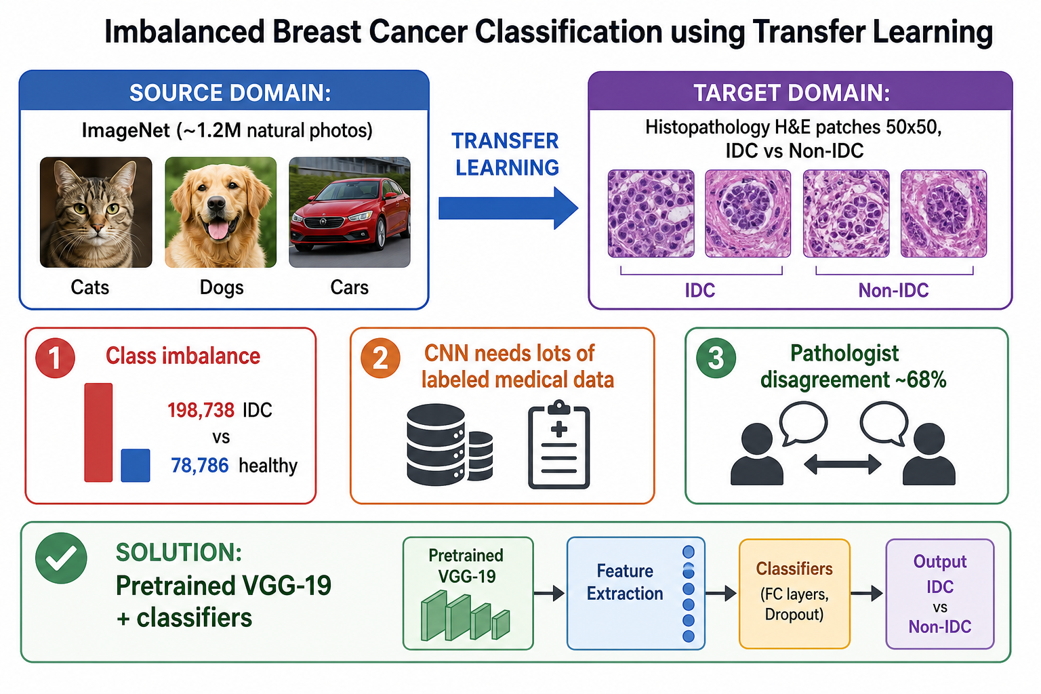
Overview: ImageNet → histopathology transfer

2. Problem

Clinical
Breast cancer confirmation often needs histopathology (H&E biopsy slides). Reading is slow, subjective (~68% inter-observer agreement cited), and hard to scale. The task here is CAD: classify each tissue patch as IDC or non-IDC.

Machine learning
- CNNs need large labeled sets; medical labels are costly.
- The public IDC patch set is imbalanced, so accuracy alone is misleading.
Approach used: transfer learning + imbalance-aware metrics.
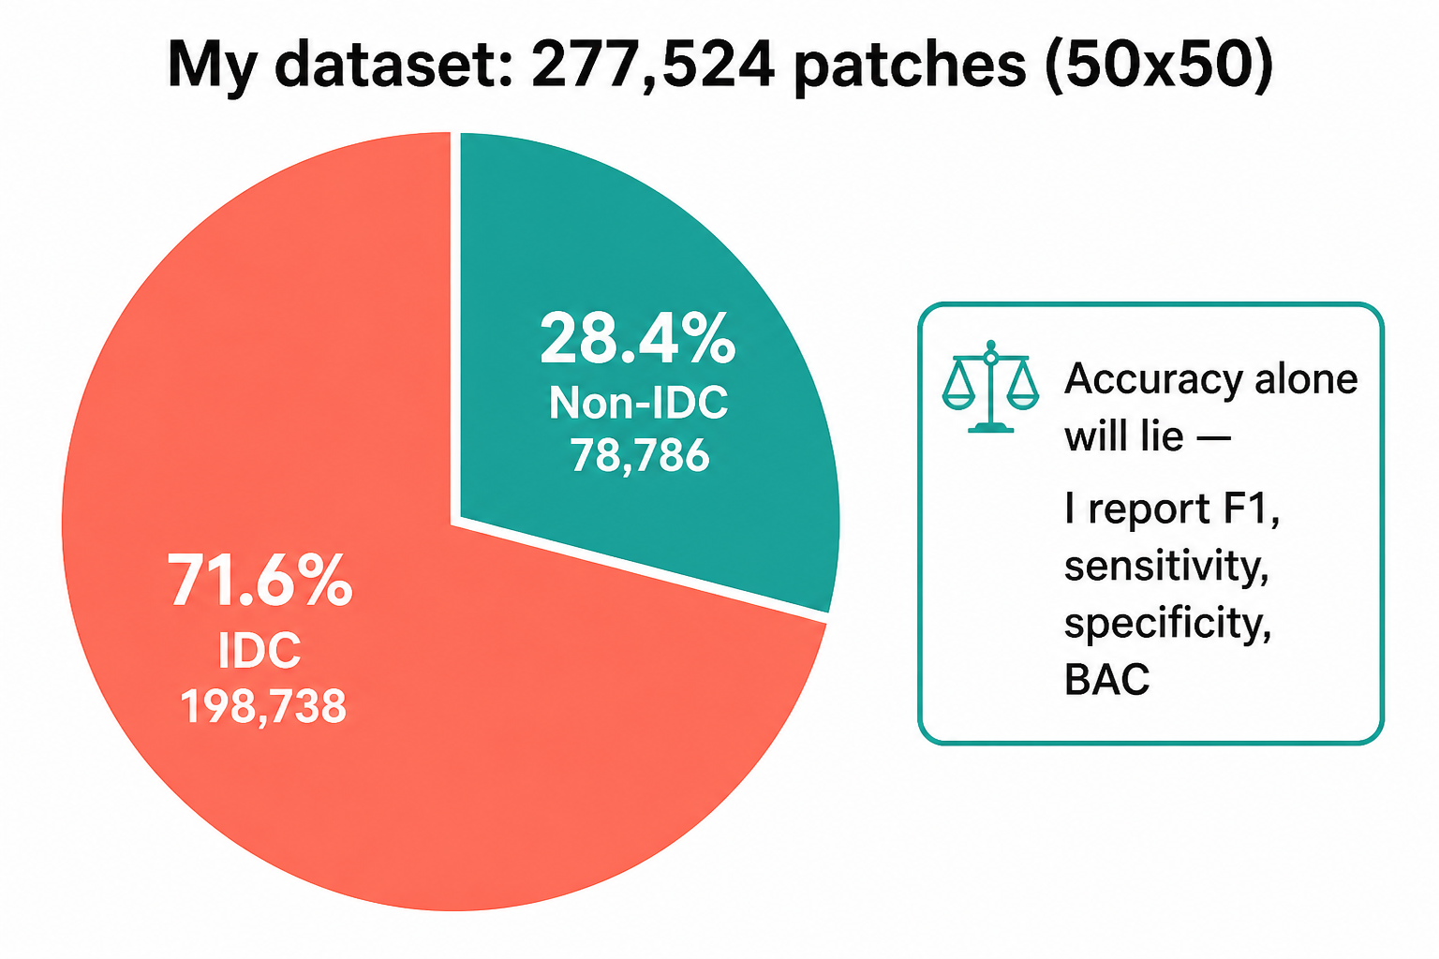
Dataset class balance

3. Research gaps addressed
Gap | Prior practice | Paper focus
Imbalance | SMOTE / ADASYN / sampling / cost-sensitive models | Full-scale histopathology, not only resampling tricks
CNN data need | Train from scratch on medical images | Reuse ImageNet features via transfer learning
Evaluation scale | Many papers use partial IDC subsets | Use all 277,524 images for fair comparison
Blind TL | “Just use VGG” | Layer-wise + classifier ablations; document negative transfer
Fair comparison | Mix partial vs full datasets | Compare mainly to full-dataset peers

Contribution: a careful transfer-learning recipe and ablations for imbalanced histopathology — not a brand-new CNN architecture.

4. Dataset
Item | Value
Total patches | 277,524
IDC (positive) | 198,738 (~71.6%)
Non-IDC | 78,786 (~28.4%)
Patch size | 50 × 50 RGB
Task | Binary: IDC vs non-IDC

Note: IDC is the majority class here (unlike many medical sets where disease is rare). Imbalance still requires F1 / sensitivity / specificity / BAC, not accuracy alone.
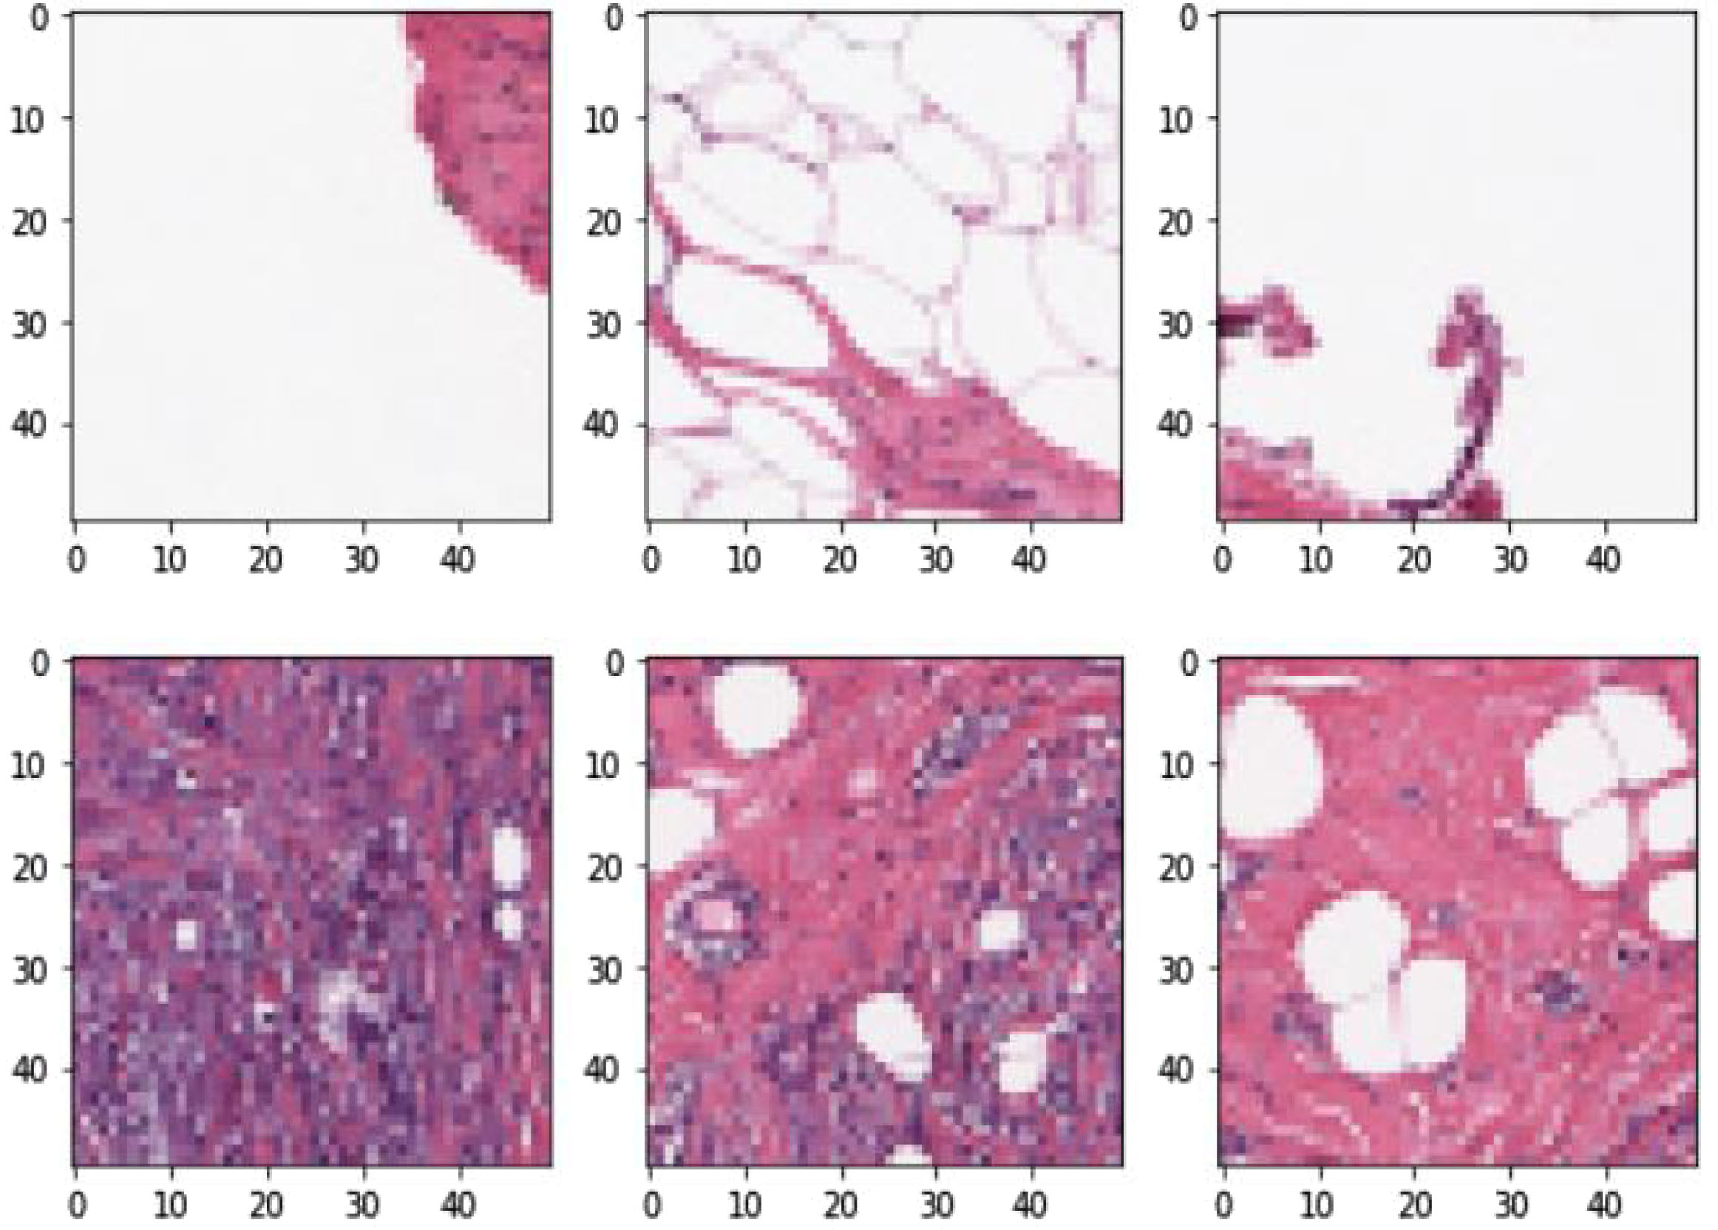
Fig. 3 from paper — sample patches

5. Transfer learning setup
- Source domain: ImageNet (~1.2M natural images)
- Target domain: histopathology patches
Generic visual filters (edges, textures, shapes) learned on ImageNet are reused on tissue images. Transfer can help or hurt; wrong layer / adaptation can cause negative transfer.
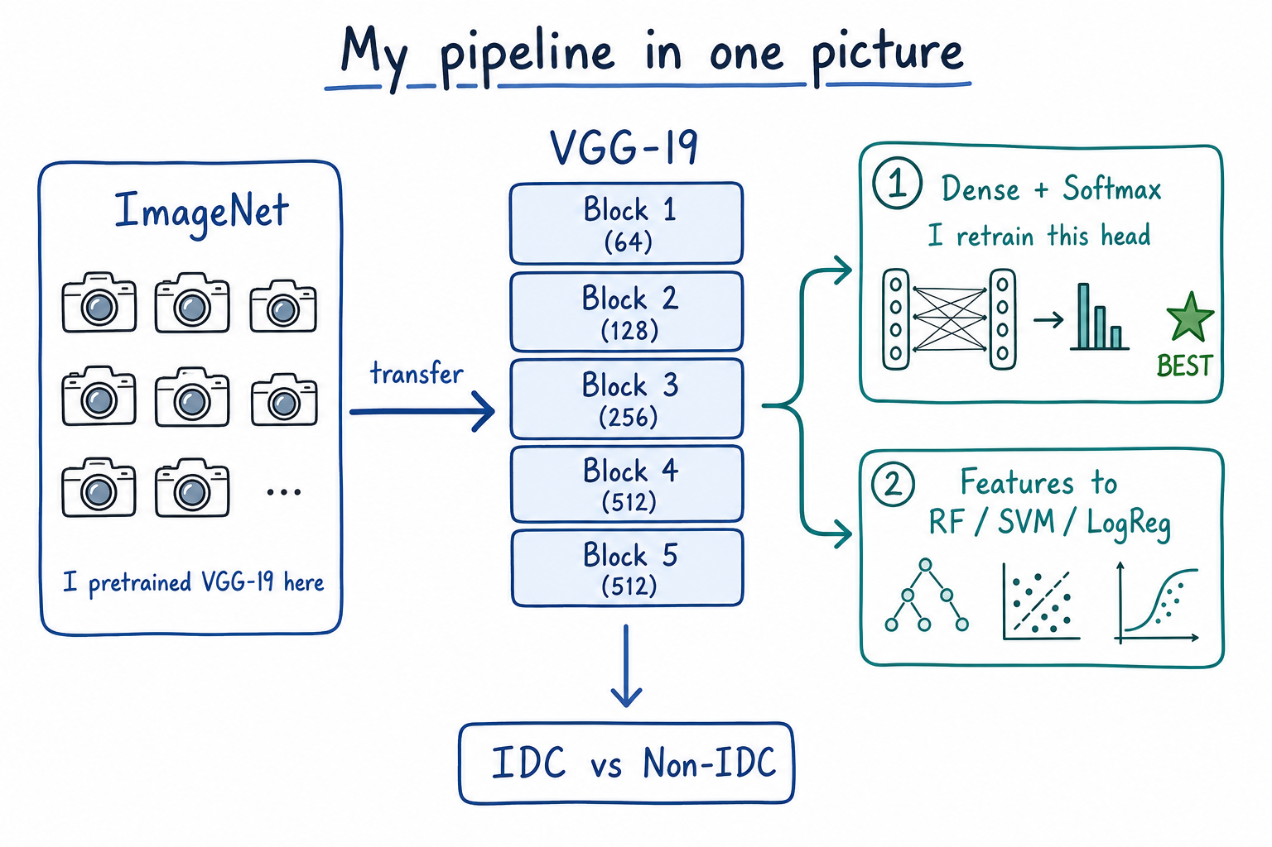
Pipeline sketch

6. Architecture: VGG-19
Backbone: VGG-19 (Simonyan & Zisserman).
- 19 weighted layers; stacked 3×3 convolutions; max-pooling; FC + softmax head
Block | Conv stack | Channels | Then
Block 1 | 2 × Conv 3×3 | 64 | MaxPool
Block 2 | 2 × Conv 3×3 | 128 | MaxPool
Block 3 | 4 × Conv 3×3 | 256 | MaxPool
Block 4 | 4 × Conv 3×3 | 512 | MaxPool
Block 5 | 4 × Conv 3×3 | 512 | MaxPool
Head | FC → FC → Softmax | 4096 / 4096 / 1000 | ImageNet classes

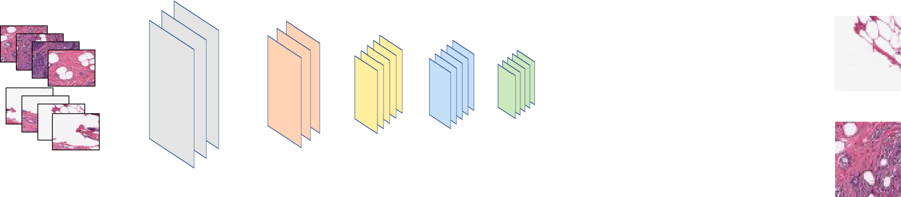
Fig. 1 from paper — VGG-19 with fully connected layers + softmax
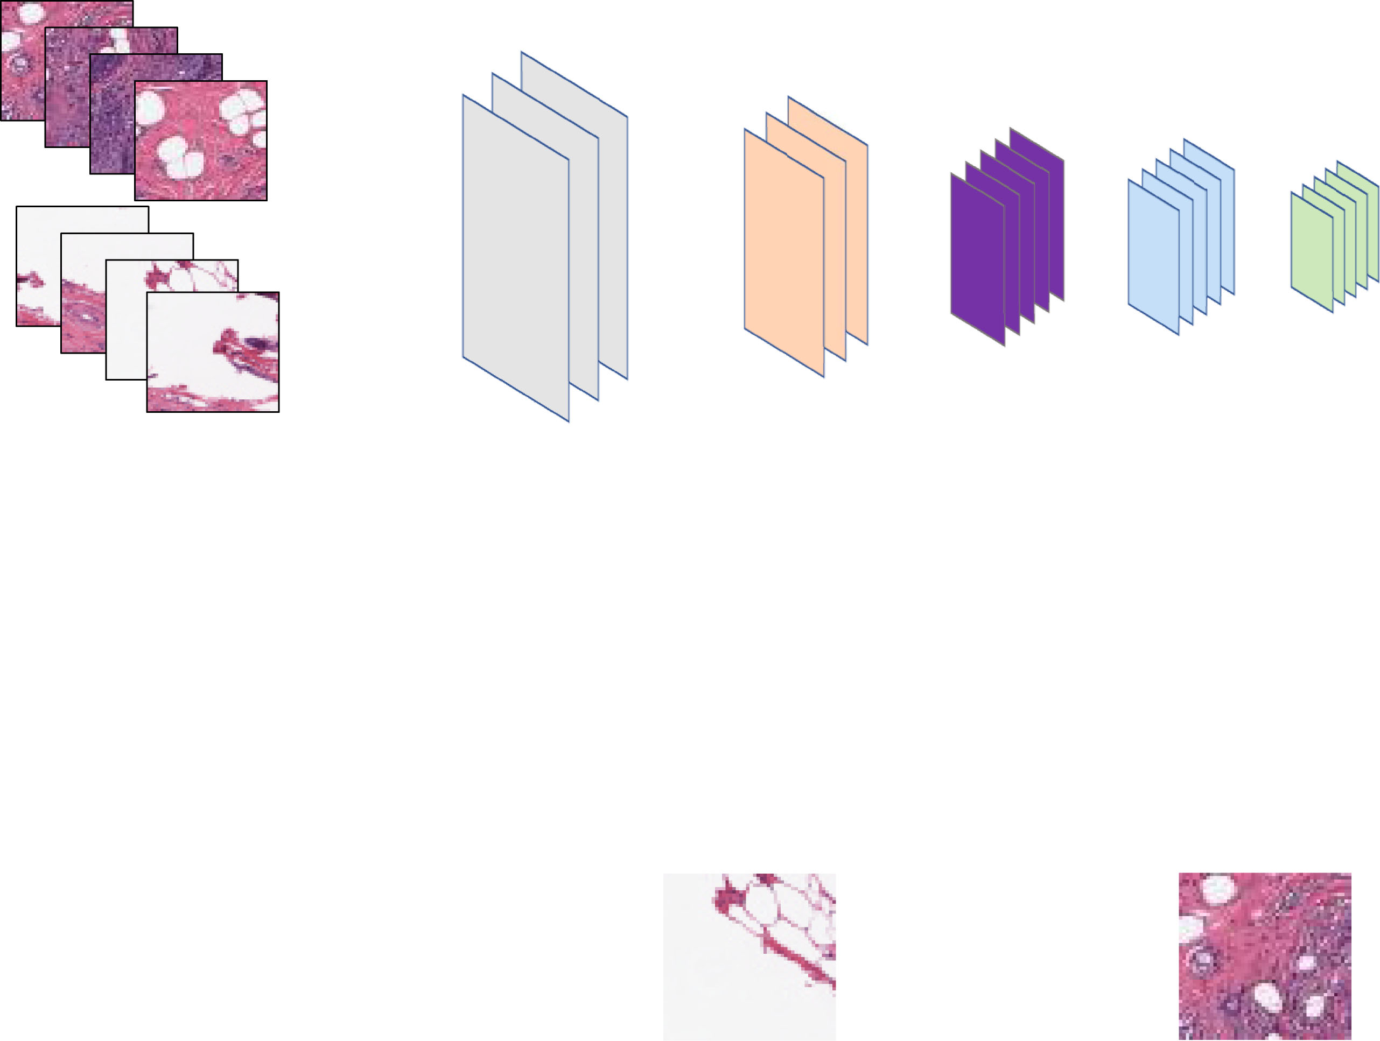
Fig. 2 from paper — VGG-19 as feature extractor + external classifiers
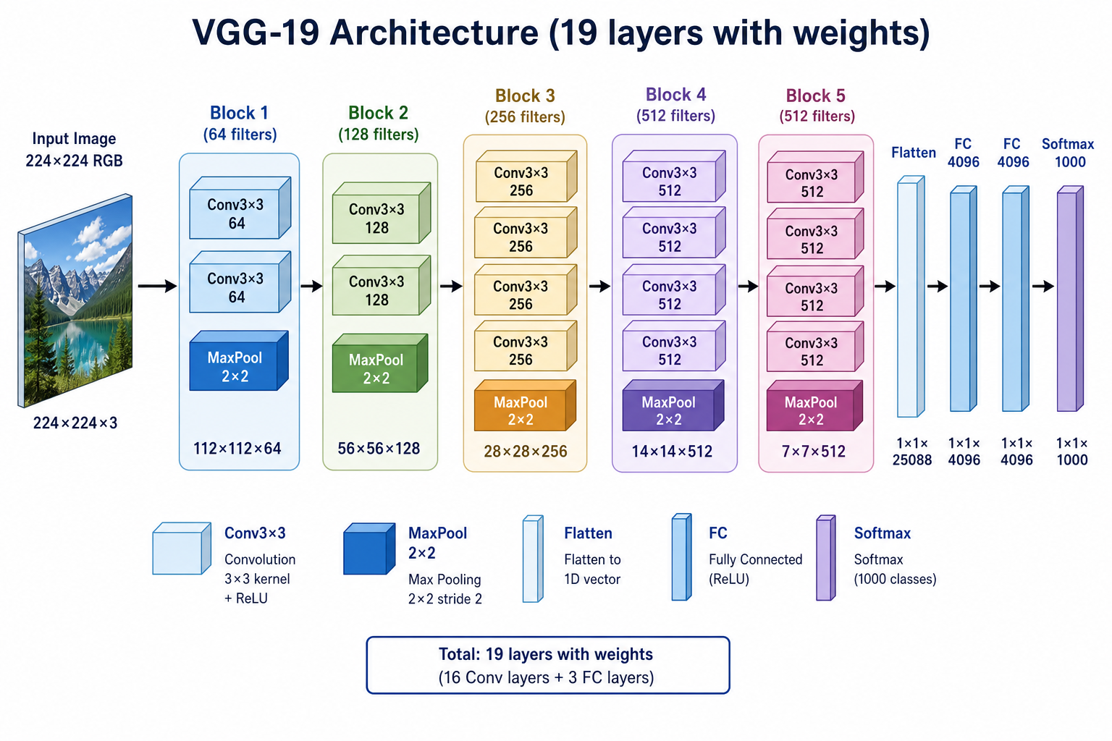
Labeled VGG-19 diagram

7. Two experimental settings (this is the key distinction)

Setting A — Layer-wise features + Random Forest (Table 4)
For each intermediate VGG-19 layer (block1_conv1 … block5_pool), features are extracted and a Random Forest is trained on those features. This is the experiment that shows middle layers can beat the last layers, and that deeper frozen features can degrade — classic negative transfer after certain convolution blocks.
- Applies Random Forest to each layer separately
- AUC roughly 0.79–0.89 depending on layer
- Best layer depends on the metric; deeper ≠ always better
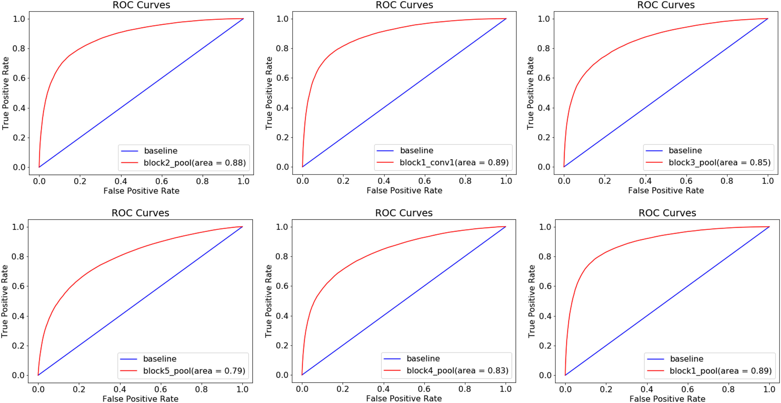
Fig. 4 from paper — ROC for selected layers

Setting B — Different classifiers on top of VGG-19 (Table 5)
Table 5 is NOT the same as Table 4. Table 5 does not sweep every convolution block. It compares different classification heads attached to the VGG-19 backbone under one shared experimental setup.
Table 5 columns fall into two groups:
- Group 1 (Fig. 2 style): VGG-19 + Logistic Regression / Linear SVM / Random Forest — the original ImageNet fully-connected head is removed; CNN features are fed to a classical classifier.
- Group 2 (Fig. 1 style, adapted): “dense layers” = the neural-network fully connected (FC) layers + softmax head — not a separate classical algorithm. Two variants: train only the dense head, or retrain VGG-19 together with the dense head on histopathology.

8. What “dense layer” means (Table 5)
Dense layer = fully connected layer in a neural network. Same idea as the FC layers in Fig. 1. It is not Random Forest, not SVM, not logistic regression. It is the standard neural classifier head that maps CNN features to class scores (then softmax).
So in Table 5:
- “VGG19 + Logistic / SVM / RF” → classical ML on extracted CNN features (Fig. 2)
- “VGG19 … dense layers” → neural FC + softmax head (Fig. 1 family)

9. “Training the dense layers” vs “Retraining VGG-19 with dense layers”
Neither column is training a CNN from scratch with no transfer learning. Both start from ImageNet-pretrained VGG-19. The difference is how much of the network is adapted to histopathology.

Column: VGG19 with training the dense layers
- Keep pretrained convolutional weights as the feature backbone (transfer learning).
- Replace / attach a dense (FC) head for the 2-class IDC task.
- Train mainly that dense head on histopathology labels.
- Convolutional filters stay largely as learned on ImageNet (little or no full-network fine-tuning).
- In the paper’s Fig. 5 language: mode without full retraining of the whole net.

Column: Retraining the VGG19 with dense layers (best result)
- Still starts from ImageNet-pretrained VGG-19 (still transfer learning, not from-scratch).
- Dense head is present for binary classification.
- The network is further trained (fine-tuned) on histopathology images — adapting more than just a frozen backbone + tiny head.
- Fig. 5 shows a large gap: with-retraining accuracy beats without-retraining.
- This is the winning setup: Acc 90.30%, F1 93.22%, Sens 93.31%, Spec 82.75%, BAC 88.03%.
Short contrast:
Setup | Starts from ImageNet? | What is trained on histopathology? | From scratch?
VGG + LR / SVM / RF | Yes (feature extractor) | Only the classical classifier | No
Train dense layers | Yes | Mostly the FC/dense head | No
Retrain VGG-19 + dense | Yes | Dense head + further adaptation of VGG-19 | No
True from-scratch CNN | No | Entire network randomly initialized | Yes (not used as the winning recipe)

10. Table 5 numbers (classifier bake-off)
Setup | Accuracy | F1 | Sensitivity | Specificity | BAC
VGG-19 + Logistic Regression | 0.7355 | 0.8366 | 0.7504 | 0.5985 | 0.6744
VGG-19 + Linear SVM | 0.7193 | 0.8351 | 0.7210 | 0.6047 | 0.6628
VGG-19 + Random Forest | 0.7868 | 0.8636 | 0.7972 | 0.7297 | 0.7634
VGG-19 + train dense layers | 0.8240 | 0.8764 | 0.8818 | 0.6842 | 0.7830
Retrain VGG-19 with dense layers | 0.9030 | 0.9322 | 0.9331 | 0.8275 | 0.8803

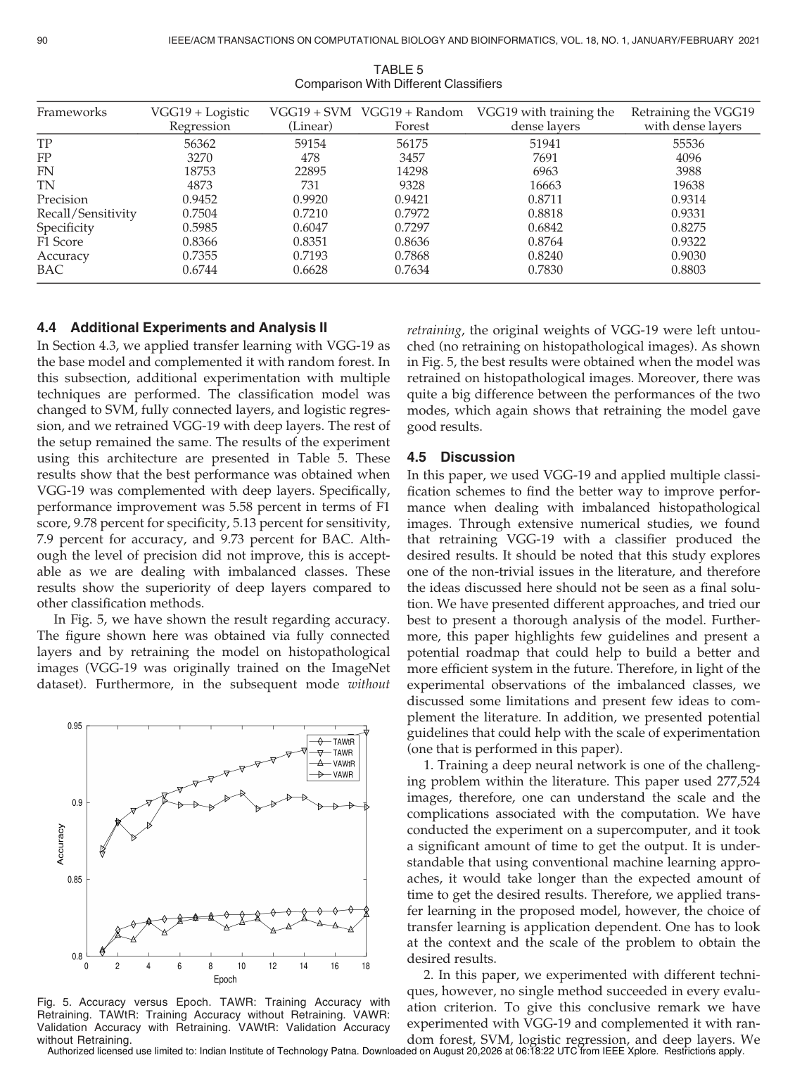
Paper page 8 — Table 5 and accuracy-vs-epoch curves
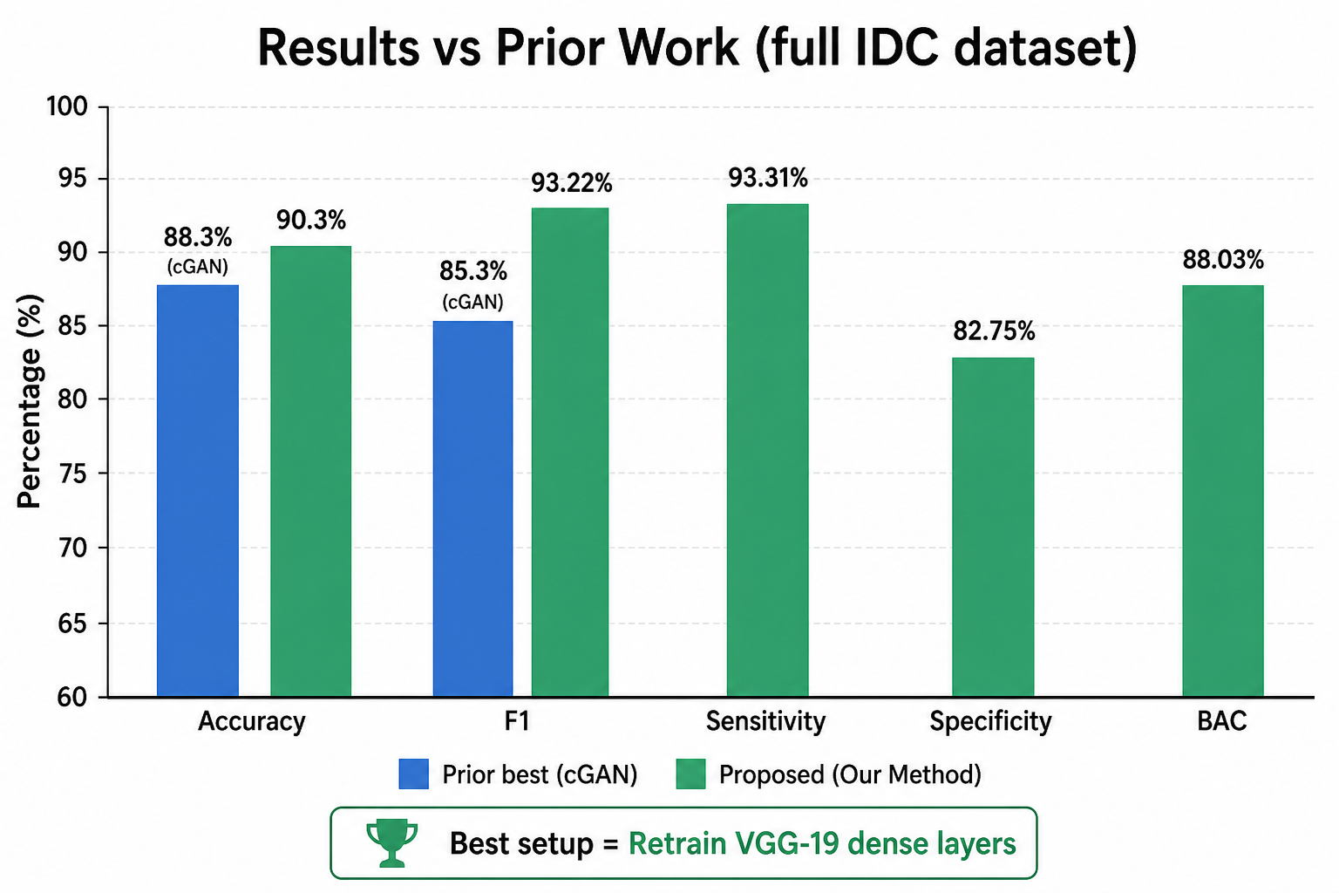
Headline results vs prior work

11. Direct answers to the Table 5 questions
Q1. Does Table 5 apply each classifier to every layer/block like Table 4?
No. Table 4 = layer-wise RF sweep. Table 5 = different classifier heads on the VGG-19 setup, not a full per-block sweep for every algorithm.
Q2. Fig. 1 (FC + softmax) or Fig. 2 (remove FC, external classifier)?
Both appear in Table 5: LR/SVM/RF follow Fig. 2 (external classifiers). The two “dense layer” columns follow the Fig. 1 neural head idea (FC/dense + softmax), adapted for binary IDC.
Q3. Is “dense layer” an algorithm like SVM?
No. Dense = fully connected neural layers. Softmax turns the last dense outputs into class probabilities.
Q4. Does “train / retrain” mean training from scratch without transfer learning?
No. Both use ImageNet-pretrained VGG-19. “Train dense layers” adapts mainly the head. “Retrain VGG-19 with dense layers” fine-tunes the transfer model more strongly on histopathology. From-scratch training is not the winning Table 5 recipe.

12. Metrics used
- Precision, Recall/Sensitivity, Specificity
- Accuracy, F1
- BAC (balanced accuracy), G-mean, AUC/ROC
Hardware reported: NVIDIA DGX-class (8× Tesla V100).

13. Conclusions from the paper
- Transfer learning helps, but is application-dependent.
- No single method wins every metric (no free lunch).
- Deeper frozen features can hurt (negative transfer) — see Table 4.
- Fine-tuning on the target domain beats frozen-backbone + weak head here.
- Competitive full-dataset results; not a finished clinical system.
Future work mentioned: stain normalization, augmentation, more classifiers/architectures, more datasets.

14. Honest limitations
- VGG-19 is older than modern pathology backbones.
- Patch-level scores ≠ patient / whole-slide clinical validation.
- Domain shift (stain, scanner, hospital) remains open.
- Centerpiece is transfer learning, not advanced imbalance losses.

Source: Imbalanced_Breast_Cancer_Classification_Using_Transfer_Learning.pdf (IEEE/ACM TCBB 2021). Figures are embedded in this Word file.

