TPC-H benchmark
TPC-H Benchmark – Interview Notes
1. What is TPC-H?
TPC-H is a decision support benchmark developed by the Transaction Processing Performance Council (TPC) to evaluate the performance of database systems running analytical queries.
It simulates a large sales and supply-chain database and runs complex SQL queries to test query processing performance.

2. Purpose of TPC-H
TPC-H is used to:
- Evaluate database performance
- Measure query processing speed
- Compare different database systems
- Test data warehouse performance
Systems commonly tested
- PostgreSQL
- MySQL
- Oracle
- SQL Server
- Distributed systems (Spark SQL, Hive)

3. Type of Workload
TPC-H represents an OLAP workload (Online Analytical Processing).
OLAP Characteristics
- Large datasets
- Complex SQL queries
- Multiple table joins
- Aggregation operations
- Business analytics queries
Example Analytical Tasks
- Sales analysis
- Supplier performance analysis
- Market share calculation
- Revenue computation

4. Database Schema
TPC-H contains 8 relational tables modeling a sales and supply chain system.
Table | Description
REGION | Geographic regions
NATION | Countries
SUPPLIER | Supplier information
CUSTOMER | Customer information
PART | Product details
PARTSUPP | Supplier–product relationship
ORDERS | Customer orders
LINEITEM | Items in each order
Important Transaction Chain
CUSTOMER → ORDERS → LINEITEM
Most queries operate on LINEITEM, which is the largest table.

5. Query Set
TPC-H includes 22 complex SQL queries.
These queries simulate real business analytics workloads.
Operations Tested
- Joins
- Aggregations
- Sorting
- Filtering
- Subqueries
- Grouping
Example Queries
Query | Purpose
Q1 | Pricing summary report
Q3 | Shipping priority revenue
Q5 | Local supplier revenue
Q9 | Product profit calculation
Q18 | Large volume customer analysis

6. Data Size (Scale Factor)
TPC-H datasets are generated using scale factors (SF).
Scale Factor | Approx Database Size
SF1 | 1 GB
SF1000 | 1 TB
Data is generated using the DBGEN tool.
Higher scale factors simulate big data workloads.

7. Benchmark Metrics
TPC-H evaluates system performance using two main metrics.
1. Query Throughput (QphH)
Measures number of queries processed per hour.
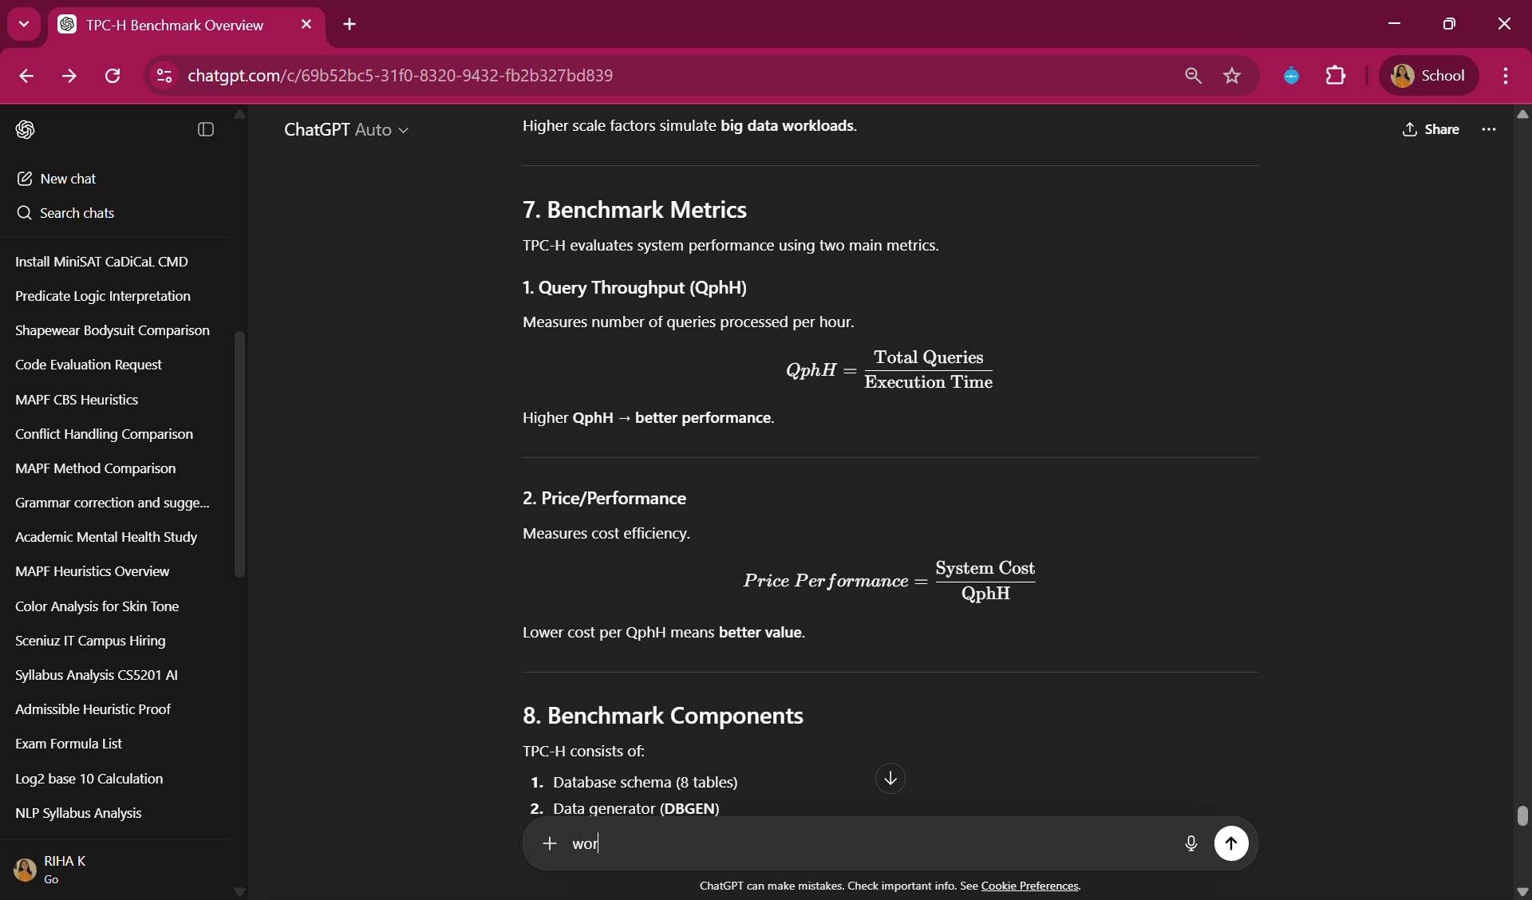
Higher QphH → better performance.

2. Price/Performance
Measures cost efficiency.
Lower cost per QphH means better value.

8. Benchmark Components
TPC-H consists of:
- Database schema (8 tables)
- Data generator (DBGEN)
- 22 analytical SQL queries
- Refresh functions (data updates)
- Performance metrics

9. Refresh Functions
TPC-H includes two refresh functions to simulate real business activity.
RF1 – Insert New Orders
Adds new rows to:
- ORDERS
- LINEITEM
Simulates customers placing new orders.
RF2 – Delete Old Orders
Removes rows from:
- LINEITEM
- ORDERS
Simulates archiving old transactions.
This ensures the benchmark reflects dynamic database workloads.

10. Example Query (TPC-H Query 1)
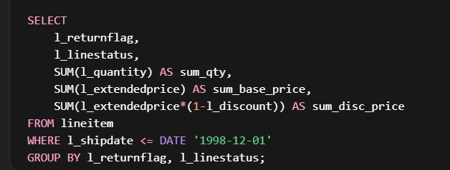
Operations used
- Filtering
- Aggregation
- Grouping

11. Why TPC-H is Important
TPC-H is widely used to:
- Compare database engines
- Evaluate query optimizers
- Benchmark distributed query systems
- Test data warehouse performance
Researchers often evaluate:
- Spark SQL
- Hive
- PostgreSQL
- DuckDB

12. TPC Benchmarks Comparison
Benchmark | Type | Use
TPC-C | OLTP | Transaction processing
TPC-H | OLAP | Analytical queries
TPC-DS | OLAP | Advanced analytics
YCSB | NoSQL | Key-value workloads

1-Line Interview Answer
TPC-H is a decision support benchmark consisting of 8 relational tables and 22 analytical SQL queries used to evaluate the performance of database systems on large-scale OLAP workloads.

