* 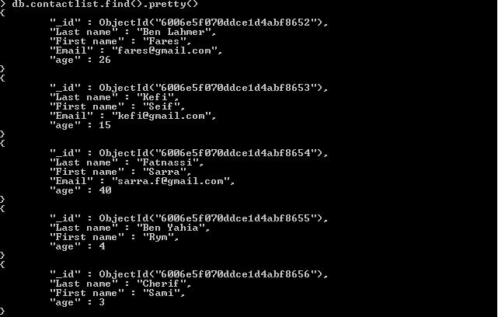Display all the information about only one person using his id
* Display all the contact list having age>18
* Display all the contact list having age>18 and name containing "ah"



* Change the contact first name of "kefi Seif" by "Kefi Anis"



* Delete the the contact list having age < 5
* Display all the contact list

