Description of expected deliverables by test automation and Load –Performance testing internal project

Youssef Abdalla

Contents

1. Introduction 2

2. General tools chain 3

3. Deliverables for the performance test 4

4. Deliverables for the functional test 4

# Introduction

This Document serves as a guide while preparing the deliverables from the internal project of the test automation and load-performance teams. The use cases we as well as the application under test are defined in the document “usecases-for-ta-and-lup” found in the same location of this document.

The deliverables described hereafter are the final deliverables expected by completing the project. In this sense, the weekly progress done in the project should therefore introduce increments towards the final deliverables presented in this document.

# General tools chain

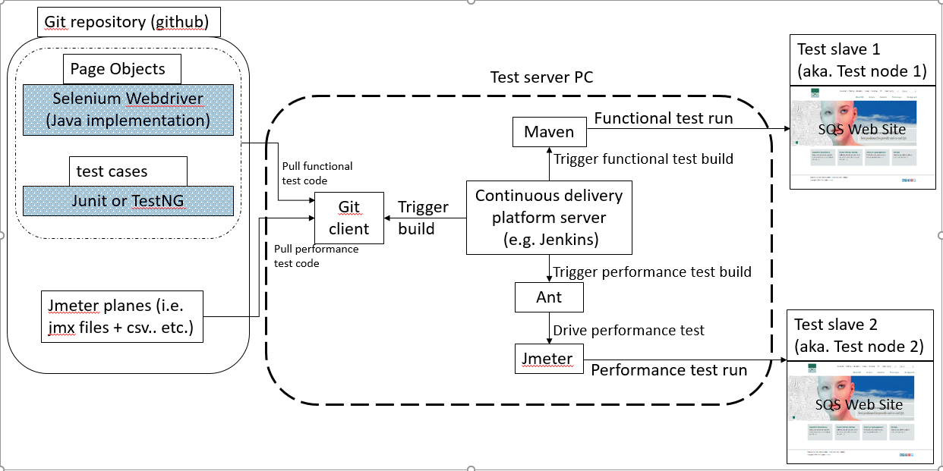

# Deliverables for the performance test

1. The Jmeter planes as per use cases description
2. The integration of the tools chain as in the figure above.
3. The Jenkins build jobs that trigger the tests.
4. Presentation describing results.
5. Live Demo in a meeting with a video recording.
6. Screencast of results.

# Deliverables for the functional test

1. The test framework based on the Page Object pattern. This can be done either by the selenium support package or without it.
2. Test cases based on Junit or TestNG.
3. The integration of the tools chain as in the figure above.
4. The Jenkins build jobs that trigger the tests.
5. Presentation describing results.
6. Live Demo in a meeting with a video recording.
7. Screencast of results.