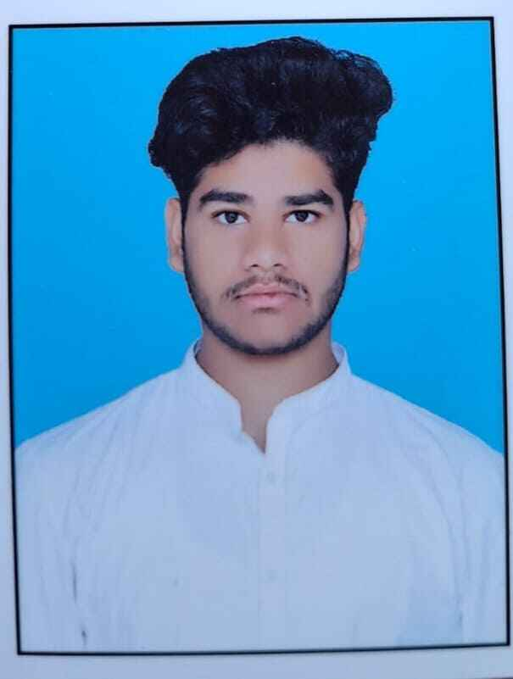

CS Rihan

Valisab road 10-157
Kadiri 515591
9014396281 or 9949833230
rihanshaik855@gmail.com
https://www.linkedin.com/in/rihan-shaik-4b7911346

TECHNICAL COMPETENCIES

OS: Windows
Languages: C
Databases: MySQL
Other Interests: prompt Engineering

INTERPERSONAL SKILLS

Team Leadership | Decision Making | Speaking and Writing Skills

INTERESTS & HOBBIES

Gaming | cooking

LANGUAGES KNOWN

English | Urdu | Hindi | Telugu

PERSONAL DETAILS

Mother’s Name: C Tabassum
Father’s Name: C Sabir
D.O.B: 12-09-2006

EDUCATION

Bachelors of Technology in Computer Science Engineering | Madanapalle Institute of Technology & Science, Kadiri Road, Andhra Pradesh
Session: 2024- pursuing | Score: 8.8 CGPA
Intermediate (state) | Viswam jr college, Madanapalle, Andhra Pradesh
Session: 2022-2024 | Percentage: 80%
Matriculation (ssc) | Valmeeki English Medium High School, kadiri, Andhra Pradesh
Session: 2017-2018 | Percentage: 76.8%

TRAINING & PROJECTS
- not yet

ACADEMIC ACHIEVEMENTS

- not yet

CERTIFICATIONS

- got a certificate for performing in drama in 1st year.
- Artist certification in 11th.
- Microsoft Office (Word, Excel, PowerPoint)

EXTRA CURRICULAR & CO-CURRICULAR ACHIEVEMENTS

- Video editing
- Playing chess

