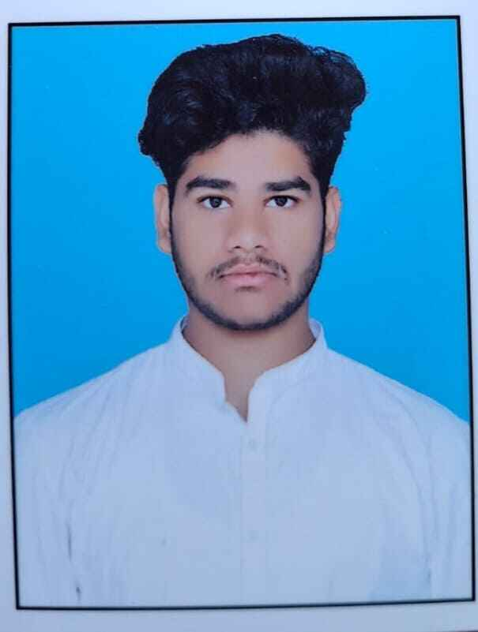

C S Rihan
📍 Kadiri, Andhra Pradesh
📞 9014396281 | 9949833230
📧 rihanshaik855@gmail.com
🔗 LinkedIn: https://www.linkedin.com/in/rihan-shaik-4b7911346

CAREER OBJECTIVE
Motivated and enthusiastic Computer Science Engineering student with strong interest in Software Development, Artificial Intelligence, and Full Stack Development. Passionate about building real-world projects and solving practical problems using technology. Seeking internship opportunities to enhance technical skills and contribute effectively to innovative teams.

EDUCATION

Bachelor of Technology (B.Tech) – Computer Science Engineering
Madanapalle Institute of Technology & Science, Andhra Pradesh
2024 – Present
CGPA: 8.8

Intermediate (State Board)
Viswam Junior College, Madanapalle
2022 – 2024
Percentage: 80%

SSC
Valmeeki English Medium High School, Kadiri
Percentage: 76.8%

TECHNICAL SKILLS
- Programming Languages: C, Java, Python (Basics), SQL, Pandas, Numpy, Machine learning.
- Database: MySQL
- Web Technologies: HTML, CSS, Flask
- Tools & Platforms: GitHub, VS Code, Microsoft Office
- Areas of Interest: Artificial Intelligence, Prompt Engineering, Full Stack Development

PROJECTS

AI Resume Analyzer
Developed an AI-powered resume screening web application that analyzes resumes and evaluates ATS compatibility, communication quality, and project relevance.

Features:
- ATS score prediction
- Resume quality analysis
- Communication evaluation
- Project authenticity checking
- User-friendly dashboard

Technologies Used:
Python, Flask, HTML, CSS

Smart Restaurant AI System
Developed and deployed an AI-powered restaurant web application designed to improve restaurant management and customer interaction.

Features:
- Smart restaurant interface
- AI-powered interaction features
- Responsive web design
- Live cloud deployment

Technologies Used:
Python, Flask, HTML, CSS, AI Integration

Live Project:
https://smart-restaurant-ai.onrender.com

CERTIFICATIONS
- Microsoft Office Certification (Word, Excel, PowerPoint)
- Drama Performance Certificate – 1st Year
- Artist Certification – Intermediate

INTERPERSONAL SKILLS
- Team Leadership
- Decision Making
- Communication Skills
- Problem Solving
- Adaptability

EXTRA CURRICULAR ACTIVITIES
- Video Editing
- Chess
- Cooking
- Gaming

LANGUAGES KNOWN
- English
- Urdu
- Hindi
- Telugu

PERSONAL DETAILS
- Father’s Name: C Sabir
- Mother’s Name: C Tabassum
- Date of Birth: 12-09-2006

