Understanding Projects, Boards, Statuses and Workflows
Customizing Your Jira Board View Without Admin Access
You can change how your Jira board looks even if you are not an admin.
You can use Quick Filters to show only the issues you need, like tasks assigned to you. You can use the search box on the board to find issues by name or number. You can also collapse or expand columns to focus on certain work stages.
You can change card layout, swimlanes, and sorting options to make the board easier to read. These changes apply only to you and do not affect other users or the project.

Workflow States and Transitions: What You Can See and Do
In Jira, a workflow shows how an issue moves from start to finish.
Workflow states are the different stages of work, such as To Do, In Progress, and Done. You can see the current state of an issue on the board or inside the issue details.
Transitions are the actions used to move an issue from one state to another, like starting work or marking it as complete. You can change an issue’s state by dragging it on the board or selecting a transition button inside the issue.
What you can do depends on your permissions. You can only see and use the transitions allowed for your role. You cannot change the workflow itself unless you have admin access.
Working Smart: Cross-Team Collaboration and Long-Term Projects
Managing Cross-Team Work in Jira
Managing cross-team work in Jira means coordinating tasks that involve multiple teams working together on the same project or related projects.
Teams can use linked issues to show dependencies between tasks handled by different teams. Epics help group related work across teams, while shared boards and filters allow everyone to track progress in one place. Assigning clear owners and using comments improves communication.
Using Jira in this way helps teams stay aligned, track dependencies, and complete work smoothly across teams.
Creating and Using Shared Boards for Team Collaboration
Shared boards in Jira help teams work together by showing issues in a common view.
To create a shared board, a board is set up using a saved filter that includes issues for all team members. The board is then shared with the team so everyone can view and use it. Team members can track progress, update issues, and move tasks across workflow stages.
Shared boards improve visibility, coordination, and communication, making team collaboration more effective.
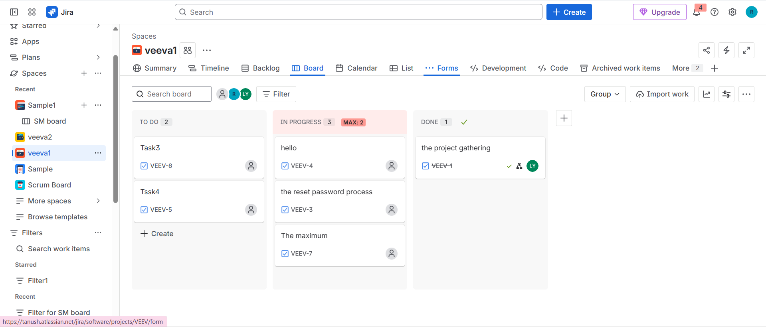
Roadmaps in Jira: Visualizing Plans and Dependencies
Roadmaps in Jira provide a visual timeline of work, helping teams plan and track progress over time.
They show Epics, issues, start and end dates, and how work is connected. Roadmaps help teams understand dependencies, plan releases, and see how changes affect timelines. Users can adjust dates, track progress, and identify risks early.
Using roadmaps makes planning clearer and helps teams stay aligned on goals and deadlines.
