Dashboards and Reports: Tracking Progress and Performance
Creating Personal and Team Dashboards in Jira
Dashboards in Jira provide a centralized view of issues, progress, and project metrics. They can be personal or shared with teams.
1. Creating a Personal Dashboard
- Click Profile → Dashboards → Create Dashboard.
- Enter a name and description.
- Select Privacy: Private or Shared with specific users/groups.
- Click Create.
Adding Gadgets: Click Add Gadget and choose gadgets like Assigned to Me, Filter Results, Pie Chart, or Sprint Health.
2. Creating a Team Dashboard
- Follow the same steps as creating a personal dashboard.
- In Privacy, select Share with Project or Group.
- Add team-relevant gadgets like Sprint Burndown, Project Progress, or Epic/Story Status.
3. Customizing Dashboards
- Resize and rearrange gadgets.
- Filter gadgets by project, issue type, or priority.
- Set refresh intervals for real-time updates.
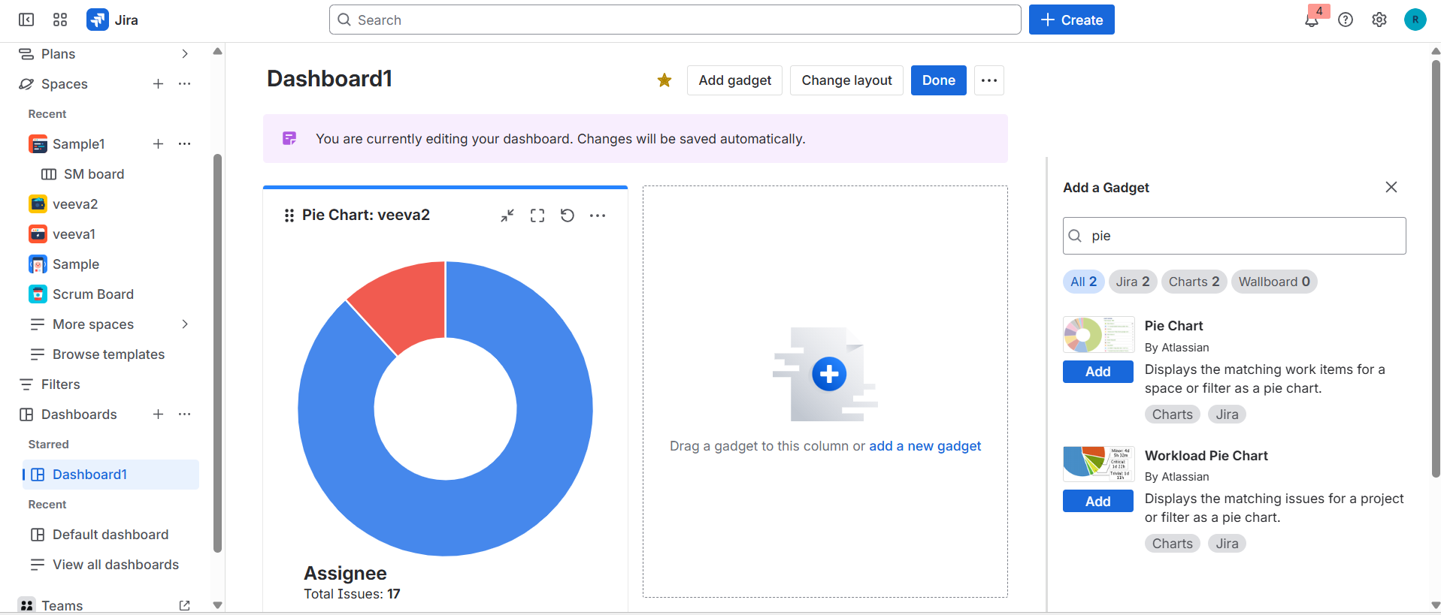
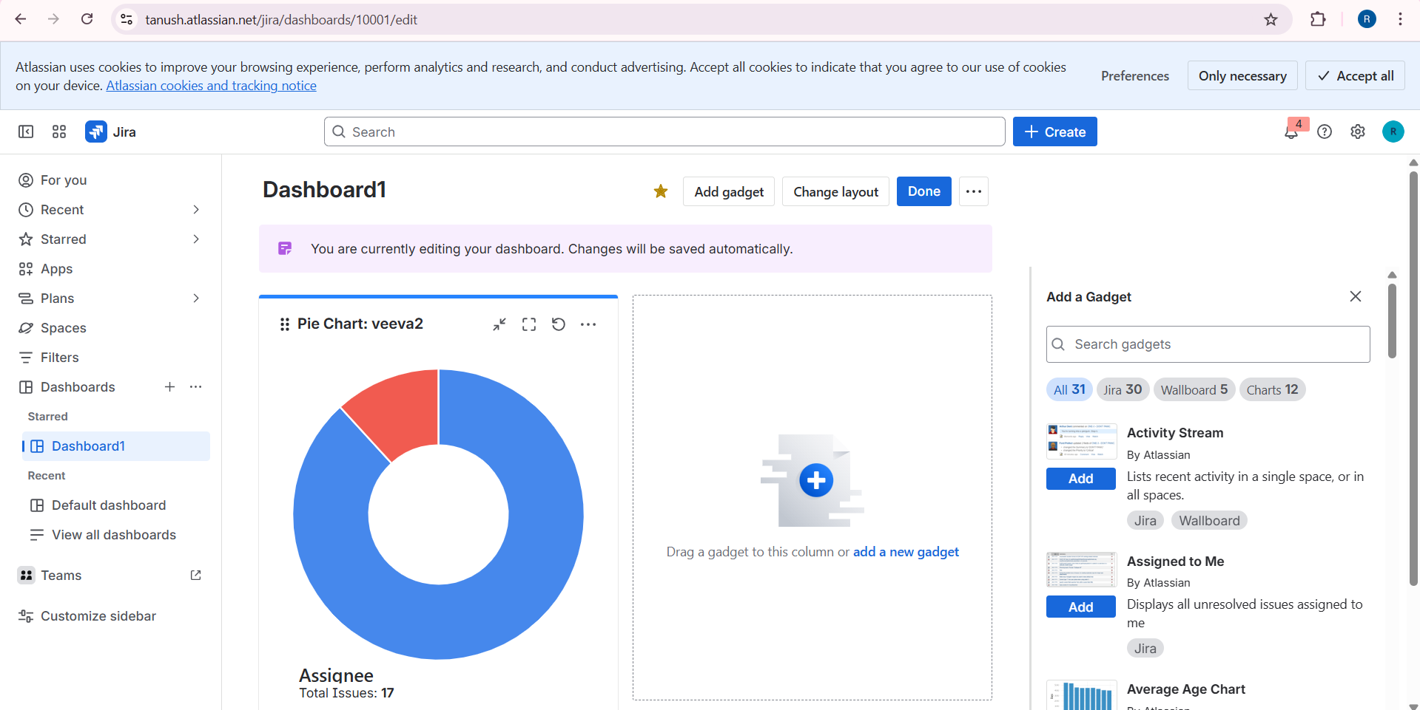

Useful Gadgets for Your Jira Dashboard:
Jira dashboards use gadgets to display important project information visually. Gadgets help you track issues, monitor progress, and understand project health at a glance. Below are some commonly used gadgets:
1. Assigned to Me
- Displays all issues assigned to the logged-in user.
- Helps you quickly focus on your tasks and priorities.
- Can be filtered by project or issue type.
2. Filter Results
- Shows issues based on a saved filter.
- Useful for tracking specific sets of issues like "High Priority Bugs" or "Sprint Tasks."
- Can display columns like status, priority, or assignee.
3. Pie Chart
- Visualizes issues grouped by fields like Status, Priority, Assignee, or Project.
- Provides an easy way to see workload distribution or progress across teams.
4. Sprint Health / Burndown
- Shows sprint progress and remaining work for Agile teams.
- Helps teams monitor if the sprint is on track.
- Can display completed vs remaining issues or story points.
5. Two-Dimensional Filter Statistics
- Displays a table of issues based on two fields, e.g., Status vs Assignee.
- Helps identify bottlenecks or uneven workload distribution.
Sharing and Cloning Dashboards with Stakeholders and Teams
Jira dashboards can be shared or cloned to make collaboration easier and provide stakeholders with the right view of project progress.
1. Sharing Dashboards
- Open the dashboard you want to share.
- Click ••• (More) → Share Dashboard.
- Choose who can view it:
  - Specific users or groups
  - Project roles
  - All logged-in users
- Click Save.
- Shared dashboards allow teams and stakeholders to see updates in real time.
2. Cloning Dashboards
- Open the dashboard you want to clone.
- Click ••• (More) → Copy Dashboard.
- Give the new dashboard a name and description.
- You can modify gadgets and filters on the cloned version without affecting the original dashboard.
Scrum Reports: Velocity, Burndown, and Sprint Report Explained
Scrum reports in Jira help Agile teams track progress, plan work, and review performance during sprints. Here are the key reports:
1. Velocity Chart
- Shows the amount of work completed in each sprint.
- Helps teams understand their capacity and plan future sprints.
- Measures work using story points, hours, or issue count.
2. Burndown Chart
- Tracks the remaining work in a sprint over time.
- Shows if the team is on track to complete the sprint.
- Helps identify potential delays early.
3. Sprint Report
- Provides a summary of the sprint: completed, incomplete, and added issues.
- Shows changes to the sprint scope during the sprint.
- Useful for retrospectives and analyzing team performance.
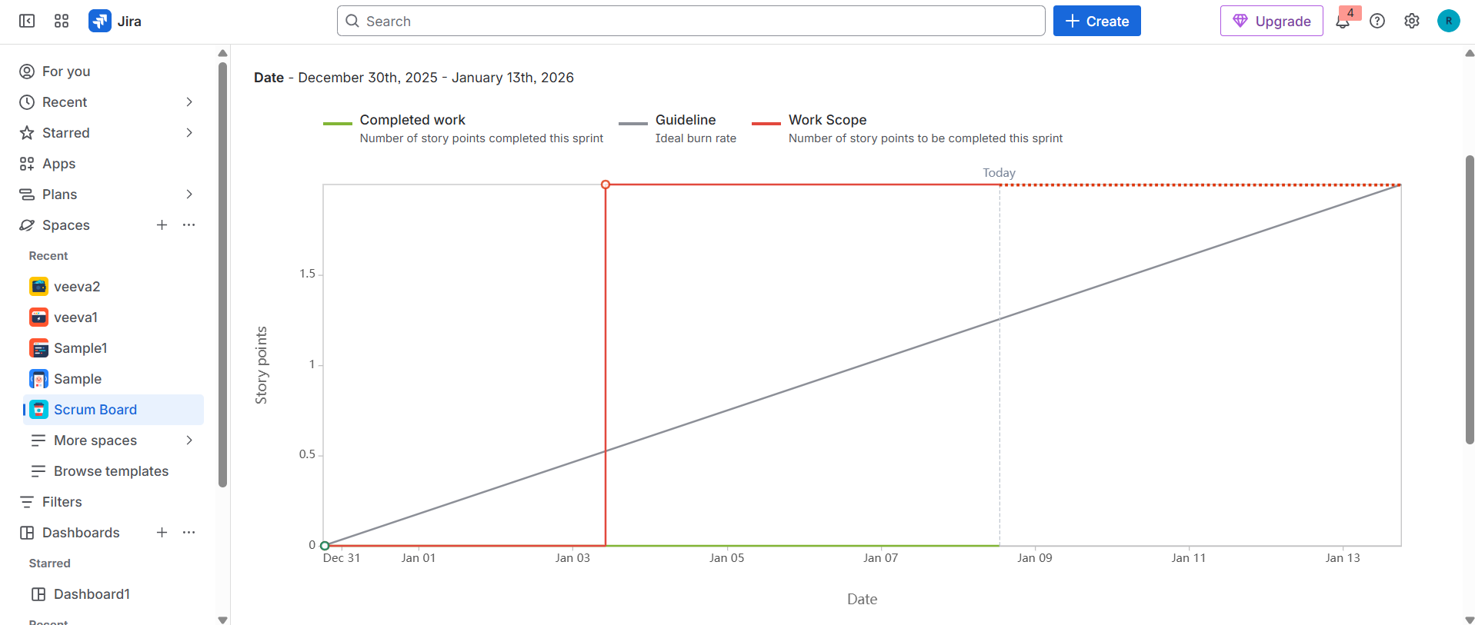

Kanban Reports: Control Chart and Cumulative Flow Diagram
Kanban reports in Jira help teams monitor workflow, spot bottlenecks, and improve efficiency. Two important Kanban reports are:
1. Control Chart
- Shows the cycle time of issues over a period.
- Helps teams see how long tasks take to complete on average.
- Useful for identifying process delays and improving efficiency.
2. Cumulative Flow Diagram (CFD)
- Displays the number of issues in each workflow state over time.
- Helps visualize workflow stability and bottlenecks.
- Shows whether work is accumulating in a particular stage (e.g., “In Progress”).
