Jira Automation – Save Time without Admin Rights
Overview
Jira Automation allows teams to save time, reduce manual work, and enforce consistency—even without Jira admin rights. Non-admin users can build powerful automation rules within their project scope to handle repetitive tasks efficiently.

What Can Be Automated in Jira by Non-Admins?
Automation is one of the most powerful features in Jira Software. Even without admin access, users can automate daily tasks, enforce team rules, and improve data quality.
Core Components of Every Automation Rule
Every Jira automation rule consists of:
- Trigger – When something happens
- Condition – Checks if the rule should run
- Action – What Jira does automatically
Automations Non-Admins Can Create
As a non-admin, you can automate:
- Automatically assign issues
- Automatically update fields
- Automatically add comments
- Automatically notify users
- Automatically add labels
- Automatically link issues
- Automatically transition issues
These automations typically work within a single project and do not require changes to Jira configuration.

Smart Checklists: Creating Reusable Checklists in Jira Issues
What Is a Smart Checklist?
A Smart Checklist is a reusable list of steps inside a Jira issue that:
- Guides work consistently
- Reduces mistakes
- Can be automatically added using automation
- Does not require admin access
Jira does not provide native checklist functionality by default.
Common Ways to Create Checklists in Jira
Teams typically use:
- Description field
- Comments
- Automation + templates
How Smart Checklists Work
Using automation, a checklist can be automatically inserted when:
- An issue is created
- An issue transitions to a specific status
- A specific issue type is selected
Why It’s Called “Smart”
A Smart Checklist is:
- Automatic
- Consistent
- Admin-free
- Reusable

Examples of Simple Automation Rules for Teams
Automation works best when rules are simple, safe, and repeatable.
Characteristics of a Good Simple Rule
- Solves one small problem
- Uses:
  - 1 trigger
  - 1–2 conditions
  - 1 clear action
- Easy to maintain
- Low risk
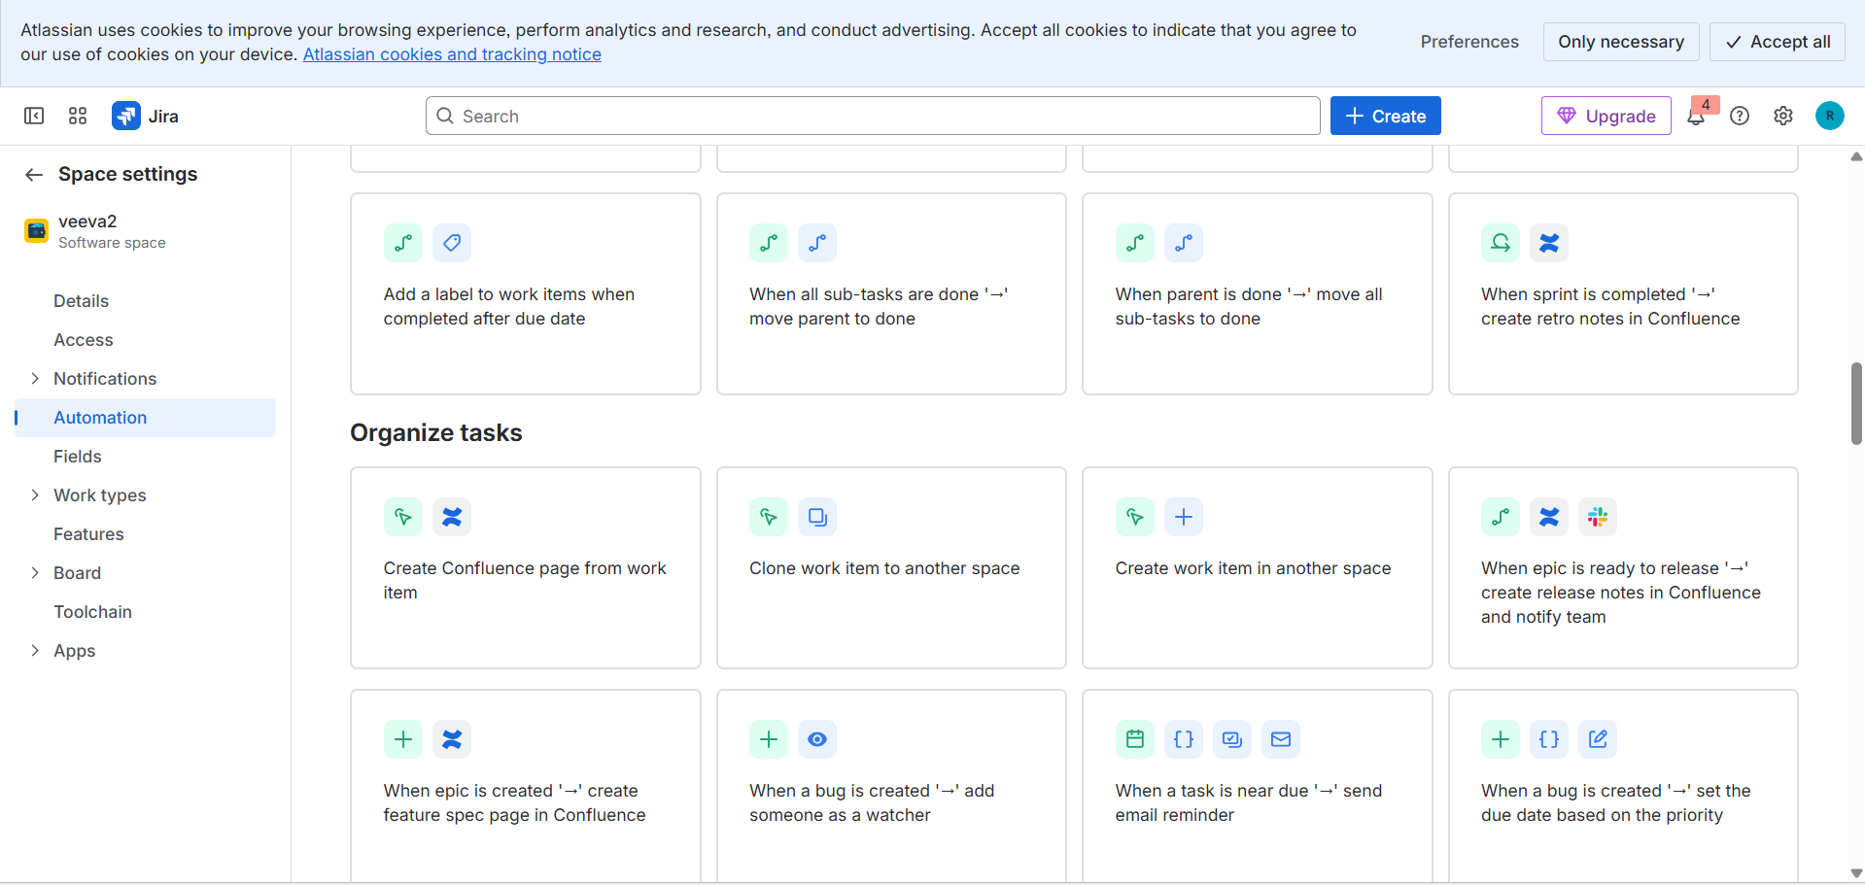
Common Simple Automation Examples
- Auto-assign issues
→ Prevents delays caused by unassigned work
- Auto-label issues
→ Ensures consistent labeling
- Auto-set resolution on “Done”
→ Prevents inaccurate reports
- Auto-add comments when issues are blocked
→ Makes blockers visible
- Auto-create subtasks
→ Saves time on repetitive setup
- Scheduled reminders
→ Prevents overdue issues from being ignored
- Auto-transition issues on field updates
→ Keeps status aligned with actual work
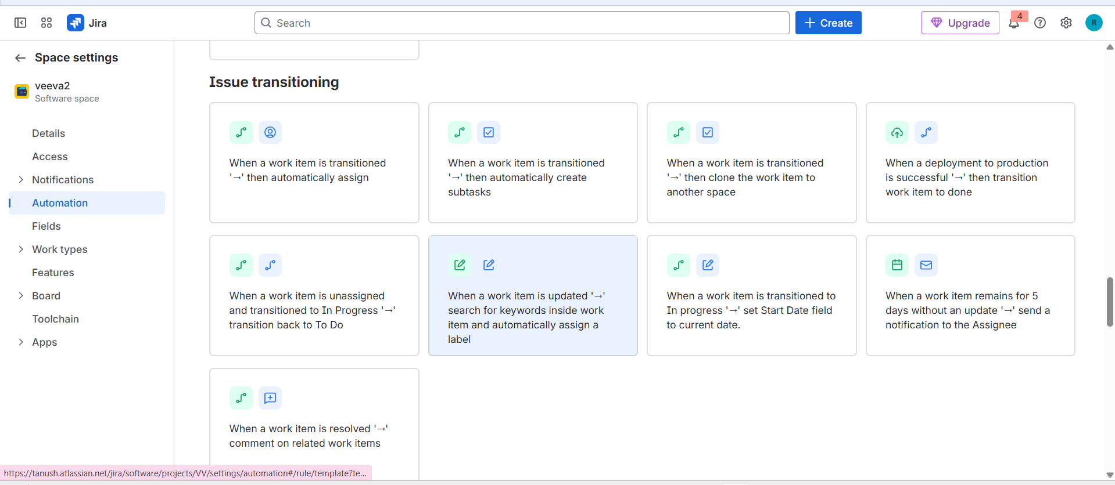
When to Ask Admins for Help with Jira Automation
Sometimes automation fails silently or behaves inconsistently. Knowing when to involve an admin early saves time.
You Need Admin Help If:
- Automation impacts multiple projects
- Required options are not visible
- A rule works for some issues but not others
- Workflow changes are needed
- Validators or workflow conditions must be added
- Post functions are required
- Custom fields must be created
- Status categories need changes
- Issues must be created in another project
- Automation quota limits are hit
- Performance issues appear
- Automation involves data security or permissions
Rule of thumb:
If automation affects Jira structure, security, or performance, involve an admin.

