BASE URL = http://localhost:3000/

1. **Akun Creator / terautentikasi**
2. Register account (POST)

Body-type = raw-json atau x-www-form-urlencoded

Body request = username, email, password

endpoint = /api/users/register

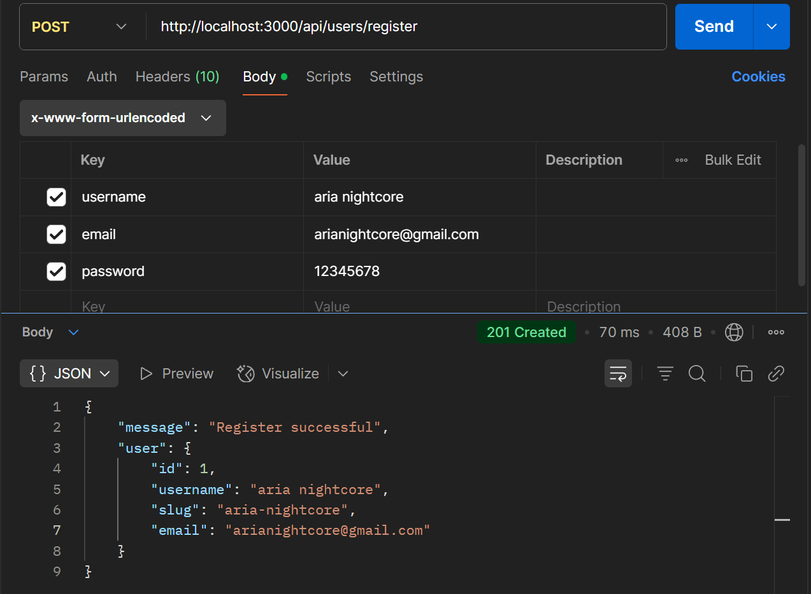

1. Login account (POST)

Body-type = raw-json atau x-www-form-urlencoded

Body request = email, password

endpoint = /api/users/login

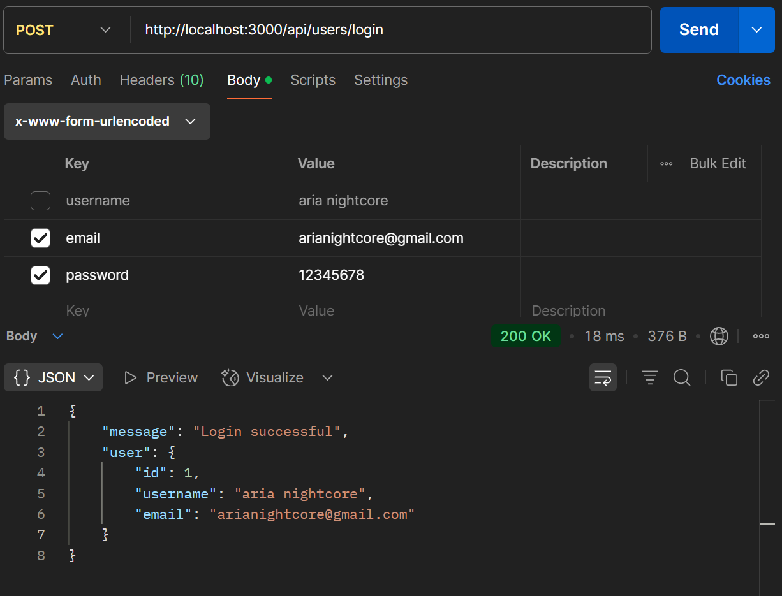

1. Get User Detail (GET)

Endpoint: /api/users/:user_id

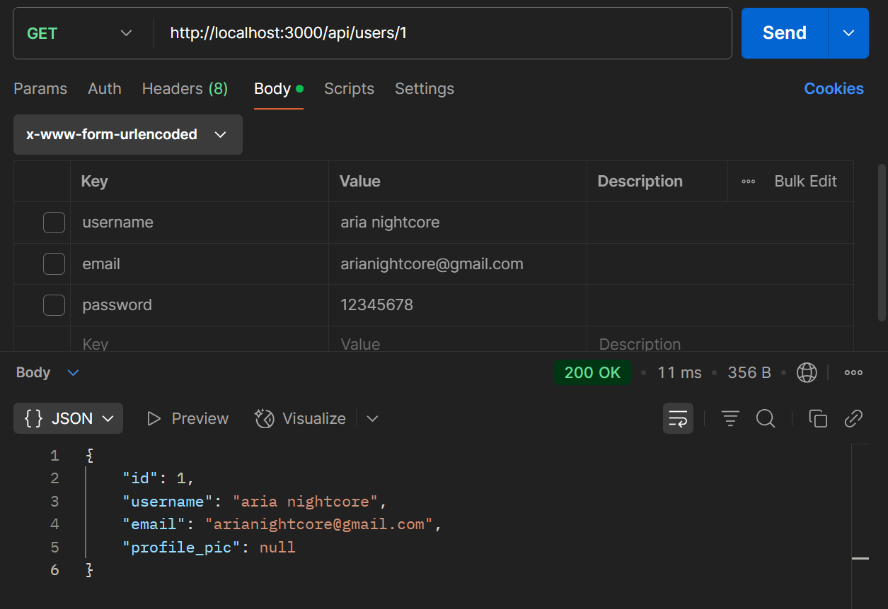

1. Update Username (PUT)

Content-Type : raw-json & x-www-form-urlencoded

Body request : username

Endpoint : /api/users/:user_id/username

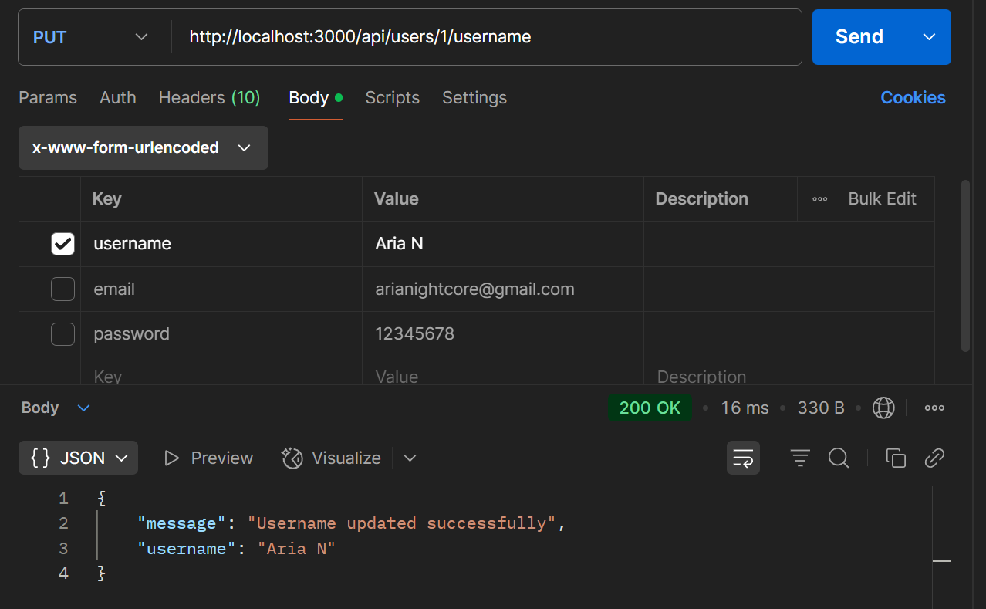

1. Upload photo profile (POST)

Body-type = form-data

Body request = profile_pic

endpoint = /api/users/:user_id/profile-picture

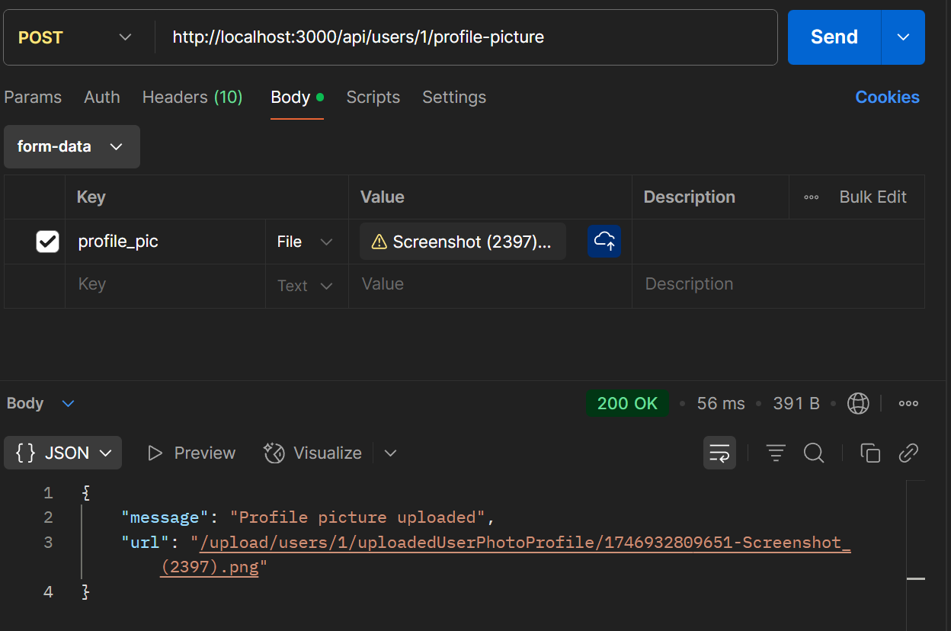

1. Update photo profile (PUT)

Body-type = raw atau x-www-form-urlencoded

Body request = profile_pic, user_id

Endpoint = /api/users/:user_id/profile-picture

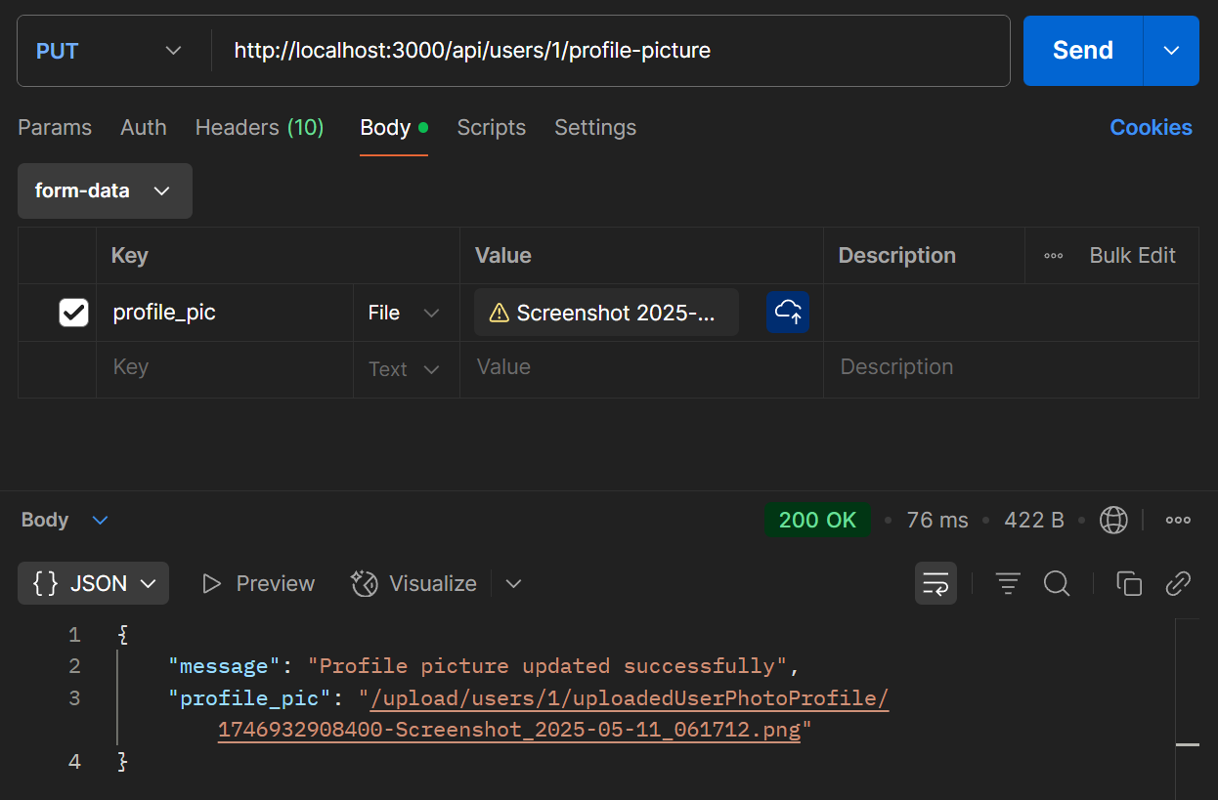

1. Delete photo profile (DELETE)

Endpoint = /api/users/:user_id/profile-picture

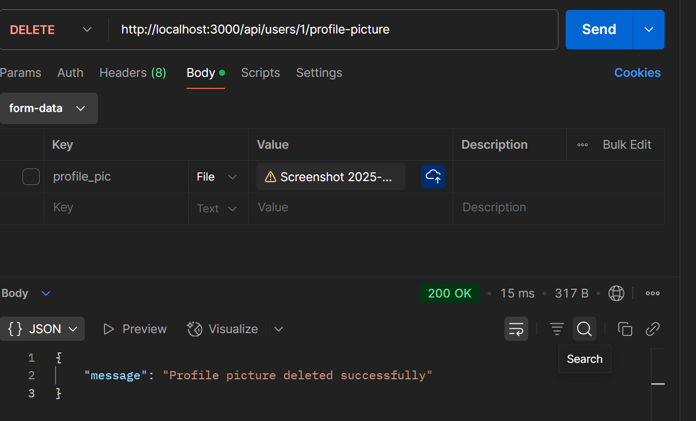

1. Delete User (DELETE)

endpoint = /api/users/:user_id

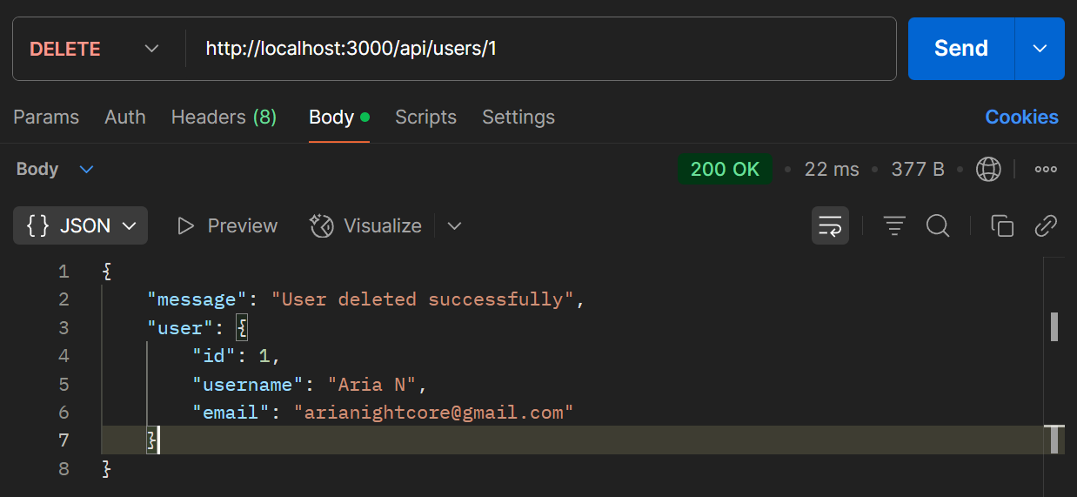

1. **Video (Content Creater & Viewer biasa tanpa register akun)**
2. **Content Creator**
3. Upload Video (POST)

Content-Type : form-data

Body request : title, description, dan video_url

Endpoint : /api/users/:user_id/videos

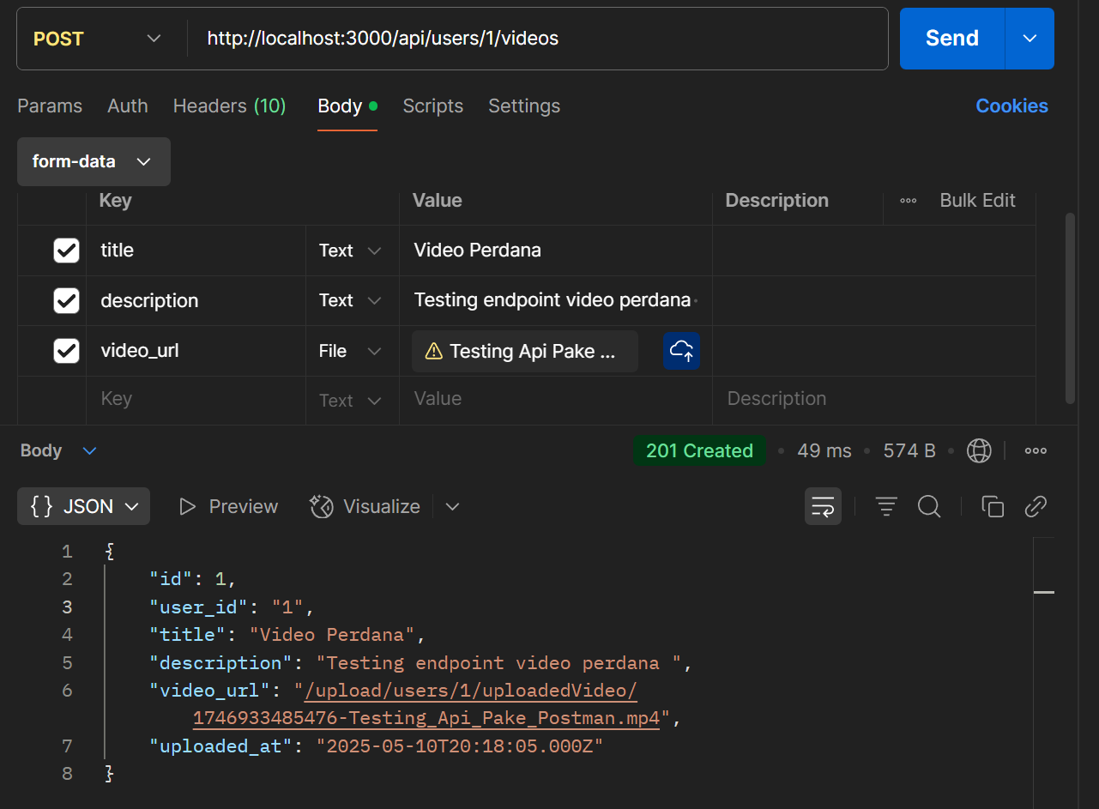

1. Update Title & Description Video (PUT)

Body request = video_id, title, description

Content-Type = raw jso, x-www-form-urlencoded

endpoint = /api/videos/:video_id

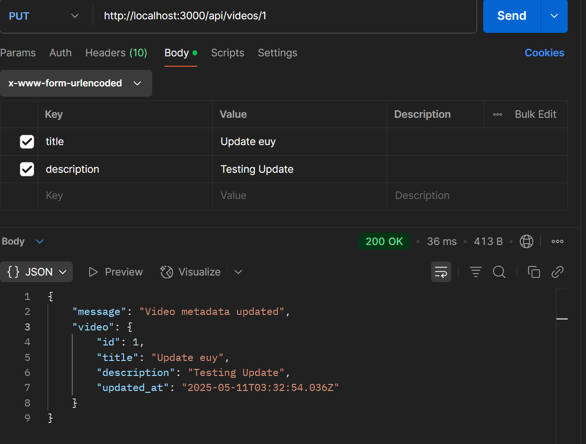

1. Post video thumbnail (POST)

Body request = video_id & thumbnail_url

Content-Type = form data

endpoint = /api/videos/:video_id/thumbnail

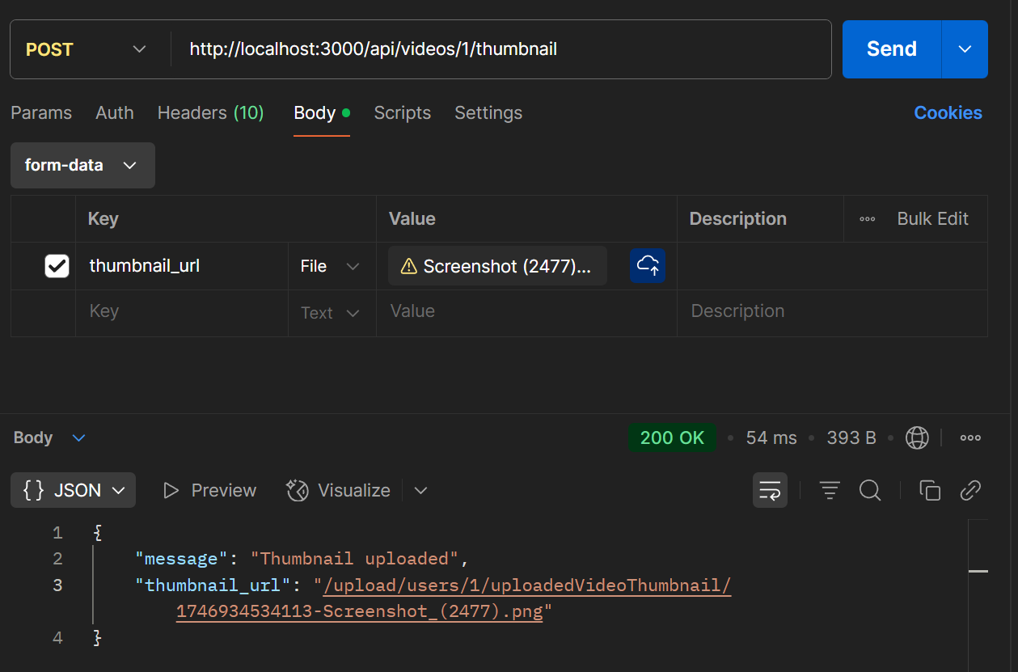

1. Update video thumbnail (PUT)

Body request = video_id & thumbnail_url

Content-Type = form data

endpoint = /api/videos/:video_id/thumbnail

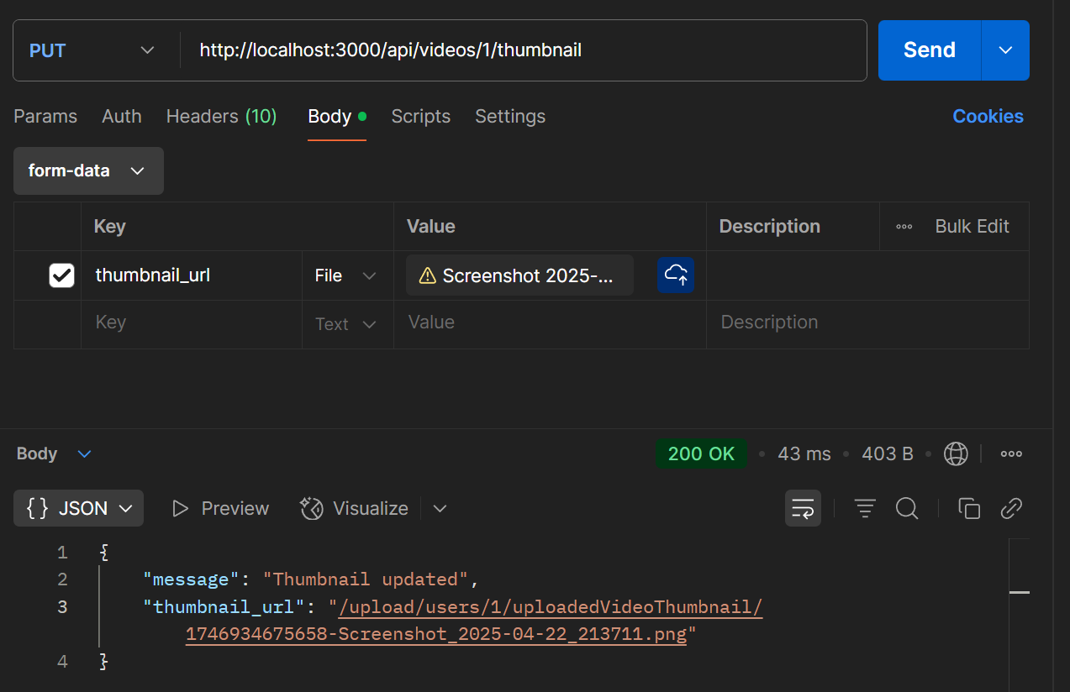

1. Get Video Thumbnail & Video (GET)

endpoint = /api/videos/:video_id/thumbnail

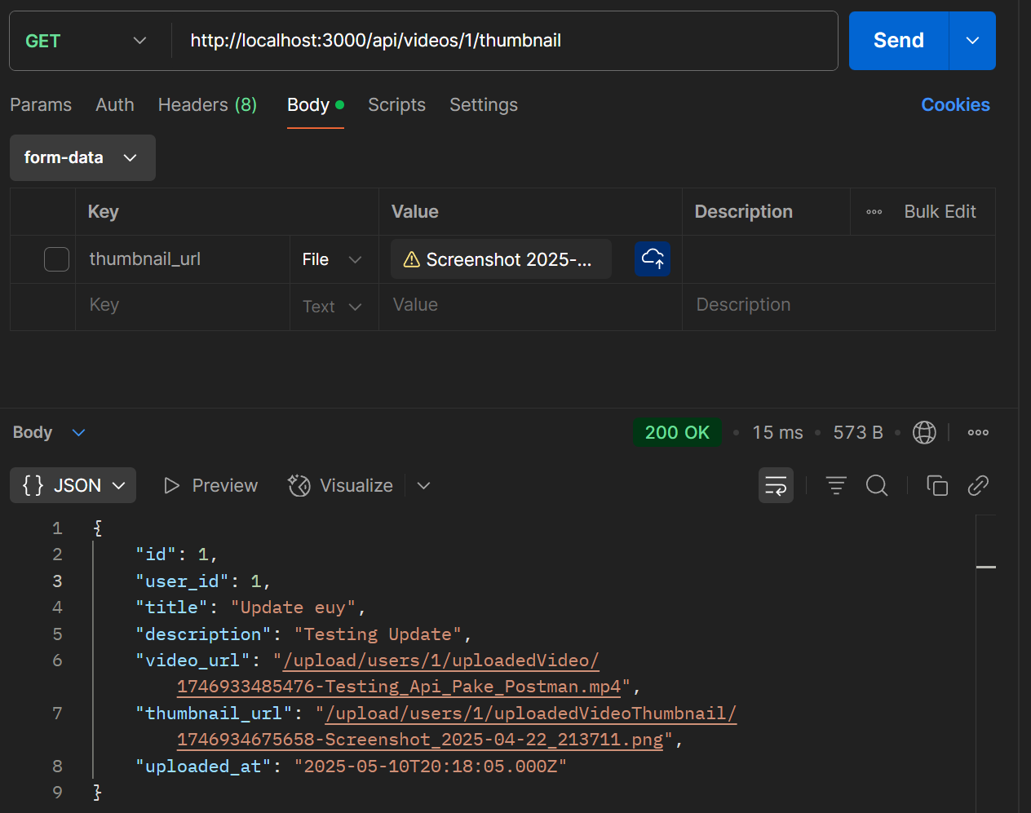

1. Delete Thumbnail (DELETE)

Endpoint = /api/videos/:video_id/thumbnail

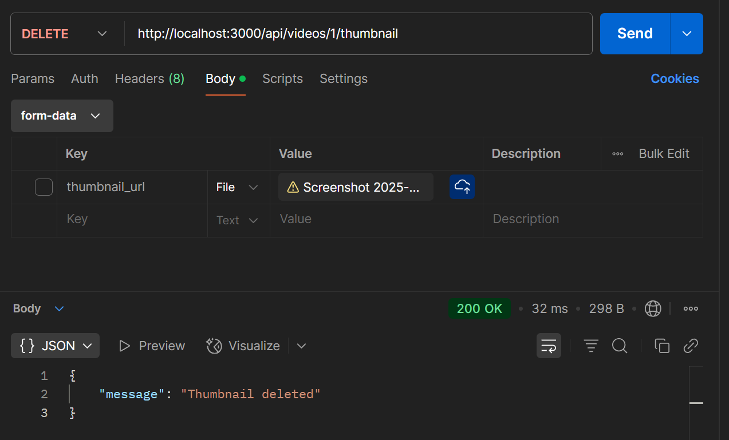

1. Delete Video (DELETE)

endpoint = /api/videos/:video_id

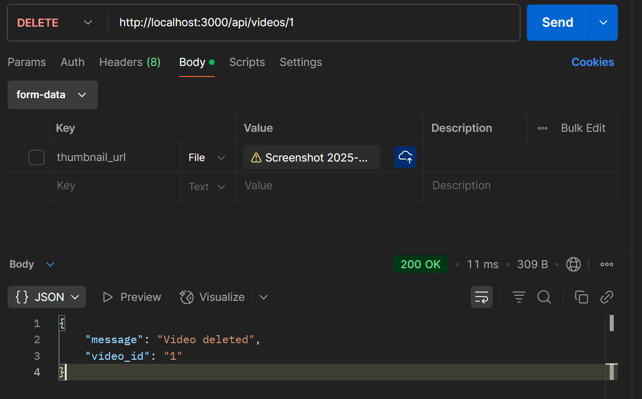

1. **Viewer biasa (ga perlu register & login akun)**
2. Get All Video for homepage (GET)

Endpoint = /api/videos

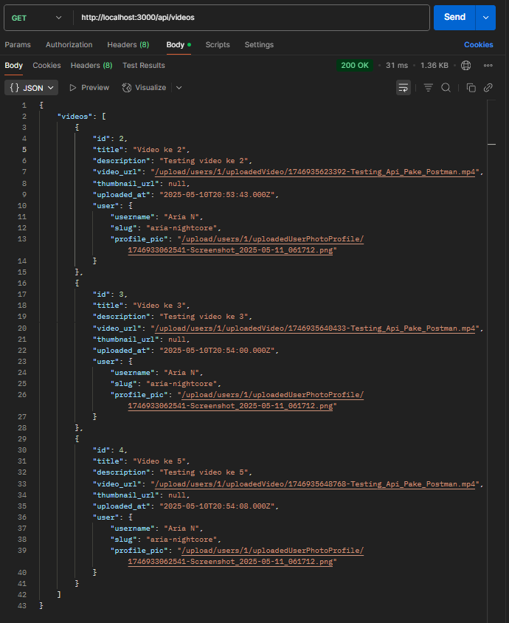

1. Get video after viewer clicked its video content (GET)

Endpoint = /api/videos/:video_id

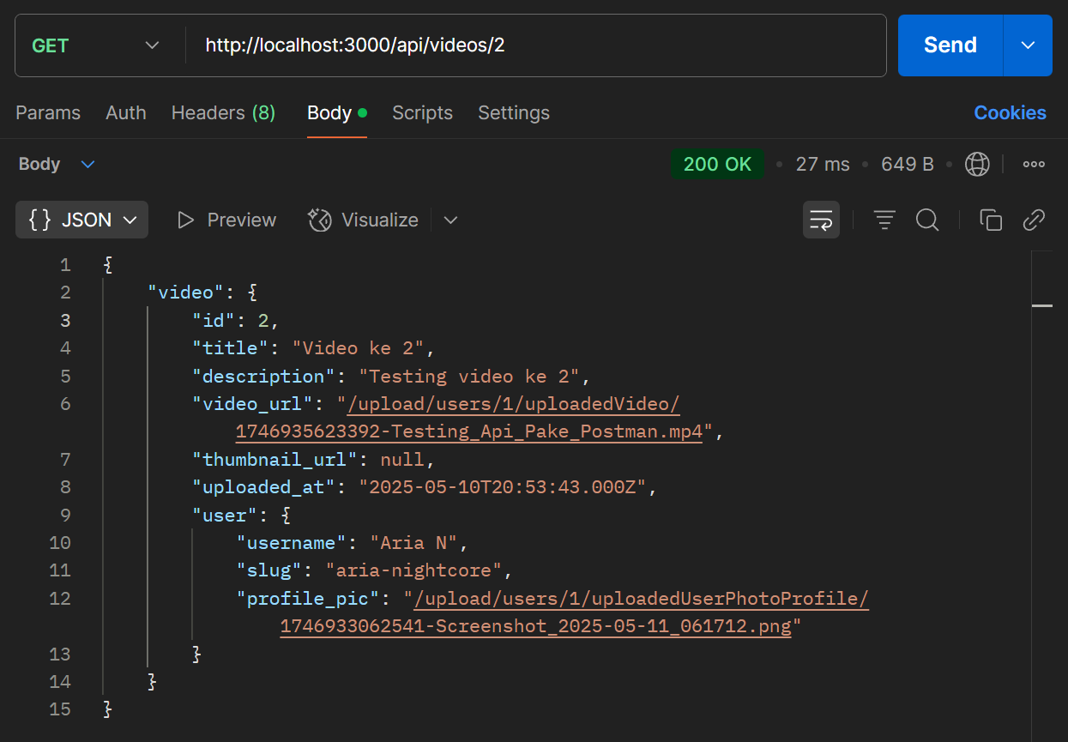

1. Click someone channel (GET) => keknya mending langsung make yang ` Get all videos on someone channel (GET)`

Endpoint = /api/channels/:slug/profile

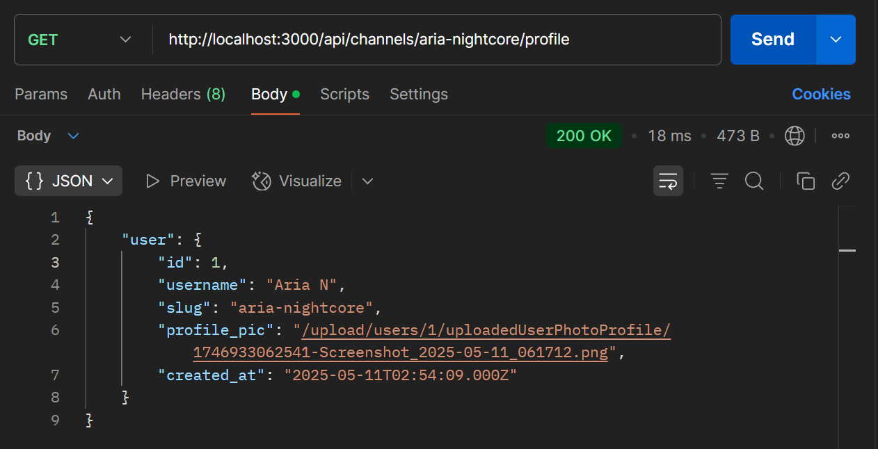

1. Get all videos on someone channel (GET)

Endpoint = /api/channels/:slug/profile

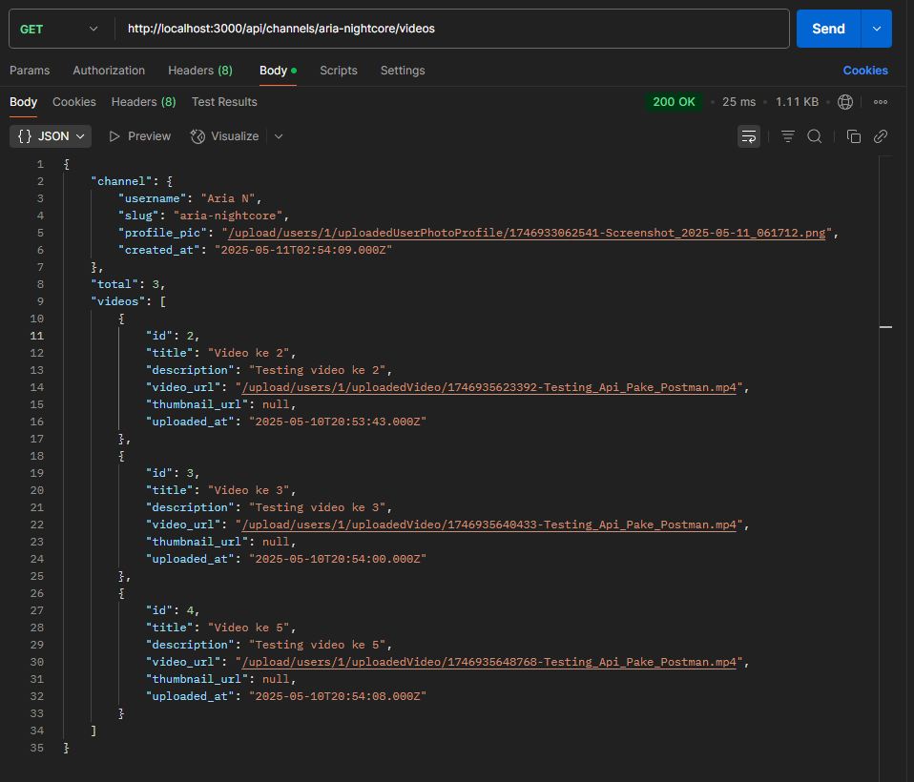

1. **Community Post di detail channel creator**

**NOTE = Di sini id dimulai dari 2 soalnya tadi testing delete dulu**

1. Upload Photo (POST)

Body-type = form-data

Body request = user_id, title, description, post_photo_url

endpoint = /api/photos

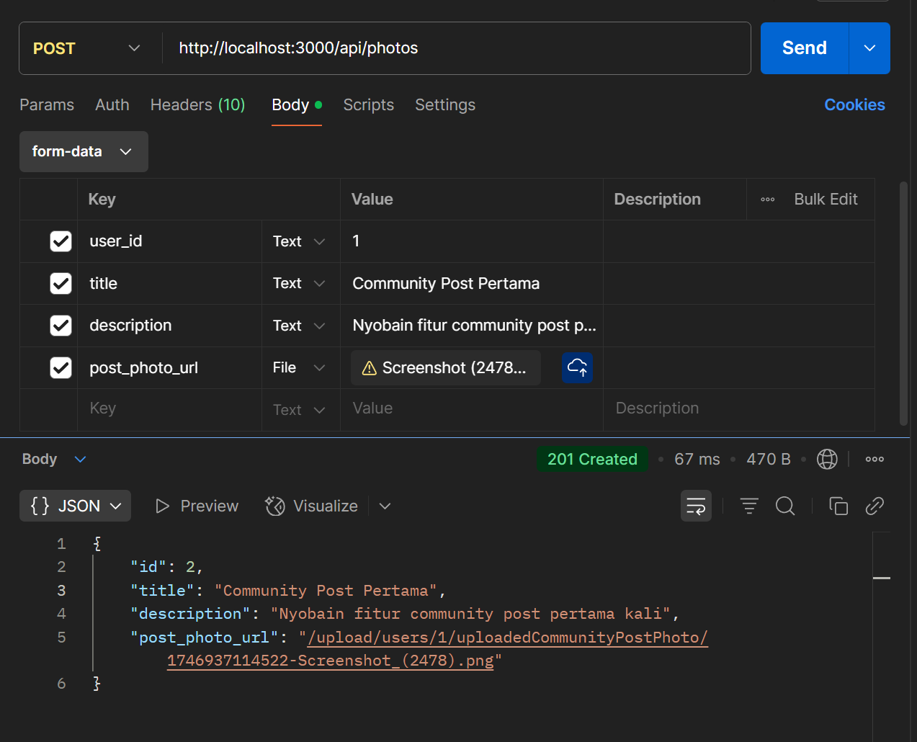

1. Get community post photo by User Channel Clicked (GET) => maksudnya kek di tab community di tiap channel youtube

Endpoint = /api/channels/:slug/community

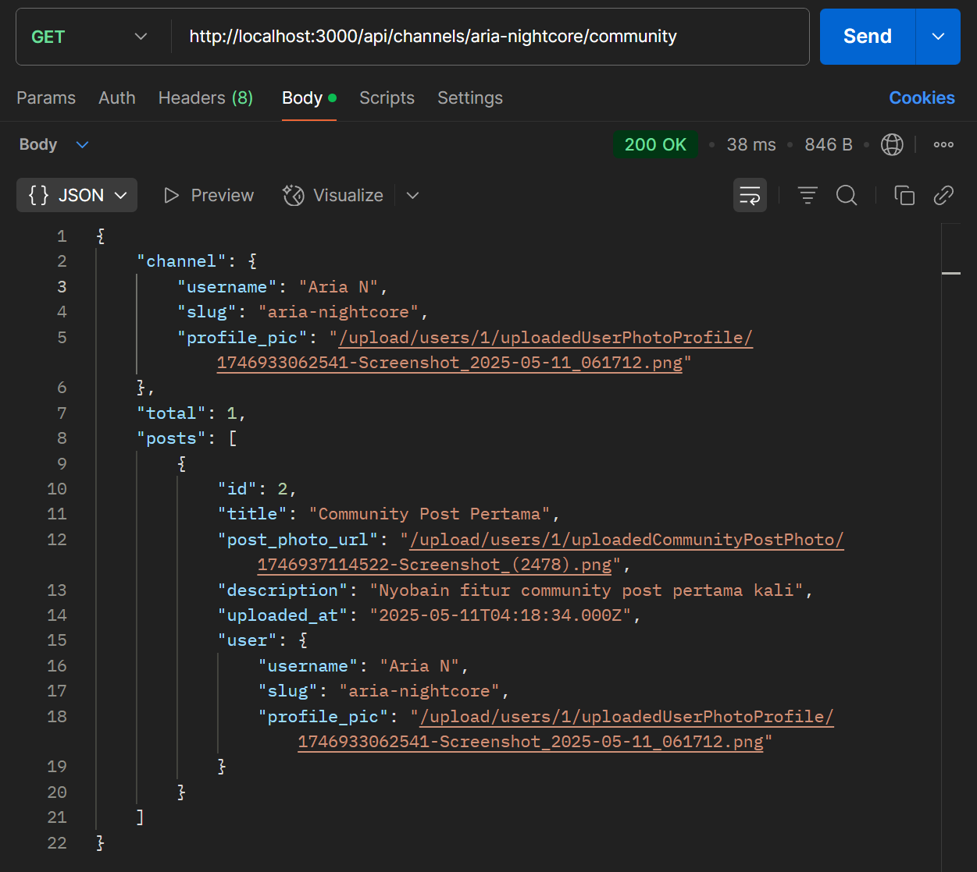

1. Get Photo by User each Photo Clicked (GET) => maksudnya semisal ada suatu community post diteken makan nanti bakal menuju halaman baru biar bisa lebih jelas entah itu diperbesar/masuk ke comment section (kalau di youtube)

Endpoint = /api/photos/:photo_id

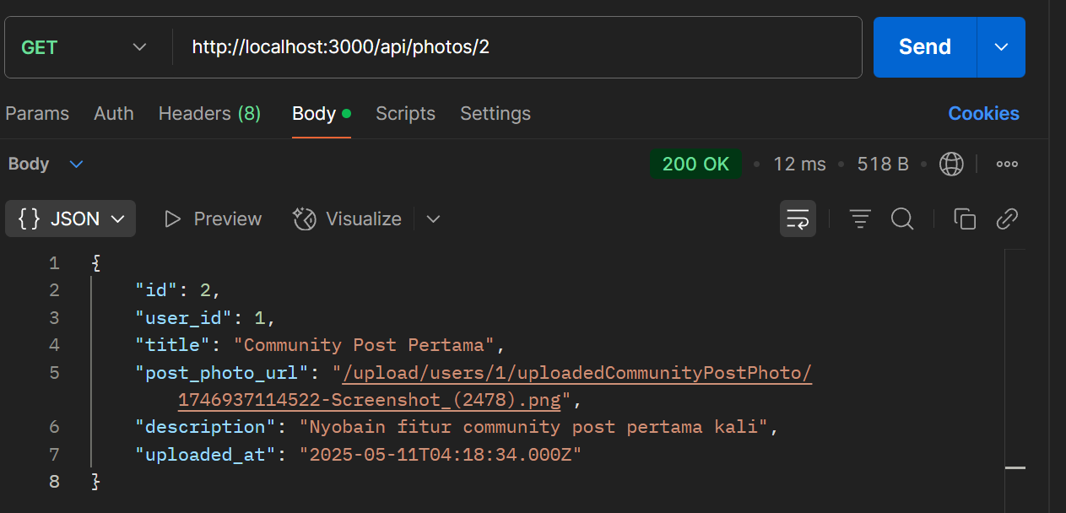

1. Delete Photo (DELETE)

Endpoint = /api/photos/:photo_id

