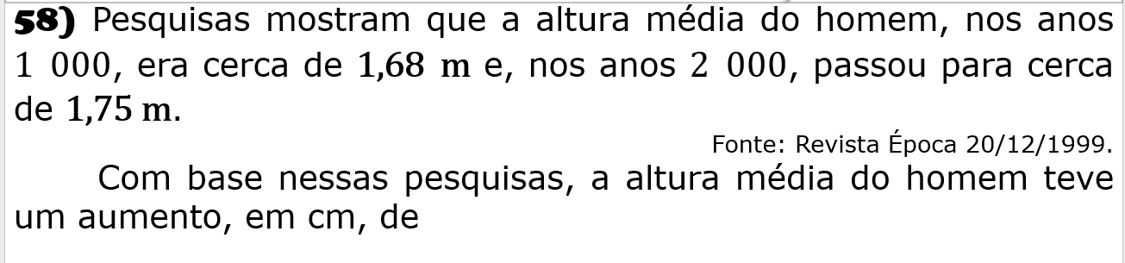

R: 0,07

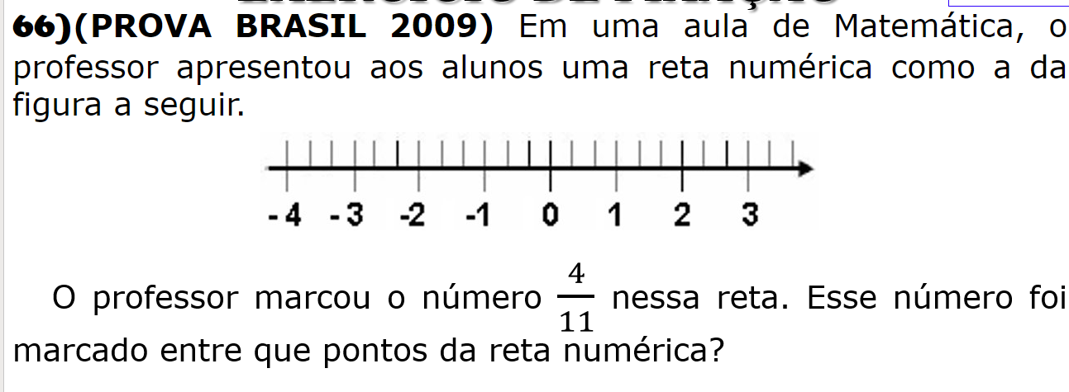

R: 0 e 1

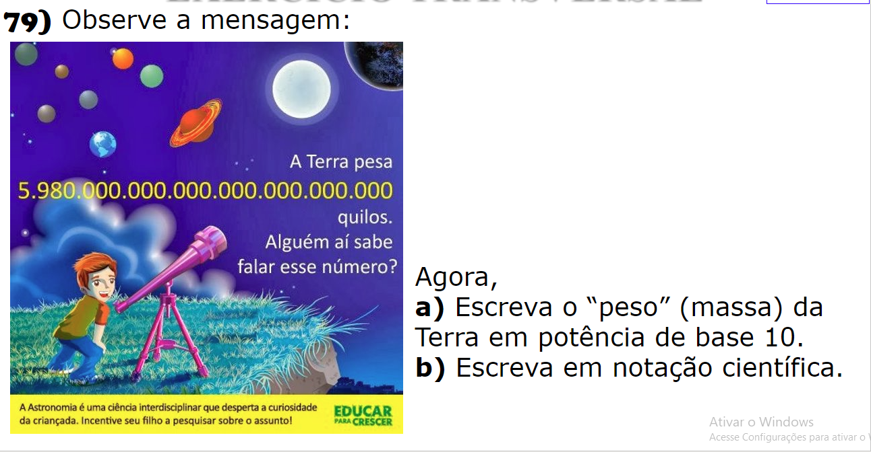

R: 5,98.1022

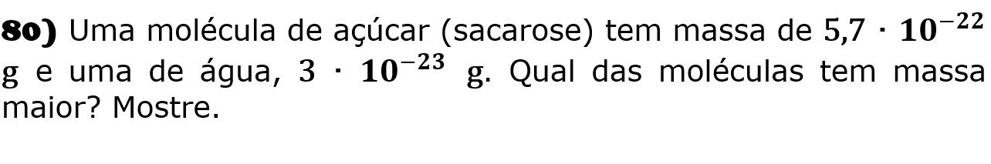

R: 3.10-23

0,00000000000000000000003

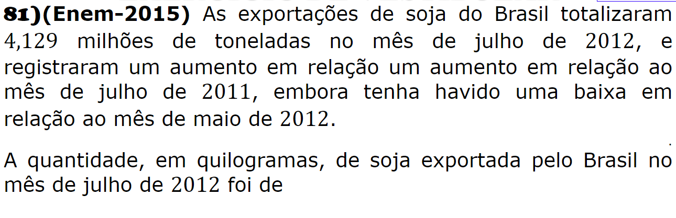

R: 4, 123.106

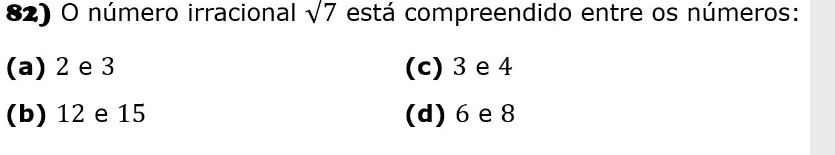

R: 2 e 3

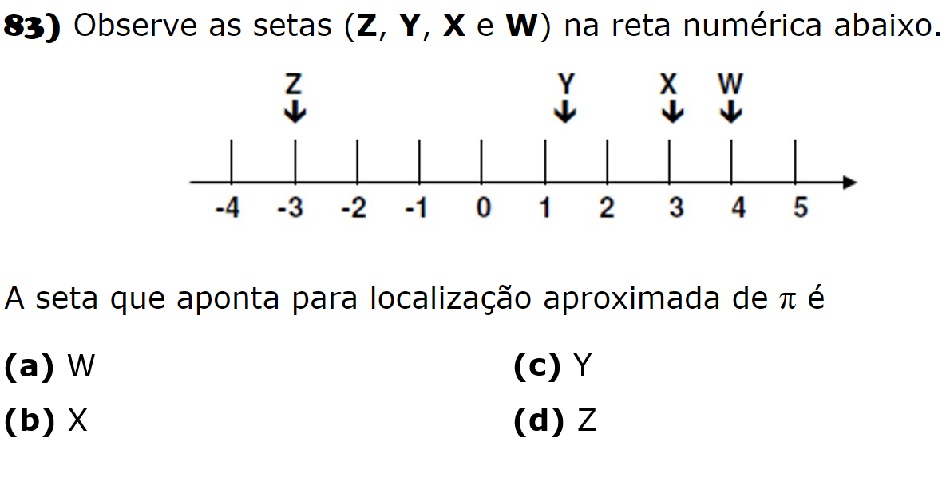

R: X