

CS4001NI Programming

50% Individual Coursework

2025-26 Autumn
Credit: 30
Student Name: Rijan Bhattarai
London Met ID: 25029641
College ID: Np01ai4a250028
Assignment Due Date: Monday, March 9, 2026
Assignment Submission Date: Monday, March 9, 2026
Module Leader: Mr. Bikram Poudel
Word Count:

Contents

1. Introduction 1
2. Class Diagram 1
3.Method Description 2
3.1 AI Model 2
3.2 Personal Plan 4
3.3 Pro Plan 6
4.Testing 8
Test 1 – Valid Prompt 8
Test 2 – Context Limit Exceeded 8
Test 3 – Monthly Limit Exhausted and Purchase Prompts 9
Test 4 – Pro Plan Infinite Prompts 10
5. Error Detection and Correction 11
Error 1 — Syntax Error: Missing Semicolon 11
Error 2 — Logical Error 11
Error 3 — Not a Statement Error 12
6. Conclusion 13
Bibliography 14
Code Listings 15
AIMode.java 15
Personal Plan 16
Pro Plan 17
Main 18

Table of Figures

Figure 1: Class Diagram 1
Figure 2: Test 1 8
Figure 3: Test 2 9
Figure 4: Test 3 9
Figure 5: Test 4 10
Figure 6: Error 1 11
Figure 7: Error 2 11
Figure 8: Error 3 12
Figure 9: AI Model.java 15
Figure 10: PersonalPlan.java 16
Figure 11: ProPlan.java 17
Figure 12: Main.java 18

1. Introduction

Introducing the project, a subscription-based, a subscription business model is one in which customers are charged a recurring fee for access to a product instead of a one-time expense (SBIGrowth, 2026), AI models for teams or individual customers. The project is differentiated into Personal Plan and Pro Plan, where personal plans are directed towards individual customers and pro plan directed towards teams due to features of team management.

The goal of this project is to track monthly quotas, enrollment of new prompts or adding team members, the project also clearly differentiates between pro and personal plans and set the restrictions for each accordingly, verify entered data for both classes.

The programming language used to develop the software is Java. Java is a high-level, object-oriented programming language developed by Sun Microsystems in 1995 (GeeksForGeeks, 2019). The reason java is used for this project is due to its scalable nature, secure platform, frameworks for enterprise development and open-source libraries (GeeksForGeeks, 2019).

2. Class Diagram

“A class diagram illustrates the structure of a system by showing its classes, attributes, methods, and the relationships among them” (Oracle Corporation, 2024). Its primary purpose is to give the developers the architecture of the program using graphics and images (Alhadi Klaib, 2021). It is convenient for both experienced and inexperienced developers who can clearly implement the overarching base architecture of the program using graphics.
The diagram below shows the IS-A inheritance relationship between the abstract parent class AI Model and its two concrete subclasses, Personal Plan and Pro Plan. Each class box displays the class name, instance variable names with data types, and the full signatures of all constructors and methods. (Oracle Corporation, 2024)

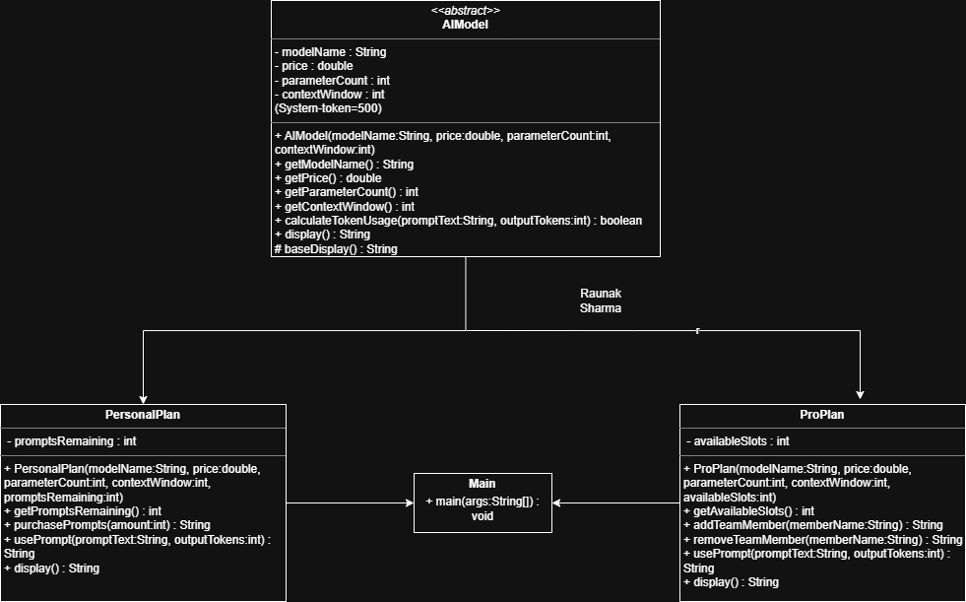
Figure 1: Class Diagram

3.Method Description
This section provides a detailed description of every method defined in AIModel.java, PersonalPlan.java, and ProPlan.java, including the constructor for each class.

3.1 AI Model
Table 1: AIModel.java method descriptions.
Method Name | AI Model
Parameter(s) | String model Name, double price, long parameter, String context Size
Return Type | N/A
Description | Constructor for the model
Internal Working | Initializes each object for the program to be used in further calculation.

Method Name | Get Model Name
Parameter(s) | None
Return Type | String
Description | A simple accessor method for getting model name.
Internal Working | Returns the model’s name

Method Name | Get Price
Parameter(s) | None
Return Type | double
Description | Accessor methods for returning the price per 1 lakh tokens in Nepali Rupees (NPR).
Internal Working | Returns the price of the model in NPR

Method Name | Get Parameter Count
Parameter(s) | None
Return Type | long
Description | An accessor function for the attribute
Internal Working | Returns parameters

Method Name | Get Context Size
Parameter(s) | None
Return Type | Int
Description | An accessor method for the attribute context size
Internal Working | Returns the context window size of a model

Method Name | Base Display
Parameter(s) | None
Return Type | String
Description | Returns the string for the baseline for future outputs
Internal Working | Uses string format to insert the value of objects into the base display for future display outputs.

Method Name | Display – Abstract
Parameter(s) | None
Return Type | String
Description | An abstract function that needs to be implemented by child class which inherit the AI Model class.
Internal Working | Base Display + Display is used to show the proper output for the user.

Method Name | Calculate Token Usage
Parameter(s) | Prompt, Expected Amount
Return Type | Boolean
Description | Returns a Boolean value depending whether the total token count is less than context window size
Internal Working | Estimates the input token using GPT formula (OpenAI, 2023), calculates the total token usage and returns true or false depending whether the total token usage is less or equal to the context window size.

3.2 Personal Plan
Table 2: PersonalPlan.java method descriptions.
Method Name | Personal Plan
Parameter(s) | prompts, model Name, price, parameter, context Size
Return Type | N/A
Description | Initializes a personal plan object with a monthly prompt quota and all four AI model attributes.
Internal Working | Initializes the objects for usage in the program

Method Name | Get Prompts
Parameter(s) | None
Return Type | int
Description | Accessor Method for accessing the number prompts
Internal Working | Returns number of prompts remaining the monthly quota

Method Name | Purchase Prompts
Parameter(s) | Add Prompts
Return Type | String
Description | Allows user to purchase prompts to add more prompts in their monthly quota
Internal Working | Adds prompt when the number of purchasing prompts is a positive value greater than zero and rejects the values that are less than one.

Method Name | Use Prompt
Parameter(s) | Prompt, Expected Output Token
Return Type | String
Description | A method that sends the prompt to the AI model
Internal Working | Checks if the user has exhausted their monthly quota or not if they have exhausted send assert an error else send the prompt to the AI model for the user to interact with the model.

Method Name | Display - Abstract
Parameter(s) | None
Return Type | String
Description | Displays the total info for the user to interact with the program
Internal Working | Concatenates the baseline display that is inherited from AI model class and adds extra information from the personal plan class for the user to get all the information about the model they have selected.

3.3 Pro Plan
Table 3: ProPlan.java method descriptions.
Method Name | Pro Plan
Parameter(s) | Team Slots, model Name, price, long parameter, String context Size
Return Type | N/A
Description | Constructor for the class Pro Plan Class.
Internal Working | Inherits from the parent class AI Model Class and initializes its own objects

Method Name | Get Available Slots
Parameter(s) | None
Return Type | int
Description | A simple accessor method for returning the number of members in the plan
Internal Working | Returns the number of slots remaining in the team

Method Name | Add Team Member
Parameter(s) | Member Name
Return Type | String
Description | A method to add team members in the current plan
Internal Working | Adds a team member to the plan if slots are available and decrements team slots by one on success

Method Name | Remove Team Member
Parameter(s) | Member Name
Return Type | String
Description | Removes a team member from the team
Internal Working | Removes a named team member from the plan and frees up a slot. Returns an error message if the member is not found in the list.

Method Name | Use Prompt
Parameter(s) | Prompt, Expected Output Token
Return Type | String
Description | A method that sends the prompt to the AI model
Internal Working | Checks if the user has exhausted their monthly quota or not if they have exhausted send assert an error else send the prompt to the AI model for the user to interact with the model.

Method Name | Display - Abstract
Parameter(s) | None
Return Type | String
Description | Displays the total info for the user to interact with the program
Internal Working | Concatenates the baseline display that is inherited from AI model class and adds extra information from the pro plan class for the user to get all the information about the model they have selected.

4.Testing
This process is also defined as the software testing phase. Software testing is an important process in the Software Development Lifecycle (SDLC). It involves verifying and validating that a Software Application is free of bugs, meets the technical requirements set by its Design and Development, and satisfies user requirements efficiently and effectively. (GeeksForGeeks, 2026)

Test 1 – Valid Prompt
A prompt is the specific text input or command given to an AI model to generate a particular, desired output. (Vocabulary, 2026). The given test is conducted on both
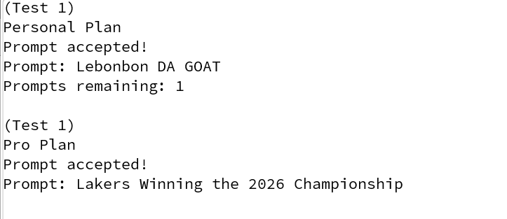
Figure 2: Test 1

Test 2 – Context Limit Exceeded
A "Context limit exceeded" error occurs when the total number of tokens (words, characters, and code) in your prompt, including conversation history and retrieved data, surpasses the maximum capacity of the AI model (Rabadon Skyler, 2026)
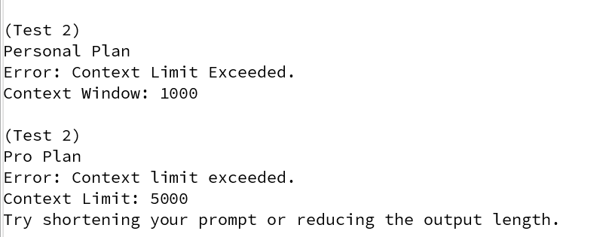
Figure 3: Test 2

Test 3 – Monthly Limit Exhausted and Purchase Prompts
When the user exhausts the monthly quota for their plan, they get prompted with an error message saying their quota has been exhausted they have the option to purchase new prompts or upgrade to a pro plan.
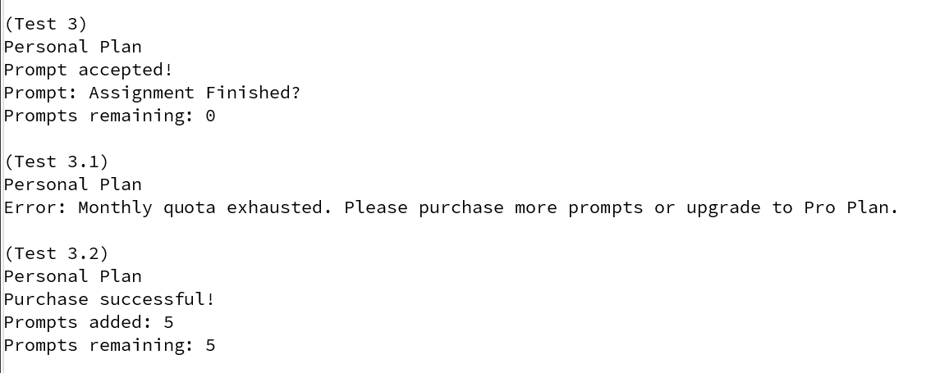
Figure 4: Test 3

Test 4 – Pro Plan Infinite Prompts
This test sets to demonstrate that the pro plan that teams have have infinite number of prompts.
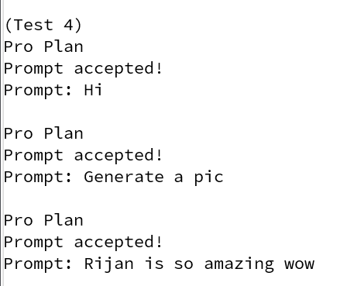
Figure 5: Test 4

5. Error Detection and Correction

This section documents three distinct errors encountered during implementation — one syntax error, one runtime error, and one logic error — along with the steps taken to identify and resolve each one.

Error 1 — Syntax Error: Missing Semicolon
Error Type | Syntax
Description | A semicolon was omitted at the end of a variable assignment inside the Personal Plan constructor
Identification | BlueJ highlighted the line in red. The compiler output read: 'error: ';' expected', with the caret pointing directly at the missing symbol.
Solution | Added the missing semicolon. Re-compiled successfully with no further errors.

Evidence:
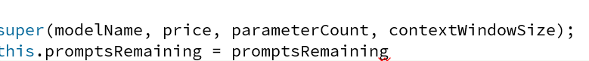
Figure 6: Error 1

Error 2 — Logical Error
Error Type | Runtime
Description | ‘!’ was missing on the function calculateTokenUsage where it is checking for tokens used
Identification | It was identified after running the program when every output was inverted
Solution | The solution was to add the ‘!’ operator infront of calculateTokenUsage(prompt, expectedAmount)

Evidence:
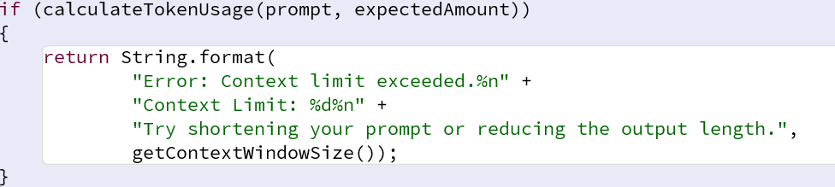
Figure 7: Error 2

Error 3 — Not a Statement Error
Error Type | Logic
Description | In calculate token usage the instead of the assignment operator the equal to operator was used
Identification | It was identified when the program didn’t run when it was set to run, and blue J highlighted in red saying it was not a statement.
Solution | Removing the extra ‘=’ and making the equal to operator an assignment operator.

Evidence:

Figure 8: Error 3

6. Conclusion

This assignment provided a practical opportunity to apply core Object-Oriented Programming principles in Java. By designing and implementing the AIModel class hierarchy, comprising the abstract parent class AIModel and its two concrete subclasses PersonalPlan and ProPlan, a deeper understanding of inheritance, encapsulation, polymorphism, and method overriding was developed.

PersonalPlan demonstrated how a child class can extend parent functionality by managing a prompt quota, enforcing business rules (rejecting invalid purchases), and overriding getDetails() to include plan-specific information. Similarly, ProPlan illustrated the use of ArrayList for dynamic data management, showing how team membership can be tracked and modified at runtime.

Debugging the three errors in Section 5 reinforced the importance of careful data validation. The Logical Error highlighted the necessity of checking the conditions properly while writing the code to not run into more run time error that occur due to logic.

Overall, this milestone has strengthened practical Java skills, improved understanding of class design, and introduced systematic testing strategies all of which will be built upon in Milestone 2 with the addition of the GUI SubscriptionGUI class.

Bibliography
Alhadi Klaib, 2021. Integrating Class Diagrams. ResearchGate, 1(1), p. 10.
Anon., 2025. Programming language. [Online]
Available at: https://www.computerhope.com/jargon/p/programming-language.htm
GeeksForGeeks, 2019. geeksforgeeks,org. [Online]
Available at: http://geeksforgeeks.org/java/introduction-to-java/
[Accessed 8 3 2026].
GeeksForGeeks, 2026. GeeksForGeeks. [Online]
Available at: https://www.geeksforgeeks.org/software-testing/software-testing-basics/
[Accessed 3 3 2026].
J., B., 2018. Effective Java 3rd edn. Boston: Addison-Wesley: s.n.
OpenAI, 2023. What is input tokens and how to calculate them, San Francisco : OpenAI.
Oracle Corporation, 2024. Java SE 21 Documentatation, San Fransico: Oracle Cororation.
Oracle Corporation, 2024. Oracle SE 21 Development. [Online].
Rabadon Skyler, 2026. Portkey. [Online]
Available at: https://portkey.ai/error-library/context-length-error-10013
[Accessed 8 3 2026].
SBIGrowth, 2026. Subscription Business Model. Wikiepdia, 2(III), p. 5.
Vocabulary, 2026. Vocabulary. [Online]
Available at: https://www.vocabulary.com/dictionary/prompt
[Accessed 8 3 2026].

Code Listings

AIMode.java
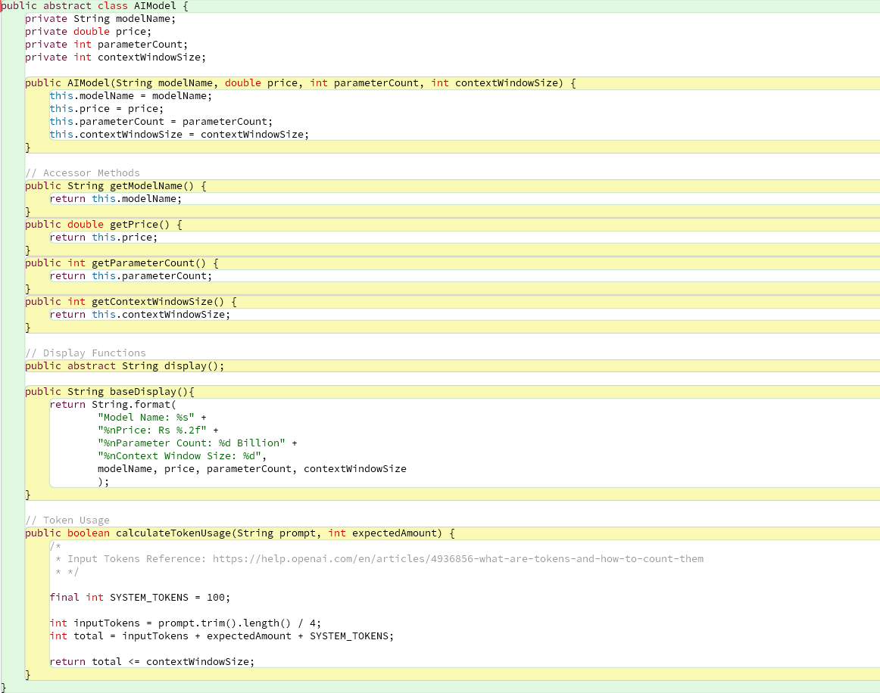
Figure 9: AI Model.java

Personal Plan
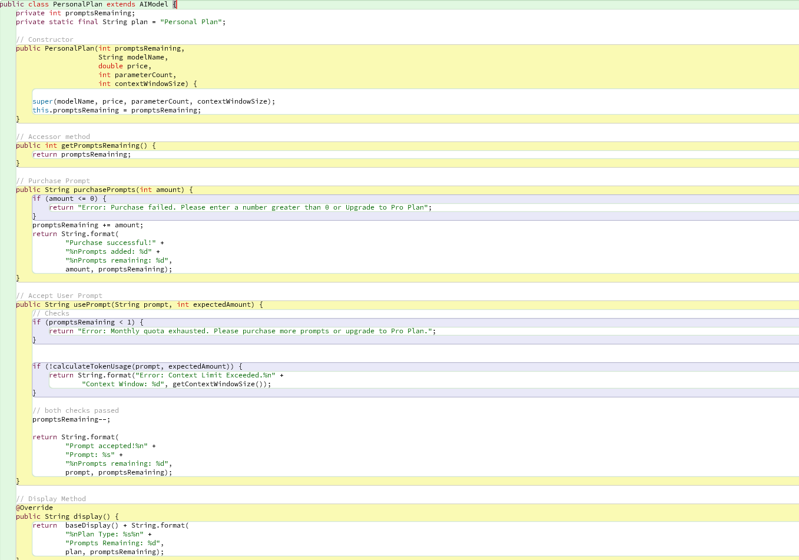
Figure 10: PersonalPlan.java

Pro Plan
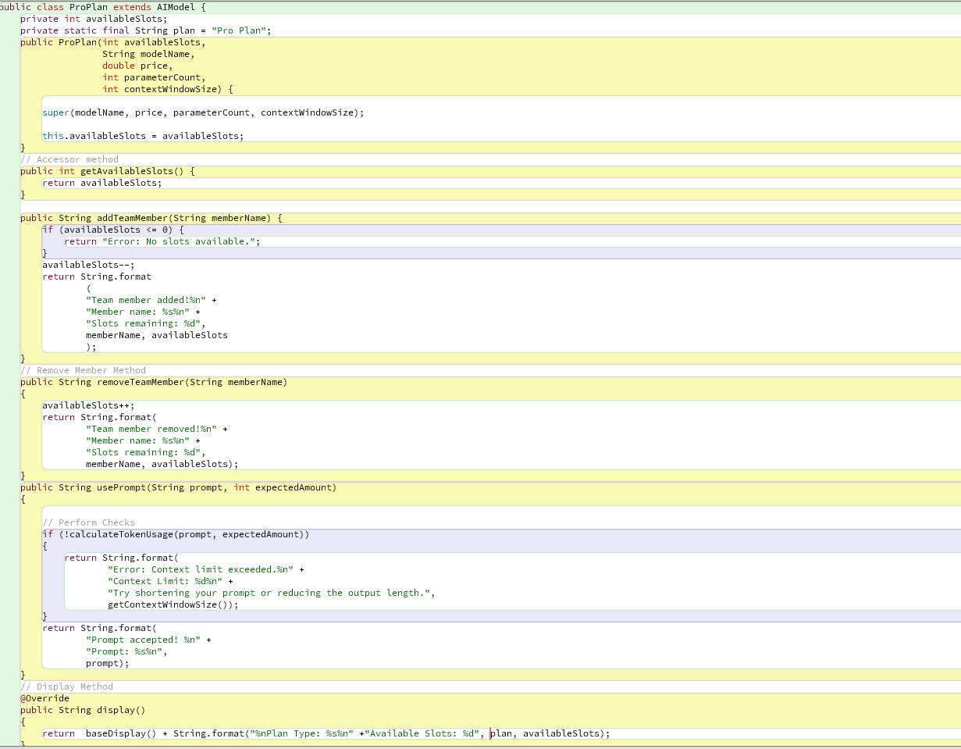
Figure 11: ProPlan.java

Main
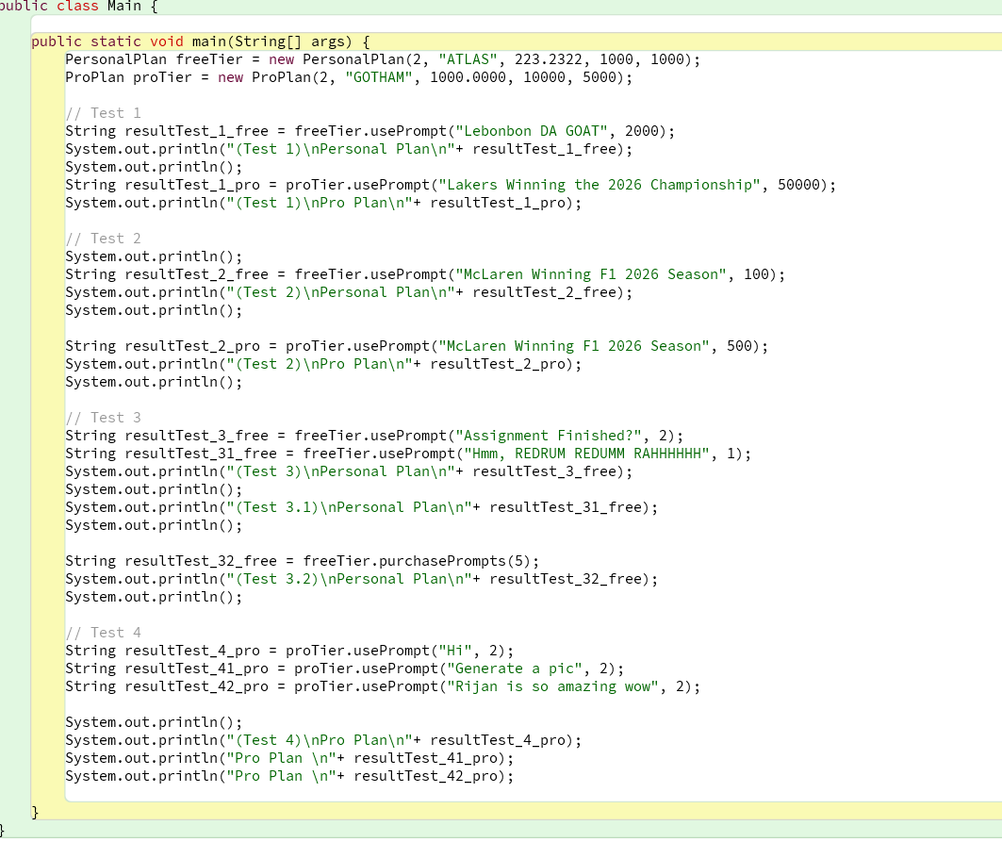
Figure 12: Main.java

