Stat 538 - HW7
FirstName LastName
#General
library(car)
## Loading required package: carData
library(svglite)
setwd(“~/Repos/Stat538_homeworks/7”)
#S6.5
##S6.5.a
To make a judgement call on whether transformation is a good idea or not we should look at the residuals and QQ plots.
# Load the dataset
pgatour <- read.csv("Data/pgatour2006.csv")
# Define the predictors
predictors <- c("DrivingAccuracy", "GIR", "PuttingAverage",
"BirdieConversion", "SandSaves", "Scrambling", "PuttsPerRound")
formula_untransformed <- as.formula(paste("PrizeMoney ~", paste(predictors, collapse = " + ")))
formula_log <- as.formula(paste("log(PrizeMoney) ~", paste(predictors, collapse = " + ")))
# Fit both models
fit_orig <- lm(formula_untransformed, data = pgatour)
fit_log <- lm(formula_log, data = pgatour)
# Generate Diagnostic Plots
par(mfrow = c(2, 2))
# Model 1: Untransformed (Check for funnel shape in Resids vs Fitted and curve in Q-Q)
plot(fit_orig, which = 1, main = "Untransformed: Residuals vs Fitted")
plot(fit_orig, which = 2, main = "Untransformed: Normal Q-Q")
# Model 2: Log-transformed (Expect constant spread and straight Q-Q line)
plot(fit_log, which = 1, main = "Log-transformed: Residuals vs Fitted")
plot(fit_log, which = 2, main = "Log-transformed: Normal Q-Q")
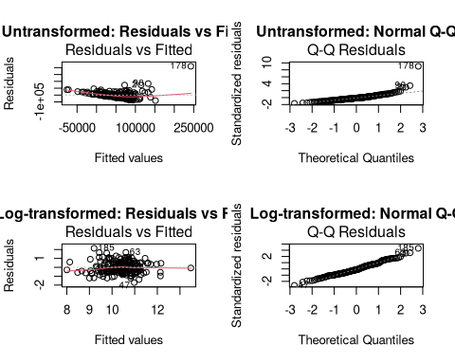
As we can see from the above plots, the log-transformation actually helps with the assumptions of normality. Before the log tranformation the assumptions of normality were violated but the log-transformation helps with that.
##S6.5.b
# Fit the full model
full_model <- lm(log(PrizeMoney) ~ DrivingAccuracy + GIR + PuttingAverage +
BirdieConversion + SandSaves + Scrambling + PuttsPerRound, data=pgatour)
# Diagnostic Plots
par(mfrow=c(2,2))
plot(full_model)
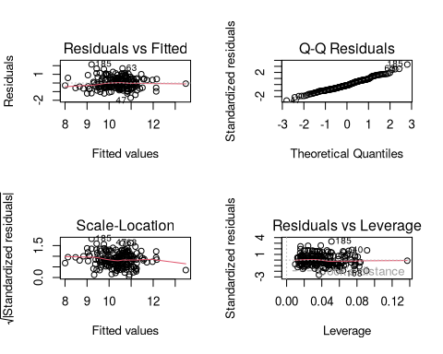
Per the plots, it seems that the assumptions of the Gauss-Markov model are left largely intact when the predicted value is log-transformed before-hand. As such, the model should be fine to use.

