report
on
descriptive analytics
Topic -Cardiovascular Disease Analysis

Submitted by – Rijual Modgil(12312704)
RPub link: https://rpubs.com/Rijual_05/1369531

1. Introduction
Cardiovascular disease (CVD) is one of the leading causes of global mortality. Early detection using data-driven approaches allows physicians to identify high-risk individuals and take timely preventive actions. This study performs a comprehensive analysis of a large cardiovascular dataset using:
- Descriptive Analytics
- Industry Application Analysis
- Business Intelligence & Predictive Modeling
- Big Data Analytics (Clustering)
- Data Visualization
The goal is to derive insights, identify hidden risk patterns, and evaluate predictive modeling performance.

2. Data Import, Cleaning & Feature Engineering
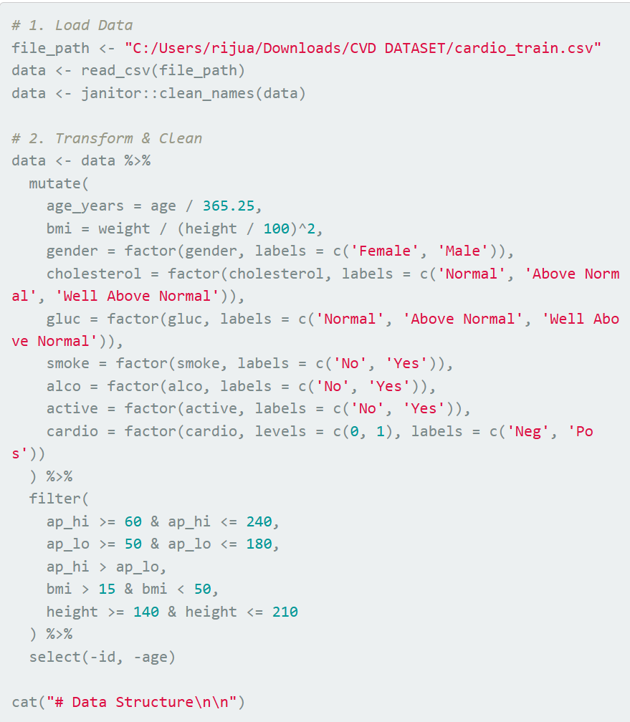
Overview
The dataset contains 68,331 patient records with demographic, lifestyle, biochemical, and clinical measurements.
Data Cleaning Steps
- Converted coded values into readable factor labels (e.g., gender, cholesterol, glucose level, smoking).
- Engineered new features:
  - age_years = age in years
  - BMI = weight / height²
- Removed physiological outliers:
  - Systolic BP < 60 or > 240
  - Diastolic BP < 50 or > 180
  - implausible BMI (<15 or >50)
  - mismatched BP (ap_hi must be > ap_lo)
  - Height < 140 cm or > 210 cm

Final Dataset Structure
- Rows: 68,331
- Columns: 13
- No missing values after cleaning

Key Descriptive Statistics
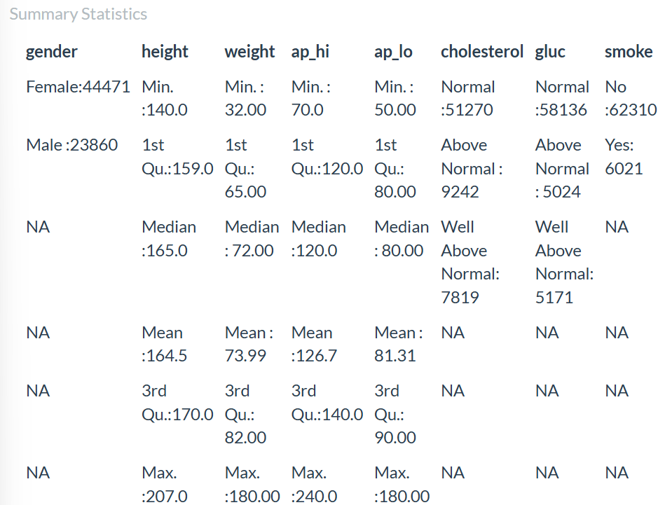
- Mean age: 53.3 years
- Mean BMI: 27.4
- Gender distribution: 65% Female, 35% Male
- Outcome distribution:
  - Negative (No CVD): 34,556
  - Positive (CVD): 33,775

3. Descriptive Analytics
3.1 Correlation Analysis
- age_years, ap_hi, and ap_lo show strong positive correlation—older patients tend to have higher blood pressure.
- BMI and weight are strongly correlated.
- No major multicollinearity concerns beyond expected physiological relationships.
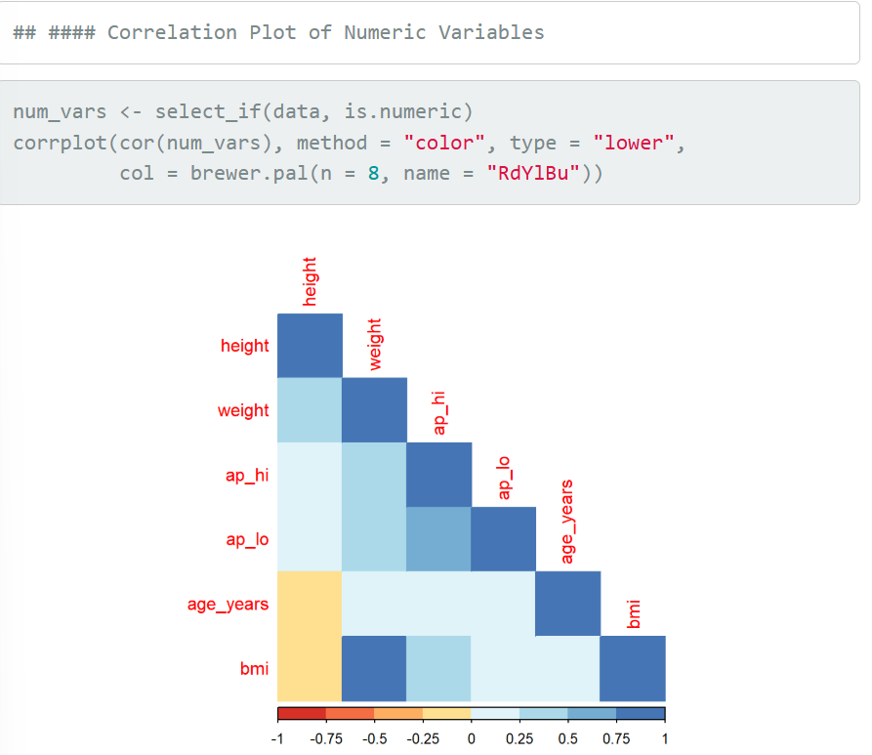

3.2 Age Distribution
- Most patients fall between 50–65 years.
- The dataset represents a middle-aged to elderly population—consistent with primary CVD risk demographics.
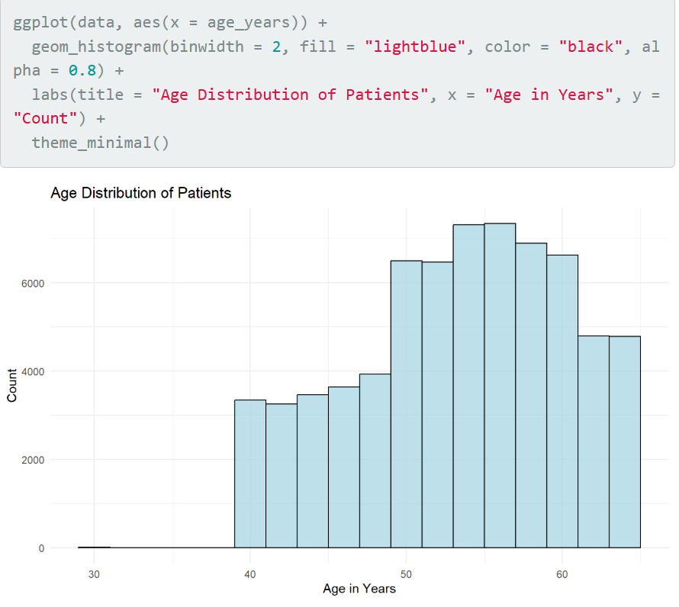

4. Industry Application Analysis
4.1 Patient Outcome Distribution
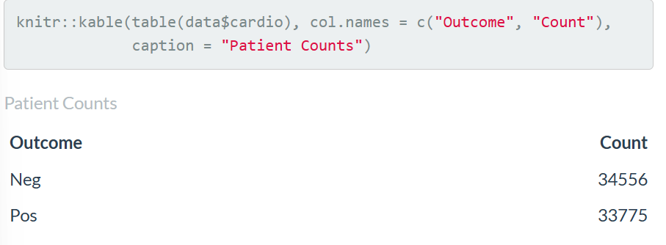
The dataset is nearly balanced:
- 50.6% Negative
- 49.4% Positive
This allows unbiased model training.
4.2 Average Clinical Measures by Outcome
Outcome | Age (yrs) | Systolic BP | Diastolic BP | BMI
No CVD | 51.7 | 119.6 | 78.1 | 26.4
CVD | 54.9 | 133.9 | 84.6 | 28.4
Interpretation
Patients with CVD are:
- Older
- Have significantly higher blood pressure
- Have higher BMI
These are well-established clinical risk factors.

5. Business Intelligence & Analytics
5.1 Statistical Test (ANOVA)
ANOVA confirmed large and statistically significant differences in systolic blood pressure between CVD and non-CVD groups (p < 0.001).
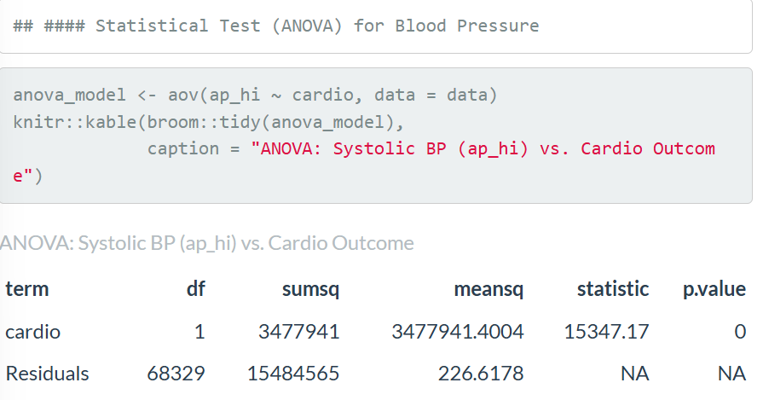
5.2 Predictive Modeling
Two models were built:
- Logistic Regression
- K-Nearest Neighbors (KNN)
Key Predictors Identified (Logistic Regression):
- Systolic BP
- Cholesterol level
- Age
- BMI
- Physical activity
- Smoking/alcohol usage (less impactful)
- 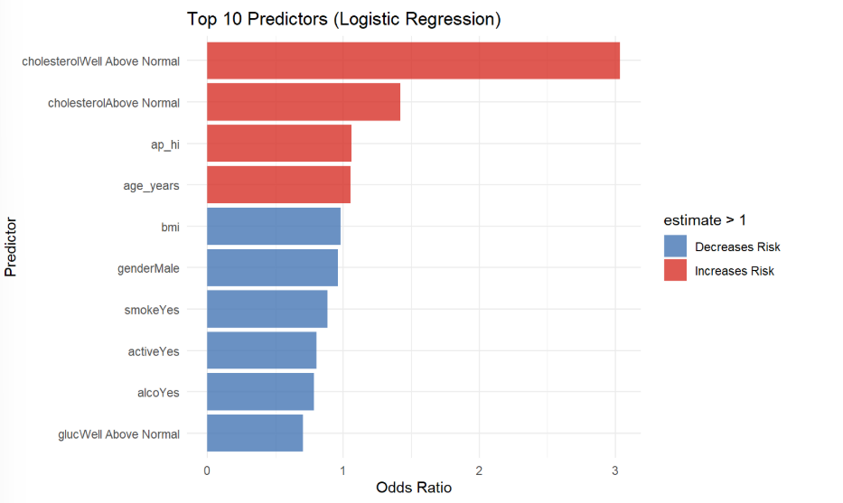
5.3 Model Evaluation
Model | Accuracy | AUC
Logistic Regression | 0.7242 | 0.7882
KNN | 0.7157 | 0.7731

Interpretation
- Logistic Regression outperformed KNN in both accuracy and AUC.
- It is also more interpretable, making it suitable for healthcare decision-making.

6. Big Data Analytics (Clustering)
6.1 K-Means Clustering (k = 3)
Clustering was performed on 5,000 sampled numerical records; clusters were visualized using PCA-reduced space.
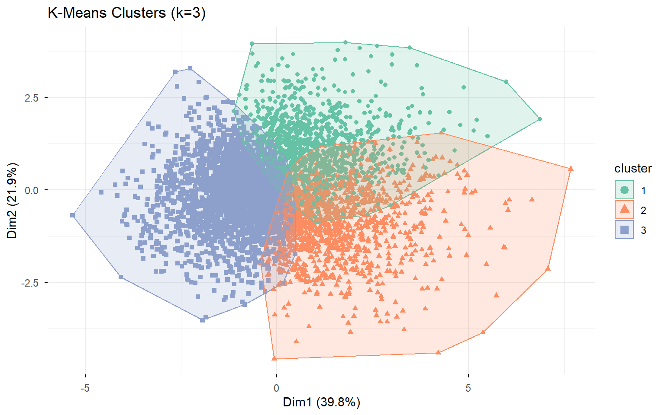
6.2 Cluster Insights
Cluster | No CVD | CVD | Interpretation
1 | 67% | 33% | Lowest-risk group
2 | 19% | 81% | High BP + older age → High-risk
3 | 40% | 60% | Medium-risk
Interpretation
Clusters align strongly with disease likelihood, meaning patient groups naturally separate based on risk factors—useful for hospital triaging or targeted health campaigns.

7. Data Visualization Insights
7.1 Glucose Levels by Outcome
- Glucose levels did not show major differences between CVD and non-CVD groups.
- Suggests glucose is not a primary risk predictor in this dataset.
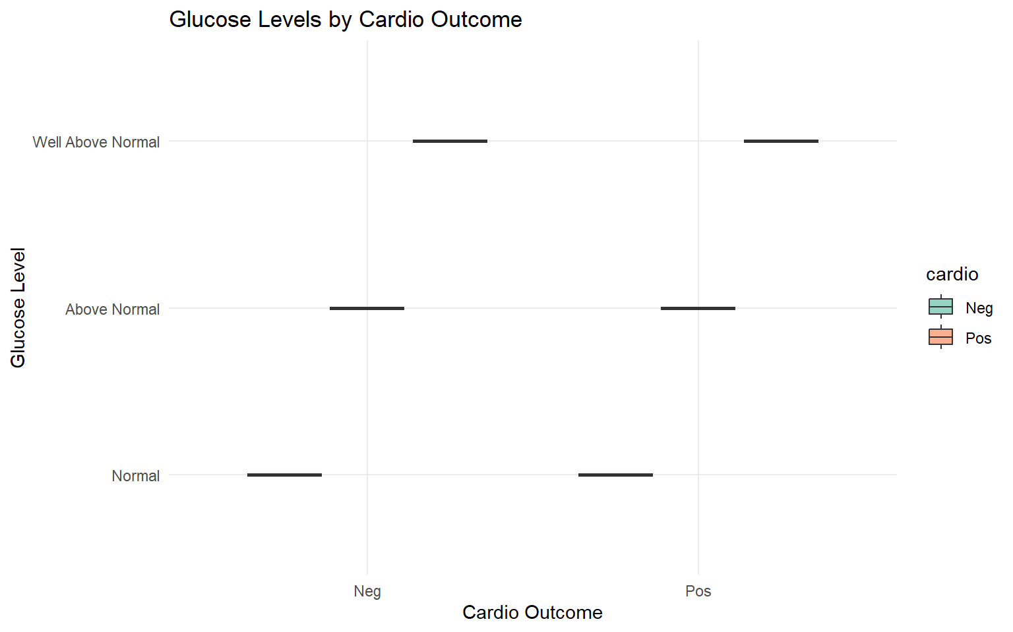
7.2 Age vs Systolic Blood Pressure (Scatter Plot)
- Clear upward trend: older patients have higher systolic BP.
- Patients with CVD cluster heavily in the upper right quadrant (high age, high BP).

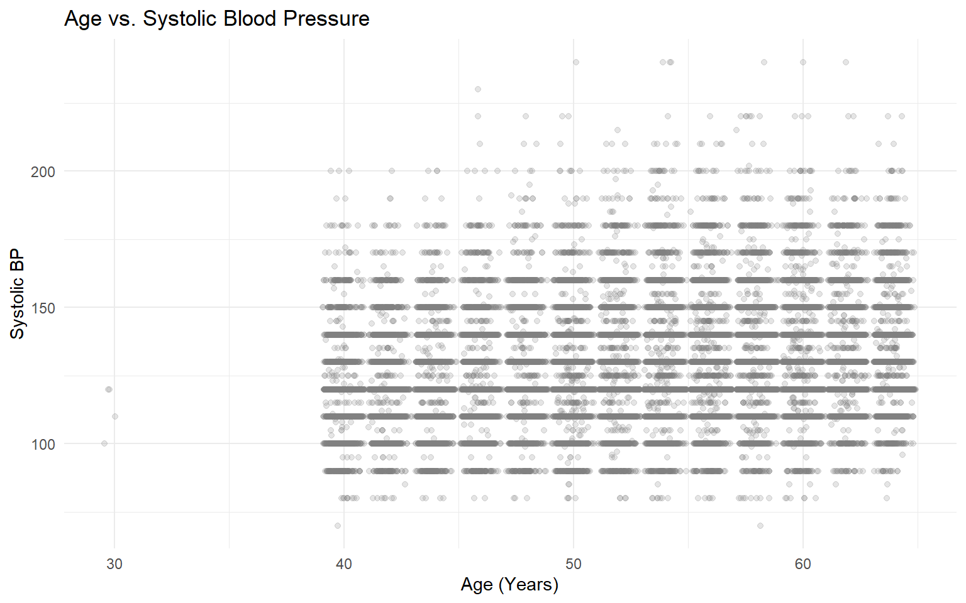

8. Conclusion
Key Findings
- Age, systolic blood pressure, and BMI are the strongest predictors of cardiovascular disease.
- Logistic Regression delivered the best predictive performance (AUC ~ 0.79).
- K-Means clustering discovered distinct patient groups aligned with disease severity.
- Dataset represents an at-risk population primarily aged 50–65 years.
Business Impact
- Hospitals can use these models to screen high-risk patients.
- Insurance companies can use risk profiles for premium adjustments.
- Governments can target high-risk clusters for preventive health programs.

9. Recommendations
For Healthcare Providers
- Integrate logistic regression-based risk scoring into EMR systems.
- Prioritize high-risk clusters for counseling and monitoring.
For Data Scientists
- Improve models using:
  - Gradient Boosting
  - Random Forests
  - Neural Networks
- Include lifestyle and socioeconomic variables for richer modeling.
For Future Work
- Implement real-time dashboards for BP and BMI tracking.
- Use longitudinal patient data to forecast disease progression.

