CSE231: Programming Assignment 1
An ELF Loader in C from Scratch (bonus: Linker)
Due date: 30th August 2026
Weightage: 3% of the Total Programming Assignment Component
No extensions will be granted; the late submission policy posted on GC will be followed. If you see an ambiguity or inconsistency in a question, please seek clarification from the teaching staff.
Plagiarism: This is an individual programming-based assignment. If any plagiarism is detected, it will be dealt with in accordance with IIITD's new plagiarism policy.
Open-sourcing of this assignment solution is not allowed, even after the course is over.
General Instructions
a) Hardware requirements:
a) You will require a machine with any Operating System that supports the Unix API. You cannot do this assignment on MacOS. You can either have a dual-boot system with any Linux OS (e.g., Ubuntu) or install WSL or a Linux VM.
b) Software requirements are:
a) C compiler and GNU make.
b) You must do version control of all your code using GitHub. You should only use a PRIVATE repository. If you are found to be using a PUBLIC access repository, then it will be considered plagiarism. NOTE that TAs will check your GitHub repository during the demo.
Deliverables
a. You should strictly follow the instructions provided above.
b. You should strictly follow the directory structure for your coding as mentioned above.
c. Proper error checking must be performed everywhere. It's up to you to decide what those necessary checks are.
d. Proper documentation should be done in your coding.
e. Your assignment submission should consist of two parts:
a. A zip file containing your source files as mentioned above. Name the zip file as “name_roll_number.zip”. If not followed then penalties shall be levied.
b. A design document inside the above “zip” file, detailing your SimpleLoader implementation, and the link to your private GitHub repository where your assignment is saved.
f. For PART A: Text highlighted in green color describes the deliverables eligible for a maximum of 1% bonus marks. You must have the correct implementation of the loader.c to get the bonus marks. i. If you are attempting bonus marks, use the starter code in the directory “with-bonus”; otherwise, use “without-bonus” to submit an implementation without bonus marks.
g. For PART B: submit boot.asm, boot.bin, execution screenshots, and a short report explaining your implementation

Assignment Details

Part A (Writing a Loader and Linker)

1. Summary
You have to implement a SimpleLoader to load a 32-bit executable in plain C, without using any library APIs for manipulating ELF files. Your SimpleLoader should compile to a shared library (lib_simpleloader.so) that can be used to load and execute the executable using a helper program, as shown below. Some starter code with the desired directory structure and placeholder files is provided with this PDF.
2. Directories and Files
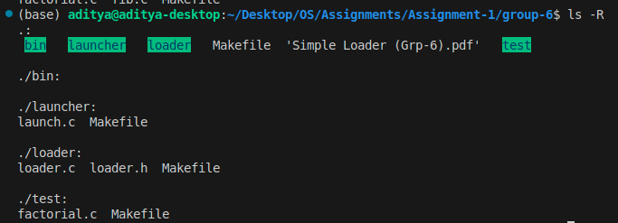
a) Each folder will contain a Makefile to compile the C file present in that directory.
b) There will be a top-level Makefile which would compile all the C-files by internally invoking the “make” command in each of the sub-directories shown above.
c) “test” folder contains the factorial.c as the testcase to be run using SimpleLoader.
d) The executable “launch” and the library “lib_simpleloader.so” should be automatically saved inside the “bin” folder by the make command. The executable “factorial” should remain inside the “test” subdirectory. e) You must pass the flag “-m32” to the gcc compiler for compiling each of the C files. f) You must pass the flags “-m32”, “-no-pie” and “-nostdlib” to the gcc compiler to compile the test case “factorial.c”. You should not make any modifications to “factorial.c” to use the SimpleLoader described here.
g) You are allowed to pass any other relevant flags (e.g., for creating a shared library, etc.) to the gcc compiler as needed.

3. SimpleLoader Implementation (“loader.c”)
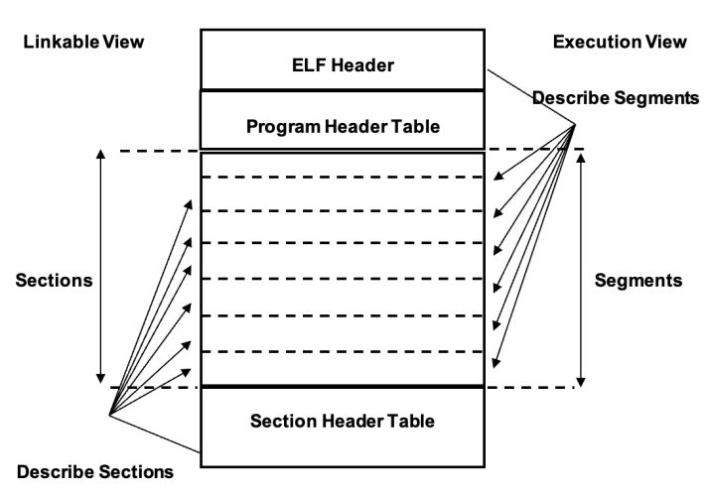
There are two views of ELF object files: the linkable view and the execution view. The ELF header is always at offset 0 in the object file. This can be considered as a roadmap for the entire file organization. The ELF header (EHDR) structure for a 32-bit object file has the following members.

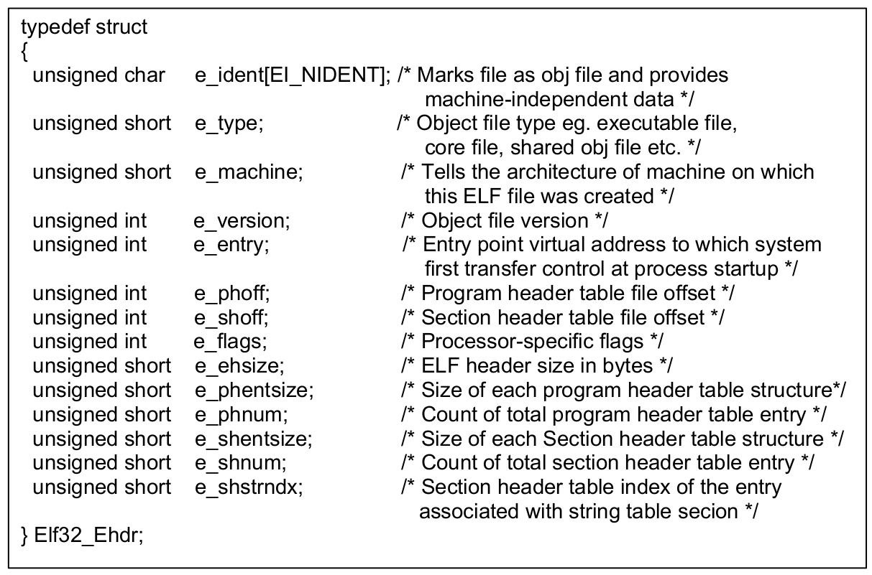
The member e_phnum of the ELF header structure gives the total count of program headers in the executable file. There will be a segment corresponding to each program header. Details about the type of segment can be obtained from the corresponding program header structure. The first program header starts at offset e_phoff bytes from the beginning of the object file. Let us now see the layout of a program
header (PHRD) structure.
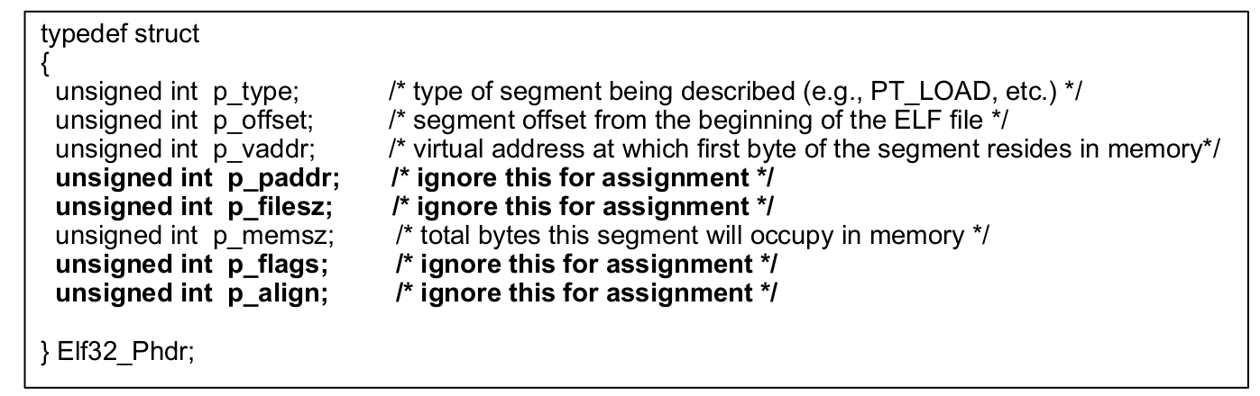
Fig 1.2 Elf32_Shrd Structure

The working of SimpleLoader is exactly the same as described in the Lecture-03 and Tutorial-02 slides. The bare minimum steps in loading and running an executable are as follows:
a) Use the “open” system call to get the file descriptor for the input binary and the “read” system call to read the content of the binary into a heap-allocated memory of appropriate size. Use malloc to allocate space for copying the content of the binary.
b) Iterate through the PHDR table and find the section of PT_LOAD (p_type) type that contains the address of the entrypoint method in factorial.c
c) Allocate memory of the size “p_memsz” using the mmap function as shown below and then copy the segment content:
d) Navigate to the entrypoint address (e_entrypoint) into the segment loaded in the memory in the above step. The entrypoint address may not be the starting address in that segment indicated by “p_vaddr”. You have to walk that segment to reach the virtual address referred to by “e_entrypoint”.
e) Once you reach that location, simply typecast the address to that of a function pointer matching “_start” method in factorial.c.
f) Call the “_start” method and print the value returned from the “_start”.
As mentioned in the Lecture-03 slides, the above steps will work only with a statically linked executable file that has to be loaded and executed. The lib_simpleloader.so is the shared library implementation of the loader.c file.
4. Implementation of Launcher (“launch.c)
The job of the launch.c is to a) ask the user to provide the ELF file as a command line argument, b) carry out necessary checks on the input ELF file, c) pass it to the loader for carrying out the loading/execution, and d) invoke the cleanup routine inside the loader. The launcher.c file has to include “loader.h,” which contains the declarations of the two APIs used in steps c and d mentioned above. Note that to compile, launch. You must include the path to the lib_simpleloader.so (“bin” folder) and also supply the library name as a parameter to the gcc. Also, note that you don’t need to recompile launch.c and loader. Every time you want to load a new executable. However, the test case must be compiled if its executable doesn’t exist, or if there are any new changes inside the test case since the last compilation.

5. Hint
Approach your assignment implementation in the following sequence:
a) Implement all the functionality of the loader inside a single loader.c file. It should be able to directly accept the executable of factorial.c as a command-line parameter and then load/run it. b) Once you are done with the above implementation, implement error handling at all required places. c) Now you should implement the launch.c file as mentioned above in the requirements. d) Your final step should be to create Makefiles, a directory structure, and a shared library version of the loader.
6. Reading / Reference Materials
a. Lecture 02 and Lecture 03 slides
b. https://man7.org/linux/man-pages/man5/elf.5.html
c. https://wiki.osdev.org/ELF_Tutorial

Part B (Bootloader)

Design and implement a tiny x86 bootloader and execute it using the QEMU emulator.

Install QEMU and NASM on your system and verify their installation.
You will be provided with 16-bit x86 assembly code for a bootloader that fits within a single 512-byte boot sector. You need to complete the filler code to understand the bootloader's functionality.

To test your bootloader, you will need to install QEMU (an emulator).

On Linux, install QEMU and NASM using the following command:
- sudo apt install nasm qemu-system-x86

Once done with the changes, you have to compile the assembly language:

- Assemble the bootloader into a raw binary image using NASM.
- Use QEMU to boot and execute the generated binary.
- Verify that the bootloader successfully displays the message in the QEMU window.

Submit the source code, generated binary, screenshots, and a short explanation of:
- Why is the bootloader limited to 512 bytes?
- Why is 0x7C00 significant?
- What does the 0x55AA boot signature represent?
- How is QEMU involved in the boot process?

Deliverables: boot.asm, boot.bin, execution screenshots, and a short report explaining your implementation

