**Name-Rijushree Guha**

**Movies Database**

* create table actor( act_id number(10) primary key,act_name varchar2(20),act_gender char(1));

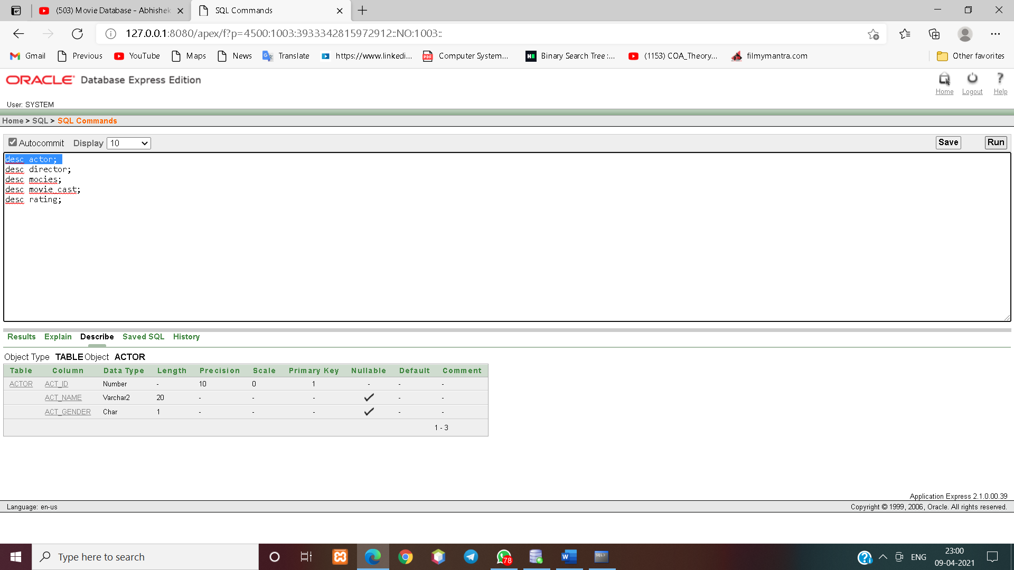

* create table director( dir_id number(10) primary key,dir_name varchar2(20),dir_phone number(10));
* MysQl: create table director( dir_id int(10) primary key,dir_name varchar(30),dir_phone int(10));

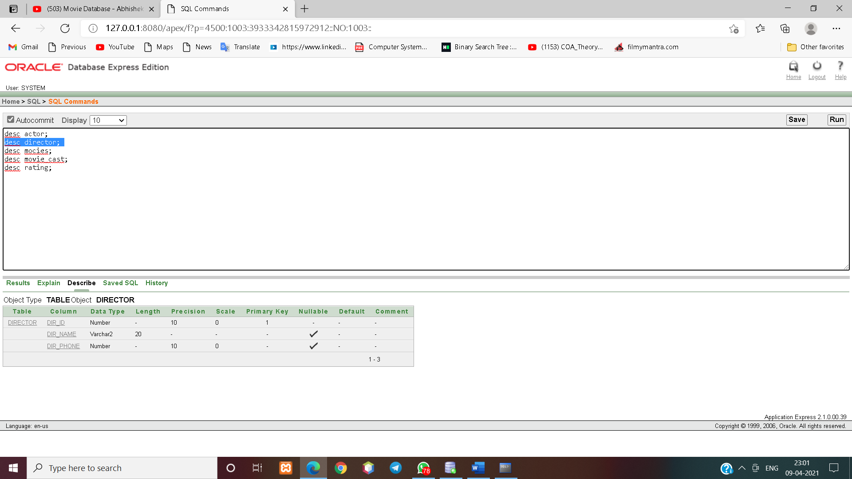

* create table movies(Mov_id number(10) primary key, Mov_Title varchar2(25), Mov_Year number(4), Mov_Lang varchar2(15), Dir_id number(10), foreign key(dir_id) references director(dir_id));

Mysql: create table movies(Mov_id int(10) primary key, Mov_Title varchar(35), Mov_Year int(4), Mov_Lang varchar(15), Dir_id int(10), foreign key(dir_id) references director(dir_id));

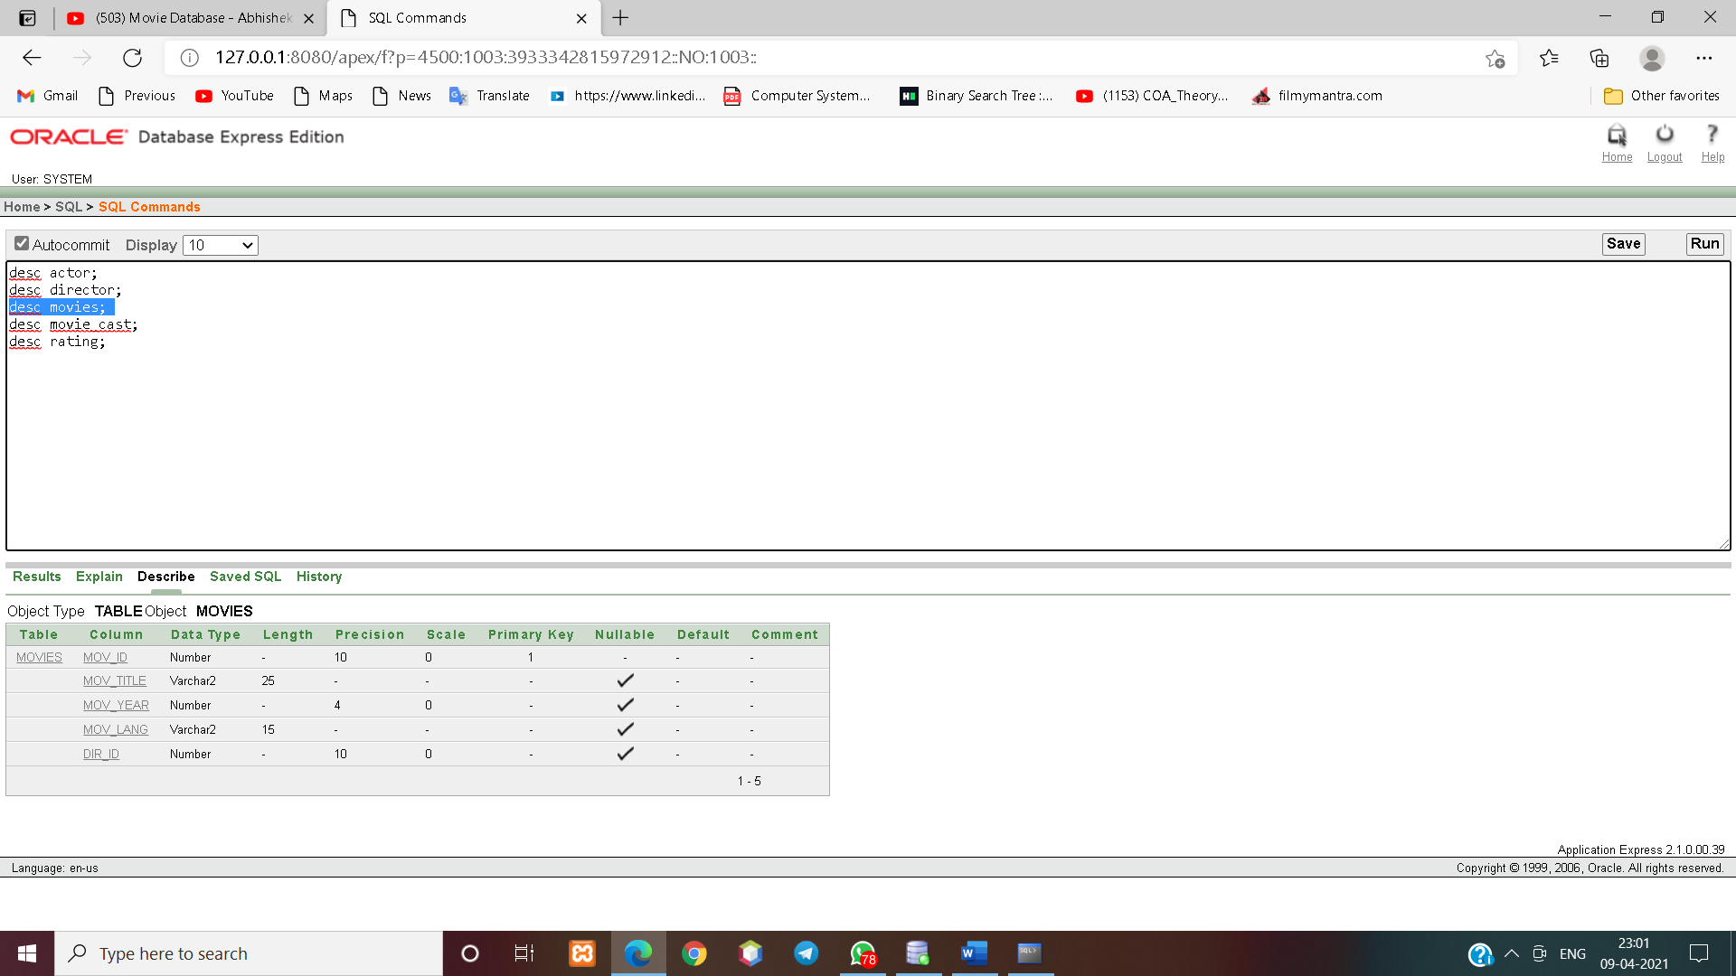

* create table MOVIE_CAST(Act_id number(10), Mov_id number(10),MRol varchar2(10), primary key(act_id,mov_id), foreign key(act_id) references actor(act_id),foreign key(mov_id) references movies(mov_id));
* Mysql: create table MOVIE_CAST(Act_id int(10), Mov_id int(10),MRol varchar(20), primary key(act_id,mov_id), foreign key(act_id) references actor(act_id),foreign key(mov_id) references movies(mov_id));

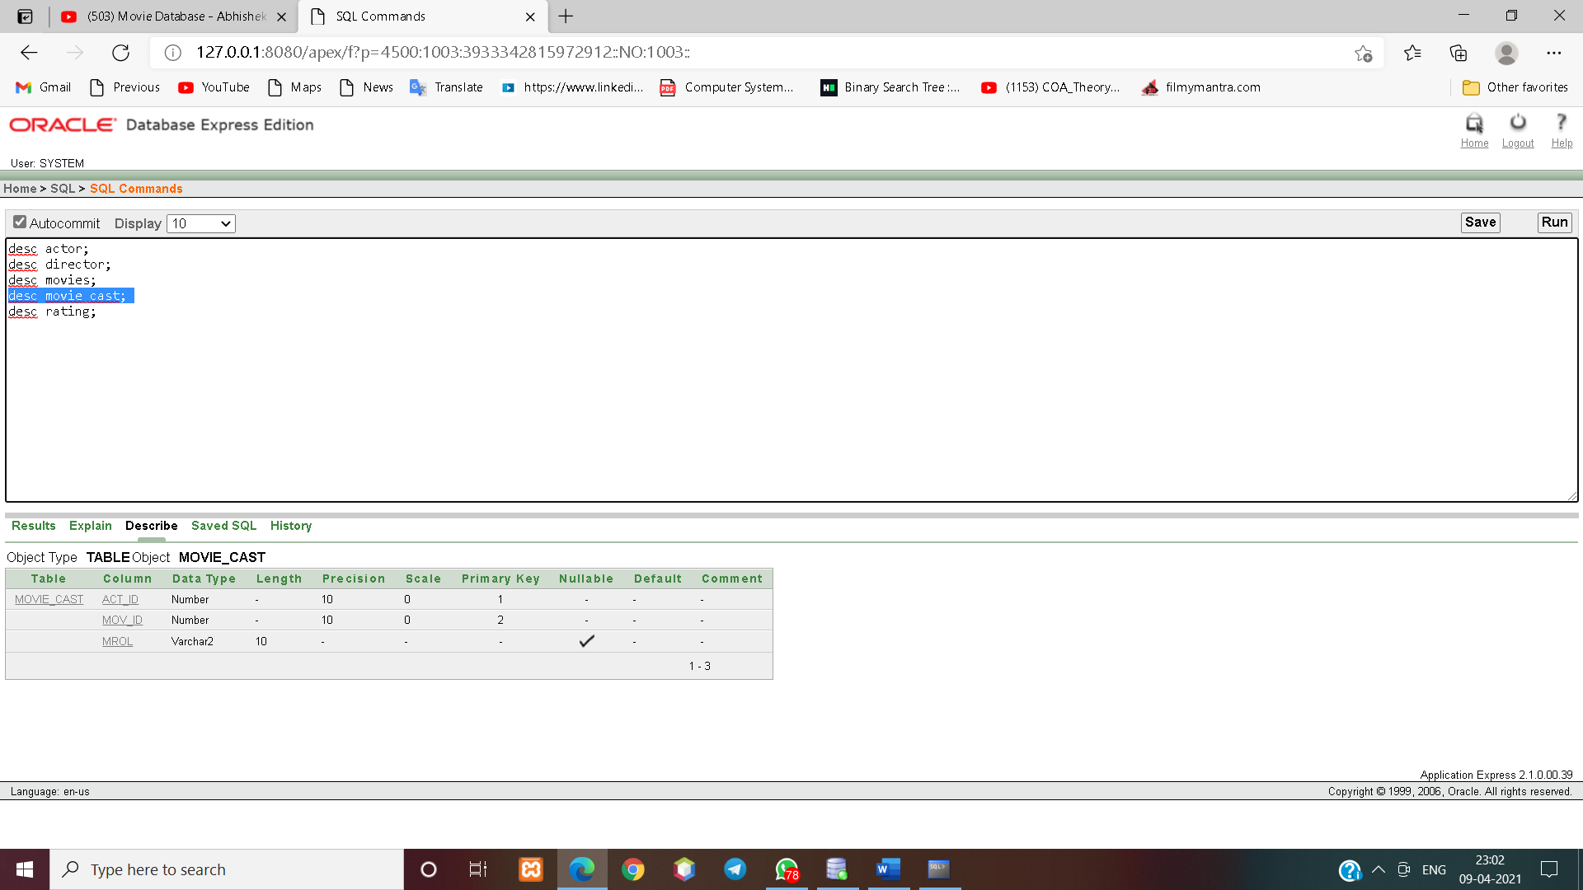

* create table rating(mov_id number(10), rev_stars number(3), primary key(mov_id,rev_stars), foreign key(mov_id) references movies(mov_id));
* Mysql: create table rating(mov_id int(10), rev_stars int(3), primary key(mov_id,rev_stars), foreign key(mov_id) references movies(mov_id));

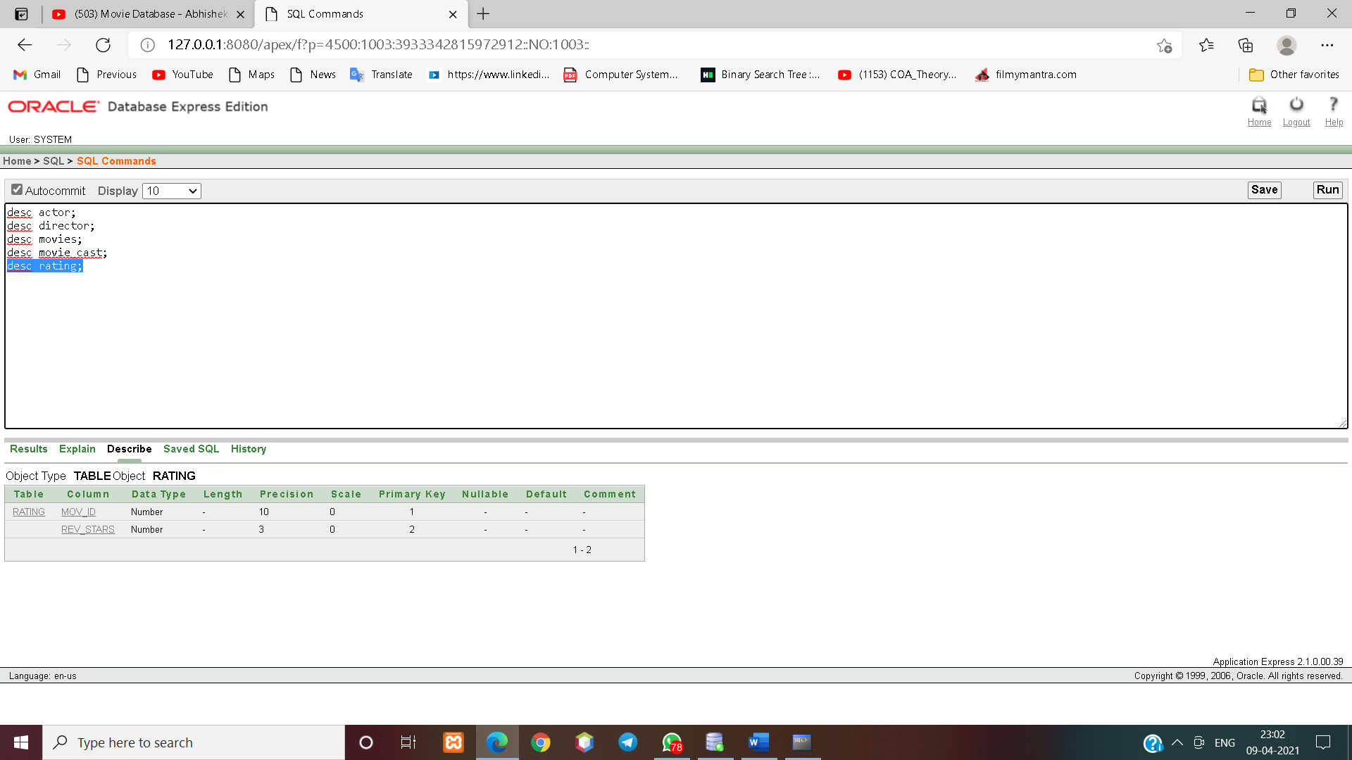

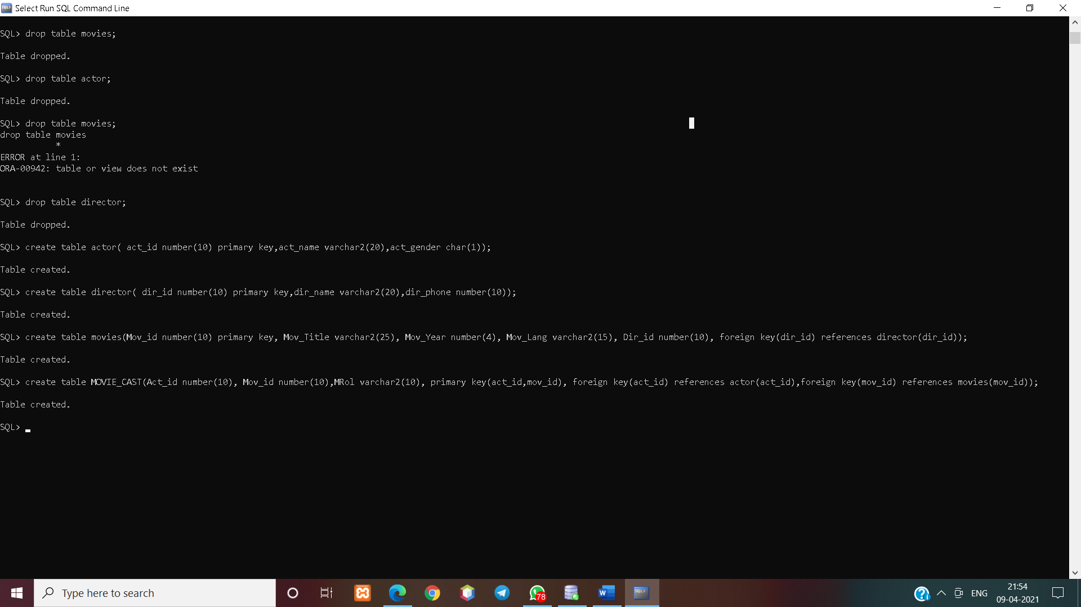

**insert into actor values(1,'Akshay Kumar','M');**

**insert into actor values(2,'Sonakshi Sinha','F');**

**insert into actor values(3,'Prabhas','M');**

**insert into actor values(4,'Anushka Shetty ','F');**

**insert into actor values(5,'Daniel Radcliff ','M');**

**insert into actor values(6,'Emma Watson','F');**

**insert into actor values(7,'Yash ','M');**

**insert into actor values(8,'Radhika Pandit','F');**

**insert into actor values(9,'Salman Khan','M');**

**insert into actor values(10,'Aishwarya Rai','F');**

**insert into actor values(11,'Shahrukh Khan','M');**

**insert into actor values(12,'Ranbir Singh ','M');**

**insert into actor values(13,'Dipika Padukon','F');**

**insert into actor values(14,'Priyanka Chopra','F');**



**insert into director values(1,'Yash Raj',9664631642);**

**insert into director values(2,'Pawan Vadeyar',9668631712);**

**insert into director values(3,'J K Rowling',8695781712);**

**insert into director values(4,'Rajamouli',9254846312);**

**insert into director values(5,'Muruli Krishna',9865871742);**

**insert into director values(6,'Subhas Gai',9878561745);**

**insert into director values(7,'SanjayLeela Bhansali',9534824327);**



**insert into movies values(1,'Mission Mangal',2019,'Hindi',5);**

**insert into movies values(2,'Hum Dil De Chuke Sanam',1994,'Hindi',1);**

**insert into movies values(3,'Harry Porter',2019,'English',3);**

**insert into movies values(4,’Santhu Straight Forward',2019,'Kannada',2);**

**insert into movies values(5,’Bahubali',2019,'Telugu',4);**

**insert into movies values(6,'Bahubali 2',2019,'Telugu',4);**

**insert into movies values(7,'KGF',2019,’Kannada’,5);**

**insert into movies values(8,'Pardes',2019,'Hindi',6);**

**insert into movies values(9,'Zero',2019,'Hindi',6);**

**insert into movies values(10,’Ram Leela’,2013,'Hindi',7);**



**insert into movie_cast values(1,1,'Hero');**

**insert into movie_cast values(2,1,'Heroin');**

**insert into movie_cast values(3,5,'Hero');**

**insert into movie_cast values(3,6,'Hero');**

**insert into movie_cast values(4,5, 'Heroin');**

**insert into movie_cast values(4,6, 'Heroin');**

**insert into movie_cast values(5,3,'Hero');**

**insert into movie_cast values(6,3, 'Heroin');**

**insert into movie_cast values(7,4,'Hero');**

**insert into movie_cast values(7,7,'Hero');**

**insert into movie_cast values(8,4,'Heroin');**

**insert into movie_cast values(11,8,'Hero');**

**insert into movie_cast values(11,9,'Hero');**

**insert into movie_cast values(12,10,'Hero');**

**insert into movie_cast values(13,10,'Heroin');**

**insert into movie_cast values(14,10,'Heroin');**

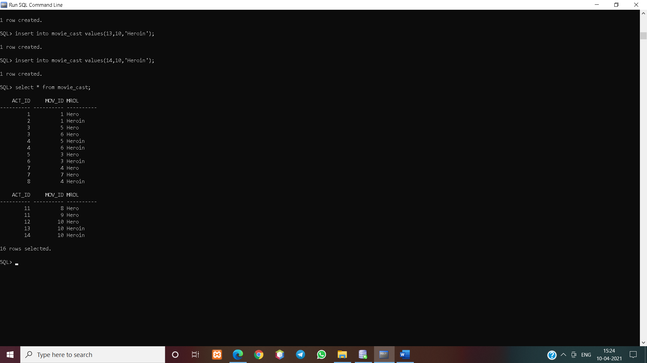

**insert into rating values(1,5);**

**insert into rating values(1,4);**

**insert into rating values(1,8);**

**insert into rating values(2,1);**

**insert into rating values(3,4);**

**insert into rating values(4,3);**

**insert into rating values(5,5);**

**insert into rating values(6,5);**

**insert into rating values(7,5);**

**insert into rating values(8,5);**

**insert into rating values(9,5);**

**insert into rating values(10,5);**



**Write SQL queries to**

1. **Find the movie names where one or more actors acted in two or more movies.**

select distinct m.mov_title from movies m, movie_cast mv where m.mov_id=mv.mov_id and act_id in(select act_id from movie_cast group by act_id having count(mov_id)>1);

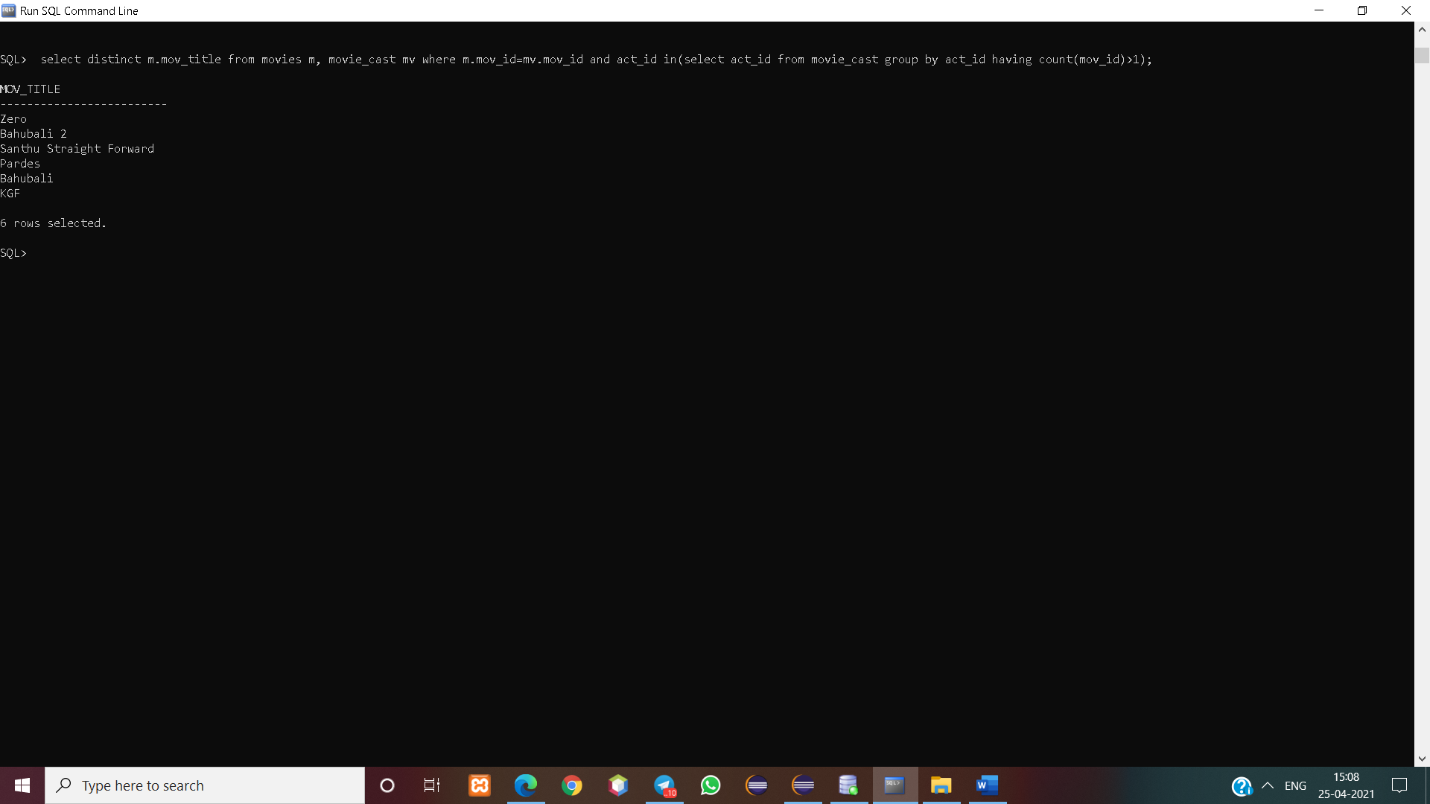

1. **List all actors who acted in a movie before 2000 and also in a movie after 2017 (use JOIN operation).**

select a.act_name from (actor a join movie_cast c on a.act_id=c.act_id) join movies m on c.mov_id=m.mov_id where m.mov_year<2000 and exists(select a.act_name from (actor a join movie_cast c on a.act_id=c.act_id) join movies m on c.mov_id=m.mov_id where m.mov_year>2017);

1. **Find the title of movies and number of stars for each movie that has at least one rating and find the highest number of stars that movie received. Sort the result by movie title.** select m.mov_id, m.mov_title as Movie_title, max(r.rev_stars) as rating from movies m, rating r where m.mov_id=r.mov_id group by m.mov_id, m.mov_title having count(r.rev_stars)>0 order by m.mov_id;
2. **Update rating of all movies directed by ‘Subhash Ghai’ to 3.**

update rating set rev_stars=3 where mov_id in(select mov_id from movies where dir_id in(select dir_id from director where dir_name='Subhas Gai'));

1. **Using cursor display details of all the movie id and title in the database.**