Explain that dCor special case of RCA when dissimilarity is Euclidean, and introduce example of trial-by-trial similarity matrix (kernel).

## Worked Examples

The purpose of this section is to illustrate some of the advantages and disadvantages associated with the univariate and multivariate connectivity metrics defined above. Consider two Regions of Interest (ROIs) with *N1* and *N2* voxels, with activity in each voxel measured across multiple time points or trials (we call these timeseries below, but they could equally be response summaries per trial, e.g, parameter estimates for an HRF). The timeseries in ROI2, Y(t), is then a function of those in ROI1, X(t), i.e:, where is the functional mapping and is independent Gaussian noise with 0 mean and standard deviation equal to . For a linear mapping, is a *N1*-by-*N2* matrix and .

An important property of the voxels in ROI1 is the covariance of their timeseries, denoted by . If is such that the timeseries are highly positively correlated, i.e, the ROI is functionally homogeneous (or the data are spatially smooth), then the mean timeseries over voxels can be a sufficient summary of activity in that ROI. Indeed, if there is additional noise on the timeseries in an ROI, then averaging is an effective way of attenuating that noise. If the voxel timeseries in ROI2 are also positively correlated (which here depends on the properties of the functional mapping ), then connectivity can be captured by a univariate metric, as shown in Example 1. However, if ROI1 is not functionally homogeneous, or if the functional mapping T is not uniform, then the remaining examples illustrate the value of multivariate metrics.

For the examples below, we assume 50 voxels in ROI1 and 60 in ROI2, each with 200 timepoints, generated for two independent runs (in order to estimate MVPD) in 20 simulated participants with Gaussian noise in ROI2 with standard deviation of 1. The Matlab script for all examples is demo.m in www.github ….

### Example 1: correlated activities in ROI1 and uniform functional mapping

Figure 1A shows a covariance matrix () that produces correlated timeseries in ROI1, while Figure 1B shows a mapping matrix () that produces a linear, one-to-one mapping between the *N1* voxels in ROI1 and the first *N1* of the *N2* voxels in ROI2 (the remaining voxels in ROI2 are therefore just random noise). Figure 1C and 1D show the first 50 timepoints of two voxels in each ROI and their positive correlation. Figure 1E shows the raw values of each of the 6 metrics and standard deviation across 20 simulations, while 1F shows their normalised values, i.e, after subtracting their mean values when there is no connectivity (and adding the resulting uncertainty). The latter is achieved by permuting the timepoints randomly for every voxel (20 times). This is important because the raw value corresponding to no true connectivity is not 0 for some metrics, such as Dcor (the normalised values therefore should be 0 when no connectivity). In terms of the basic (raw) values (Figure 1E), univariate metrics like Pearson’s correlation coefficient and UPVD are best, and close to their maximum value of 1. While dCor is also close to 1, once normalised for baseline values (Figure 1F), its mean value becomes lower than for the univariate measures (note that there is also increased spread in the normalised univariate measures, but this is due to the finite data used in the permutation, and for these measures, the expected value when no connectivity is zero, so raw measures are arguably more suitable). Nonetheless, it is interesting to note that the multivariate metrics are still above zero, particularly dCor, i.e., they can capture univariate effects too.

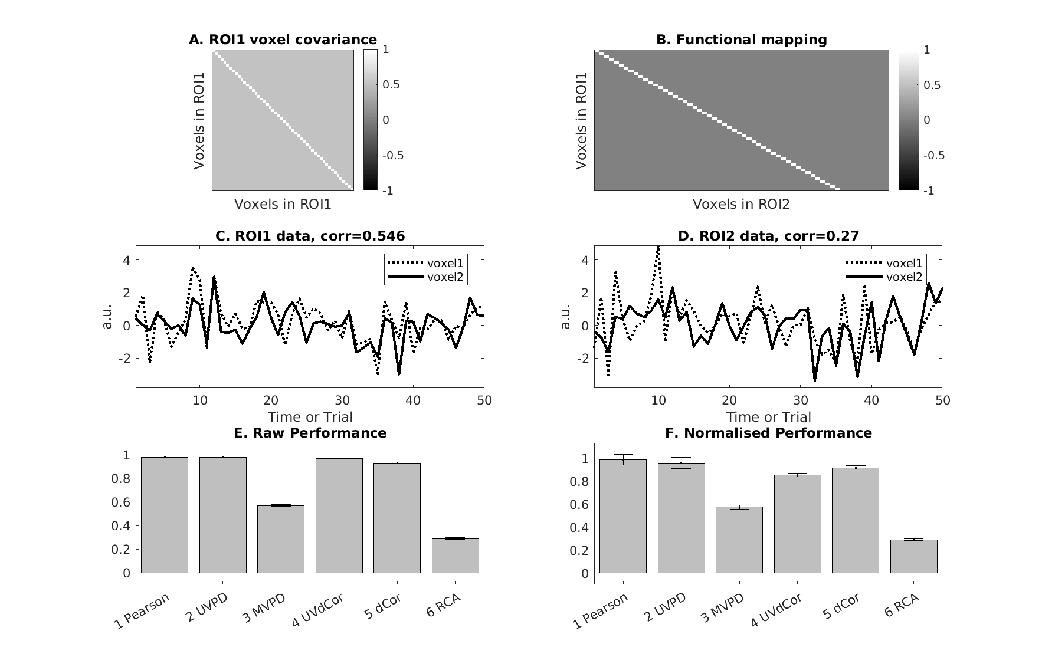

### Example 2: presence of anticorrelated voxel activities within ROI1

Figure 2B has the same functional mapping as in Example 1 above, but now there are two functional subdivisions within ROI1, which are negatively correlated, as indicated in Figure 2A. This pattern has been seen in real fMRI data for example (Geerligs & Henson, 2016), when ROIs do not respect the functional anatomy of the brain. This “structure” can be seen in Figure 2C-D, which show timecourse now in an “image” format, rather than the line plots in Figures 1C-D. In this case, averaging over voxels in ROI1 (and ROI2) destroys most of the signal, leaving just noise, and hence weak univariate connectivity (Figure 2E-F). However, the multivariate metrics (dCor, RCA and to a lesser extent MVPD) still recover the significant coupling between the two ROIs.

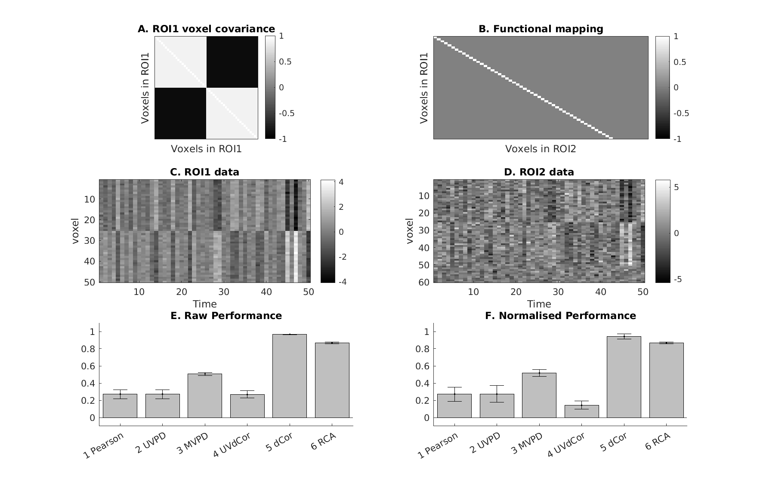

**Figure 2.** *The functional mapping from ROI1 to ROI2 may create an anticorrelation among the voxels in the second region, thus consequently leading to low performance for the UV-methods. Lower-left panel shows the activity of two voxels in ROI1 (in this example all the voxels in ROI1 are uncoupled). Upper-lower panel shows the functional mapping between the two ROIs, which generates in ROI2 voxel activities characterized by strong anticorrelations. Lower-right panel shows the activity (obtained by transforming the voxels in ROI1 though the mapping) of two voxels. Upper-right panel shows the performance (mean value and standard deviation across 10 subjects) obtained by the three UV-methods (Pearson, UVPD and UVdCor) and by the three MV-methods (MVPD, dCor and RCA).*

### Example 3: anticorrelation within ROI2 induced by the functional mapping

Figure 3A has the same covariance matrix for ROI1, but now the mapping T in Figure 3B induces negative correlation in half of the voxels in ROI2, such that the univariate connectivity is abolished, particularly when normalizing (Figure 3F).

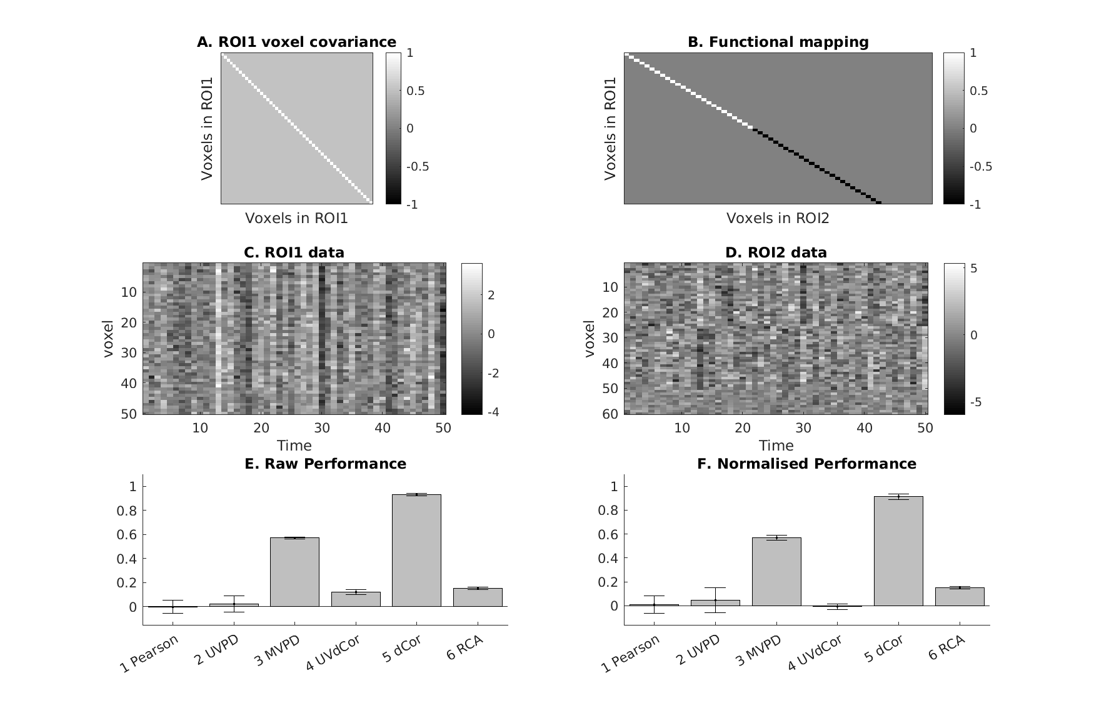

**Figure 3.** *The functional mapping from ROI1 to ROI2 may create an anticorrelation among the voxels in the second region, thus consequently leading to low performance for the UV-methods. Lower-left panel shows the activity of two voxels in ROI1 (in this example all the voxels in ROI1 are uncoupled). Upper-lower panel shows the functional mapping between the two ROIs, which generates in ROI2 voxel activities characterized by strong anticorrelations. Lower-right panel shows the activity (obtained by transforming the voxels in ROI1 though the mapping) of two voxels. Upper-right panel shows the performance (mean value and standard deviation across 10 subjects) obtained by the three UV-methods (Pearson, UVPD and UVdCor) and by the three MV-methods (MVPD, dCor and RCA).*

### Example 4: Mappings that change across runs

Figure 4A has the same covariance matrix for ROI1, but now the functional mapping is random (Figure 4B), with equal probability of positive and negative connections. The latter again abolishes any univariate connectivity. More importantly, this mapping is assumed to change across runs (so Figure 4B is just an example from one run). This might happen if the voxelwise sampling of the underlying neurons changes across runs, e.g, to uncorrectable motion, or if there are effects of learning across runs that change the functional connectivity. Or it might happen if different runs contain different stimuli (where each timepoint represents one trial with one stimulus), and there are complex, nonlinear interactions between neurons in the two ROIs that depend on the specific stimuli. In any case, changes in T across run detrimentally affect MVPD, because the multivariate mapping is trained on one run and tested on 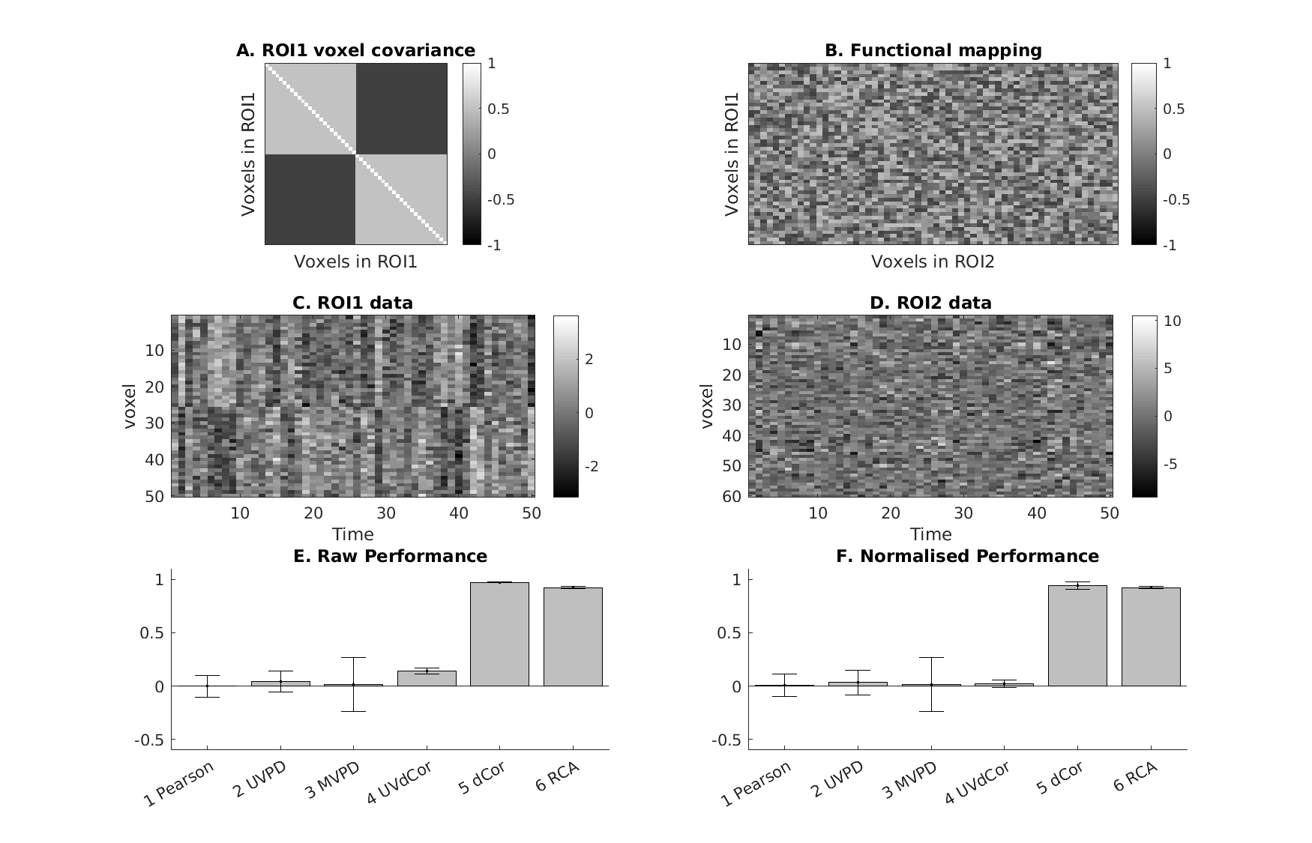another. However, the within-run measures of dCor and RCA remain sensitive.

**Figure 4.** *The presence of structured noise in the data leads dCor and MVPD to reach low performance. Left panel shows the simulated transformation between the two ROIs (a simple one-to-one voxel mapping). Right panel shows the performance (mean value and standard deviation across 10 subjects) obtained by the six different functional connectivity methods.*

### Example 5: nonlinear mapping

In Figure 5A-B, the voxel covariance in ROI1 and the functional mapping matrix T are identical to those in Example 1. However, the timeseries in ROI2 are now a nonlinear function of those in ROI1 and T, here illustrated by taking the absolute value of . Thus whereas the timeseries in ROI1 (Figure 5C) are centred around zero, the timeseries in ROI2 (Figure 5D) are generally above zeros (except for the additive Gaussian noise). This now abolishes connectivity according to all measures except dCor, which can handle such nonlinearity (Figure 6F). Note however that this is because dCor uses a Euclidean metric of similarity of voxel-patterns between timepoints (trials) – if we change the similarity measure in RCA from (Pearson) correlation to Euclidean, then RCA can also produce significant connectivity just like dCor in this example.

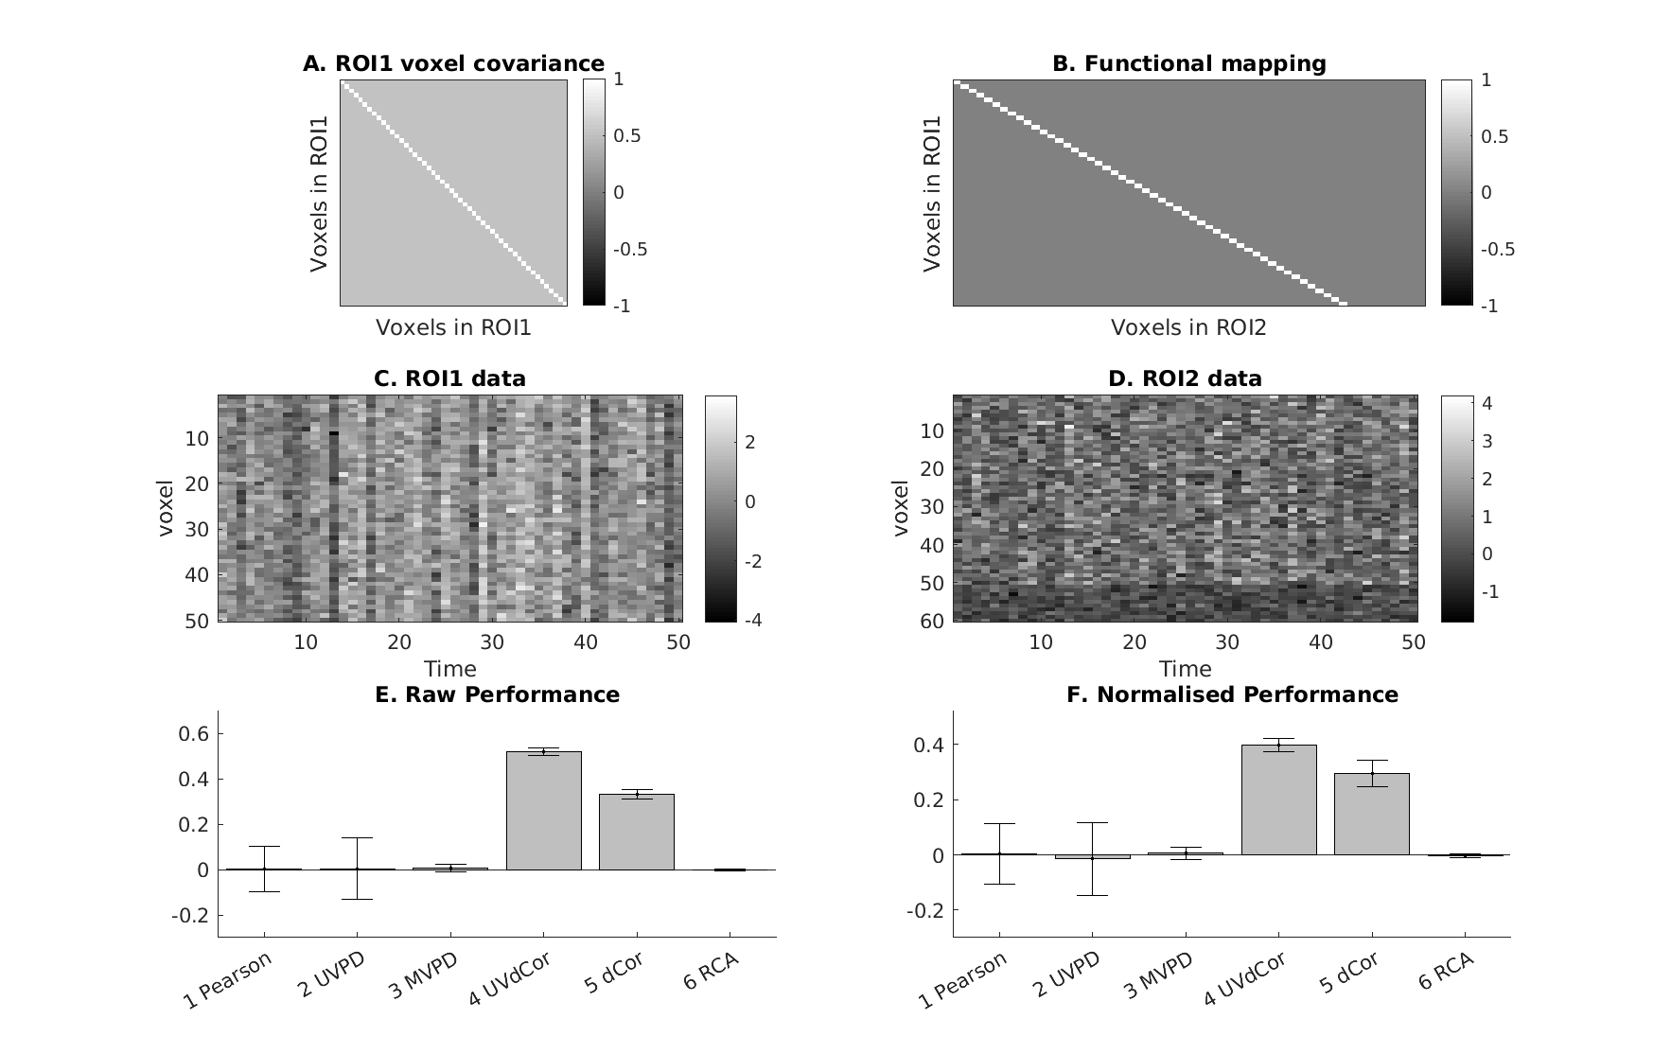

**Figure 5.** *Inconsistent linear MV mappings between the two regions cannot be detected by MVPD. In this example activity of each voxel in ROI2 is a weighted combination of activities of all voxels in ROI1 with some additive noise. Importantly the weights change for independent measurements, i.e. runs. This severely affects MVPD. However, RCA and dCor can detect these types of interactions.*

### Example 6: structured noise in ROI2

In Figure 6A-B, the voxel covariance in ROI1 and the functional mapping matrix T are identical to those in Example 2, such that there is no univariate connectivity. However, additional structured noise has been added to ROI2, which is identical across voxels (producing the coherent pattern in Figure 6D). This reduces performance of dCor (Figure 6F), which uses a Euclidean measure of similarity between timepoints (trials), but not RCA, which uses a correlational measure which is invariant to constant off-sets in the voxel-patterns.

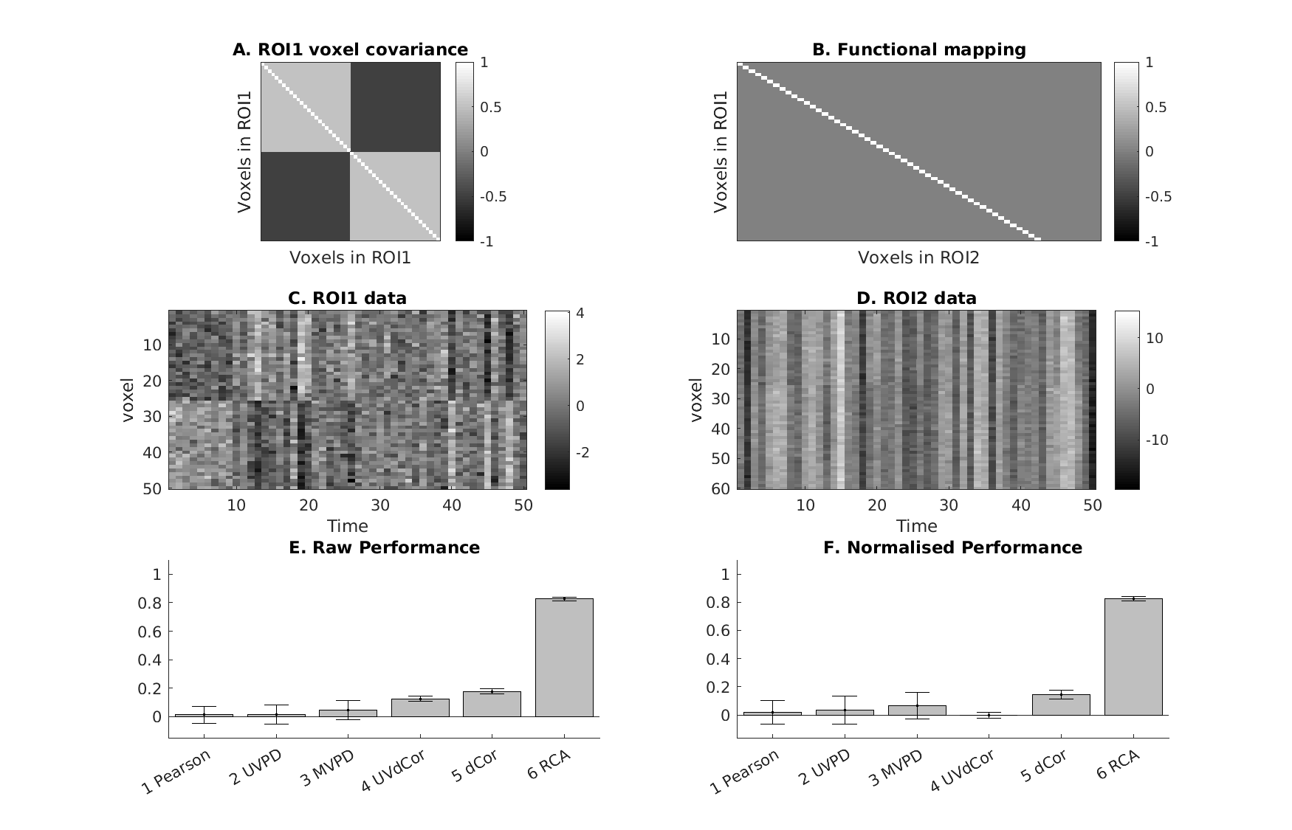

**Figure 6.** *Inconsistent linear MV mappings between the two regions cannot be detected by MVPD. In this example activity of each voxel in ROI2 is a weighted combination of activities of all voxels in ROI1 with some additive noise. Importantly the weights change for independent measurements, i.e. runs. This severely affects MVPD. However, RCA and dCor can detect these types of interactions.*

### Example 7: Averaging across trials of same stimulus

Until now, we have considered each timepoint to be independent. If each timepoint represents a trial, then sometimes the same stimulus is repeated across multiple trials. Figure 7A shows results when each voxel within ROI1 is independent, together with an non-uniform mapping T (like in Example 3), ignoring the case that the 200 timepoints are 10 trials of each of 20 stimuli, ie some timepoints represent the same stimulus. The mean value of raw RCA is 0.70.

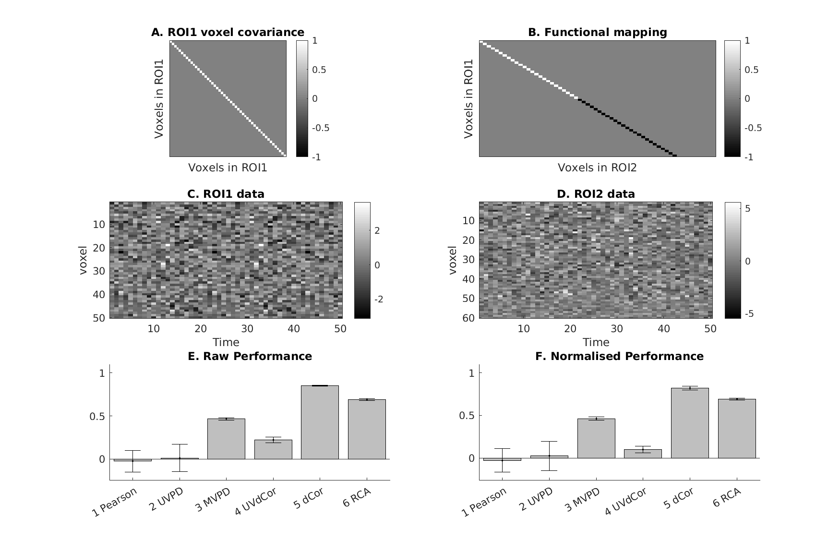

**Figure 7A.** *No averaging*

Figure 7B shows the results after first averaging across all trials with the same stimulus (such that only 20 “timepoints” enter the estimation of connectivity. The mean value of raw RCA is 0.90, i.e, increased relative to Figure 7A. The reason for this is that averaging reduces noise in the voxelwise pattern of each stimulus….

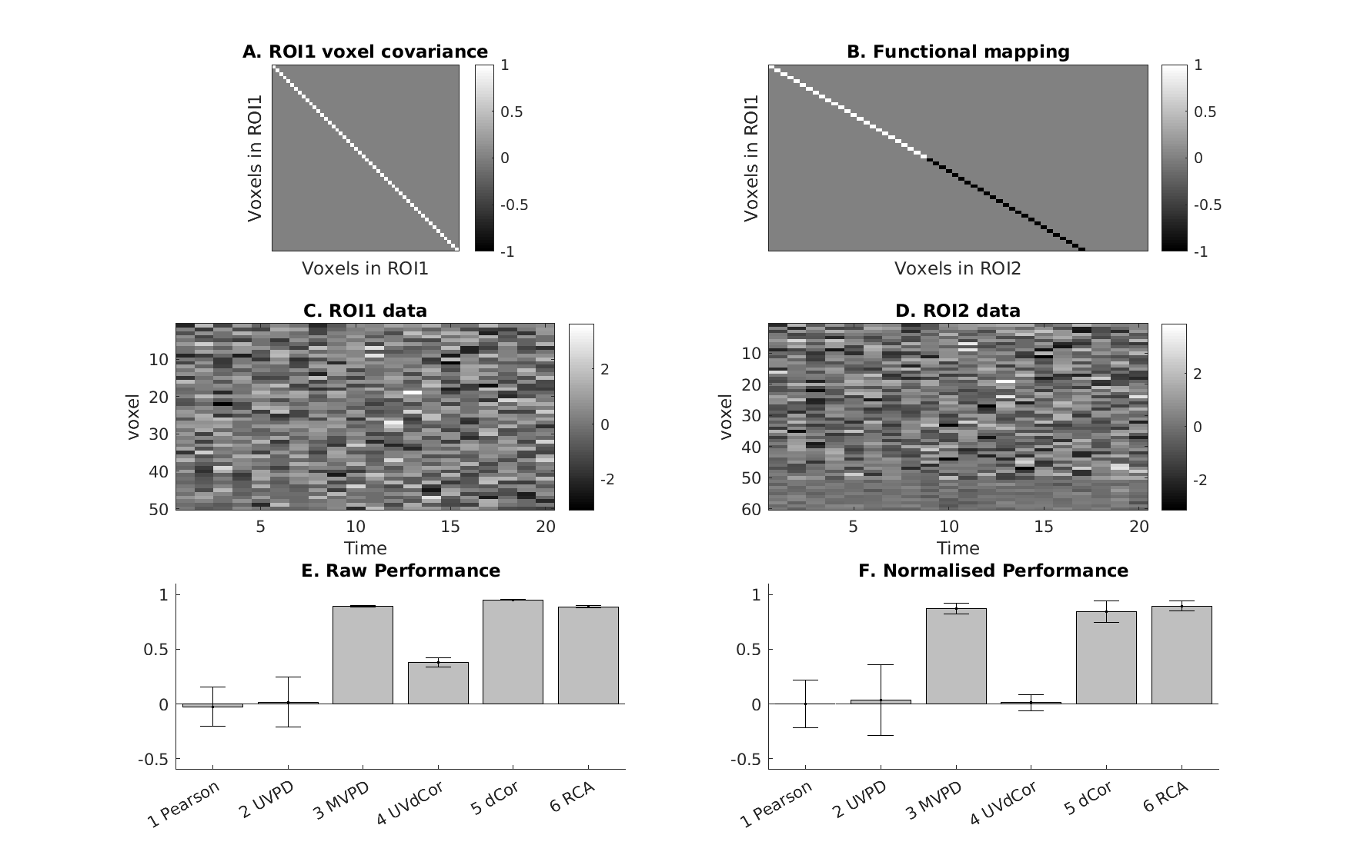

**Figure 7B.** *Averaging first*