1st topic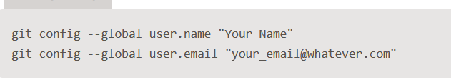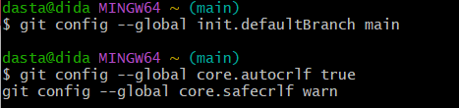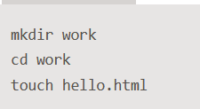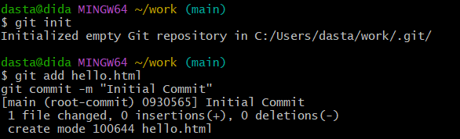

3rd Topic

2nd Topic

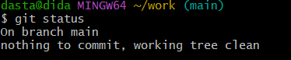

4th Topic

5th topic

7th topic

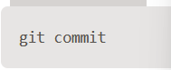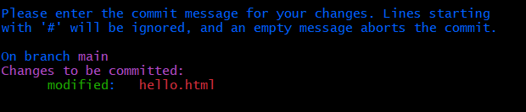

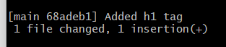

8th topic

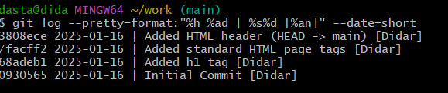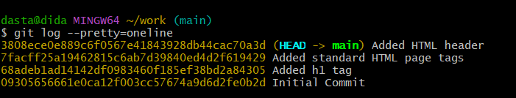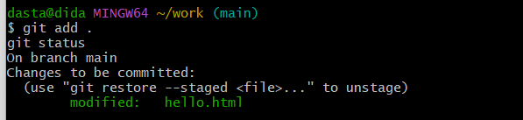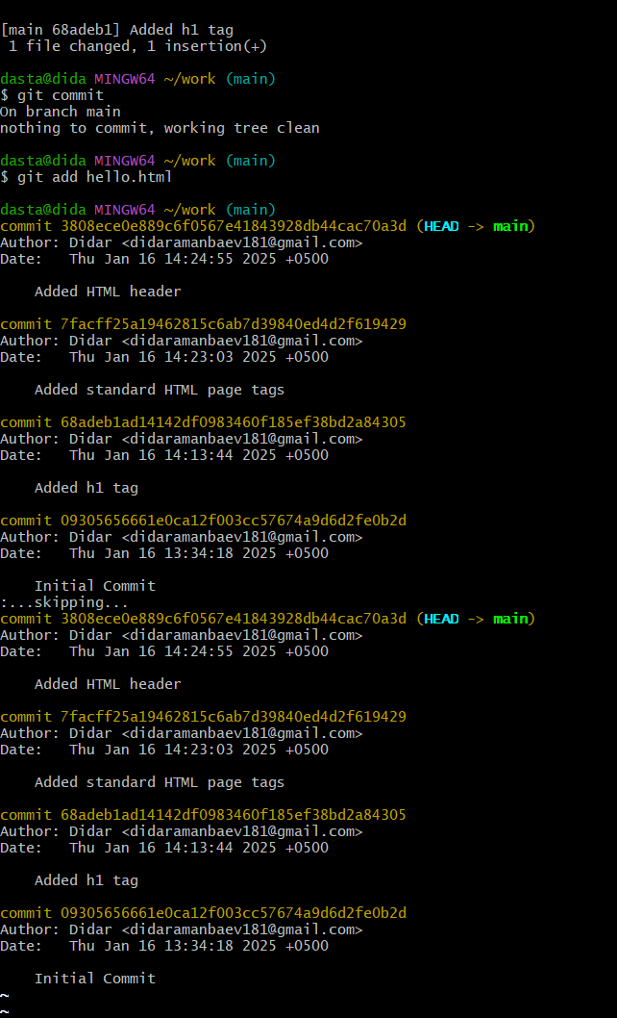

9th topic

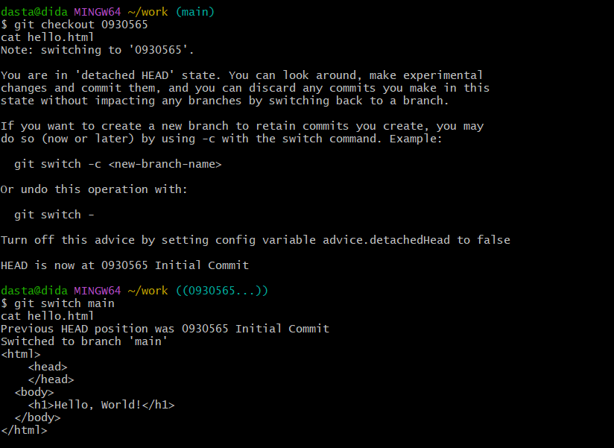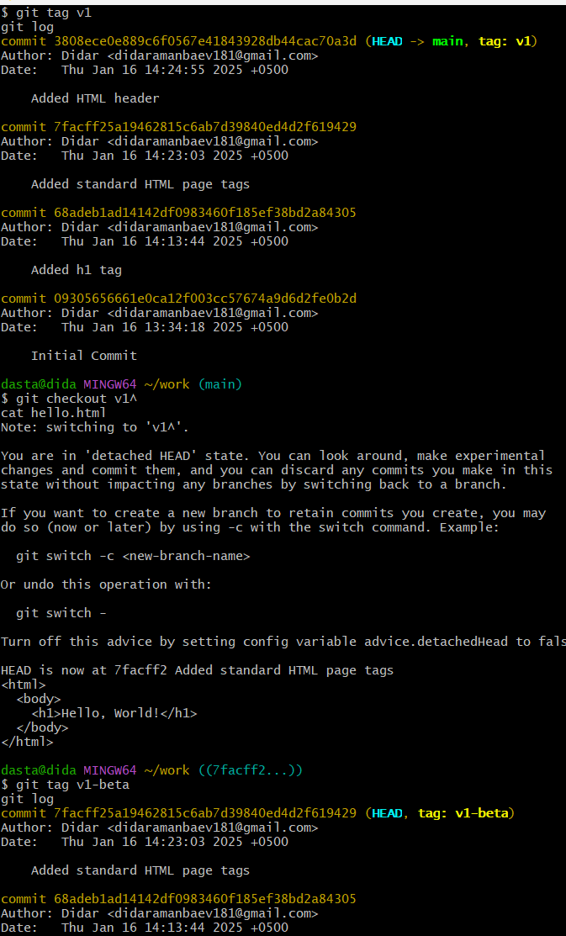

10th topic

11th topic

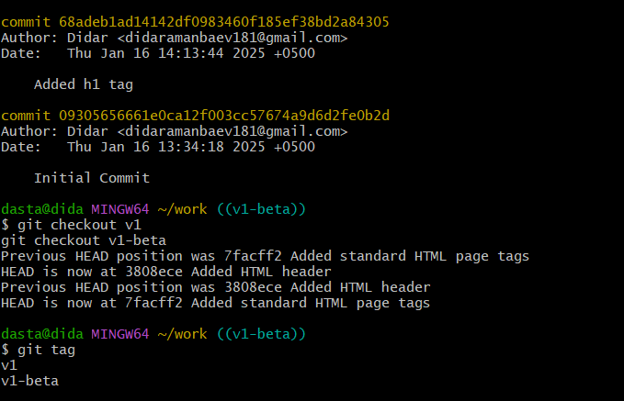

12th topic

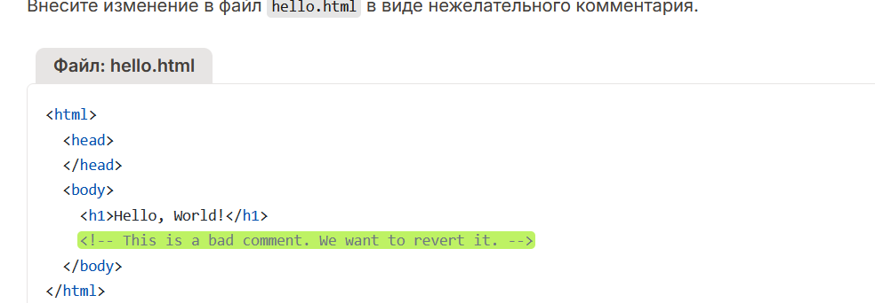

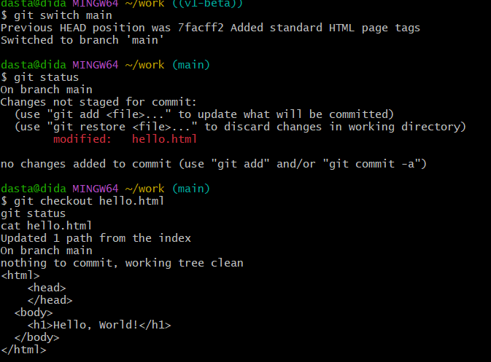

13th topic

