As my teacher said, we can consider the shoulder of Mickey Mouse
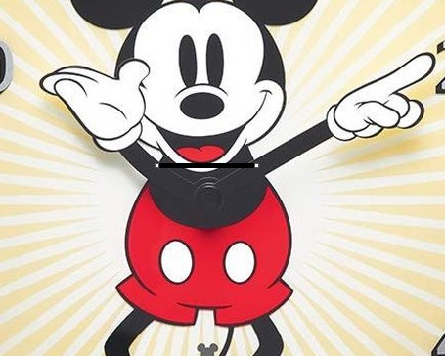

After which, the arms should spin on the circle that goes through shoulder, and center – center of image.
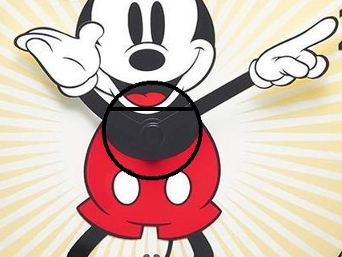
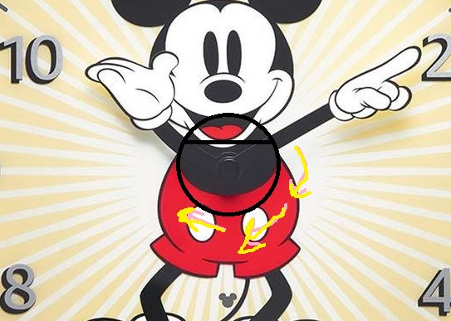

This result represented in code: ex01_Clock_B.py

However, Mickey Mouse’s hands come off him when spinning, which is why it’s worth spinning its hands not in a large circle, but in a small one that is drawn in the center:
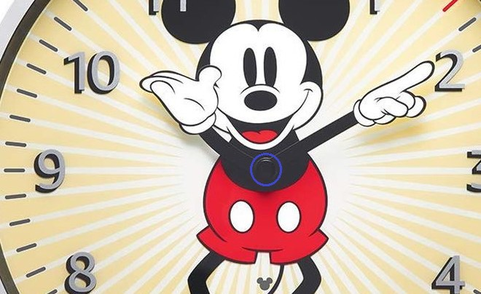
This result represented in: ex01_Clock_C.py

